**MG Robert M Joyce**

**School for Family and MWR**

**Mobile Training**

**NAF Financial Management**

Participant Guide

[**https://www.imcomacademy.com/ima/?page\_id=11999**](https://www.imcomacademy.com/ima/?page_id=11999)

****

**What are your Course Expectations?**

\_\_\_\_\_\_\_\_\_\_\_\_\_\_\_\_\_\_\_\_\_\_\_\_\_\_\_\_\_\_\_\_\_\_\_\_\_\_\_\_\_\_\_\_\_\_\_\_\_\_\_\_\_\_\_\_\_\_\_\_\_\_\_\_\_\_\_\_\_\_\_\_\_\_\_\_\_\_\_\_\_\_\_\_\_\_\_\_\_\_\_\_\_\_\_\_\_\_\_\_\_\_\_\_\_\_\_\_\_\_\_\_\_\_\_\_\_\_\_\_\_\_\_\_\_\_\_\_\_\_\_\_\_\_\_\_\_\_\_\_\_\_\_\_\_\_\_\_\_\_\_\_\_\_\_\_\_\_\_\_\_\_\_\_\_\_\_\_\_\_\_\_\_\_\_\_\_

**Course Objectives**

* Given NAF financial management protocols, interpret and relate specific guidance to NAF program operations in accordance with AR215-1, Chapter 16 and annual IMCOM G9 Program Budget Guidance.
* Given a NAF Income Statement, analyze its components to distinguish ways the information can be used to make program operating decisions in accordance with AR 215-1 and annual IMCOM G9 Program Budget Guidance.
* Given a NAF Variance Report and other historical financial reports, interpret data to identify trends and recommend corrective action if needed in accordance with AR 215-1, Chapter 16.
* Given an overview of the budget process, examine IMCOM and garrison strategic guidance and historical data for budget applicability to determine five year program requirements for inclusion in the Manager’s Narrative IAW AR 215-1.
* Given personnel management guidance, consider the role of the manager in proper labor scheduling and budget monitoring to ensure short and long term financial success.
* Given a scenario, consider future program requirements to formulate an annual NAF operating budget for one program to meet identified future requirements in accordance with annual IMCOM G9 Program Budget Guidance.
* Given the CPMC Process and a CPMC decision matrix, examine the program manager’s role in CPMC management in accordance with legal, Army, IMCOM and/or Garrison imperatives.

**Why make money?**

\_\_\_\_\_\_\_\_\_\_\_\_\_\_\_\_\_\_\_\_\_\_\_\_\_\_\_\_\_\_\_\_\_\_\_\_\_\_\_\_\_\_\_\_\_\_\_\_\_\_\_\_\_\_\_\_\_\_\_\_\_\_\_\_\_\_\_\_\_\_\_\_\_\_\_\_\_\_\_\_\_\_\_\_\_\_\_\_\_\_\_\_\_\_\_\_\_\_\_\_\_\_\_\_\_\_\_\_\_\_\_\_\_\_\_\_\_\_\_\_\_\_\_\_\_\_\_\_\_\_\_\_\_\_\_\_\_\_\_\_\_\_\_\_\_\_\_\_\_\_\_\_\_\_\_\_\_\_\_\_\_\_\_\_\_\_\_\_\_\_\_\_\_\_\_\_\_

**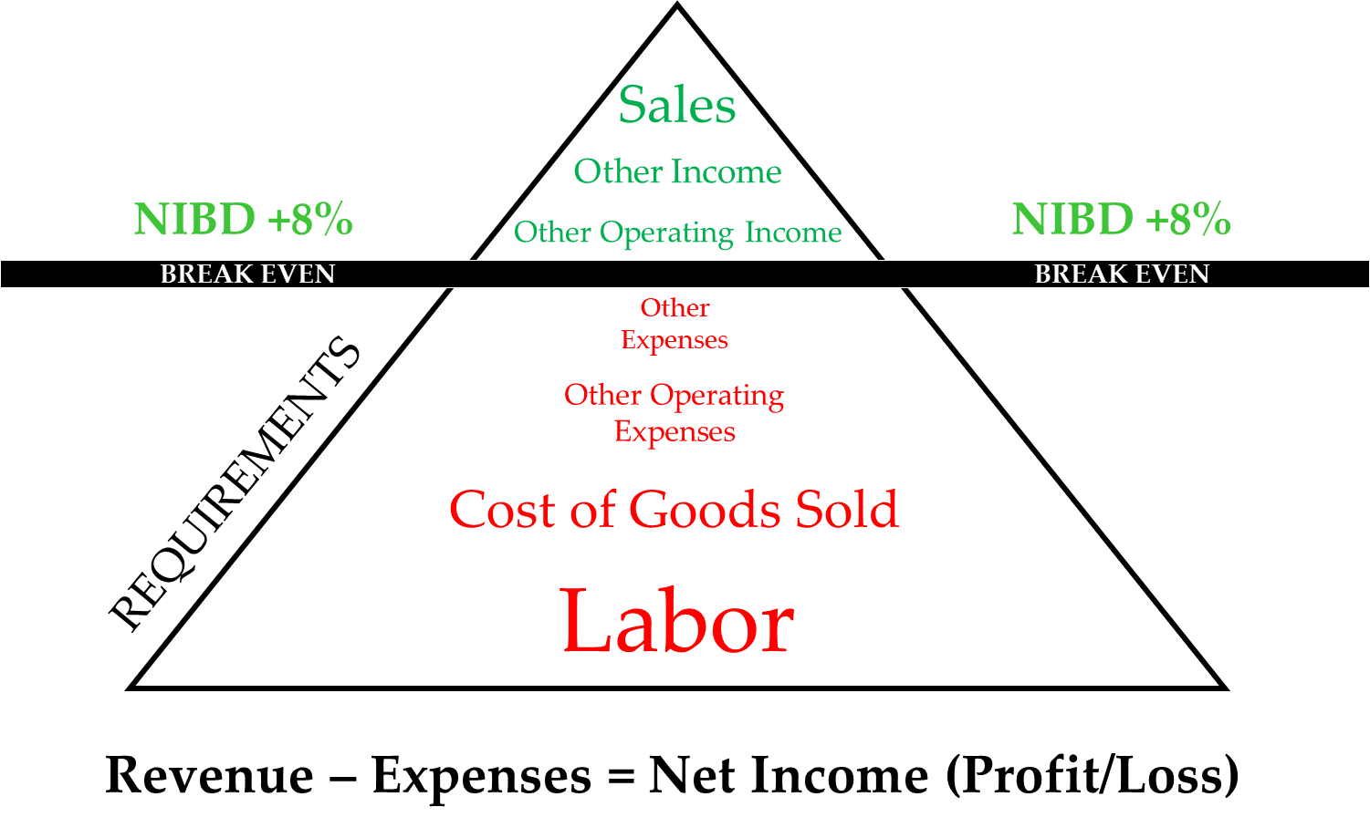**

**NAF Financial Management Module One**

The first module of the NAF Financial Management course will provide the foundation for what you need to know as a Program Manager for Family and MWR.

**Module One Objectives**

* Identify and interpret regulations and operating guidance
* Explain sources and streams of funding for MWR programs
* Relate the Uniform Funding and Management process to your own program funding sources

|  |  |  |
| --- | --- | --- |
| **FMWR Funding Categories** | | |
| **Category A** | **Category B** | **Category C** |
| * **Authorized 100 % APF** * **Minimum standard is 85% APF** | * **MIX APF & NAF** * **Minimum standard is 65% APF** | * **NAF FUNDED** |
| * **Mission Sustaining Activities** * **Critical for retention and readiness of Soldiers** * **Promotes the physical and mental well-being of the soldier** * **Little or no ability to generate NAF $** * **Authorized to be funded 100% with APF dollars - authorization, however, does not guarantee fund availability** * **Examples: Libraries, recreation centers, and fitness/sports operations** | * **Enhanced Community Support Activities** * **Provides for the readiness & retention of Soldiers & contribute to the military mission by fostering a sense of community spirit** * **Have potential to raise a limited amount of NAF $, but lack the ability to sustain themselves based purely on their business.** * **Authorized to receive the majority of their funding from APF funds - total amount depends upon the installation commander's priorities & availability of funds** * **Examples: CYS, arts and crafts, auto crafts, bowling centers with 16 or less lanes, & outdoor recreation services** | * **Business Activities** * **Considered nonessential from the perspective of the military mission** * **Desirable as a means of providing recreational activity with morale benefit** * **Business activities with highest capability of generating revenues** * **Should be self-sustaining** * **Receive little or no direct APF support & are expected to generate a profit** * **Some exceptions for remote sites & OCONUS installations** * **Examples: Clubs, golf courses, & bowling centers** |

**Family and MWR Basic Management Course Knowledge Check**

1. What are Appropriated Funds?
2. What is the difference between direct APF and indirect APF?
3. What are Nonappropriated Funds?
4. What are two sources of NAF that are not locally generated from sales or other operating income?
5. Name at least 3 offices that have responsibility for managing NAF?
6. Name at least 1 regulation that governs the use of NAF.

**GROUP ACTIVITY**

* You are analyzing a Cat C Bowling Center that has lost money for 2 straight quarters.
* What are at least 5 considerations you need to address to become **financially** **successful**? Why?
* Each group will be assigned a level
  + Program Manager
  + Division Chief
  + Garrison/DFMWR
  + ID
  + Headquarters
* Chart your answers
* Choose a scribe and spokesperson to brief your results

Notes:

\_\_\_\_\_\_\_\_\_\_\_\_\_\_\_\_\_\_\_\_\_\_\_\_\_\_\_\_\_\_\_\_\_\_\_\_\_\_\_\_\_\_\_\_\_\_\_\_\_\_\_\_\_\_\_\_\_\_\_\_\_\_\_\_\_\_\_\_\_\_\_\_\_\_\_\_\_\_\_\_\_\_\_\_\_\_\_\_\_\_\_\_\_\_\_\_\_\_\_\_\_\_\_\_\_\_\_\_\_\_\_\_\_\_\_\_\_\_\_\_\_\_\_\_\_\_\_\_\_\_\_\_\_\_\_\_\_\_\_\_\_\_\_\_\_\_\_\_\_\_\_\_\_\_\_\_\_\_\_\_\_\_\_\_\_\_\_\_\_\_\_\_\_\_\_\_\_\_\_\_\_\_\_\_\_\_\_\_\_\_\_\_\_\_\_\_\_\_\_\_\_\_\_\_\_\_\_\_\_\_\_\_\_\_\_\_\_\_\_\_\_\_\_\_\_\_\_\_\_\_\_\_\_\_\_\_\_\_\_\_\_\_\_\_\_\_\_\_\_\_\_\_\_\_\_\_\_\_\_\_\_\_\_\_\_\_\_\_\_\_\_\_\_\_\_\_\_\_\_\_\_\_\_\_\_\_\_\_\_\_\_\_\_\_\_\_\_\_\_\_\_\_\_\_\_\_\_\_\_\_\_\_\_\_\_\_\_\_\_\_\_\_\_\_\_\_\_\_\_\_\_\_\_\_\_\_\_\_\_\_\_\_\_\_\_\_\_\_\_\_\_\_\_\_\_\_\_\_\_\_\_\_\_\_\_\_\_\_\_\_\_\_\_\_\_\_\_\_\_\_\_\_\_\_\_\_\_\_\_\_

**Regulations and Policies**

What regulations or policies guide the financial management of your program?

**NOTES:**

\_\_\_\_\_\_\_\_\_\_\_\_\_\_\_\_\_\_\_\_\_\_\_\_\_\_\_\_\_\_\_\_\_\_\_\_\_\_\_\_\_\_\_\_\_\_\_\_\_\_\_\_\_\_\_\_\_\_\_\_\_\_\_\_\_\_\_\_\_\_\_\_\_\_\_\_\_\_\_\_\_\_\_\_\_\_\_\_\_\_\_\_\_\_\_\_\_\_\_\_\_\_\_\_\_\_\_\_\_\_\_\_\_\_\_\_\_\_

* **AR 215-1**: *Military Morale, Welfare, and Recreation Programs and Nonappropriated Fund Instrumentalities*
* **IMCOM Reg 215-1-1**: *IMCOM G9, Family and Morale, Welfare, and Recreation Business Operating Standards (IMCOM BOS)*
* **DODI 7000.14-R**: *Financial Management Regulation, Volume 1-16*
* **AR 11-2**: *Managers’ Internal Control Program*
* **DFAS-IN Regulation 37-1, Ch. 32**: *Accounting Procedures for Army Nonappopriated Fund Instrumentalities*

G9 [Financial Management resources: https://army.deps.mil/army/cmds/imcom\_G9/G9/Divisions/Pages/NAFFM\_Bdgt\_Analysis.aspx](C:\\Users\\rosemary.clark\\AppData\\Local\\Microsoft\\Windows\\INetCache\\Content.Outlook\\8VBX2NXK\\Financial Management resources: https:\\army.deps.mil\\army\\cmds\\imcom_G9\\G9\\Divisions\\Pages\\NAFFM_Bdgt_Analysis.aspx)

**NAF and NAFI**

**Nonappropriated Funds:**

* Cash and other assets received from sources other than funds appropriated by congress. They are predominantly generated at the local level
* NAFs are government funds used for the collective benefit of those who utilize FMWR programs
* NAFs are separate and apart from funds on the books of The United States Treasury
* Money collected for goods and services offered to authorized patrons (See *AR 215-1, Sec 6-2 or Table 6-1*, page 19). We have 30 categories of authorized patrons. GC determines who gets service. Generate between $800-$900M in yearly revenues

**NAF Instrumentalities are a *DoD Organizational Entity* which*:***

* Performs an essential government function. Assists in recruiting and retention, adds to Quality of Life (QOL)
* Maintains custody of and control over Nonappropriated Funds. (Fund Manager) *AR 215-1, Sec 5-6*
* NAFI’s are not incorporated under the laws of any state
* Tax exempt
* FMWR is not the only NAFI on an installation – Sunday collections in military chapels deposited into Chaplains’ Funds, on-post Veterninary Clinic funds, Billeting/Lodging separate from FMWR, Post Restaurant Fund, Civilian Welfare Fund, etc. We don’t share our $ with them, and they don’t share with us. See *AR 215-1, Sec. 4-8* page 8 for additional supplemental mission NAFIs
* Supplemental Mission NAF accounts, see *AR 215-1, Sec 4-7*, page 7

**Fund Manager**

Who is your fund manager?

* They are appointed
* They are the approving authority
* They are responsible for monitoring FMWR activities
* They ensure internal management controls are in place

The Fund Manager for IMWRF

* Monitors FMWR activities for regulatory compliance, especially regarding internal controls (*Cash Control System, Retail Sales Accountability, and Physical Security*).
* They ensure a series of checks and balances/ separation of duties are in place and functioning

**Funding**

* Describe a way your program/activity has received funding in the last quarter

\_\_\_\_\_\_\_\_\_\_\_\_\_\_\_\_\_\_\_\_\_\_\_\_\_\_\_\_\_\_\_\_\_\_\_\_\_\_\_\_\_\_\_\_\_\_\_\_\_\_\_\_\_\_\_\_\_\_\_\_\_\_\_\_\_\_\_\_\_\_\_\_\_\_\_\_\_\_\_\_\_\_\_\_\_\_\_\_\_\_\_\_\_\_\_\_\_\_\_\_\_\_\_\_\_\_\_\_\_\_\_\_\_\_\_\_\_\_\_\_\_\_\_\_\_\_\_\_\_\_\_\_\_\_\_\_\_\_\_\_\_\_\_\_\_\_\_\_\_\_\_\_\_\_\_\_\_\_\_\_\_\_\_\_\_\_\_\_\_\_\_\_\_\_\_\_\_\_\_\_\_\_\_\_\_\_\_\_\_\_\_\_\_\_\_\_\_\_\_\_\_\_\_\_\_\_\_\_\_\_\_\_\_\_\_\_\_\_\_

**Uniform Funding & Management**

UFM (Uniform Funding & Management) is the process used to convert appropriated funds (APF) into nonappropriated funds (NAF) for the purpose of providing FMWR support services under a single set of rules and procedures in order to:

* Procure property and services for FMWR
* Manage employees
* Provide programs
* Streamline financial reporting and management

***UFM is only available for FMWR Programs that are authorized APF expenses.***

*See AR 215-1, Table D-1*

**Notes:**

\_\_\_\_\_\_\_\_\_\_\_\_\_\_\_\_\_\_\_\_\_\_\_\_\_\_\_\_\_\_\_\_\_\_\_\_\_\_\_\_\_\_\_\_\_\_\_\_\_\_\_\_\_\_\_\_\_\_\_\_\_\_\_\_\_\_\_\_\_\_\_\_\_\_\_\_\_\_\_\_\_\_\_\_\_\_\_\_\_\_\_\_\_\_\_\_\_\_\_\_\_\_\_\_\_\_\_\_\_\_\_\_\_\_\_\_\_\_\_\_\_\_\_\_\_\_\_\_\_\_\_\_\_\_\_\_\_\_\_\_\_\_\_\_\_\_\_\_\_\_\_\_\_\_\_\_\_\_\_\_\_\_\_\_\_\_\_\_\_\_\_\_\_\_\_\_\_\_\_\_\_\_\_\_\_\_\_\_\_\_\_\_\_\_\_\_\_\_\_\_\_\_\_\_\_\_\_\_\_\_\_\_\_\_\_\_\_\_\_\_\_\_\_\_\_\_\_\_\_\_\_\_\_\_

**Funding Levels**

* How are individual Garrison FMWR APF funding levels determined?

\_\_\_\_\_\_\_\_\_\_\_\_\_\_\_\_\_\_\_\_\_\_\_\_\_\_\_\_\_\_\_\_\_\_\_\_\_\_\_\_\_\_\_\_\_\_\_\_\_\_\_\_\_\_\_\_\_\_\_\_\_\_\_\_\_\_\_\_\_\_\_\_\_\_\_\_\_\_\_\_\_\_\_\_\_\_\_\_\_\_\_\_\_\_\_\_\_\_\_\_\_\_\_\_\_\_\_\_\_\_\_\_\_\_\_\_\_\_\_\_\_\_\_\_\_\_\_\_\_\_\_\_\_\_\_\_\_\_\_\_\_\_\_\_\_\_\_\_\_\_\_\_\_\_\_\_\_\_\_\_\_\_\_\_\_\_\_\_\_\_\_\_\_\_\_\_\_\_\_\_\_\_\_\_\_\_\_\_\_\_\_\_\_\_\_\_\_\_\_\_\_\_\_\_\_\_\_\_\_\_\_\_\_\_\_\_\_\_\_

**Sources of Funds**

Appropriated Funds are used to fund things like Base Operations (Utilities, New projects, and the FMWR MDEPS (QDPC, QACS, and QCYS)). These are mission essential programs and services that receive funds appropriated by congress. NAF are a mix of funds that are self-generated (e.g. sales), outside sources, donations, the AAFES Dividends, etc.

**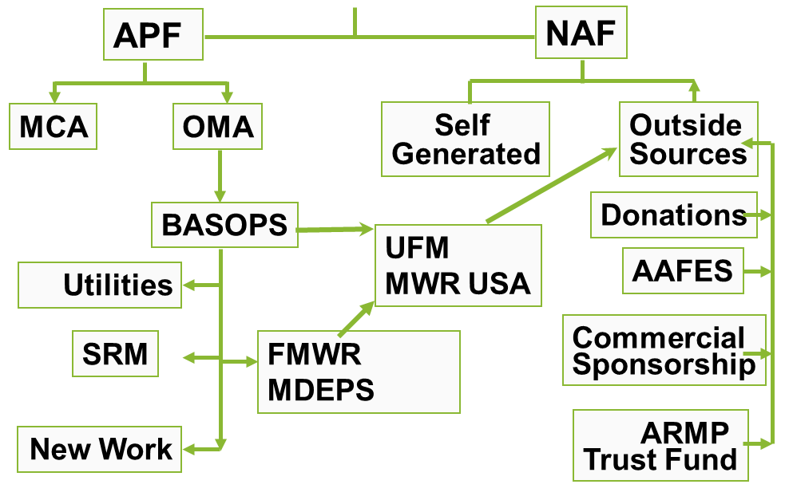**

**KEY:**

MCA – Military Construction Army

OMA – Operation and Maintenance Army

BASOPS – Base Operations

SRM – Sustainment Restoration Modernization

MDEP – Management Decision Package

UFM – Uniform Funding Management

MWR USA – MWR Utilization Support and Accountability

**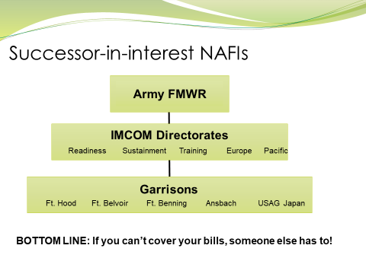**

**NAF Financial Management Module Two**

**Income Statements as a Management Tool**

In module 2 of the NAF Financial Management course, participants will discover the process for tracking FMWR Financials to include Location, Program, and GLACs. The learners will also explore an income statement, its components, and distinguish ways the income statement can be used to manage a program.

**Module Two Objectives**

* Describe the monthly income statement by categorizing information contained on the statement.
* List the seven major elements of an income statement and their value in program operation.
* Perform standard income statement calculations and relate their value to program operations.
* Establish best uses of the five (5) key financial trends in FMWR.
* Recognize the role of analysis in financial management and examine reports available for conducting an analysis.

**Give Us Your Digits!**

Do you know your Program, Location, and Department Codes?



Program

Code

Location

Code

Department

Code

**Standard NAFI Number (SNN) – A SNN** must be provided on all documents forwarded to NAF Financial Services (NFS) in order to ensure that the income or expense is accurately recorded in the correct activity's account.



Garrison /

Installation Code

Fund

Program

Code

Location

Code

Department

Code

GLAC

**12-digit Standard NAFI Number by Element**

**Roll Things Up!**

*General Ledger Account Codes (GLACs) are used to track expenses and income.*

**Income Statements**

What is an Income Statement and what is it used for?

**Notes:**

\_\_\_\_\_\_\_\_\_\_\_\_\_\_\_\_\_\_\_\_\_\_\_\_\_\_\_\_\_\_\_\_\_\_\_\_\_\_\_\_\_\_\_\_\_\_\_\_\_\_\_\_\_\_\_\_\_\_\_\_\_\_\_\_\_\_\_\_\_\_\_\_\_\_\_\_\_\_\_\_\_\_\_\_\_\_\_\_\_\_\_\_\_\_\_\_\_\_\_\_\_\_\_\_\_\_\_\_\_\_\_\_\_\_\_\_\_\_\_\_\_\_\_\_\_\_\_\_\_\_\_\_\_\_\_\_\_\_\_\_\_\_\_\_\_\_\_\_\_\_\_\_\_\_\_\_\_\_\_\_\_\_\_\_\_\_\_\_\_\_\_\_\_\_\_\_\_\_\_\_\_\_\_\_\_\_\_\_\_\_\_\_\_\_\_\_\_\_\_\_\_\_\_\_\_\_\_\_\_\_\_\_\_\_\_\_\_\_\_\_\_\_\_\_\_\_\_\_\_\_\_\_\_\_\_\_\_\_\_\_\_\_\_\_\_\_

**Income Statements**

* + The formal documentation of a NAF programs financial performance.
  + A historical document prepared 15 to 20 days after the close of the monthly accounting period.
  + It compares revenue to expenses.
  + It reflects a net income or a loss for the period.
  + It uses the basic income statement format below.

**Revenue – Expense = Net Income (or Loss)**





**Seven Major Elements** *(more info at end of participant guide)*

1. Net Sales
   * Daily Activity Report (DAR), Cashier’s Report, etc.
   * GLACs 301-307
2. Cost of Goods Sold
   * Cost associated with the purchase of merchandise which will be sold at retail.
   * GLACs 401-456
3. Gross Income from Sales
   * Net Sales minus COGs
4. Gross Income from Operations
   * Includes Sales + Other Operating Income
   * GLACs 501-599
5. Labor and Percentage of Labor
   * Total Labor costs are calculated by adding together the GLACs which are used to record the parts of Labor cost.
   * GLACs 601-632
6. Net Income/Loss from Operations
   * Gross Income from Operations minus Labor and Other Operating Expenses
   * OOE GLACs 647-799
7. Net Income/Loss before Depreciation (NIBD)
   * Difference between Total Revenue and Total Expenses (before depreciation)

**Income Statement Calculations**

**Group Activity**

* You will work as a group
* Complete the missing calculations in the Income Statement

**Financial Formulas**

1. **COGS% =** (Cost of Goods Sold / Net Sales) x 100
2. **Gross Income from Sales =** Net Sales – Cost of Goods Sold
3. **Gross Income from Operations =** Gross Income from Sales + Other Operating Income
4. **Labor% =** [Labor Costs / (Net Sales + Other Operating Income + Other Income)] x 100
5. **Net Income from Operations** **=** Gross Income from Operations – Labor – Other Operating Expenses
6. **NIBD =** Net Income from Operations + Other Income – Other Expenses
7. **NIBD% =** [NIBD **/** (Net Sales + Other Operating Income + Other Income)] x 100
8. **Net Income After Depreciation (NIAD) =** NIBD - Depreciation

|  |  |  |  |  |
| --- | --- | --- | --- | --- |
| **Income Statement** | | | | |
| 1 | Net Sales | $ 7,000.00 |  |  |
| 2 | - Cost of Goods Sold | $ 2,450.00 | COGS % |  |
|  | = Gross Income from Sales |  |  |  |
| 3 | + Other Operating Income | $ 11,000.00 |  |  |
|  | = Gross Income from Operations |  |  |  |
| 4 | - Labor | $ 7,200.00 | Labor % |  |
| 5 | - Other Operating Expenses | $ 1,000.00 |  |  |
|  | = Net Income/Loss from Operations |  |  |  |
| 6a | + Other Income | $ 600.00 |  |  |
| 6b | - Other Expenses | $ 200.00 |  |  |
|  | = Net Income/Loss before Depreciation (NIBD) |  | NIBD % |  |
| 7 | - Depreciation | $ 400.00 |  |  |
|  | = Net Income/Loss after Depreciation |  |  |  |

**Does an Income Statement paint the total picture of your Program Financials?**

**Analyzing Financials**

What is Analysis?

A comparative analysis is a method used in the examination of \_\_\_\_\_\_\_\_\_\_\_\_ \_\_\_\_\_\_\_\_\_\_\_\_ to identify \_\_\_\_\_\_\_\_ trends by the item-by-item comparison of \_\_\_\_\_\_\_\_ or \_\_\_\_\_\_\_\_\_\_ sets of data.

**Program Reports: What are some reports you use in your program?**

**Five Key Financial Reports and what they tell you…**

* + This month vs last month
    - May highlight upward or downward trends
    - May be useful to analyze percentages (e.g. Labor, COGs)
    - May be used to start to isolate any problem areas
  + This month vs budget
    - Highlights differences with actual figures
    - Called the monthly variance report
    - Variances should be explained by program managers and may need an action plan
  + This month vs same month last year
    - Good for seasonal activities
    - Useful for detecting cost and income changes
    - Highlights changes over a longer period of time
  + YTD this year vs YTD last year
    - Good picture between two years
    - Can help predict the rest of year
  + YTD this year vs YTD budget
    - Reveals if you are on target with your AOB

**Group Exercise:**

* Given one of the 5 Key Financial Reports, provide at least one scenario in which you would use the report you are assigned.
* Work as a table group to complete the exercise on chart paper.

\_\_\_\_\_\_\_\_\_\_\_\_\_\_\_\_\_\_\_\_\_\_\_\_\_\_\_\_\_\_\_\_\_\_\_\_\_\_\_\_\_\_\_\_\_\_\_\_\_\_\_\_\_\_\_\_\_\_\_\_\_\_\_\_\_\_\_\_\_\_\_\_\_\_\_\_\_\_\_\_\_\_\_\_\_\_\_\_\_\_\_\_\_\_\_\_\_\_\_\_\_\_\_\_\_\_\_\_\_\_\_\_\_\_\_\_\_\_\_\_\_\_\_\_\_\_\_\_\_\_\_\_\_\_\_\_\_\_\_\_\_\_\_\_\_\_\_\_\_\_\_\_\_\_\_\_\_\_\_\_\_\_\_\_\_\_\_\_\_\_\_\_\_\_\_\_\_\_\_\_\_\_\_\_\_\_\_\_\_\_\_\_\_\_\_\_\_\_\_\_\_\_\_\_\_\_\_\_\_\_\_\_\_\_\_\_\_\_\_\_\_\_\_\_\_\_\_\_\_\_\_\_\_\_\_\_\_\_\_\_\_\_\_\_\_\_\_\_\_\_\_\_\_\_\_\_\_\_\_\_\_\_\_\_\_\_\_\_\_\_\_\_\_\_\_\_\_\_\_\_\_\_\_\_\_\_\_\_\_\_\_\_\_\_\_\_\_\_\_\_\_\_\_\_\_\_\_\_\_\_\_\_\_\_\_\_\_\_\_\_\_\_\_\_\_\_\_\_\_\_\_\_\_\_\_\_\_\_\_\_\_\_\_\_

**Standard Management Information Reports for Finance (SMIRF)**

* + **Summary Account Comparison** – This report compares the actual financial results of the current year and 5 years prior.
  + **Income by Month** – This report provides the fiscal year by month in a side-by- side format and includes all GLAC’s.
  + **Horse Blanket YTD Income Statement** – This report summarizes the income statement by major element (i.e. Division-specific Program Group).
  + **Budget vs Actual** – This report compares the actual financial results with the budget for the month requested and includes the year-to-date results.
  + **GLAC Query Summary** – This report provides monthly and year-to-date financial data on individual summary GLAC’s. It also includes quarterly totals.
  + **GLAC Query Actual** – This report provides monthly and year-to-date financial data on individual GLAC’s. It also includes quarterly totals.

**NAF Financial Management Labor Module**

In the labor module of the NAF Financial Management course, students will review the NAF employment categories, and discuss labor scheduling and how it relates to budgeting. Learners will consider the role of the manager in proper labor scheduling and budget monitoring to ensure short and long term financial success.

**Staffing Mix Impact on Labor Expense and NIBD**



|  |  |  |  |  |  |  |
| --- | --- | --- | --- | --- | --- | --- |
| Category |  |  |  |  |  | Total |
| Benefits? |  |  |  |  |  |  |
| Minimum |  |  |  |  |  |  |
| Maximum |  |  |  |  |  |  |
| Rate |  |  |  |  |  |  |

*(you must solve for each person: hours x rate = weekly labor rate)*

**Minimum Labor Cost: \_\_\_\_\_\_\_\_\_\_\_\_\_ Maximum Labor Cost: \_\_\_\_\_\_\_\_\_\_\_\_\_**

**Module Objectives**

* **Recognize the new fiscal reality and how labor impacts business**
* **Identify program code and associated labor standard**
* **Identify key inputs and outputs for controlling labor costs**

**Labor Categories**

Appointment Categories *(AR 215-3, Ch 2-2.)*

* + Regular employee serves in a continuing position on a scheduled basis
    - Regular full-time (RFT) if the regular workweek is 40 hours
    - Regular part-time (RPT) if the workweek is from 20 to 39 hours
  + Flexible employee serves in a continuing position on a scheduled or an as needed basis.
    - There is no upper limit to the number of hours a flexible employee may work (subject to overtime obligations and work scheduling requirements.)
    - A time limitation of less than one year may be made to a FLX appointment
    - FLX employees may be guaranteed a specific number of hours each
  + Seasonal
    - Positions not needed for the entire year as “seasonal positions”
      * Regular Full Time Seasonal (RFS)
      * Regular Part-Time Seasonal (RPS)
    - If the position will not last at least 6 months, a seasonal appointment may not be used.

**What are some labor challenges facing FMWR programs?**

\_\_\_\_\_\_\_\_\_\_\_\_\_\_\_\_\_\_\_\_\_\_\_\_\_\_\_\_\_\_\_\_\_\_\_\_\_\_\_\_\_\_\_\_\_\_\_\_\_\_\_\_\_\_\_\_\_\_\_\_\_\_\_\_\_\_\_\_\_\_\_\_\_\_\_\_\_\_\_\_\_\_\_\_\_\_\_\_\_\_\_\_\_\_\_\_\_\_\_\_\_\_\_\_\_\_\_\_\_\_\_\_\_\_\_\_\_\_\_\_\_\_\_\_\_\_\_\_\_\_\_\_\_\_\_\_\_\_\_\_\_\_\_\_\_\_\_\_\_\_\_\_\_\_\_\_\_\_\_\_\_\_\_\_\_\_\_\_\_\_\_\_\_\_\_\_\_\_\_\_\_\_\_\_\_\_\_\_\_\_\_\_\_\_\_\_\_\_\_\_\_\_\_\_\_\_\_\_\_\_

\_\_\_\_\_\_\_\_\_\_\_\_\_\_\_\_\_\_\_\_\_\_\_\_\_\_\_\_\_\_\_\_\_\_\_\_\_\_\_\_\_\_\_\_\_\_\_\_\_\_\_\_\_\_\_\_\_\_\_\_\_\_\_\_\_\_\_\_\_\_\_\_\_\_\_\_\_\_\_\_\_\_\_\_\_\_\_\_\_\_\_\_\_\_\_\_\_\_\_\_\_\_\_\_\_\_\_\_\_\_\_\_\_\_\_\_\_\_\_\_\_\_\_\_\_\_\_\_\_\_\_\_\_\_\_\_\_\_\_\_

**Labor Standards (IAW *IMCOM Reg 215-1-1)***

**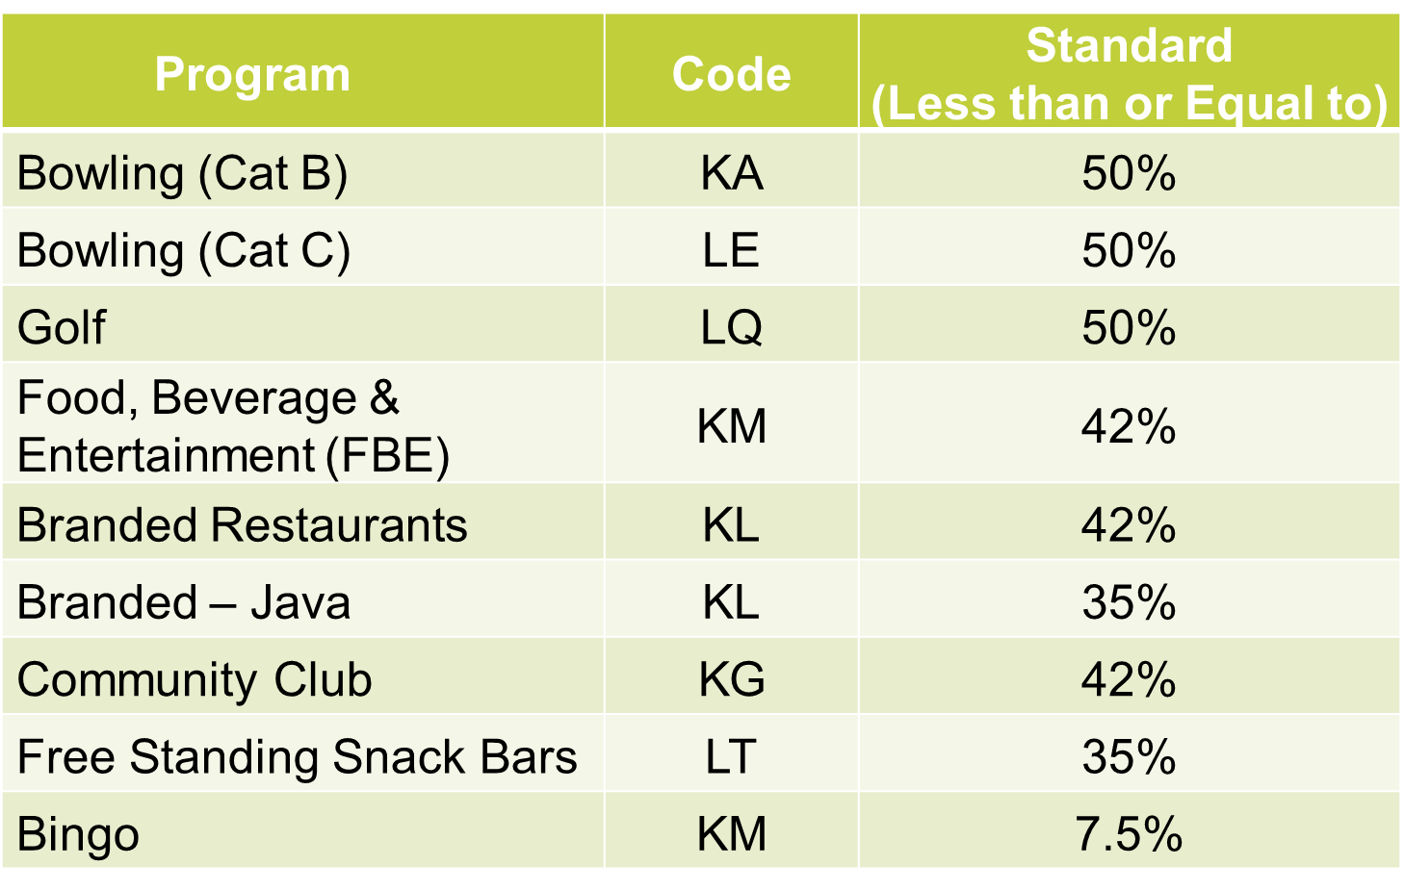**

***What is YOUR labor standard?***

**How do you control labor costs?**

\_\_\_\_\_\_\_\_\_\_\_\_\_\_\_\_\_\_\_\_\_\_\_\_\_\_\_\_\_\_\_\_\_\_\_\_\_\_\_\_\_\_\_\_\_\_\_\_\_\_\_\_\_\_\_\_\_\_\_\_\_\_\_\_\_\_\_\_\_\_\_\_\_\_\_\_\_\_\_\_\_\_\_\_\_\_\_\_\_\_\_\_\_\_\_\_\_\_\_\_\_\_\_\_\_\_\_\_\_\_\_\_\_\_\_\_\_\_\_\_\_\_\_\_\_\_\_\_\_\_\_\_\_\_\_\_\_\_\_\_\_\_\_\_\_\_\_\_\_\_\_\_\_\_\_\_\_\_\_\_\_\_\_\_\_\_\_\_\_\_\_\_\_\_\_\_\_\_\_\_\_\_\_\_\_\_\_\_\_\_\_\_\_\_\_\_\_\_\_\_\_\_\_\_\_\_\_\_\_\_

**How frequently do you monitor labor?**

\_\_\_\_\_\_\_\_\_\_\_\_\_\_\_\_\_\_\_\_\_\_\_\_\_\_\_\_\_\_\_\_\_\_\_\_\_\_\_\_\_\_\_\_\_\_\_\_\_\_\_\_\_\_\_\_\_\_\_\_\_\_\_\_\_\_\_\_\_\_\_\_\_\_\_\_\_\_\_\_\_\_\_\_\_\_\_\_\_\_\_\_\_\_\_\_\_\_\_\_\_\_\_\_\_\_\_\_\_\_\_\_\_\_\_\_\_\_\_\_\_\_\_\_\_\_\_\_\_\_\_\_\_\_\_\_\_\_\_\_\_\_\_\_\_\_\_\_\_\_\_\_\_\_\_\_\_\_\_\_\_\_\_\_\_\_\_\_\_\_\_\_\_\_\_\_\_\_\_\_\_\_\_\_\_\_\_\_\_\_\_\_\_\_\_\_\_\_\_\_\_\_\_\_\_\_\_\_\_\_

**What can you do to better manage labor?**

\_\_\_\_\_\_\_\_\_\_\_\_\_\_\_\_\_\_\_\_\_\_\_\_\_\_\_\_\_\_\_\_\_\_\_\_\_\_\_\_\_\_\_\_\_\_\_\_\_\_\_\_\_\_\_\_\_\_\_\_\_\_\_\_\_\_\_\_\_\_\_\_\_\_\_\_\_\_\_\_\_\_\_\_\_\_\_\_\_\_\_\_\_\_\_\_\_\_\_\_\_\_\_\_\_\_\_\_\_\_\_\_\_\_\_\_\_\_\_\_\_\_\_\_\_\_\_\_\_\_\_\_\_\_\_\_\_\_\_\_\_\_\_\_\_\_\_\_\_\_\_\_\_\_\_\_\_\_\_\_\_\_\_\_\_\_\_\_\_\_\_\_\_\_\_\_\_\_\_\_\_\_\_\_\_\_\_\_\_\_\_\_\_\_\_\_\_\_\_\_\_\_\_\_\_\_\_\_\_\_

**Labor = Largest \_\_\_\_\_\_\_\_\_\_\_\_\_\_\_\_ Expense**

**Labor Model**

* An efficient allocation of \_\_\_\_\_\_\_\_\_\_ hours based on forecasted revenue
  + - Utilization of labor tied to a labor cost standard
    - Adjust operation hours based on \_\_\_\_\_\_\_\_\_\_ and operational cost
* A financial management tool used to schedule and adjust labor on a \_\_\_\_\_\_\_\_\_\_, \_\_\_\_\_\_\_\_\_\_, and \_\_\_\_\_\_\_\_\_\_ basis
* Defines the specific key performance indicators (\_\_\_\_\_\_\_\_) that an organization uses to track the workforce across multiple departments to productivity, cost, and service level
* Utilized to aid in the determination of the \_\_\_\_\_\_\_\_\_\_ staffing mix of full-time, part-time and flex employees

**Labor Model**

* Key Inputs:
  + *Revenue* *Forecasting*:
    - \_\_\_\_\_\_\_\_\_ Data such as revenue, cover counts, and average check
    - Number of functions or events booked, guests, and current trends
  + *Cost of Goods Sold*: based on budget, trends, and established \_\_\_\_\_\_\_\_\_\_
  + *Other Operating Expenses*: based on budget and established benchmarks
  + *Net Income Before Depreciation (NIBD)*: based on \_\_\_\_\_\_\_\_\_\_\_\_\_\_\_ needs and established benchmarks
  + *Average Hourly Cost of Labor*:
    - Total Labor Cost divided by Productive Hours *(Total hours worked minus Leave Taken- Annual, Holiday, and Sick)*
    - Total Labor Cost from financial reports
* Key Outputs:
  + Total Payroll Cost (\_\_\_\_\_\_\_\_\_\_) for budget time period
  + Allowable hours of labor for \_\_\_\_\_\_\_\_\_\_ scheduling

**Labor Scheduling**

**Effective Management Practices**

* Define \_\_\_\_\_\_\_\_\_\_ manning requirement for facility and develop long term action plan to meet standard/manning requirement
  + Through attrition and/or BBAs, adjust the employment status of new hires
    - RFT to RPT
    - RPT to Flex
    - Flex to Seasonal
* **Staffing:** “right person” in the \_\_\_\_\_\_\_\_\_ position
  + Recruiting, Selecting, Hiring and Training
  + Correct mix of Full-time, Part-time and Flex
* **Scheduling**: “right number of \_\_\_\_\_\_\_\_\_\_” in the right job at the right time
  + Providing proper service to guests, while controlling labor costs
  + Effective staffing and scheduling based on forecasted customer count and sales
* **Increase Productivity:**
  + Increase revenue while controlling labor
  + Increase revenue generating events \_\_\_\_\_\_\_\_\_\_ increased labor
  + Up-Selling and yield management
  + Cross Train Staff
* **Control** **Cost**:
  + Menu re-engineering, portion control, pricing
  + Operational hours
  + Utilized \_\_\_\_\_\_\_\_\_\_

**Group Activity**- Labor Scheduling

* Based on the given information, create a weekly staffing schedule

|  |  |  |  |  |  |  |  |
| --- | --- | --- | --- | --- | --- | --- | --- |
|  | **Monday** | **Tuesday** | **Wednesday** | **Thursday** | **Friday** | **Saturday** | **Sunday** |
| **Employee** |  |  |  |  |  |  |  |
|  |  |  |  |  |  |  |  |
|  |  |  |  |  |  |  |  |
|  |  |  |  |  |  |  |  |
|  |  |  |  |  |  |  |  |

|  |  |  |  |  |  |  |  |
| --- | --- | --- | --- | --- | --- | --- | --- |
|  | **Monday** | **Tuesday** | **Wednesday** | **Thursday** | **Friday** | **Saturday** | **Sunday** |
| **Employee** |  |  |  |  |  |  |  |
|  |  |  |  |  |  |  |  |
|  |  |  |  |  |  |  |  |
|  |  |  |  |  |  |  |  |
|  |  |  |  |  |  |  |  |

**Labor Budgeting**

* **Revenue Forecasting**
  + \_\_\_\_\_\_\_\_\_\_ forecasting revenue is a critical component for maximizing revenues and minimizing expenses
  + The following details must be considered:
    - *Food & Beverage Operations* = Forecasted Customer Counts x Average Guest Check plus booked events
    - *Bowling Center* = Forecasted Lines per Lane per day x Average Revenue per Line Bowled x Number of lanes for the facility x Number of open days for the month
    - *Golf* = Forecasted Rounds Played x Average Revenue per Round
* **Cost of Goods Sold (COGS)**
  + Use “Current COGS %”, “YTD COGS %” from your \_\_\_\_\_\_\_\_\_\_ statement or “COGS %” from your Budget whichever is a more accurate and realistic figure based on current operations
  + This figure needs to be realistic, do **NOT** simply utilize the targeted benchmark if the facility cannot meet that percentage mark
* **Desirable Labor Cost Percentage**
  + Use the \_\_\_\_\_\_\_\_\_\_ in the *IMCOM Reg 215-1-1 (or other directed)* labor standard or target based on phased-in approach for those operations greater than 5% above standard.
* **Other Operating Expense**
  + Use “Current Other Operating Expenses (OOE) %” or “YTD OOE %” from your financial statement or “Budgeted %” from your budget whichever is more accurate and realistic figure based on your current operational situation or \_\_\_\_\_\_\_\_\_\_
* **Net Income Before Depreciation (NIBD)**
  + Use the percentage in the “Benchmark” from Guidance (Annual Budget Guidance/Local Guidance), or Budgeted NIBD percentage (NIBD %) from your Budget whichever is more accurate and realistic figure based on your \_\_\_\_\_\_\_\_\_\_ operational situation

**How to calculate “Average Hourly Labor Cost”**

* **“Average Hourly Labor Cost”** represents the dollar amount you spend per hour any employee works in the facility.
* **Total Payroll Cost =** Total Labor per a given month from your financial statement
* **Productive Hours =** Total hours worked minus Leave Taken (Annual, Holiday, and Sick)

**Average Hourly Labor Cost Calculation Example:**

* + Total Labor Cost for the month: $320,000 (from Financial Statement)
  + Total Productive Hours for the month: 16,000 hours

\_\_\_\_\_\_\_\_\_\_\_\_\_\_\_\_\_\_\_  **/** \_\_\_\_\_\_\_\_\_\_\_\_\_\_\_\_\_  **= $**\_\_\_\_\_\_\_\_\_\_  **per hour**

**Individual Activity** – Labor Budgeting

Using your financial statement and labor schedule, fill-in-the-blanks:

* Monthly Total Labor: $ \_\_\_\_\_\_\_\_\_\_\_\_\_\_\_\_\_\_\_\_\_\_\_\_\_
* Monthly Total Revenue: $ \_\_\_\_\_\_\_\_\_\_\_\_\_\_\_\_\_\_\_\_\_\_\_\_

Example: (50% labor standard; $5000 weekly labor)

* I need to make $\_\_\_\_\_\_\_\_\_ a month in revenue to ONLY cover my labor.
* Based on my program labor standard of \_\_\_\_\_\_\_\_%, I need to make $\_\_\_\_\_\_\_\_\_\_\_\_ a month in revenue to meet my labor standard.

**NAF Financial Management Module Three**

**Analyzing a Variance**

In module 3 of the NAF Financial Management course, students will recognize that budgets do not always get executed as planned. There are several familiar causes that can have an effect on budget plans. The learners will also explore a variance; how to calculate the variance; and distinguish cause and effect relationships in order to identify root causes, identify trends and recommend resulting/corrective action.

**Module Three Objectives**

* Analyze a variance report to identify actual financial operations performing outside of established standards
* Perform an analysis of the Actual vs. Budget for a given financial trend
* Conduct an analysis to determine financial trend
* Distinguish cause and effect
* Formulate possible causes for identified trends and recommend resulting/corrective action(s)

**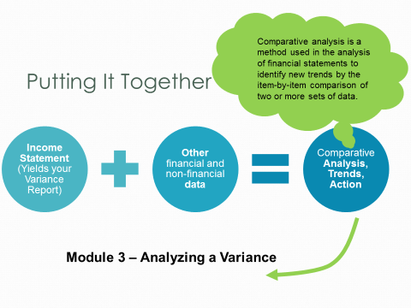**

**Five Key Financial Reports**

**Variance**

* This month vs last month
* This month vs budget
* This month vs same month last year
* YTD this year vs YTD last year
* YTD this year vs budget YTD

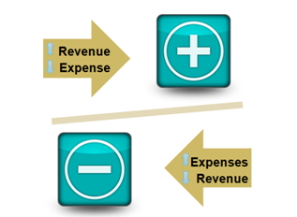

**The + or – of Financial Trends**

* Expressed as either positive or negative
* In general, when revenue is "down" or expenses are "up," the financial trend is considered **negative**
* Conversely, when revenue is "up" or expenses are "down," the financial trend is considered **positive**
* **Which trends should managers analyze? Why?**

**SMIRF Reports – Budget vs Actual (Variance)**

What is a Variance?

\_\_\_\_\_\_\_\_\_\_\_\_\_\_\_\_\_\_\_\_\_\_\_\_\_\_\_\_\_\_\_\_\_\_\_\_\_\_\_\_\_\_\_\_\_\_\_\_\_\_\_\_\_\_\_\_\_\_\_\_\_\_\_\_\_\_\_\_\_\_\_\_\_\_\_\_\_\_\_\_\_\_\_\_\_\_\_\_\_\_\_\_\_\_\_\_\_\_\_\_\_\_\_\_\_\_\_\_\_\_\_\_\_\_\_\_\_\_\_\_\_\_\_\_\_\_\_\_\_\_\_\_\_\_\_\_\_\_\_\_\_\_\_\_\_\_\_\_\_\_\_\_\_\_\_\_\_\_\_\_\_\_\_\_\_\_\_\_\_\_\_\_\_\_\_\_\_\_\_\_\_\_\_\_\_\_\_\_\_\_\_\_\_\_\_\_\_\_\_\_\_\_\_\_\_\_\_\_\_\_

**Example: 726 Supplies Expense**

**Actual – Budgeted = Variance/Budgeted x 100 = Variance %**

**$1300 – $1000 = 300 / $1000 = 0.3 x 100 = 30 %**

**HOW DO YOU MEASURE UP?**

What are your numbers compared against?

\_\_\_\_\_\_\_\_\_\_\_\_\_\_\_\_\_\_\_\_\_\_\_\_\_\_\_\_\_\_\_\_\_\_\_\_\_\_\_\_\_\_\_\_\_\_\_\_\_\_\_\_\_\_\_\_\_\_\_\_\_\_\_\_\_\_\_\_\_\_\_\_\_\_\_\_\_\_\_\_\_\_\_\_\_\_\_\_\_\_\_\_\_\_\_\_\_\_\_\_\_\_\_\_\_\_\_\_\_\_\_\_\_\_\_\_\_\_\_\_\_\_\_\_\_\_\_\_\_\_\_\_\_\_\_\_\_\_\_\_

*Headquarters Guidance*

\_\_\_\_\_\_\_\_\_\_\_\_\_\_\_\_\_\_\_\_\_\_\_\_\_\_\_\_\_\_\_\_\_\_\_\_\_\_\_\_\_\_\_\_\_\_\_\_\_\_\_\_\_\_\_\_\_\_\_\_\_\_\_\_\_\_\_\_\_\_\_\_\_\_\_\_\_\_\_\_\_\_\_\_\_\_\_\_\_\_\_\_\_\_\_\_\_\_\_\_\_\_\_\_\_\_\_\_\_\_\_\_\_\_\_\_\_\_\_\_\_\_\_\_\_\_\_\_\_\_\_\_\_\_\_\_\_\_\_\_

*Industry Standards*

\_\_\_\_\_\_\_\_\_\_\_\_\_\_\_\_\_\_\_\_\_\_\_\_\_\_\_\_\_\_\_\_\_\_\_\_\_\_\_\_\_\_\_\_\_\_\_\_\_\_\_\_\_\_\_\_\_\_\_\_\_\_\_\_\_\_\_\_\_\_\_\_\_\_\_\_\_\_\_\_\_\_\_\_\_\_\_\_\_\_\_\_\_\_\_\_\_\_\_\_\_\_\_\_\_\_\_\_\_\_\_\_\_\_\_\_\_\_\_\_\_\_\_\_\_\_\_\_\_\_\_\_\_\_\_\_\_\_\_\_

*Local Standards*

\_\_\_\_\_\_\_\_\_\_\_\_\_\_\_\_\_\_\_\_\_\_\_\_\_\_\_\_\_\_\_\_\_\_\_\_\_\_\_\_\_\_\_\_\_\_\_\_\_\_\_\_\_\_\_\_\_\_\_\_\_\_\_\_\_\_\_\_\_\_\_\_\_\_\_\_\_\_\_\_\_\_\_\_\_\_\_\_\_\_\_\_\_\_\_\_\_\_\_\_\_\_\_\_\_\_\_\_\_\_\_\_\_\_\_\_\_\_\_\_\_\_\_\_\_\_\_\_\_\_\_\_\_\_\_\_\_\_\_\_

**WHICH HAS PRIORITY? WHY?**

\_\_\_\_\_\_\_\_\_\_\_\_\_\_\_\_\_\_\_\_\_\_\_\_\_\_\_\_\_\_\_\_\_\_\_\_\_\_\_\_\_\_\_\_\_\_\_\_\_\_\_\_\_\_\_\_\_\_\_\_\_\_\_\_\_\_\_\_\_\_\_\_\_\_\_\_\_\_\_\_\_\_\_\_\_\_\_\_\_\_\_\_\_\_\_\_\_\_\_\_\_\_\_\_\_\_\_\_\_\_\_\_\_\_\_\_\_\_\_\_\_\_\_\_\_\_\_\_\_\_\_\_\_\_\_\_\_\_\_\_

\_\_\_\_\_\_\_\_\_\_\_\_\_\_\_\_\_\_\_\_\_\_\_\_\_\_\_\_\_\_\_\_\_\_\_\_\_\_\_\_\_\_\_\_\_\_\_\_\_\_\_\_\_\_\_\_\_\_\_\_\_\_\_\_\_\_\_\_\_\_

**Analyzing a Variance**

* Analyze Data at the Lowest Level Possible
* Compare actual results to budget estimates for each Income Statement item

***REMEMBER: Variances may be favorable or unfavorable, significant or insignificant. YOU SHOULD ANALYZE BOTH POSTIIVE AND NEGATIVE VARIANCES*!**

**GROUP EXERCISE**

* Calculate the missing data
* Work as a table group to complete the exercise. Be prepared to brief your numbers.

**How to Calculate your Variance**

*Actual – Budget = Variance/Budgeted x 100 = Variance %*

***Remember! Some of these calculations are based off total revenue.*** 

**Financial Formulas**

1. **COGS% =** (Cost of Goods Sold / Net Sales) x 100
2. **Gross Income from Sales =** Net Sales – Cost of Goods Sold
3. **Gross Income from Operations =** Gross Income from Sales + Other Operating Income
4. **Labor% =** [Labor Costs / (Net Sales + Other Operating Income + Other Income)] x 100
5. **Net Income from Operations** **=** Gross Income from Operations – Labor – Other Operating Expenses
6. **NIBD =** Net Income from Operations + Other Income – Other Expenses
7. **NIBD% =** [NIBD **/** (Net Sales + Other Operating Income + Other Income)] x 100
8. **Net Income After Depreciation (NIAD) =** NIBD - Depreciation

**Cause and Effect-** *Possible Reasons and Actions for the Variance*

|  |  |  |  |
| --- | --- | --- | --- |
| **Data** | **Variance**  **(unfavorable)** | **Possible Reasons** | **Possible Actions** |
| Sales | $1,000 |  |  |
| Labor | 2% |  |  |
| Operating Income | $200 |  |  |
| COGS% | 10% |  |  |
| Other Operating Expense | $50 |  |  |
| NIBD% | 8% |  |  |

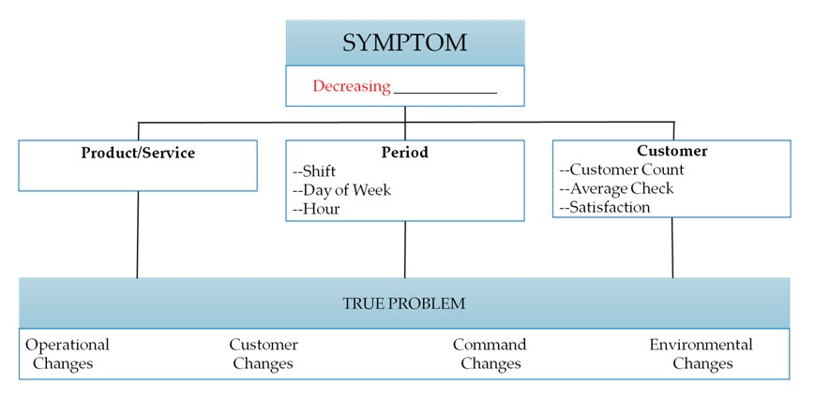**Diagnostic Tool: Root Cause Analysis**

|  |  |  |  |
| --- | --- | --- | --- |
| **TRUE PROBLEM**  **Declining Spin Class Participation ($2 per class/max 15 participants)** | | | |
| Operational  Changes | Customer  Changes | Command  Changes | Environmental  Changes |
|  |  |  |  |

**Monthly Variance Report Exercise**

*Analyze*:

* Why the variance occurred
* How you are going to FIX unfavorable variances or DUPLICATE or CONTINUE favorable variances.

**NAF Financial Management Module Four**

In module 4 of the NAF Financial Management course, students will review the steps necessary for budget creation. Learners will consider the role of strategic guidance and historical data in formulating short and long term requirements to conceive the manager’s narrative and 5-year plan.

**Module Four Objectives**

* Identify and apply the NAF Annual Operating Budget (AOB) Process
* Identify and discuss strategic guidance; synthesize with the NAF AOB Process
* Recognize strategic opportunities by applying the SWOT process to program Management
* Describe the NAF 5yr Plan Program Requirements and how they should be used during AOB development

**The Manager’s Role**

**Formulate**

**Plan**

**Annual Operating Budgets (AOB)**

* 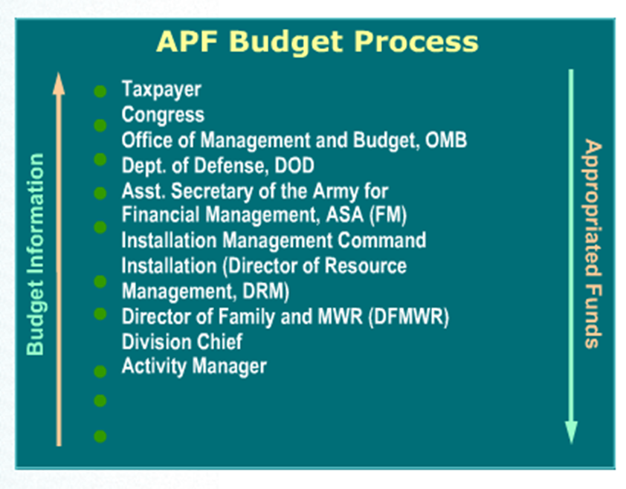**APF Budget Process Notes:**
* Centralized Process
* Six-year plan
  + Next fiscal year = budget year
  + Five following years = out years
* Leads to the President’s annual budget
  + Passed by Congress
  + Signed by the President
* **NAF Budget Process Notes:**

**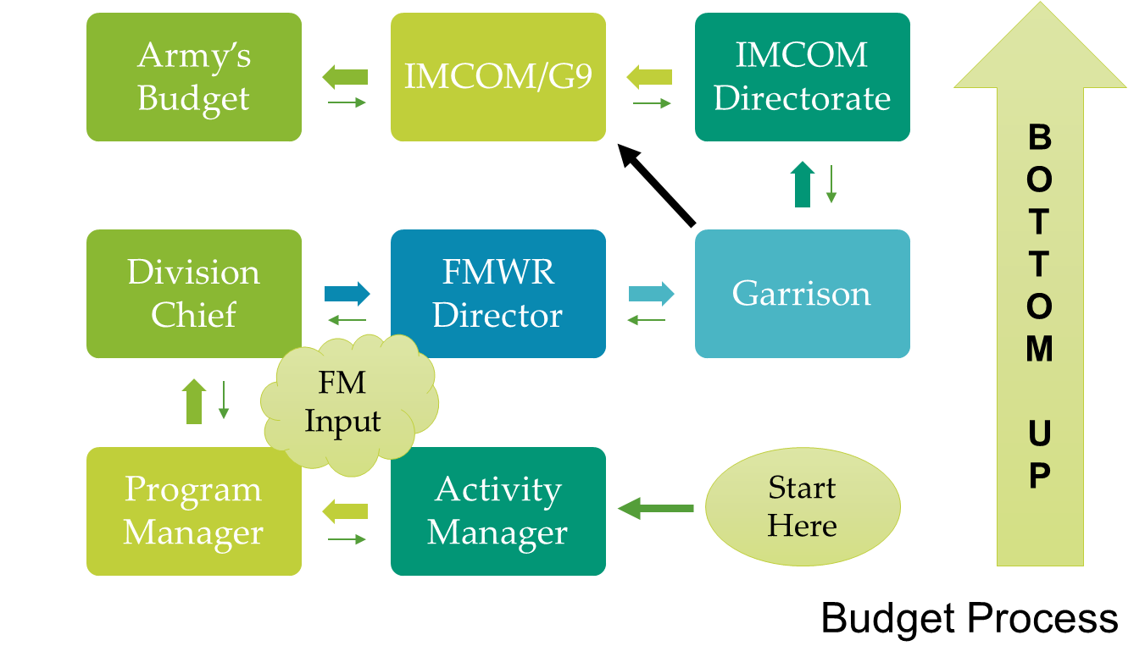**

**Managers implement financial planning practices according to the annual budget guidance through:**

1. Formulating the \_\_\_\_\_\_\_\_\_\_\_\_\_\_\_\_\_\_ \_\_\_\_\_\_\_\_\_\_\_\_\_\_\_\_\_\_\_\_\_.
2. Tracking and monitoring \_\_\_\_\_\_\_\_\_\_\_\_ \_\_\_\_\_\_\_\_\_\_\_\_\_\_\_\_ throughout the year.
3. Analyzing and explaining budget \_\_\_\_\_\_\_\_\_\_\_\_\_\_\_\_\_\_.
4. Implementing actions to correct \_\_\_\_\_\_\_\_\_\_\_\_\_\_\_\_\_ variances.

**Notes:**

\_\_\_\_\_\_\_\_\_\_\_\_\_\_\_\_\_\_\_\_\_\_\_\_\_\_\_\_\_\_\_\_\_\_\_\_\_\_\_\_\_\_\_\_\_\_\_\_\_\_\_\_\_\_\_\_\_\_\_\_\_\_\_\_\_\_\_\_\_\_\_\_\_\_\_\_\_\_\_\_\_\_\_\_\_\_\_\_\_\_\_\_\_\_\_\_\_\_\_\_\_\_\_\_\_\_\_\_\_\_\_\_\_\_\_\_\_\_\_\_\_\_\_\_\_\_\_\_\_\_\_\_\_\_\_\_\_\_\_\_\_\_\_\_\_\_\_\_\_\_\_\_\_\_\_\_\_\_\_\_\_\_\_\_\_\_\_\_\_\_\_\_\_\_\_\_\_\_\_\_\_\_\_\_\_\_\_\_\_\_\_\_

**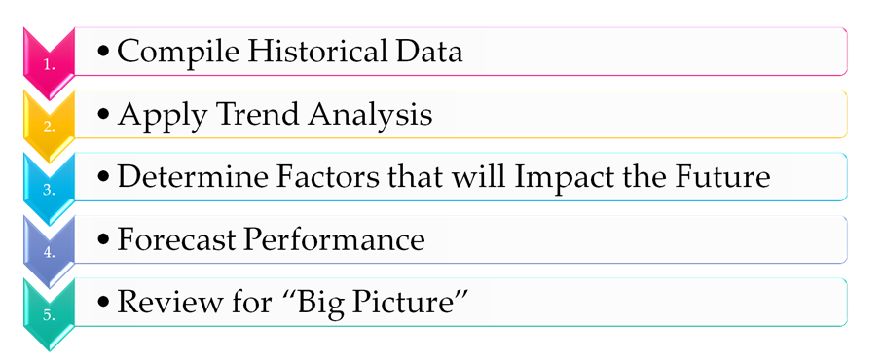NAF AOB Process**

**NAF AOB Process: Group Exercise**

* Brainstorm examples of things we would look at for the 5 steps.

** *Compile Historical Data***

****

***Apply Trend Analysis***

****

***Determine Factors that will Impact the Future***

****

***Forecast Performance***



***Review for “Big Picture”***

**Formulating Strategy:**

* Vision and Mission Statements
  + Army
  + IMCOM
  + G9 (FMWR)
  + Local
* Long-Term Objectives
* Alternative Strategies
* Strategy Selection

***Why is it important to incorporate your own strategies into higher level strategies?***

**\_\_\_\_\_\_\_\_\_\_\_\_\_\_\_\_\_\_\_\_\_\_\_\_\_\_\_\_\_\_\_\_\_\_\_\_\_\_\_\_\_\_\_\_\_\_\_\_\_\_\_\_\_\_\_\_\_\_\_\_\_\_\_\_\_\_\_\_\_\_\_\_\_\_\_\_\_\_\_\_\_\_\_\_\_\_\_\_\_\_\_\_\_\_\_\_\_\_\_\_\_\_\_\_\_\_\_\_\_\_\_\_\_\_\_\_\_\_\_\_\_\_\_\_\_\_\_\_\_\_\_\_\_\_\_\_\_\_\_\_\_\_\_\_\_\_\_\_\_\_\_\_\_\_\_\_\_\_\_\_\_\_\_\_\_\_\_\_\_\_\_\_\_\_\_\_\_\_\_\_\_\_\_\_\_\_\_\_\_\_\_\_\_\_\_\_\_\_\_\_\_\_\_\_\_\_\_\_\_\_**

**SWOT**

|  |  |  |
| --- | --- | --- |
|  | Helpful  to achieving the objective | Harmful  to achieving the objective |
| Internal Origin  (attributes of the environment) | Strengths | Weaknesses |
| External Origin  (attributes of the environment) |  | Opportunities  Threats |

**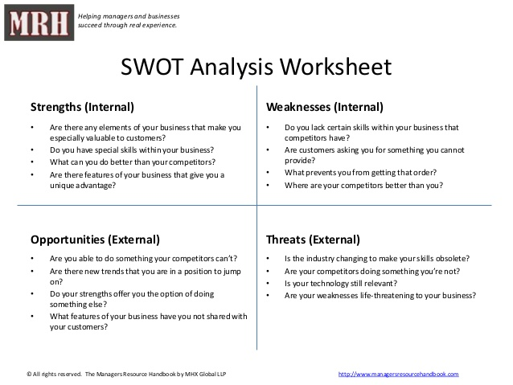**[**http://www.managersresourcehandbook.com**](http://www.managersresourcehandbook.com)

**When analyzing INTERNAL Strengths and Weaknesses ask yourself:**

1. What are the strengths of our program?
2. What are the weaknesses of our program?

**When analyzing EXTERNAL Opportunities and Threats ask yourself:**

1. What opportunities exist in our external environment?
2. What threats to the program exist in our external environment?

**SWOT Group Exercise**

1. In your table groups, identify Strengths or Weaknesses, Opportunities and Threats for an FMWR program that directly impact the AOB.
2. Chart your responses on the Chart Paper.
3. Select a spokesperson to brief the large group.

|  |  |
| --- | --- |
| **Strengths (Internal)**   * List any resources and capabilities that you could use for competitive advantage (i.e.: products and services offered, human capital, intangibles, uniqueness) | **Weaknesses (Internal)**   * List financial elements that keep you from competing at the same level as your competitors (i.e.: lack of revenue and recapitalization) |
| **Opportunities (External)**   * List attainable actions that you have not yet taken, or maximized (i.e.: supplier discounts, equipment investments, industry trends) | **Threats (External)**   * List factors that do you do not have control over (i.e.: what do your competitors do better, lower prices, better service, greater product selection) |

**SWOT Wrap Up**

* Know the mission and vision
* Pay attention to the world around you and what your competition is doing
* Keep a running SWOT on your desktop
* Recognize your Strengths
* Seek out Opportunities
* Remember that you are the lead strategist

**Five year Program Requirements**

* Benefits of the 5-year plan:
* Balanced Family and MWR installation program
* Integration of Family and MWR activities
* Prioritizes programs according to significance to readiness and retention
* Includes both APF and NAF revenues and expenses
* Must be prepared in accordance with guidance from:
* AR 215-1 (Section 15-1 and 15-2)
  + *At a minimum, plans will integrate the results of -* 
    - Comprehensive review(s)
    - Needs assessment(s)
    - Priorities
    - Financial management strategies
* Current fiscal year (FY) budget guidance

***You* are at the heart of this process and that of managing our facilities and programs**

**If *you* are not involved in this process… someone else is making all the decisions for *you***

**NAF Financial Management Module Five**

**Annual Operating Budget (AOB)**

In module 5 of the NAF Financial Management course students will apply a scenario to the 5-Steps of the NAF Annual Operating Budget Process and complete a Manager’s Narrative for the scenario.

**Module Five Objectives**

* Given a scenario, apply the 5-Steps of the NAF Annual Operating Budget Process. Learners will:

1. Compile Historical Data
2. Apply a Trend Analysis
3. Determine factors that will impact the future
4. Forcast Performance and determine requirements
5. Review Big Picture

* Define components of the Manager’s Narrative in the NAF AOB and relate to the budget and planning process

**NAF AOB Process**

1. Compile Historical Data

* + Calendars
  + Financial
  + Non-Financial

2. Apply Trend Analysis

* + 5 Key Financial Trends
  + How has my program performed over the last 3-5 yrs?

3. Determine Factors that will impact the Future

* + Budget reductions and revisions
  + Policy, Command changes

4. Forecast Performance

* + Should I be making a profit?
  + Should I be applying break-even analysis?

5. Review the “Big Picture”

* + Does my data make sense?
  + Can I live up to my projections

**Outdoor Recreation Scenario**

- You are the Program Manager for an Outdoor Recreation Program (ODR) at Ft. Perfect, USA. The ODR program operates out of a building near Lake Tholocco on the Northwest side of the garrison. The ODR facility is 25,000 square feet, steel frame construction and was built in 1996. The facility houses the equipment checkout center, to include a large equipment checkout (canoes, boats, tents, campers, etc.), customer service area, travel camp office, lake lodging rentals, pro-shop, and administrative offices. Hunter education courses are also held in the facility.

- The ODR manages a travel camp site that boasts 30 concrete pads available for RV hook-up and 12 tent camp spaces. There are shower and laundry facilities available in the travel camp.

- ODR also manages the checkout of 6 covered picnic areas, 1 enclosed picnic room that can hold 40 people and 3 uncovered picnic areas at 3 small fishing lakes around the garrison.

**Available Programs**

|  |  |
| --- | --- |
| * Camping Equipment | * Canopies, Tables, Chair Issue |
| * Boats & Accessories Issue | * Fishing and Hunting Permits |
| * Sport Equipment | * Paintball Field & Equipment |

- Lake Tholocco is a 640 acres lake but has been closed since 2015 due to a broken dam. The garrison recently repaired the dam and the lake will open to the public again next fiscal year. The lake will be available for boating, fishing, and special events. Swimming is open during the summer months and only during designated day light hours when lifeguards are on duty, 10 a.m. - 6 p.m.

**West Beach Snack Bar**

- In the past, the West Beach Snack Bar on Lake Tholocco was open from Memorial Day weekend through Labor Day. Hours of operation for the Snack Bar were Wednesday through Friday from 12 p.m. until 2 p.m., Saturday & Sunday from 12 p.m. until 5 p.m., and holidays from 12 p.m. until 5 p.m. (unless posted otherwise).

- The Snack Bar offered a menu of American fare, including: Hamburgers, Hot Dogs, Chili Cheese Nachos, Buffalo wings, Chicken Tenders, and Popcorn Shrimp, and assorted beverages.

- Since the dam broke in 2015 the snack bar has remained closed.

- The DFMWR has informed you that the lake will be open next summer and to reopen the snack bar in anticipation that the swim season and lake recreational activities will bring in hungry patrons.

**Given the scenario, complete the NAF AOB process in order to prepare to open the West Beach Snack Bar next summer.**

**Group Exercise – We will do one step at a time!**

Compile Historical Data

****

Apply a Trend Analysis

****

Determine factors that will impact the future

****

Forcast Performance and determine requirements

****

Review Big Picture

***If you are not involved in this process…someone else is making all the decisions for you***

**Manager’s Narrative**

* Describes
  + Current program
  + Out-years
* Includes
  + Needed construction, personnel adjustments, program changes, revenue generators, equipment, etc.
  + Planned changes or improvements
  + HOW and WHY there is a variance between actual and budget
* Incorporates manager’s decisions & ideas into long-range plan
* Covers the budget year & the next four years

**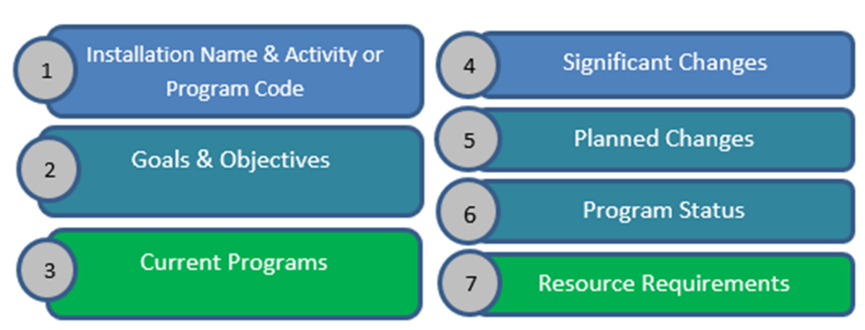**

1. Installation Name & Activity or Program Code
2. Goals & Objectives
3. Current Programs
   * + Serves as the baseline for developing the costs and direction.
4. Significant Changes
   * + Description of what has changed since last year such as population changes or new programs.
5. Planned Changes
   * + Documentation of decisions for changes or improvements, itemizing requirements by fiscal year.
6. Program Status
   * + Requires use of assessment tools such as program-specific evaluations and rating scales.
7. Resource Requirements
   * + For all activities and programs, a description of what is needed to meet goals.

**Manager’s Narrative Matching Game**

1. \_\_\_\_ Requires use of assessment tools such as program-specific evaluations and rating scales.
2. \_\_\_\_ Documentation of decisions for changes or improvements, itemizing requirements by fiscal year.
3. \_\_\_\_ Description of what has changed since last year such as population changes or new programs.
4. \_\_\_\_ For all activities and programs, a description of what is needed to meet goals.
5. \_\_\_\_ Serves as the baseline for developing the costs and direction.

**A. Description of current programs**

**B. Description of significant changes**

**C. Description of planned changes**

**D. Report on status of programs to designated standards**

**E. Resource requirements**

**Manager’s Narrative Exercise**

* Develop a Manager’s Narrative for the Snack Bar based on the given scenario
  + Use the provided template
* Work as a group
  + Complete all sections fully
  + Use the information ascertained from the AOB group work
* Turn in your completed/updated manager’s narrative to the instructors

**NAF Financial Management Module Six**

**Capital Purchase and Minor Construction (CPMC)**

In module 6 of the NAF Financial Management course, students will review processes for planning for capital purchases and minor construction. Students will further explore capitalization and depreciation and their impact on monthly income statements. Finally, the learner will explore a decision matrix and its applicability to the CPMC project.

**Module Six Objectives**

* Define and describe the CPMC Process
* Identify and apply the Capitalization and Depreciation procedures as they relate to the CPMC Process
* Identify and apply the decision matrix approach to ranking CPMC proposals
* Distinguish and discuss the key components of a CPMC proposal

**GROUP EXERCISE:** What would you bring to the deserted island?

1. **\_\_\_\_\_\_\_\_\_\_\_\_\_\_\_\_\_\_\_\_\_\_\_\_\_\_\_\_\_\_\_\_\_\_\_\_\_\_\_\_\_**
2. **\_\_\_\_\_\_\_\_\_\_\_\_\_\_\_\_\_\_\_\_\_\_\_\_\_\_\_\_\_\_\_\_\_\_\_\_\_\_\_\_\_**
3. **\_\_\_\_\_\_\_\_\_\_\_\_\_\_\_\_\_\_\_\_\_\_\_\_\_\_\_\_\_\_\_\_\_\_\_\_\_\_\_\_\_**
4. **\_\_\_\_\_\_\_\_\_\_\_\_\_\_\_\_\_\_\_\_\_\_\_\_\_\_\_\_\_\_\_\_\_\_\_\_\_\_\_\_\_**
5. **\_\_\_\_\_\_\_\_\_\_\_\_\_\_\_\_\_\_\_\_\_\_\_\_\_\_\_\_\_\_\_\_\_\_\_\_\_\_\_\_\_**

**Decision Matrix** (sample)

**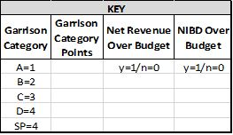**

**Reviewing the 5 Year Plan:**

* Examining what remains to be executed
* Changing priorities
* Estimating cost changes
* Determining which projects are in progress
* Determining the validity of existing projects
* Determining what needs to be added to the budget

**WHY DO WE NEED TO REVIEW THE PLAN?**

**What is CPMC?**

* *AR215-1, Ch. 15-7.*
* Is it a Capital Purchase? Or is it Construction? Or is it SRM?
* NAF Construction from $250K-$1M is considered NAF Minor Construction
* IMCOM Directorate approves
* Congress tracks major construction $1M or more

\_\_\_\_\_\_\_\_\_\_\_\_\_\_\_\_\_\_\_\_\_\_\_\_\_\_\_\_\_\_\_\_\_\_\_\_\_\_\_\_\_\_\_\_\_\_\_\_\_\_\_\_\_\_\_\_\_\_\_\_\_\_\_\_\_\_\_\_\_\_\_\_\_\_\_\_\_\_\_\_\_\_\_\_\_\_\_\_\_\_\_\_\_\_\_\_\_\_\_\_\_\_\_\_\_\_\_\_\_\_\_\_\_\_\_\_\_\_\_\_\_\_\_\_\_\_\_\_\_\_\_\_\_\_\_\_\_\_\_\_\_\_\_\_\_\_\_\_\_\_\_\_\_\_\_\_\_\_\_\_\_\_\_\_\_\_\_\_\_\_\_\_\_\_\_\_\_\_\_\_\_\_\_\_\_\_\_\_\_\_\_\_\_\_\_\_\_\_\_\_\_\_\_\_\_\_\_\_\_\_

\_\_\_\_\_\_\_\_\_\_\_\_\_\_\_\_\_\_\_\_\_\_\_\_\_\_\_\_\_\_\_\_\_\_\_\_\_\_\_\_\_\_\_\_\_\_\_\_\_\_\_\_\_\_\_\_\_\_\_\_\_\_\_\_\_\_\_\_\_\_

**CPMC Knowledge Check:**

* Fixed assets are tangible properties purchased by or donated to a NAFI that have an expected life of \_\_\_\_\_\_\_\_\_\_\_\_\_ or more and cost \_\_\_\_\_\_\_\_\_\_\_\_\_ or more.
* Could also be a group of \_\_\_\_\_\_\_\_\_\_\_\_\_ assets with a useful life of at least \_\_\_\_\_\_\_\_\_\_\_\_\_ .
* Assets which do not meet capitalization criteria are considered \_\_\_\_\_\_\_\_\_\_\_\_\_ items and are not capitalized.
* Minor construction projects cost between \_\_\_\_\_\_\_\_\_\_\_\_\_ and \_\_\_\_\_\_\_\_\_\_\_\_\_ .
* NAF dollars can be used for maintenance and repair projects over \_\_\_\_\_\_\_\_\_\_\_\_\_ .
* \_\_\_\_\_\_\_\_\_\_\_\_\_\_\_\_\_ approve CPMC projects up to $1,000,000 and \_\_\_\_\_\_\_\_\_\_\_\_\_ tracks projects larger than that amount.

**Capital Purchase and Minor Construction**

**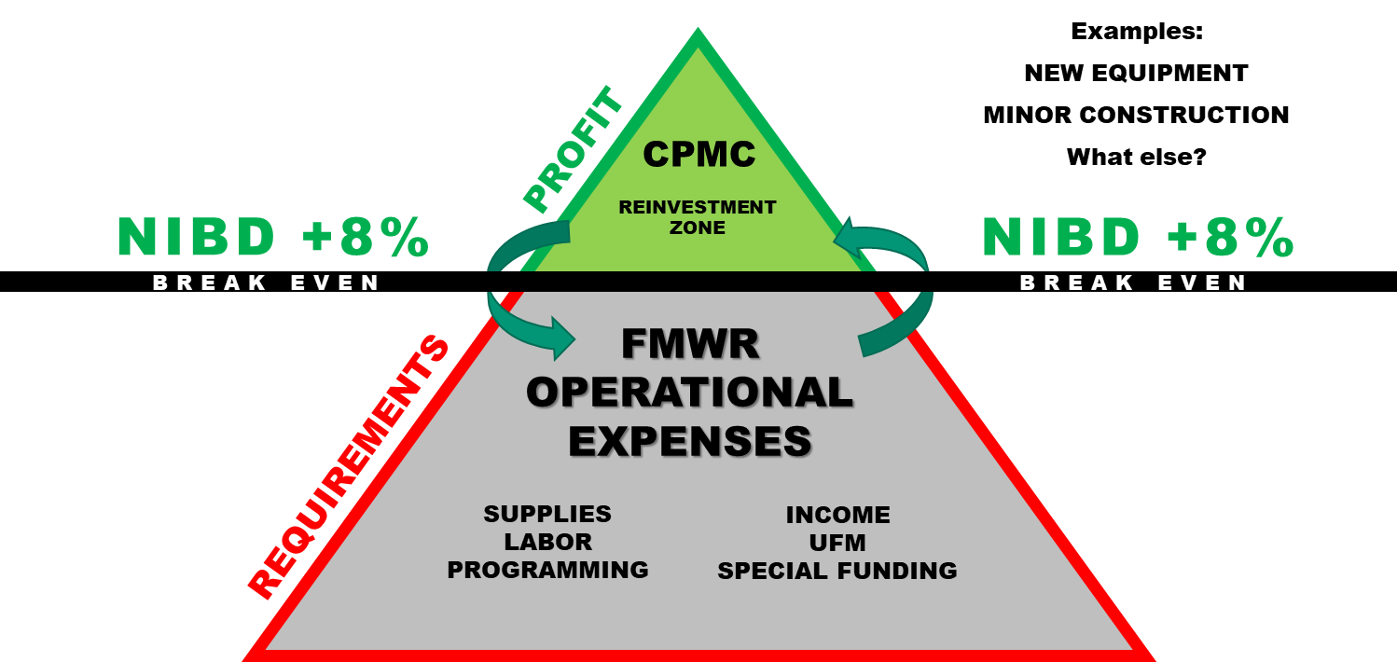**

**Capitalization:**

* Fixed asset
* Cash payment
* Balance Sheet
* Recorded fixed asset
* No impact to equity of fund

**Depreciation:** *Asset ÷ Life Expectancy (in months)*

**CPMC Proposal**

* *AR215-1, Ch 15-7.*
* DD Form 1391 (Construction only)
* Consolidated list
* Submitted in FMBS
* Approved locally
* NIBD

**CPMC Wrap-Up!**

* 5-year plan
* Fixed asset report
* Program changes and enhancements
* Alternatives
* Priorities
* FMBS

**NAF Financial Management Module Seven**

**Annual Operating Budget (AOB) Variance Report**

In module 7 of the NAF Financial Management course, students will complete, brief, and participate in small and large group review of their AOB Variance Report. Next, they will complete an Individual Action Plan (IAP), review course expectations, and complete the End of Course Survey.

**Annual Operating Budget (AOB) Variance Report Exercise**

* Review your Annual Operating Budget (AOB) report
  + Complete the analysis section
  + Tell us what the variance is saying
    - Why the variance occurred
    - How you are going to FIX unfavorable variances or DUPLICATE or CONTINUE favorable variances!
* Each table will choose 1 person to brief their analysis to the large group
* Turn in your completed/updated report to the instructors

***Financial Management Wrap-Up***

**INCOME STATEMENT**

* The basic income statement formula is Revenue minus Expenses equals Net Income/Loss.
  + *Net Income/Loss = Revenue - Expenses*
* The terms income statement and financial statement are not interchangeable although they are often used that way. The income statement is only one part of the financial stateemnt which also includes the balace sheet and supporting schedules.
* The simplified income statement format is comprised of seven major categories which are subtotals obtained by adding and subtracting the appropriate GLACs.
* The format prescribed in AR 215-1 is:

|  |  |  |  |
| --- | --- | --- | --- |
| **+** | SALES | 7,000 |  |
| **-** | COST OF GOODS SOLD | 4,900 | 70% |
| **=** | **GROSS INCOME FROM SALES** | 2,100 |  |
| **+** | OTHER OPERATING INCOME | 500 |  |
| **=** | **GROSS INCOME FROM OPERATIONS** | 2,600 |  |
| **-** | LABOR | 1,900 | 25.3% |
| **-** | OPERATING EXPENSES | 200 | 2.7% |
| **=** | **NET INCOME BEFORE DEPRECIATION (NIBD)** | 500 | 6.7% |
| **-** | DEPRECIATION | 275 |  |
| **=** | **NET INCOME AFTER DEPRECIATION (NIAD)** | 225 | 3% |

* There are six steps in the trend analysis process

1. Select a type of trend analysis and lay out the data.
2. Determine where negative trends exist.
3. Select a single line where a negative trend exists and begin review of the data that is summarized to obtain the summary line of the income statement.
4. Display the GLACs that comprise the summary line in the same format as the original analysis. Determine which GLAC(s) caused the negative trend.
5. Identify the operational changes that may have caused the negative trend.
6. Decide on management action to improve performance.

**SALES**

* The single fact that distiguishes sales from other operating incomes is that there is always a product cost (cost of goods sold) associated with sales.
* The formula to calculate nets sales is:

|  |  |
| --- | --- |
| **+** | Cash Sales |
| **+** | Credit Sales |
| **+** | Layaway Sales |
| **-** | Sales Returns and Allowances |
| **-** | Customer Discounts |
| **-** | Employee Discounts |
| **=** | **Net Sales** |

* Sales trends can be monitored in either “real” dollars or as a percent of Total Revenue. A decrease in either represents a negative trend.
* In order to prepare a Sales Analysis, management must be familiar with the source documents from which the information can be extracted. Often management must design systems which gurarantee needed data is not lost during the recording process or when entered in the accounting system. The base source documents are:
  + Daily Activity Report (DAR)
  + Cashier’s Report
  + Cash Register Reading and Detail Tapes (if applicable)
  + Scatter Sheets
  + Sales Accountability Inventories
* Full analysis of a negative and positive sales trend often requires use of several different analyses.

**COST OF GOODS SOLD**

* Cost of Goods Sold (COGS) is defined as the cost associated with the purchase of merchandise which will be sold at retail. By definition, this cost includes any freight required to get the product to your location.
* The formula for calculating COGS is beginning inventory plus all purchases and receipts, minus all issues to other activities/departments, minus vendor returns, and minus ending inventory.
  + *COGS = beginning inventory + all purchases and receipts – all issues to other activities/departments – vendor returns – ending inventory.*
* COGS trends are monitored using the COGS Percentage which is below:
  + *COGS% = COGS $/Net Sales $ x 100*
* In order to undertand a specific problem, management must have a detailed understanding of the GLACs which are combined mathematically to calculate COGS.
* The causes of consistently low COGS% are:

1. Over Pricing
2. Under Portioning
3. Sales Recorded in the Wrong Department

* The causes of consistently high COGS% are:

1. Insufficient Pricing
2. Over Portioning
3. Employee/Customer Theft of Money or Inventory
4. Sales Recorded in the Wrong Department

* The casues for fluctuating COGS% are divided into subcategories:

1. Change in Sales Mix
2. Operational Problems
   1. Incorrect Inventory
   2. Receiving Report not Submitted
   3. Transfer Voucher not Prepared
   4. Sales Not Properly Documented
   5. Merchandise or Goods Diverted
   6. Over/Under Portioning
3. Administrative Problems
   1. Errors on Inventory Paperwork
   2. Errors on Transfer Vouchers
   3. Errors on Receiving Reports

**OTHER OPERATING INCOME**

* Other Operating Income (OOI) is defined as the revenue collected for services provided or use of equipment/facilities. Also included in this definition is the commission paid to us by concessionaires who operate FMWR related activities on the installation.
* There is never a direct cost of goods associated with OOI.
* Total OOI is computed by totaling all of the 500 series GLACs used by the activity or program.
* OOI trends can be monitored in either real dollars or as in percent of Total Revenue.

**OTHER INCOME**

* Other Income (OI) is defined as the revenue collected from other than normal operations. The funds are not generated directly from selling a product or service associated with the activities primary purpose.
* The major sources of OI are interest, gain on the sale of fund property, “grants” from higher headquarters, and charitable donations.
* Total OI is calculated by adding together all of the 800 series accounts.

**TOTAL REVENUE**

* Total Revenue is defined as the mathematical total of all of the income recorded on the income statement.
* The equation for calculating Total Revenue is the sum of Sales, Other Operating Income, and Other Income.
  + *TR = Sales + OOI + OI*
* Total Revenue is the base upon which all percentages (except COGS %) are computed.

**LABOR**

* Labor cost is defined as the total expense for services rendered by employees to complete the particular mission of the program or activity for which they work.
* Labor cost includes all of the direct cost of wages and shift differentials as well as the indirect costs resulting from the employer’s contributions to FICA, health and life insurance, worker’s compensation, and retirement.
* Total Labor costs are calculated by adding together the GLACs which are used to record the parts of Labor cost. Review of these GLACs month to month may assist management in determining causes for increasing Labor costs.
* Incorrect estimates of Labor cost for the end of the month may skew reported financial data unless management is involved in providing input.
* Labor cost is monitored using absolute dollars and Labor cost %. While the Labor cost % is the most common tool used, absolute dollars are used when Labor cost is considered a fixed cost expense.
* The formula for calculating Labor cost % is:
  + *Labor Cost % = Labor Cost $ / Total Revenue $ x 100*
* There are four possible causes for increasing Labor cost

1. Scheduling Problems
2. Staffing Problems
3. Controlling Pay and Benefits Increases
4. Excess Use of Overtime

**OTHER OPERATING EXPENSE**

* Other Operating Expense (OOE) is defined as the cost of operation not associated with COGS or Labor that are consumed to provide a product or service to the customer.
* Total OOE is calculated by adding together the individual GLACs used to record the expenses. There are more than 70 different GLACs avaiable for use.
* OOE is monitored using both absolute dollars and the OOE%. In general, we treat OOE as a variable cost and that is why the percentage is the most used method of monitoring trends.
* There are several different types of operating expenses:
  + Fixed – Do not change as use or revenue change
  + Variable – Change proportionately with changes in use or revenue.
  + Discretionary – A required expense that can be postponed without a major impact to operations
  + Nondiscretionary – A required expense that cannot be postponed.
  + Emergency – An unplanned expense which cannot be postponed.
* The formulas for calcualting the OOE% and any individual operating expense:
  + *OOE% = OOE$/Total Rev$ x 100*
  + *Individual Expense = Ind Exp $/Total Rev$ x 100*
* The major causes for increases in OOE are:
  + Excessive Use (Poor Controls)
  + Increasing Costs
  + Cost Shifting from APF to NAF
  + Poor Procurement
  + Poor Administration of Expense Areas

**OTHER EXPENSE**

* Other Expenses (OE) is defined as expenses incurred from other than normal operations. These expenses are not generated directly from selling a product or service.
* Most of the GLACs that comprise OE can be used only at the IMWRF level.
* Total OE is calculated by adding together all of the 800 series GLACs.
* OE is less periodic than other forms of expense. By the isolated nature of the expense it is also relatively easy to determine causes for negative trends.

**NET INCOME/LOSS BEFORE DEPRECIATION (NIBD)**

* Net Income (Loss) is defined as the difference between Total Revenue and Total Expenses. If the figure is positive it is Net Income, and if the figure is negative it is Net Loss.
* We monitor Net Income (Loss) in terms of both absolute dollars and as a percent of Total Revenue. Absolute dollar comparisons are important because it is Net Income dollars that gurantee the future of the fund. On the other hand use of Net Income % is useful because it relates the return on investment to the Revenue which produced it.
* The Net Income % is calculated by dividing Net Income dollars by Total Revenue dollars and multiplying by 100.

**DEPRECIATION**

* Depreciation is defined as a non-cash expense which allocates the cost of the asset over its expected useful life.
* Depreciation is treated as a cost of doing business and is charged to the activity using the asset.
* Total Depreciation is calculated by adding together all of the 850 series GLACs that are used by the activity.
* Depreciation Expense is monitored based on increases and decreases in dollars as compared to a standard. While the standard is normally the budget, previous month depreciation and the depreciation for the same period last year are also used.
* The potential causes for increased Depreciation costs are:
  + Purchase of Additional Fixed Assets
  + Depreciation Schedule is Shortened
* The portential causes for decreased Depreciation costs are:
  + An Asset is Completely Depreciated
  + Fixed Assets are Sold (or disposed of)
  + Depreciation Schedule is Lengthened

**INVENTORY MANAGEMENT**

* Inventory Management is defined as the process by which you provide a variety of merchandise that meets customers needs and desires while safeguarding the fund’s assets from theft, obsolescence, and waste.
* The value of resale inventory is determined based on multiplying the physical count of the product by the cost price to determine the total value for each line item. All of the line items are then added together for the value of total inventory.
* We monitor inventory using one or more of the three techniques below:
  + Total Dollar Value –Est. a dollar ceiling for the total value of inventory.
  + Number of Units – Est. a minimum and maximum number of products for each line item of inventory. Computes a par stock for each item.
  + InventoryTurnover Ratio – Based on computing the ratio of COGS to average inventory. Tells you how much of inventory is used to support sales in a given month.
* The formula for computing par stock:
  + *Par Stock Level = Requisition Objective + Safety Level*
  + *Par Stock Level = Average Use Per Month/Desired Inv Turnover + (Avg Daily Use x Number of Days for Delivery)*
* The formula for Inventory Turnover Ratio is:
  + *Average Inventory = Begin Inv + End Inv / 2*
  + *Inventory Turnover Ratio = COGS/Avg Inventory*
* There are three types of generic inventory problems:

1. Low Turnover
   1. Causes
      1. Over Ordering
      2. Dead Stock
      3. Too Many Lines of Product
      4. Buying Quantity to Reduce Price
2. High Turnover
   1. Causes
      1. Stockage Level is set too low (Requistion Objective)
      2. Safety Level is set too low
3. Inventory Accountability
   1. Causes
      1. Administrative
         1. Posting errors
         2. Transfer documents not prepared
         3. Incorrect Inventory Count
      2. Operational
         1. Waste
         2. Pilferage