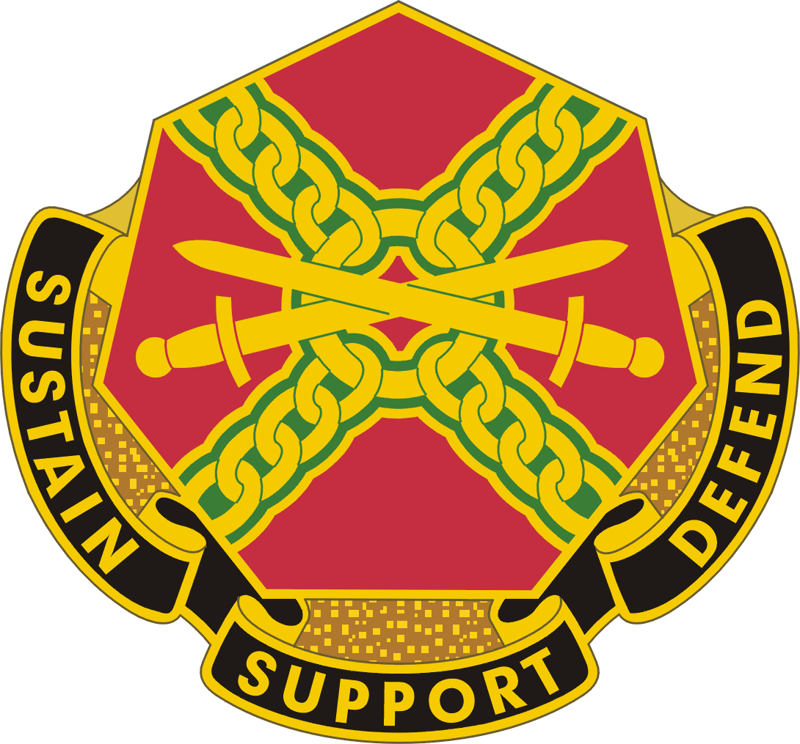

NEW EMPLOYEE CHECKLIST

NEW EMPLOYEE INFORMATION
Name: |  |  | Start date:
Position: |  |  | Rating Official:
Assigned Sponsor: |  |  | Higher Level Reviewer:

PHASE 1: WITHIN 3 DAYS OF FIRM ACCEPTANCE OF JOB
YES NO
Did you receive a welcome letter to welcome you to the team
Did you receive name and contact information for your sponsor

PHASE 2: FIRST DAY
YES NO
Did your sponsor meet you upon arrival
Did your supervisor provide you with the New Employee Checklist and the Employee Training Checklist
Were you briefed on your first week activities (work schedule, locations, etc...)
Scheduled Onboarding session at Workforce Development, 219 Nash Blvd. Date:_______________________
Were you provided with your supervisor’s contact information

PHASE 3: WITHIN FIRST WEEK – INTRODUCTIONS, TOURS, AND ADMINISTRATIVE PROCEDURES
YES NO
Team Member Orientation Brief scheduled with Workforce Development Division DATE: ____________________
Were you introduced to department staff and key personnel
Did you conduct a tour of the following areas and review general administrative procedures:
Tour Facility, including:  - Office / Desk / Work Station  - Copy Centers  - Printers  - Kitchen / Cafeteria / Break Areas | - Fax Machines  - Restrooms  - Mail Rooms  - Bulletin Boards  - Authorized Work Areas  - Security Office | - Conference Rooms  - Parking  - Office Supplies  - Tools / Equipment  - Coffee / Water / Vending Machines  - Emergency Exits and Procedures
Review general administrative  procedures: | - Keys / Access Cards  - Telephone Alert Roster  - Picture ID / Name Badges | - Telephone Access Policy & Procedures  - Building and/or Computer Access Cards  - Inclement Weather Procedures
Was an initial performance planning meeting conducted: Review position description, work assignments, performance expectations, training & education requirements (e.g. CES Level 1 / SDC) and Individual Development Plan (IDP) Date:___________________
Discuss work schedule, hours, payroll, time cards (if applicable), ATAAPS, labor accounting & leave / absence policies and procedures
Were you welcomed by appropriate leaders (including rating official and higher level reviewer)
Given an overview of Organization and its mission
If you are in a bargaining unit position, were you informed of your union representative
Do you understand your role in support of the Organization and the Army missions
Were you introduced to the Army Values – Loyalty, Duty, Respect, Selfless Service, Honor, Integrity, Personal Courage
Did you learn about military rank and insignia and titles of address for senior Civilians
Were you informed of all mandatory training requirements (see Employee Training Checklist)

Continuation: PHASE 3: WITHIN FIRST WEEK – INTRODUCTIONS, TOURS, AND ADMINISTRATIVE PROCEDURES
Complete the following actions in this order to ensure a timely processing of your network account.
Update work contact info (GAL) in milConnect https://www.dmdc.osd.mil/milconnect
Register for an AKO account https://login.us.army.mil/suite/login/ or call the AKO Helpdesk 1-866-335-ARMY(2769)
Register for an Army Training & Certification Tracking System (ATCTS) account: https://atc.us.army.mil/iastar/login.php NOTE: ensure both AKO and Enterprise Email addresses are entered
Complete DoD Cyber Awareness Challenge Training and sign Acceptable Use Policy: https://cs.signal.army.mil/DoDIAA/default.asp
Supervisor or Directorate Business Office completes DD2875 System Authorization Access Request (SAAR) for new employee.
NOTE: Ensure the new employee, the supervisor, and the security manager, all digitally sign the form before routing to the USAG Information Management Officer (IMO) for signature; so, the IMO can upload a completed copy to the new user's ATCTS profile. Permissions to all the network services (printers, fileshares, ect) are granted based on the organization/office symbol reflected on the submitted DD2875.
Contact the Army Enterprise Service Desk (AESD) at 1-866-335-2769 or use the Service Request Management (SRM) link: https://portal.aesdpro.aesd-w.army.mil/group/aesd/home to submit a Remedy ticket and attach the completed DD2875 for creation of the new network account.
Were the following policies and procedures reviewed:
Review key policies:  - Time and Attendance Reporting  - Family & Medical Leave Act (FMLA) / Leaves of Absence  - Vacation and Sick Leave  - Overtime  - Official Use of Govt. Property | - Diversity Awareness  - Sexual Harassment / Assault  - Holidays  - Performance Reviews  - Appropriate Attire  - Safety | - Ethics / Joint Ethics Regulation  - Standards of Conduct  - Progressive Disciplinary Actions  - Visitors / Security  - Emergency Procedures  - Confidentiality (specific procedures to safeguard confidential / sensitive material)
Review computer use policies:  - Establish Email | - Intranet / SharePoint  - Shared Drives  - Databases  - Internet Use | - VPN / Mobile Phone  - Outlook Address List Profile  - Microsoft Office  - Other Software / Applications
Review general administrative  procedures:  - Business Cards  - Purchase Requests | - Vehicle Registration  - Govt. Travel Card  - Conference Rooms  - Organizational Policies  - Official Travel | - Mail (incoming and outgoing)  - Shipping (FedEx, DHL, and UPS)  - Military Driver Requirement  - Severe Weather Procedures

PHASE 4: WITHIN FIRST 30 DAYS
YES NO
Complete the Arrival & In-processing Survey
Identified short / long term training requirements (CES, SDC, Career Program, AR 350-1 required training as well as organizational training, etc.)
Update your profile in ACT (including your new supervisor)
Explanation of your Career Program (CP) and career path DATE: _________________________
Review and finalize performance elements, standards, and sign performance plan. DATE: ________________
Set development goals for IDP with supervisor in ACT DATE: ________________________
Meet key partners from other departments
Receive feedback about work assignments, training and provided feedback about job satisfaction to date

Completed the following initial mandatory training online or face-to-face:
Information Security Program https://lms.army.mil Search- Initial Security Program
Anti-Terrorism http://jko.jten.mil/courses/atl1/launch.html Search JS-US007
Operations Security (OPSEC) https://www.iad.gov/ioss or at https://www.lms.army.mil
Risk Management Basic https://www.lms.army.mil Risk Management Basic Civilian

A copy of this checklist and the Arrival & In-processing Survey must be turned in to Workforce Development Division within 10 business days after the new employee’s 30th day.

WITHIN FIRST 90 DAYS
YES NO
Revisit and adjust performance standards and/or IDP as needed
Conduct and document first quarterly performance discussion and counseling DATE:_________________
Receive training, as needed, to understand internal systems, general operating practices, and obtain other information or skills required in the performance of your job

Completed all required mandatory training from Phase 4 and additional training:
Alcohol and Drug Abuse Program Face-to-Face
Resilience Face-to-Face
Sexual Harassment/Assault Response Prevention (SHARP) Face-to-Face
Suicide Prevention Face-to-Face
Threat Awareness and Reporting Program (TARP) MPA
Equal Employment Opportunity (EEO) Anti-Harassment, No FEAR Act https://www.lms.army.mil
Search EEO 203A - for non-supervisors or EEO 203B - for supervisors of civilians

A copy of this checklist must be turned in to
Workforce Development Division within 10 business days after the new employee’s 90th day.

PHASE 5: WITHIN FIRST 180 DAYS
YES NO
Continuing discussion about expectations, culture, and the Army Profession
Conducted in progress review. Discussed formal performance feedback, review of IDP, and career goals.
Met higher level reviewer DATE: __________________
Complete the Orientation & Integration Survey

A copy of this checklist and the Orientation & Integration Survey must be turned in to
Workforce Development Division within 10 business days after the new employee’s 180th day.

WITHIN FIRST 270 DAYS
YES NO
Revisit and adjust performance standards and/or IDP as needed
Conduct and document quarterly performance discussion and counseling DATE:_________________

A copy of this checklist must be turned in to
Workforce Development Division within 10 business days after the new employee’s 270th day.

PHASE 6: WITHIN FIRST YEAR
YES NO
All onboarding requirements are complete, including CES training requirements and SDC (if required)
Completed the final performance appraisal. Meet with rating official and higher level reviewer DATE:________________

A copy of this checklist must be turned in to
Workforce Development Division within 10 business days after the new employee’s 365^{h} day.

HELPFUL LINKS AND INFORMATION
Forms and Resources:
- Army Civilian Personnel Online: https://compo.dcpds.cpms.osd.mil
- Army Career Tracker (ACT): https://actnow.army.mil/
- GoArmyEd: https://www.goarmyed.com/
- ADRP 1: http://armypubs.army.mil/doctrine/DR_pubs/dr_a/pdf/adrp1.pdf
- Center for the Army Profession and Ethic (CAPE) Civilian Video: http://cape.army.mil/civilians.php
- Supervisor Acculturation Guide: http://www.tradoc.army.mil/dcspil/Acculturation/documents/Final%20Documents%20for%20Acculturation%20Program/Civilian%20Acculturation%20Supervisor%20Guide.pdf
- Army Civilian Acculturation Handbook http://www.tradoc.army.mil/dcspil/Acculturation/documents/AcculturationHandbook.pdf

Required Training:
- AR 350-1, Army Training and Leader Development: http://armypubs.army.mil/epubs/pdf/r350_1.pdf
- AR 350-1 Mandatory Training with resource information/web links and other training information:
http://www.civiliantraining.army.mil/Pages/MandatoryTraining.aspx
- Joint Ethics Regulation: http://www.dod.mil/dodgc/defense_ethics/ethics_regulation/
- CES and SDC enrollment: https://www.atrrs.army.mil/channels/chrtas/student/logon.aspx

**For additional resources refer to the Civilian Employee Smart Book, found in the WDD Document Library at https://army.deps.mil/army/cmds/imcom_usag8/drum/dhr/WDD/SitePages/Home.aspx

