**MG Robert M Joyce**

**School for Family and MWR**

**Mobile Training**

**Internal Controls**

Participant Guide



**NAF Internal Controls Course Agenda**

**Module 1: NAF Internal Controls in the Operational Environment.**

**Module 2: Managing Internal Controls through ‘Reasonable Control’.**

**Module 3: Evaluating and Monitoring Controls.**

**Module 4: Corrective Action Plan**

**What are your Course Expectations?**

__________________________________________________________________________________________________________________________________________________________________________________________________________________

**COURSE OBJECTIVE:** Given the General Accounting Office (GAO) framework for Internal Controls, students should be able to analyze the five standards and apply the standards to daily operations to ensure reasonable control over their area of responsibility.

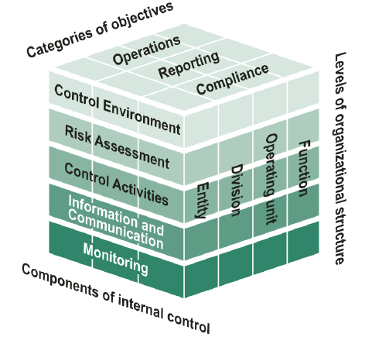

**FIVE STANDARDS OF INTERNAL CONTROLS**

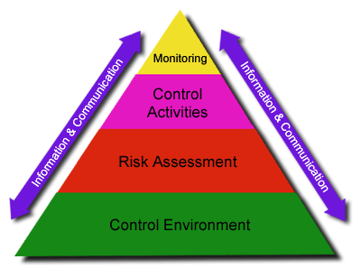

**Information and Communication:** Information should be recorded and communicated to management and others within the entity who need it; and in a form and within a time frame that enables them to carry out their internal control and other responsibilities.

**Control Environment:** Management and employees should establish and maintain an environment throughout the organization that sets a positive and supportive attitude toward internal control and conscientious management.

**Risk Assessment:** Internal control should provide for an assessment of the risks the agency faces from both external and internal sources.

**Control Activities:** Internal control activities help ensure that management’s directives are exercised. The control activities should be effective and efficient in accomplishing the agency’s control objectives.

**Monitoring:** Internal control monitoring should assess the quality of performance over time and ensure that the findings of audits and other reviews are promptly resolved.

**NAF Internal Controls Module One**

**MODULE ONE OBJECTIVES:**

* Identify breakdowns in internal controls, impacts and possible mitigating responses.
* Relate each standard of internal controls to the operational environment.
* Given the 5 step Risk Assessment process, apply to determine level of risk.

**EXERCISE INSTRUCTIONS**

* Choose someone to scribe on the chart paper.
* Using the scenario (below), answer the questions.
* Choose someone to out-brief the large group.

**SCENARIO**

*We will be doing multiple group excercises using this scenario as the basis for the activity and disccsion. (scenario continues to the following page)*

**Bob, the Program Manager for the Home-Away, USA Bowling Center is really looking forward to the day because it is the start of the summer leagues with Child and Youth Services (CYS).**

**When Bob arrives at the Bowling Center he notices the door is not secure. The Assistant Manager, Mary usually locks up in the evenings. Bob wonders why the door is not secured.**

**Bob enters the facility and calls out to see if anyone else is there. No one responds so he enters the facility and checks to see if any of the other doors are unlocked and does a quick check to see if anything is out of place. All of the other doors were secure and nothing seems to be out of place. Bob makes a mental note to discuss the situation with Mary but is not overly concerned since this has never happened before and it is in fact an Army installation with military police patrolling all night.**

**Bob continues to go about his morning routine and the rest of the Bowling Center staff begin arriving for work and preparing for the league participants that will arrive in an hour. The bowlers from CYS arrive and Bob begins to issue shoes. He tells the cashier, “if any other customers need rentals, I’ll just ring them up on your register until we’ve slowed down a little.”**

**A few minutes later one of the CYS staff asked Bob, “Are there a few more children’s sized bowling balls available? Even with sharing there doesn’t seem to be enough bowling balls for each lane.” Bob responds, “Hmmm, that’s weird, I just ordered more than enough to have at least two child-sized bowling balls per lane.” Bob was puzzled by the question because just the day before he had asked a staff member to ensure that all of the new eight and ten pound bowling balls, purchased last month, were out and available for the youth league. He is able to get a few of the participants to use the next weight up and the league play goes well. Everyone seems happy, Bob thinks to himself, today was a good day.**

**It is also the end of the month and Bob is looking forward to doing his inventory. He prides himself on keeping the best inventory on the Garrison and every month he proves it. However, today will be different. Bob had to miss the last two inventories due to a family emergency. He asked Josh, who is an outstanding employee, to conduct the inventories thinking it would be great training for him. The inventories would be complete and someone else would be able to do it when Bob is not available. Bob told Josh, “Just pick someone from the staff to assist you with the count.” Josh picked a newly hired employee, thinking he might as well take the new guy, this way he (Josh) can get the count done and train the new guy the way he likes to do it.**

**Bob starts reviewing the inventory with Josh assisting and he (Bob) notices that even though the records show that everything is in its place and accounted for, something seems odd. He questions Josh who then looks at his notes and states that everything was accounted for the previous month. Bob takes note and moves on, not wanting to disturb his rhythm as he wants to get everything accounted for in a timely manner. He’ll go back and investigate later when he has more time. Bob finally gets everything entered into the system so he decides to look into the issue that he discovered while reviewing the inventory with Josh. He pulls the past three inventories and begins to cross reference everything. He notices the problems quickly and calls Josh into the office.**

**Later that day, during a cash count, he discovers that the change draw is short $157.00. This has never happened before. He looks at the past months records and cannot find any errors. He goes to his SOP to check the steps that he needs to take in this situation. They are dated before his time, and are based on using an old system - Micros. He uses RecTrac for everything now. He tries to figure out where and when the discrepancy might have occurred, but things just don’t match up. Bob is not sure what steps to take to resolve this issue and prevent future occurrences. Frustrated, he thinks, “I’ll look into it later when I have more time.”**

**The next day Bob arrives to work to find out that his head cashier, Susie has called out sick again. Susie has been working at the Bowling Center for six months. Since completing her 1 year probationary period, she has called in sick at least one day a week, every week. Bob is not looking forward to counseling her again. Bob has spoken to her about this issue several times. He has informally counseled her and has placed her on a leave restriction requiring that she provide a doctor’s note when leave is not prearranged, but he has never formally counseled her. Since the last informal counseling, Susie has been out at least two days a week, but she has brought in a doctor’s note, as requested. Because of her history, this time he knows that he should go ahead and make arrangements to cover her shift for at least the next two days. Bob says (to himself), “If only she would call in the day before then at least I could schedule someone in advance to cover her shift.” Bob is at his wits end so he makes an appointment with his Human Resources Department to request guidance on how to deal with this situation with Susie. He can’t do it today because now he has to get ready for another special event.**

**BREAKOUT EXERCISE QUESTIONS – CONDUCTING ANALYSIS**

1. What is your impression of the Bowling Center program in this scenario?
2. Is there anything you would change within the Bowling Center Program?
3. Who should Bob have contacted?
4. Identify possible areas for fraud, waste, and abuse.

**WHAT ARE INTERNAL CONTROLS?**

* A process effected by an organizations people, designed to provide _________________ _____________ in reliability of financial reporting, compliance with laws and regulations, and effective and efficient operations.
* A control is any technique, tool, device, check or balance in our everyday work - Designed to ensure what happen happen; and what _____________happen, happen.

**WHY ARE INTERNAL CONTROLS IMPORTANT?**

* Internal Controls are part of effective management.
* Internal Controls ensure:

- Accurate and Reliable Information

- Compliance with Laws & Policies

- Safeguarding of Resources

- Economical & Efficient Use of Resources

- Safety of Operations

**INTERNAL CONTROL OBJECTIVES**

* Reliability of financial reporting

**A =**

* Compliance with Laws and Regulations

**C =**

* Effectiveness/Efficiency of Operations

**E =**

**REASONABLE ASSURANCE**

* An acceptable degree of confidence in the general reliability of internal controls to deter or detect material failures in complying with the Federal Manager’s Financial Integrity Act (FMFIA) objectives.
* The determination of reasonable assurance is a subjective management judgment based on “confidence that internal controls are adequate and operating as intended.”
* Recognizes acceptable levels of risk exists that cannot be avoided because the cost of absolute control exceeds the benefits derived.

**CONTROL ENVIRONMENT**

What do I do to ensure a “controlled environment” is in place?

**THE “GOLDILOCKS” PRINCIPLE**

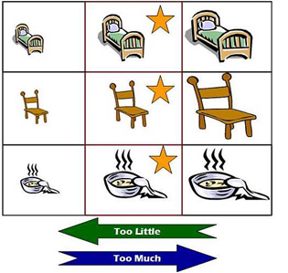

**RISK MANAGEMENT:** Risk Management is the process of evaluating the risks in a functional area based on the key internal controls that are in place.

**Notes:**

________________________________________________________________________________________________________________________________________________________________________________________________________________________________________________________________________________________________________________________________________

**RISK ASSESSMENT**

**(1)**

**IDENTIFY**

**(2)**

**ANALYZE/ASSESS**

**(5)**

**MONITOR**

**(3)**

**DEVELOP/DECIDE**

**(4)**

**IMPLEMENT**

* Identify Risks

- Identify Objectives

- Internal Factors

- External Factors

- Factors that contribute to increase the risk to agency is exposed

* Analyze/Assess

- Day to Day management of activities

- Potential for Loss

- Risk during change

- Rank using any qualitative or quantitative method

- Analysis of estimating risks impact

- Analysis of risk’s likelihood

* Develop/Decide

- What controls should be in place to mitigate the risk identified?

**RISK ASSESSMENT MATRIX**

|  |  |  |  |  |  |  |
| --- | --- | --- | --- | --- | --- | --- |
| **Risk Assessment Matrix** | | | | | | |
|  | | **Probability** | | | | |
| Severity | | Frequent  A | Likely  B | Occasional  C | Seldom  D | Unlikely  E |
| Catastrophic | I | E | E | H | H | M |
| Critical | II | E | H | H | M | L |
| Marginal | III | H | M | M | L | L |
| Negligible | IV | M | L | L | L | L |
| E – Extremely High Risk  H – High Risk  M – Moderate Risk  L – Low Risk | | | | | | |

**Probability** is the likelihood of an event. This is your estimate, given what information you know and what others have experienced. The probability levels estimated for each hazard are based on the mission, COA, or frequency of a similar event.

**Frequent** occurs very often, known to happen regularly. You would expect that it will definitely happen.

**Likely** occurs several times, a common occurrence. You know it will occur at some point.

**Occasional** occurs sporadically, but is not uncommon.

**Seldom** means it is remotely possible, it could occur at some time. Usually several things must go wrong for it to happen.

**Unlikely** means you assume something will not occur, but it is not impossible.

**Severity** is expressed in terms of the degree to which an incident will impact mission capability, readiness or the like. The degree of severity estimated for each hazard is based on knowledge of the results of similar past events.

**Catastrophic** equates to complete mission failure or the loss of ability to accomplish a mission.

- Death or permanent total disability.

- Loss of major or mission-critical systems or equipment.

- Major property or facility damage.

- Severe environmental damage.

- Mission-critical security failure. &/or

- Unacceptable collateral damage.

**Critical** equates to severely degraded mission capability or readiness and the like. Causing disability or temporary total disability exceeding three months’ time.

- Extensive major damage to equipment or systems.

- Significant damage to property or the environment.

- Security failure. &/or

- Significant collateral damage.

**Marginal** would result in degraded mission capability, readiness, etc. Causing minor damage to equipment or systems, property, or the environment. In other words…

- Lost days due to injury or illness not exceeding three months. &/or

- Minor damage to property or the environment.

**Negligible** results in little or no adverse impact on mission capability.

- First aid or minor medical treatment might be needed.

- Slight equipment or system damage, but fully functional or serviceable. &/or

- Little or no property or environmental damage.

**COMPOSITE RISK MANAGEMENT EXERCISE (DD FORM 2977)**

* Conduct a Risk Assessment of your cash management process (if you don’t have a cash management process, please use the scenario)
  + Complete the form individually
  + Brief your DD Form 2977 to your group
  + Provide feedback to each individual

**NAF Internal Controls Module Two**

**MODULE 2 DESCRIPTION:** In this module, learners will further explore the five (5) components of Internal Controls, with primary focus on the ‘Control Activities’ component. Learners will examine various types of controls and evaluate their effectiveness.

**MODULE 2 OBJECTIVES:**

* Identify and categorize the operational elements that require internal controls.
* Identify drivers that determine need for an internal control.
* Select the best type of control to meet program objectives.
* Evaluate implementation of internal control to determine if controls are being used as intended.
* Evaluate the controls to determine if controls are effective in achieving objectives.

**RISK CATEGORIES:** Identify the primary categories for each identified risk

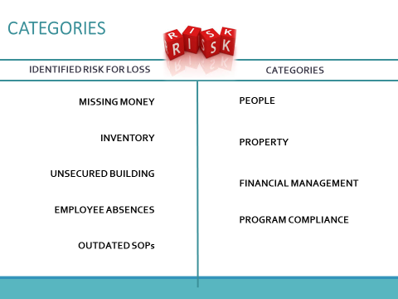

**TRIGGERS & DRIVERS:**

* Triggers that let us know there is a potential break down in internal controls.
* Drivers are those things that require us to have a control in place such as; laws, regulations, directives, budget, etc.

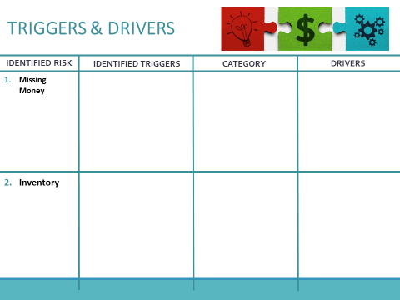

**KEY INTERNAL CONTROLS:** Some controls are required by policy or directive. These types of controls are known as “key internal controls” and without them they could seriously impair a system or process.

**Provide at least one example of a ‘key internal control’ you have in place:**

________________________________________________________________________________________________________________________________________________________________________________________________________________________________________________________________________________________________________________________________________

**SELECTING THE BEST CONTROLS – GROUP EXERCISE**

* Internal Control Process to discuss: **SNACK BAR FOOD INVENTORY**
* Select a control for the process or procedure.
* Answer the following questions:
  + Why did you select this/these control(s)?

_________________________________________________________________________________________________________________________________________________________________________________

* + How will you implement this control?

_________________________________________________________________________________________________________________________________________________________________________________

* + What could be the consequences if you did not have the control(s) in place?

____________________________________________________________________________________________________________________________________________________________________________________

**CONTROL ACTIVITIES:** Control Activities are the policies, procedures, techniques, and mechanisms that enforce directives. Some primary examples of Control Activities are:

* Reviews by Management at the Functional or Activity Level
* Management of Human Capital
* Information Processing
* Segregation of Duties

*Find more examples control activities in the GAO - Standards for Internal Control in the Federal Government.*

**EVALUATION OF CONTROL:** Give an example of how to evaluate a control.

__________________________________________________________________________________________________________________________________________________________________________________________________________________

**INTERNAL CONTROL EVALUATION PLAN (ICEP):** Before you begin evaluating your controls, you need to formulate a plan. The ICEP serves to document the required schedule of internal control evaluations within the reporting organization.

* The Internal Control Evaluation should identify the following:
  + Areas to be evaluated
  + Year for the evaluation
  + Official responsible for ensuring the evaluation is conducted

**INTERNAL CONTROL EVALUATION (ICE):** Internal Control Evaluations must be supported by specific documentation, regardless of the method used to conduct the evaluation.

* The evaluation must indicate:
* Who conducted the evaluation
* The date the evaluation was conducted
* The methods used to test key internal controls
* What weaknesses were detected
* Corrective actions taken

**Internal Control Evaluation Certification Form**

The Evaluation of the control is captured on DA Form 11-2. The completion of the DA Form 11–2 is certification that the evaluation was performed and appropriately documented. It is not intended to serve as a substitute for documenting the evaluation. All supporting documentation used to reach conclusions must be referenced on DA Form 11–2 and either attached or available for review. Documentation must be sufficient enough for an independent reviewer to reach the similar conclusions.

**NAF Internal Controls Module Three**

**MODULE 3 DESCRIPTION:** In this module, learners will further explore the five (5) standards of Internal Controls, with primary focus on the ‘Monitoring’ component. Learners will examine various types of controls, roles & responsibilities, and develop corrective action & monitoring plans.

**MODULE 3 OBJECTIVES:**

* Construct a corrective action plan for a material weakness.
* Given a material weakness, develop a monitoring plan to review internal controls over time.
* Explore the roles and responsibilities associated with Internal Controls and established monitoring plan.
* Formulate a Corrective Action & Monitoring Plan to monitor material risks.

**MATERIAL WEAKNESS:** A material weakness is the absence or ineffectiveness of internal controls that constitutes a deficiency or weakness that must be corrected.

* Criteria:
  + It must involve a weakness in internal controls (i.e., not in place, not being used or adequate)
  + It must warrant the attention of the next level of command (i.e., the higher level must resolve the problem or be aware of it)
* Other factors (must be significant and systemic with one or more risk factors):
  + Actual or potential loss of resources
  + Sensitivity of resources involved
  + Magnitude of funds/property/resources.
  + Unreliable info that could cause bad decisions
  + Diminished credibility of Army and/or IMCOM
  + Impaired mission, injury, death

**CORRECTIVE ACTION PLAN – EXERCISE INSTRUCTIONS**

* Your table has been assigned one (1) deficiency.
* Develop a Corrective Action Plan (CAP) to correct the material weakness/deficiency.
  + Define the achievable milestones
  + Prove your control will work (what does success look like)
* Select a scribe to capture your responses on the chart paper.
* Select a spokesperson to outbrief.

**Notes:**

________________________________________________________________________________________________________________________________________________________________________________________________________________________________________________________________________________________________________________________________________

______________________________________________________________________________________________________________________________________________________________________________________________________________________________________________________

**WHAT IS MONITORING?**

* Monitoring is when you observe or check on the progress or quality of something over a period of time; to keep under systematic review.

**Notes:**

________________________________________________________________________________________________________________________________________________________________________________________________________________________________________________________________________________________________________________________________________

**MONITORING PLAN – EXERCISE INSTRUCTIONS**

* Using the deficiency and Corrective Action Plan you developed in the previous exercise, develop a Monitoring Plan.
* The Monitoring Plan should include:
  + What is being monitored?
  + How it will be monitored?
  + When it will be monitored?
  + Who will be responsible for monitoring?
* Select a scribe to capture responses.
* Select a spokesperson to out-brief the (large) group.

**Notes:**

______________________________________________________________________________________________________________________________________________________________________________________________________________________________________________________

* **What are some financial impacts of having controls in place?**
* **Is there a cost savings?**

________________________________________________________________________________________________________________________________________________________________________________________________________________________________________________________________________________________

**ROLES & RESPONSIBILITIES**

* **Senior Responsible Official:** The Senior Responsible Official –or– **SRO** is the Director of the Directorate that the Internal Control function falls under. This is usually a General Officer or a member of the Senior Executive Service.
* **Assessable Unit Manager:** The Assessable Unit Manager–or– **AUM** is the military or civilian head of an assessable unit. Preferably at the general officer or senior executive service level but not lower than an O–6, GS–15, or equivalent. In exceptional cases where the grade structure does not support having an AUM at this level, the AUM will be the senior military or HQDA civilian functional manager. The AUM ensures that the results of required internal control evaluations are certified.
* **Internal Control Administrator:** The Internal Control Administrator –or– **ICA** is the individual designated by the SRO to administer the MICP for a reporting organization. The AUMs designate ICAs below the reporting organizational level.

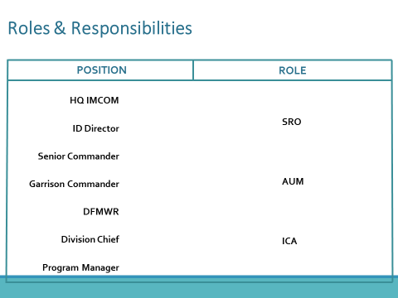

**CORRECTIVE ACTION PLAN**

|  |  |
| --- | --- |
| **1. Preparer:** | **2. Start Date:**  **(Date you will begin working on your action.)** |
|  | **3. End Date:**  **(Date action is completed and implemented.)** |
| **4. Identified Weakness:** | |
| **5. Current State:**  **(What is the current state that requires implementation of an action plan?)** | |
| **6. Corrective Action:** | |
| **7. Milestone(s) with Dates:**  **(Significant steps- and responsible person)** | |
| **8. Methods Used to Test and Monitor:** | |
| **9. Financial Impact:**  **(There are always costs associated with an action, salary-to include yours, staff, supplies, etc.)** | |

**NAF Internal Controls Module Four**

**MODULE 4 – DESCRIPTION:** In this module, students will present a Corrective Action Plan (CAP) to their group and class.

## MODULE 4 - AGENDA

* Corrective Action Plan (CAP) Presentations
* Administrative Items

**Corrective Action Plan Individual Assignment**

* Identify one (1) deficiency.
  + Choose one from your program.
* Develop a Corrective Action Plan (CAP) to correct the material weakness/deficiency.
  + Complete all sections (1-9)
  + Complete the form individually
* Brief your CAP to your group.
  + - Provide feedback to each individual
    - Update form accordingly
    - Each table will choose 1 person to brief their CAP to the large group
* Turn in your completed/updated form to the instructors.

**INTERNAL CONTROLS RECAP**

**Evaluation**

**Monitoring**

**Corrective Action Plan**

**Risk Assessment**

* **Identify Breakdowns**
* **Relate Standards to Operational Environment**
* **Determine Level of Risk**
* **Identify, Categorize Operational Elements**
* **Identify Drivers**
* **Select Best Control**
* **Evaluate Controls**
* **Corrective Action Plan**
* **Monitoring Plan**
* **Roles & Responsibilities**
* **Corrective Action Plan Feedback**