**MG Robert M Joyce**

**School for Family and MWR**

**Mobile Training**

**NAF Financial Management**

Participant Guide

****

**Syllabus:**

**Title:** NAF Financial Management Course

**Course Description:** NAF Financial Management Course learners will recognize and apply financial management processes required to successfully operate a non-appropriated fund (NAF) program. This course is a practical hands on approach to increase student proficiency in interpreting regulations and operating guidance, analyzing income statements, calculating and identifying labor and other operating expenses, and formulating an annual operating budget (AOB), including CPMC.

**Course Goal/Outcome:** Learners will be able to formulate program financial requirements and devise financial requirements through the development of an AOB.

**Target Audience:** Family and MWR Program Managers NF3 and above or GS equivalent.

**Course Objectives:**

1. Given NAF financial management protocols, interpret and relate specific guidance to NAF program operations in accordance with AR215-1, Chapter 16 and annual IMCOM G9 Program Budget Guidance.
2. Given a NAF Income Statement, analyze its components to distinguish ways the information can be used to make program operating decisions in accordance with AR 215-1 and annual IMCOM G9 Program Budget Guidance.
3. Given a NAF Variance Report and other historical financial reports, interpret data to identify trends and recommend corrective action if needed in accordance with AR 215-1, Chapter 16.
4. Given an overview of the budget process, examine IMCOM and garrison strategic guidance and historical data for budget applicability to determine five year program requirements for inclusion in the Manager’s Narrative IAW AR 215-1.
5. Given a scenario, consider future program requirements to formulate an annual NAF operating budget for one program to meet identified future requirements in accordance with annual IMCOM G9 Program Budget Guidance.
6. Given the CPMC Process and a CPMC decision matrix, examine the program manager’s role in CPMC management in accordance with legal, Army, IMCOM and/or Garrison imperatives.

**General Information:**

**IACET CEUs:** Pending

**Foundation Courses:**

1. Family & MWR Orientation Course (Online)
2. Family & MWR Basic Management Course (Online)
3. Operation Excellence –Customer Service Training (Online or Classroom)
4. Introduction to Family and MWR Delivery System (Online)

**Length of Course:** 3.5 Days Classroom

**Academic Integrity** includes the commitment to the values of honesty, trust, fairness, respect, and responsibility. Appropriate credit of others for the scientific work and ideas applies to all forms of scholarship, not just publications. The submission of another person’s work represented as that of the student’s without properly citing the source of the work will be considered plagiarism and will result in an unsatisfactory grade for the work submitted or for the entire course, and may result in academic dismissal.

**Course Learning Assessment/Grading:**

* Students are expected to complete all performance requirements for the course and to demonstrate mastery of the course concepts and course learning outcomes. Mastery of course concepts may require demonstration of critical thinking and communication skills by a combination of projects, self-assessments, quantitative reasoning, interviews, observations, written assignments, and/or other activities.
* Students are expected to receive an overall grade of 75% or above to receive credit for the course.

|  |  |
| --- | --- |
| **Assignments** | **Points** |
| Monthly Variance Report Exercise | 25 |
| Manager’s Narrative Exercise | 25 |
| AOB Budget Variance Exercise | 25 |
| Individual Action Plan | 25 |

**Academy Faculty Contact Information:**

|  |  |  |
| --- | --- | --- |
| James Moore | (210) 466-1012 | [James.A.Moore270.naf@mail.mil](mailto:James.A.Moore270.naf@mail.mil) |
| Farrah Santiago | (210) 466-1025 | [Farrah.M.Santiago.naf@mail.mil](mailto:Farrah.M.Santiago.naf@mail.mil) |
| Patricia Villarreal | (210) 466-1026 | [Patricia.M.Villarreal2.naf@mail.mil](mailto:Patricia.M.Villarreal2.naf@mail.mil) |
| Matthew Jobe | (210) 466-1021 | Matthew.C.Jobe.naf@mail.mil |
| Patrice Turner-Lapp | (210) 466-1013 | Patrice.S.Turner-Lapp.naf@mail.mil |
| Rosemary Clark | (210) 466-1008 | Rosemary.A.Clark4.naf@mail.mil |

**Course Agenda**

Day One:

Module 1: Introduction to NAF Financial Management

# Module 2: Income Statements as a Management Tool

# Module 3: Analyzing a Variance

Day Two:

# Module 3: Analyzing a Variance continued

# Module 4: Program Requirements

# Module 5: Annual Operating Budget

Day Three:

# Module 5: Annual Operating Budget continued

# Module 6: The CPMC Process

Day Four:

Module 7: Wrapping it Up *(AOB Variance Budget briefing completed during class)*

**Additional Training Resources:**

* Applied Financial Planning – Income Statement Analysis (Online)
* Applied Financial Planning – Breakeven Analysis (Online)
* Applied Financial Planning – Forecasting (Online)
* Applied Financial Planning – Retail Sales Accountability (Online)
* Budgeting in the NAF System (Online)
* Budgeting for APF Support (Online)

**Course Materials:**

**Materials:** School for Family & MWR Student Policies, Syllabus, Student Handouts

**References:**

Department of the Army (2010). *Army regulation 215-1, military morale, welfare, and recreation programs and nonappropriated fund instrumentalities*. Department of the Army, Washington, DC. Retrieved from [http://armypubs.army.mil/epubs/pdf/r215\_1.pdf.](http://armypubs.army.mil/epubs/pdf/r215_1.pdf)

Department of the Army (2010). *Army regulation 11-2, army programs managers’ internal control program.* Department of the Army, Washington, DC. Retrieved from [http://armypubs.army.mil/epubs/pdf/r11\_2.pdf.](http://armypubs.army.mil/epubs/pdf/r11_2.pdf)

Installation Management Command, G9 (2018). *FY19 Budget Guidance.* Financial

Management Division, IMCOM, Ft. Sam Houston, TX. Retrieved from <https://army.deps.mil/army/cmds/imcom_G9/G9/NAFFM_Budget/SitePages/ProgramBudgets.aspx>

Installation Management Command (2018). IMCOM regulation 215-1-1, business operating standards. IMCOM, Ft. Sam Houston, TX. Retrieved from <http://www.mwrbrandcentral.com/bo/wp-content/uploads/2018/06/IMCOM_Reg_215-1-1_IMCOM_BOS_20180531SIGNED-1.pdf>

School for Family and MWR. (2015). *Applied Financial Planning Suite*. IMCOM, Ft. Sam Houston, TX. Retrieved from [http://www.imcomacademy.com/.](http://www.imcomacademy.com/)

School for Family and MWR. (2015). *FMWR budgeting in the NAF system*. IMCOM, Ft. Sam Houston, TX. Retrieved from [http://www.imcomacademy.com/.](http://www.imcomacademy.com/)

Under Secretary of Defense, Comptroller (2017). *DOD 7000.14-R Financial management regulation, volume 1-16.* Department of Defense, Washington, DC. Retrieved from [http://comptroller.defense.gov/fmr/.](http://comptroller.defense.gov/fmr/)

**Official Transcript Request.**

To request an official transcript for Continuing Education Units (CEUs) or American Council on Education (ACE) college recommended credit please go to http://imcomcacademy.com select course catalog tab, administration then official transcript to complete the form. You may also go to the direct URL link: https://www.imcomacademy.com/ima/?page\_id=201

**What are your Course Expectations?**

**Course Objectives**

* Given NAF financial management protocols, interpret and relate specific guidance to NAF program operations in accordance with AR215-1, Chapter 16 and annual IMCOM G9 Program Budget Guidance.
* Given a NAF Income Statement, analyze its components to distinguish ways the information can be used to make program operating decisions in accordance with AR 215-1 and annual IMCOM G9 Program Budget Guidance.
* Given a NAF Variance Report and other historical financial reports, interpret data to identify trends and recommend corrective action if needed in accordance with AR 215-1, Chapter 16.
* Given an overview of the budget process, examine IMCOM and garrison strategic guidance and historical data for budget applicability to determine five year program requirements for inclusion in the Manager’s Narrative IAW AR 215-1.
* Given a scenario, consider future program requirements to formulate an annual NAF operating budget for one program to meet identified future requirements in accordance with annual IMCOM G9 Program Budget Guidance.
* Given the CPMC Process and a CPMC decision matrix, examine the program manager’s role in CPMC management in accordance with legal, Army, IMCOM and/or Garrison imperatives.

**Why make money?**

**NAF Financial Management Module One**

The first module of the NAF Financial Management course will provide the foundation for what you need to know as a Program Manager for Family and MWR.

**Module One Objectives**

* Identify and interpret regulations and operating guidance
* Explain sources and streams of funding for MWR programs
* Relate the Uniform Funding and Management process to your own program funding sources

|  |  |  |
| --- | --- | --- |
| **FMWR Funding Categories** | | |
| **Category A** | **Category B** | **Category C** |
| * **Authorized 100 % APF** * **Minimum standard is 85% APF** | * **MIX APF & NAF** * **Minimum standard is 65% APF** | * **NAF FUNDED** |
| * **Mission Sustaining Activities** * **Critical for retention and readiness of Soldiers** * **Promotes the physical and mental well-being of the soldier** * **Little or no ability to generate NAF $** * **Authorized to be funded 100% with APF dollars - authorization, however, does not guarantee fund availability** * **Examples: Libraries, recreation centers, and fitness/sports operations** | * **Enhanced Community Support Activities** * **Provides for the readiness & retention of Soldiers & contribute to the military mission by fostering a sense of community spirit** * **Have potential to raise a limited amount of NAF $, but lack the ability to sustain themselves based purely on their business.** * **Authorized to receive the majority of their funding from APF funds - total amount depends upon the installation commander's priorities & availability of funds** * **Examples: CYS, arts and crafts, auto crafts, bowling centers with 16 or less lanes, & outdoor recreation services** | * **Business Activities** * **Considered nonessential from the perspective of the military mission** * **Desirable as a means of providing recreational activity with morale benefit** * **Business activities with highest capability of generating revenues** * **Should be self-sustaining** * **Receive little or no direct APF support & are expected to generate a profit** * **Some exceptions for remote sites & OCONUS installations** * **Examples: Clubs, golf courses, & bowling centers** |

**Family and MWR Basic Management Course Knowledge Check**

1. What are Appropriated Funds?
2. What is the difference between direct APF and indirect APF?
3. What are Nonappropriated Funds?
4. What are two sources of NAF that are not locally generated from sales or other operating income?
5. Name at least 3 offices that have responsibility for managing NAF?
6. Name at least 1 regulation that governs the use of NAF.

**GROUP ACTIVITY**

* You are a Program Manager
  + What are at least 5 considerations you need to be **financially** **successful**?
  + Why?
* You will work as a group
* Chart your answers
* Choose a scribe and spokesperson to brief your results

Notes:

\_\_\_\_\_\_\_\_\_\_\_\_\_\_\_\_\_\_\_\_\_\_\_\_\_\_\_\_\_\_\_\_\_\_\_\_\_\_\_\_\_\_\_\_\_\_\_\_\_\_\_\_\_\_\_\_\_\_\_\_\_\_\_\_\_\_\_\_\_\_\_\_\_\_\_\_\_\_\_\_\_\_\_\_\_\_\_\_\_\_\_\_\_\_\_\_\_\_\_\_\_\_\_\_\_\_\_\_\_\_\_\_\_\_\_\_\_\_\_\_\_\_\_\_\_\_\_\_\_\_\_\_\_\_\_\_\_\_\_\_\_\_\_\_\_\_\_\_\_\_\_\_\_\_\_\_\_\_\_\_\_\_\_\_\_\_\_\_\_\_\_\_\_\_\_\_\_\_\_\_\_\_\_\_\_\_\_\_\_\_\_\_\_\_\_\_\_\_\_\_\_\_\_\_\_\_\_\_\_\_\_\_\_\_\_\_\_\_\_\_\_\_\_\_\_\_\_\_\_\_\_\_\_\_\_\_\_\_\_\_\_\_\_\_\_\_\_\_\_\_\_\_\_\_\_\_\_\_\_\_\_\_\_\_\_\_\_\_\_\_\_\_\_\_\_\_\_\_\_\_\_\_\_\_\_\_\_\_\_\_\_\_\_\_\_\_\_\_\_\_\_\_\_\_\_\_\_\_\_\_\_\_\_\_\_\_\_\_\_\_\_\_\_\_\_\_\_\_\_\_\_\_\_\_\_\_\_\_\_\_\_\_\_\_\_\_\_\_\_\_\_\_\_\_\_\_\_\_\_\_\_\_\_\_\_\_\_\_\_\_\_\_\_\_\_\_\_\_\_\_\_\_\_\_\_\_\_\_\_\_

\_\_\_\_\_\_\_\_\_\_\_\_\_\_\_\_\_\_\_\_\_\_\_\_\_\_\_\_\_\_\_\_\_\_\_\_\_\_\_\_\_\_\_\_\_\_\_\_\_\_\_\_\_\_\_\_\_\_\_\_\_\_\_\_\_\_\_\_\_\_\_\_\_\_\_\_\_\_

**Regulations and Policies**

What regulations or policies guide the financial management of your program?

**NOTES:**

AR215-1 Military Morale, Welfare, and Recreation Programs and Nonappropriated Fund Instrumentalities <http://armypubs.army.mil/epubs/pdf/r215_1.pdf>

[Financial Management resources https://army.deps.mil/army/cmds/imcom\_G9/G9/Divisions/Pages/NAFFM\_Bdgt\_Analysis.aspx](C:\\Users\\karen.m.nichols\\AppData\\Local\\Microsoft\\Windows\\INetCache\\Content.Outlook\\56W3T4AD\\Financial Management resources https:\\army.deps.mil\\army\\cmds\\imcom_G9\\G9\\Divisions\\Pages\\NAFFM_Bdgt_Analysis.aspx)

**Fund Manager**

Who is your fund manager?

* They are appointed
* They are the approving authority
* They are responsible for monitoring MWR activities
* They ensure internal management controls are in place

The Fund Manager for IMWRF

* Monitors MWR activities for regulatory compliance, especially regarding internal controls (*Cash Control System, Retail Sales Accountability, and Physical Security*).
* They ensure a series of checks and balances/ separation of duties are in place and functioning

**Sources of Funds**

Appropriated Funds are used to fund things like Base Operations (Utilities, New projects, and the MWR MDEPS (QDPC, QACS, and QCYS)). These are mission essential programs and services that receive funds appropriated by congress. NAF are a mix of funds that are self-generated (e.g. sales), outside sources, donations, the AAFES Dividends, etc.

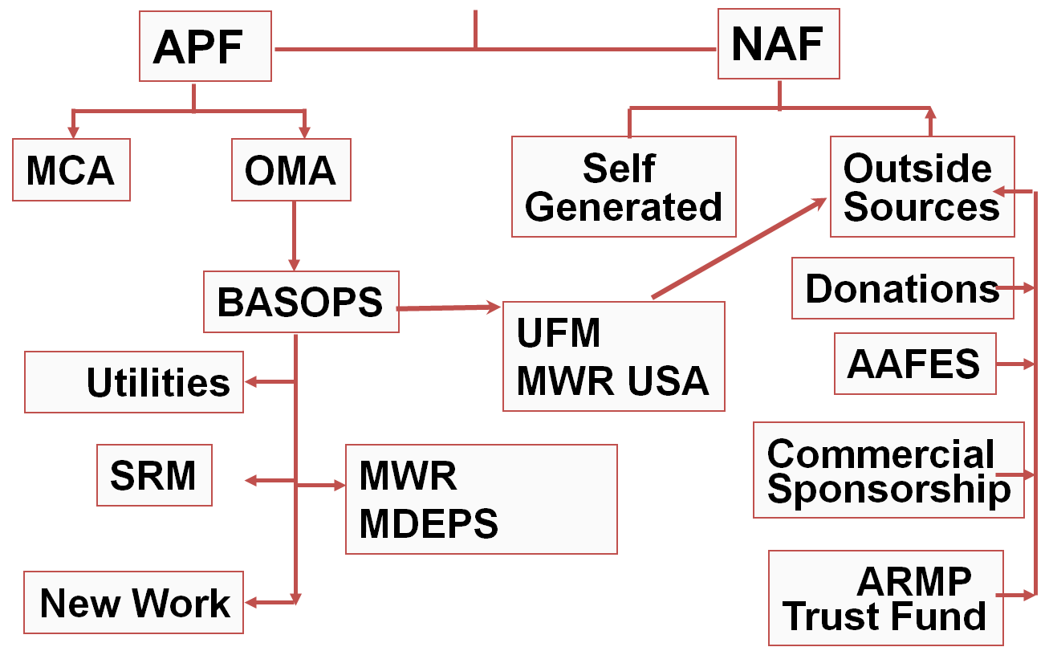

**KEY:**

MCA – Military Construction Army

OMA – Operation and Maintenance Army

BASOPS – Base Operations

SRM – Sustainment Restoration Modernization

MDEP – Management Decision Package

UFM – Uniform Funding Management

MWR USA – MWR Utilization Support and Accountability

**NOTES:**

**\_\_\_\_\_\_\_\_\_\_\_\_\_\_\_\_\_\_\_\_\_\_\_\_\_\_\_\_\_\_\_\_\_\_\_\_\_\_\_\_\_\_\_\_\_\_\_\_\_\_\_\_\_\_\_\_\_\_\_\_\_\_\_\_\_\_\_\_\_\_\_\_\_\_\_\_\_\_\_\_\_\_\_\_\_\_\_\_\_\_\_\_\_\_\_\_\_\_\_\_\_\_\_\_\_\_\_\_\_\_\_\_\_\_\_\_\_\_\_\_\_\_\_\_\_\_\_\_\_\_\_\_\_\_\_\_\_\_\_\_\_\_\_\_\_\_\_\_\_\_\_\_\_\_\_\_\_\_\_\_\_\_\_\_\_\_\_\_\_\_\_\_\_\_\_\_\_\_\_\_\_\_\_\_\_\_\_\_\_\_\_\_\_\_\_\_\_\_\_\_\_\_\_\_\_\_\_\_\_\_\_\_\_\_\_\_\_\_\_\_\_\_\_\_\_\_\_\_\_\_\_\_\_\_\_\_\_\_\_\_\_\_\_\_\_\_\_\_\_\_\_\_\_\_\_\_\_\_\_\_\_\_\_\_\_\_\_\_\_\_\_\_\_\_\_\_\_\_\_\_\_\_\_\_\_\_\_\_\_\_\_\_\_\_\_\_**

**NAF and NAFI**

**Nonappropriated Funds:**

* Cash and other assets received from sources other than funds appropriated by congress. They are predominantly generated at the local level
* NAFs are government funds used for the collective benefit of those who utilize MWR programs
* NAFs are separate and apart from funds on the books of The United States Treasury
* Money collected for goods and services offered to authorized patrons (See AR 215-1, Sec 6-2 or Table 6-1, page 19). *We have 30 categories of authorized patrons. GC determines who gets service. Generate between $800-$900M in yearly revenues*

**NAF Instrumentalities are a *DoD Organizational Entity which:***

* Performs an essential government function. Assists in recruiting and retention, adds to Quality of Life (QOL)
* Maintains Custody of and control over Nonappropriated Funds. (Fund Manager) AR 215-1, Sec 5-6
* NAFI’s are not incorporated under the laws of any state
* Tax exempt
* MWR is not the only NAFI on an installation – Sunday collections in military chapels deposited into Chaplains’ Funds, on-post Veterninary Clinic funds, Billeting/Lodging separate from MWR, etc. We don’t share our $ with them, and they don’t share with us. See AR 215-1, Sec. 4-8 page 8 for additional supplemental mission NAFIs
* Supplemental Mission NAF accounts, see AR 215-1, Sec 4-7, page 7

**Notes:**

****

**Uniform Funding & Management**

UFM (Uniform Funding & Management) is the process used to convert appropriated funds (APF) into nonappropriated funds (NAF) for the purpose of providing MWR support services under a single set of rules and procedures in order to:

* **Procure property and services for MWR**
* **Manage employees**
* **Provide programs**
* **Streamline financial reporting and management**

**UFM is only available for FMWR Programs that are authorized APF expenses.**

* **See AR 215-1, Table D-1**

**Notes:**

**NAF Financial Management Module Two**

**Income Statements as a Management Tool**

In module 2 of the NAF Financial Management course, participants will discover the process for tracking FMWR Financials to include Location, Program, and GLACs. The learners will also explore an income statement, its components, and distinguish ways the income statement can be used to manage a program.

**Module Two Objectives**

* Describe the monthly income statement by categorizing information contained on the statement.
* List the seven major elements of an income statement and their value in program operation.
* Perform standard income statement calculations and relate their value to program operations.
* Recognize the role of analysis in financial management and examine reports available for conducting an analysis.

**Give Us Your Digits!**

Do you know your Program, Location, and Department Codes?



Program

Code

Location

Code

Department

Code

**Standard NAFI Number (SNN) – A SNN** must be provided on all documents forwarded to NAF Financial Services (NFS) in order to ensure that the income or expense is accurately recorded in the correct activity's account.



Garrison /

Installation Code

Fund

Program

Code

Location

Code

Department

Code

GLAC

**12-digit Standard NAFI Number by Element**

***(Example)***

**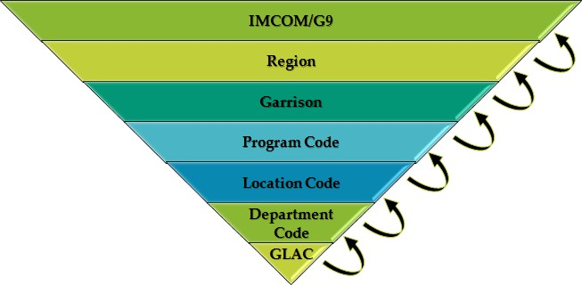Roll Things Up!**

### **IMCOM Directorate**

*General Ledger Account Codes (GLACs) are used to track expenses and income.*

**Income Statements**

What is an Income Statement and what is it used for?

**Notes:**

\_\_\_\_\_\_\_\_\_\_\_\_\_\_\_\_\_\_\_\_\_\_\_\_\_\_\_\_\_\_\_\_\_\_\_\_\_\_\_\_\_\_\_\_\_\_\_\_\_\_\_\_\_\_\_\_\_\_\_\_\_\_\_\_\_\_\_\_\_\_\_\_\_\_\_\_\_\_\_\_\_\_\_\_\_\_\_\_\_\_\_\_\_\_\_\_\_\_\_\_\_\_\_\_\_\_\_\_\_\_\_\_\_\_\_\_\_\_\_\_\_\_\_\_\_\_\_\_\_\_\_\_\_\_\_\_\_\_\_\_\_\_\_\_\_\_\_\_\_\_\_\_\_\_\_\_\_\_\_\_\_\_\_\_\_\_\_\_\_\_\_\_\_\_\_\_\_\_\_\_\_\_\_\_\_\_\_\_\_\_\_\_\_\_\_\_\_\_\_\_\_\_\_\_\_\_\_\_\_\_\_\_\_\_\_\_\_\_\_\_\_\_\_\_\_\_\_\_\_\_\_\_\_\_\_\_\_\_\_\_\_\_\_\_\_\_

**Income Statements**

* + The formal documentation of a NAF programs financial performance.
  + A historical document prepared 15 to 20 days after the close of the monthly accounting period.
  + It compares revenue to expenses.
  + It reflects a net income or a loss for the period.
  + It uses the basic income statement format below.

**Revenue – Expense = Net Income (or Loss)**

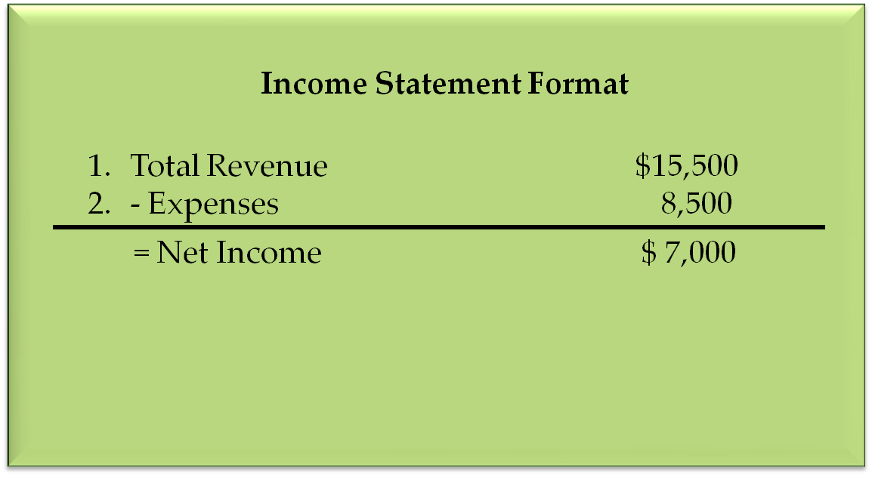

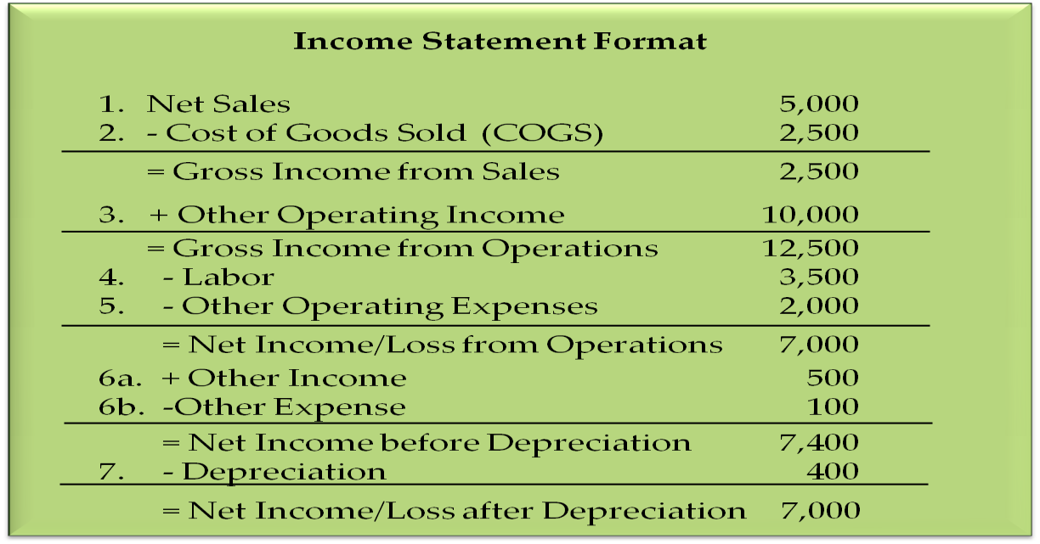

**Seven Major Elements**

1. Net Sales
2. Cost of Goods Sold
3. Gross Income from Sales
4. Gross Income from Operations
5. Percentage of Labor
6. Net Income/Loss from Operations
7. Net Income/Loss before Depreciation (NIBD)

**Income Statement Calculations**

**Group Activity**

* You will work as a group
* Complete the missing calculations in the Income Statement

|  |  |  |  |  |
| --- | --- | --- | --- | --- |
| **Income Statement** | | | | |
| 1 | Net Sales | $ 7,000.00 |  |  |
| 2 | - Cost of Goods Sold | $ 2,450.00 | COGS % |  |
|  | = Gross Income from Sales |  |  |  |
| 3 | + Other Operating Income | $ 11,000.00 |  |  |
|  | = Gross Income from Operations |  |  |  |
| 4 | - Labor | $ 7,200.00 | Labor % |  |
| 5 | - Other Operating Expenses | $ 1,000.00 |  |  |
|  | = Net Income/Loss from Operations |  |  |  |
| 6a | + Other Income | $ 600.00 |  |  |
| 6b | - Other Expenses | $ 200.00 |  |  |
|  | = Net Income/Loss before Depreciation (NIBD) |  | NIBD % |  |
| 7 | - Depreciation | $ 400.00 |  |  |
|  | = Net Income/Loss after Depreciation |  |  |  |

**Financial Formulas**

1. Cost of Goods Sold/Net Sales x 100 = ***Percentage* of Cost of Goods Sold**
2. Net Sales – Cost of Goods Sold = **Gross Income from Sales**
3. Gross Income from Sales + Other Operating Income = **Gross Income from Operations**
4. Labor Costs/(Net Sales + Other Operating Income + Other Income) =

***Percentage* of Labor**

1. Gross Income from Operations – Labor – Other Operating Expenses = **Net Income or Loss from Operations**
2. Net Income/Loss from Operations + Other Income – Other Expenses = **Net Income or Loss before Depreciation (NIBD)**
3. Net Income/Loss before Depreciation/Total Net Revenue = ***Percentage* of Net Income/Loss before Depreciation**
4. NIBD - Depreciation **= Net Income or Loss after Depreciation (NIAD)**

**Does an Income Statement paint the total picture of your Program Financials?**

**Analyzing Financials**

What is Analysis?

\_\_\_\_\_\_\_\_\_\_\_\_\_\_\_\_\_\_\_\_\_\_\_\_\_\_\_\_\_\_\_\_\_\_\_\_\_\_\_\_\_\_\_\_\_\_\_\_\_\_\_\_\_\_\_\_\_\_\_\_\_\_\_\_\_\_\_\_\_\_\_\_\_\_\_\_\_\_\_\_\_\_\_\_\_\_\_\_\_\_\_\_\_\_\_\_\_\_\_\_\_\_\_\_\_\_\_\_\_\_\_\_\_\_\_\_\_\_\_\_\_\_\_\_\_\_\_\_\_\_\_\_\_\_\_\_\_\_\_\_\_\_\_\_\_\_\_\_\_\_\_\_\_\_\_\_\_\_\_\_\_\_\_\_\_\_\_\_\_\_\_\_\_\_\_\_\_\_\_\_\_\_\_\_\_\_\_\_\_\_\_\_

**Program Reports: What are some reports do you use in your program?**

**Five Key Financial Reports and what they tell you…**

* + This month vs last month
  + This month vs budget
  + This month vs same month last year
  + YTD this year vs YTD last year
  + YTD this year vs YTD budget

**Group Exercise:**

* Given one of the 5 Key Financial Reports, provide at least one scenario in which you would use the report you are assigned.
* Work as a table group to complete the exercise on chart paper.

\_\_\_\_\_\_\_\_\_\_\_\_\_\_\_\_\_\_\_\_\_\_\_\_\_\_\_\_\_\_\_\_\_\_\_\_\_\_\_\_\_\_\_\_\_\_\_\_\_\_\_\_\_\_\_\_\_\_\_\_\_\_\_\_\_\_\_\_\_\_\_\_\_\_\_\_\_\_\_\_\_\_\_\_\_\_\_\_\_\_\_\_\_\_\_\_\_\_\_\_\_\_\_\_\_\_\_\_\_\_\_\_\_\_\_\_\_\_\_\_\_\_\_\_\_\_\_\_\_\_\_\_\_\_\_\_\_\_\_\_\_\_\_\_\_\_\_\_\_\_\_\_\_\_\_\_\_\_\_\_\_\_\_\_\_\_\_\_\_\_\_\_\_\_\_\_\_\_\_\_\_\_\_\_\_\_\_\_\_\_\_\_\_\_\_\_\_\_\_\_\_\_\_\_\_\_\_\_\_\_\_\_\_\_\_\_\_\_\_\_\_\_\_\_\_\_\_\_\_\_\_\_\_\_\_\_\_\_\_\_\_\_\_\_\_\_\_\_\_\_\_\_\_\_\_\_\_\_\_\_\_\_\_\_\_\_\_\_\_\_\_\_\_\_\_\_\_\_\_\_\_\_\_\_\_\_\_\_\_\_\_\_\_\_\_\_\_\_\_\_\_\_\_\_\_\_\_\_\_\_\_\_\_\_\_\_\_\_\_\_\_\_\_\_\_\_\_\_\_\_\_\_\_\_\_\_\_\_\_\_\_\_\_\_\_

**Standard Management Information Reports for Finance (SMIRF)**

* + **Summary Account Comparison** – This report compares the actual financial results of the current year and 5 years prior.
  + **Income by Month** – This report provides the fiscal year by month in a side-by- side format and includes all GLAC’s.
  + **Horse Blanket YTD Income Statement** – This report summarizes the income statement by major element (i.e. Division-specific Program Group).
  + **Budget vs Actual** – This report compares the actual financial results with the budget for the month requested and includes the year-to-date results.
  + **GLAC Query Summary** – This report provides monthly and year-to-date financial data on individual summary GLAC’s. It also includes quarterly totals.
  + **GLAC Query Actual** – This report provides monthly and year-to-date financial data on individual GLAC’s. It also includes quarterly totals.

**NAF Financial Management Module Three**

**Analyzing a Variance**

In module 3 of the NAF Financial Management course, students will recognize that budgets do not always get executed as planned. There are several familiar causes that can have an effect on budget plans. The learners will also explore a variance; how to calculate the variance; and distinguish cause and effect relationships in order to identify root causes, identify trends and recommend resulting/corrective action.

**Module Three Objectives**

* Analyze a variance report to identify actual financial operations performing outside of established standards
* Establish best uses of the five (5) key financial trends in FMWR
* Perform an analysis of the Actual vs. Budget for a given financial trend
* Conduct an analysis to determine financial trend
* Distinguish cause and effect
* Formulate possible causes for identified trends and recommend resulting/corrective action(s)

**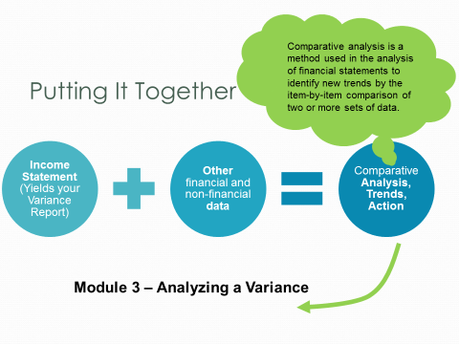**

**Five Key Financial Reports**

**Variance**

* This month vs last month
* This month vs budget
* This month vs same month last year
* YTD this year vs YTD last year
* YTD this year vs budget YTD

**The + or – of Financial Trends**

* Expressed as either positive or negative
* In general, when revenue is "down" or expenses are "up," the financial trend is considered **negative**
* Conversely, when revenue is "up" or expenses are "down," the financial trend is considered **positive**
* **Which trends should managers analyze? Why?**



**NOTES:**

**SMIRF Reports – Budget vs Actual (Variance)**

What is a Variance?

**Example: 726 Supplies Expense**

**Actual – Budgeted = Variance/Budgeted x 100 = Variance %**

**$1300 – $1000 = 300 /$1000 x 100 = 0.3 x 100 = 30 %**

$1300 – $1000 = 300 /$1000 x 100 = 0.3 x 100 = 30 %

**HOW DO YOU MEASURE UP?**

What are your numbers compared against?

*Headquarters Guidance*

*Industry Standards*

*Local Standards*

**WHICH HAS PRIORITY? WHY?**

**Analyzing a Variance**

* Analyze Data at the Lowest Level Possible
* Compare actual results to budget estimates for each Income Statement item

***REMEMBER: Variances may be favorable or unfavorable, significant or insignificant. YOU SHOULD ANALYZE BOTH*!**

***GROUP EXERCISE***

* Calculate the missing data
* Work as a table group to complete the exercise. Be prepared to brief your numbers.

**How to Calculate your Variance**

Actual – Budget = Variance/Budgeted x 100 = Variance %

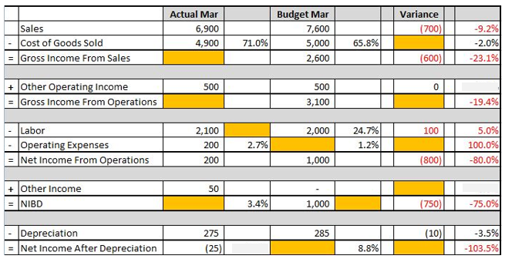

***Remember! Some of these calculations are based off total revenue.*Cause and Effect-** *Possible Reasons and Actions for the Variance*

**Financial Formulas**

1. Cost of Goods Sold/Net Sales x 100 = ***Percentage* of Cost of Goods Sold**
2. Net Sales – Cost of Goods Sold = **Gross Income from Sales**
3. Gross Income from Sales + Other Operating Income = **Gross Income from Operations**
4. Labor Costs/(Net Sales + Other Operating Income + Other Income) =

***Percentage* of Labor**

1. Gross Income from Operations – Labor – Other Operating Expenses = **Net Income or Loss from Operations**
2. Net Income/Loss from Operations + Other Income – Other Expenses = **Net Income or Loss before Depreciation (NIBD)**
3. Net Income/Loss before Depreciation/Total Net Revenue = ***Percentage* of Net Income/Loss before Depreciation**
4. NIBD - Depreciation **= Net Income or Loss after Depreciation (NIAD)**

|  |  |  |  |
| --- | --- | --- | --- |
| **Data** | **Variance** | **Possible Reasons** | **Possible Actions** |
| Sales | ($1,000) |  |  |
| Labor | 2% |  |  |
| Operating Income | $200 |  |  |
| COGS% | 10% |  |  |
| Other Operating Expense | $50 |  |  |
| NIBD% | 8% |  |  |

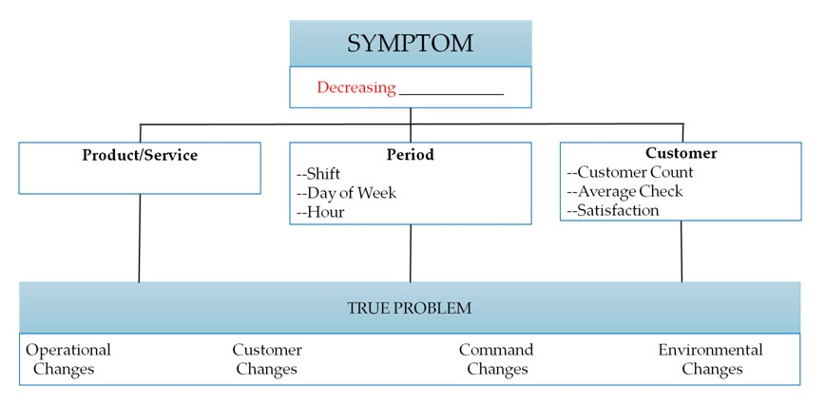**Diagnostic Tool: Root Cause Analysis**

|  |  |  |  |
| --- | --- | --- | --- |
| **TRUE PROBLEM**  **Declining Spin Class Participation ($2 per class/max 15 participants)** | | | |
| Operational  Changes | Customer  Changes | Command  Changes | Environmental  Changes |
|  |  |  |  |

**Monthly Variance Report Exercise**

*Analyze*: Why the variance occurred

How you are going to FIX unfavorable variances or DUPLICATE or CONTINUE favorable variances.

**NAF Financial Management Module Four**

In module 4 of the NAF Financial Management course, students will review the steps necessary for budget creation. Learners will consider the role of strategic guidance and historical data in formulating short and long term requirements to conceive the manager’s narrative and 5-year plan.

**Module Four Objectives**

* Identify and apply the NAF Annual Operating Budget (AOB) Process
* Identify and discuss strategic guidance; synthesize with the NAF AOB Process
* Describe the NAF 5yr Plan Program Requirements and how they should be used during AOB development

**The Manager’s Role**

**Formulate**

**Plan**

**Annual Operating Budgets (AOB)**

* **APF Budget Process Notes:**

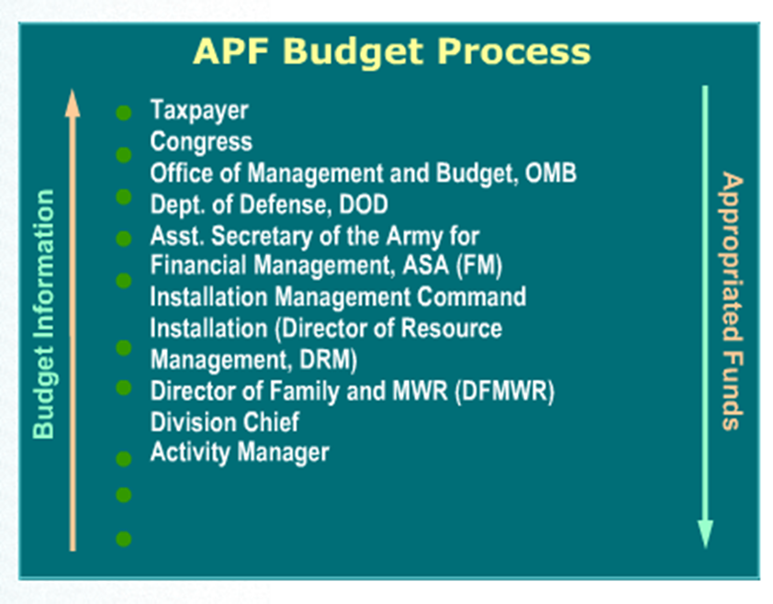

* Centralized Process
* Six-year plan
  + Next fiscal year = budget year
  + Five following years = out years
* Leads to the President’s annual budget
  + Passed by Congress
  + Signed by the President
* **NAF Budget Process Notes:**

**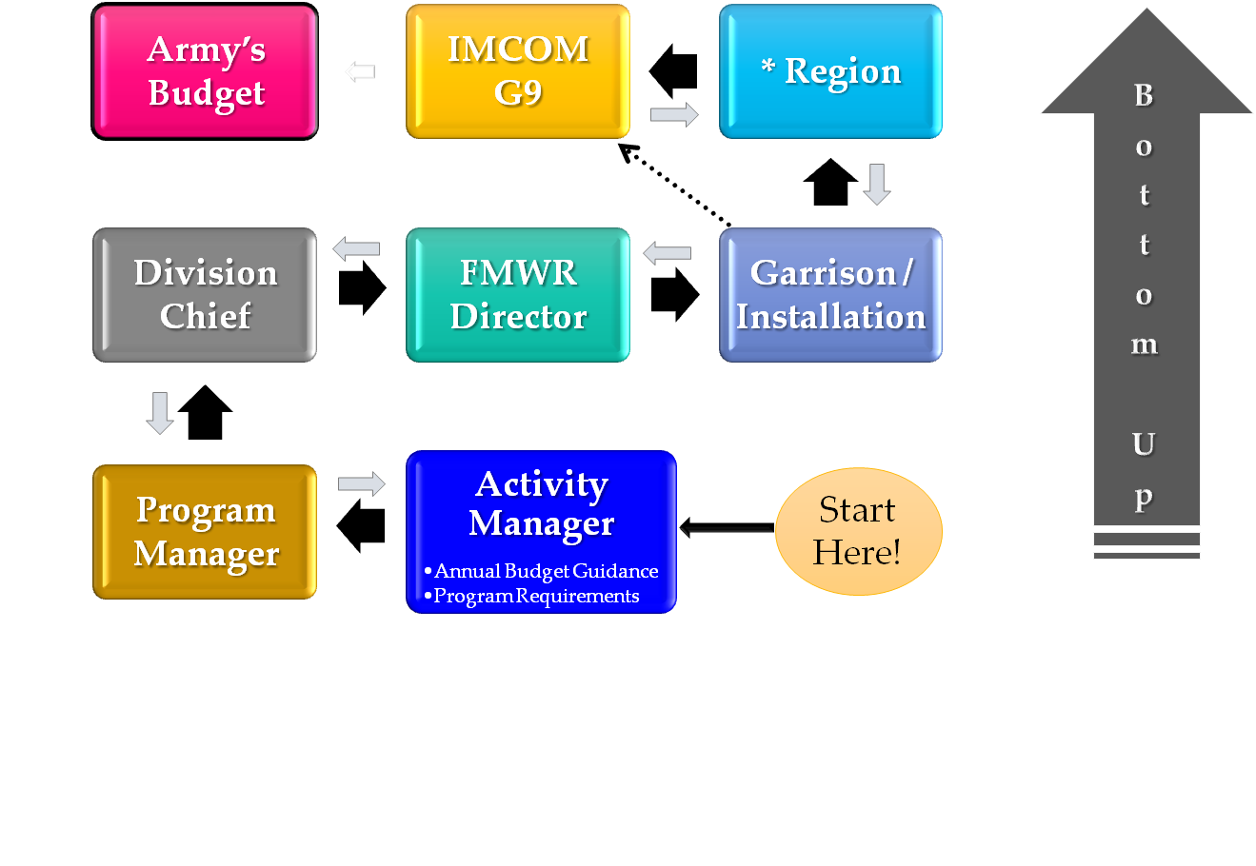**

**Directorate**

NAF Budget Process

**Managers implement financial planning practices according to the annual budget guidance through:**

1. Formulating the \_\_\_\_\_\_\_\_\_\_\_\_\_\_\_\_\_\_ \_\_\_\_\_\_\_\_\_\_\_\_\_\_\_\_\_\_\_\_\_.
2. Tracking and monitoring \_\_\_\_\_\_\_\_\_\_\_\_ \_\_\_\_\_\_\_\_\_\_\_\_\_\_\_\_ throughout the year.
3. Analyzing and explaining budget \_\_\_\_\_\_\_\_\_\_\_\_\_\_\_\_\_\_.
4. Implementing actions to correct \_\_\_\_\_\_\_\_\_\_\_\_\_\_\_\_\_ variances.

**Notes:**

\_\_\_\_\_\_\_\_\_\_\_\_\_\_\_\_\_\_\_\_\_\_\_\_\_\_\_\_\_\_\_\_\_\_\_\_\_\_\_\_\_\_\_\_\_\_\_\_\_\_\_\_\_\_\_\_\_\_\_\_\_\_\_\_\_\_\_\_\_\_\_\_\_\_\_\_\_\_\_\_\_\_\_\_\_\_\_\_\_\_\_\_\_\_\_\_\_\_\_\_\_\_\_\_\_\_\_\_\_\_\_\_\_\_\_\_\_\_\_\_\_\_\_\_\_\_\_\_\_\_\_\_\_\_\_\_\_\_\_\_\_\_\_\_\_\_\_\_\_\_\_\_\_\_\_\_\_\_\_\_\_\_\_\_\_\_\_\_\_\_\_\_\_\_\_\_\_\_\_\_\_\_\_\_\_\_\_\_\_\_\_\_

**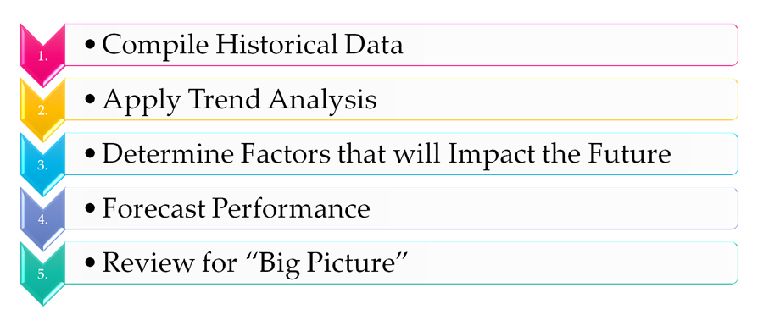NAF AOB Process**

**NAF AOB Process: Group Exercise**

* Brainstorm examples of things we would look at for the 5 steps.

** *Compile Historical Data***

****

***Apply Trend Analysis***

****

***Determine Factors that will Impact the Future***

****

***Forecast Performance***



***Review for “Big Picture”***

**Formulating Strategy:**

* Vision and Mission Statements
  + Army
  + IMCOM
  + G9 (FMWR)
  + Local
* Long-Term Objectives
* Alternative Strategies
* Strategy Selection

***Why is it important to incorporate your own strategies into higher level strategies?***

**\_\_\_\_\_\_\_\_\_\_\_\_\_\_\_\_\_\_\_\_\_\_\_\_\_\_\_\_\_\_\_\_\_\_\_\_\_\_\_\_\_\_\_\_\_\_\_\_\_\_\_\_\_\_\_\_\_\_\_\_\_\_\_\_\_\_\_\_\_\_\_\_\_\_\_\_\_\_\_\_\_\_\_\_\_\_\_\_\_\_\_\_\_\_\_\_\_\_\_\_\_\_\_\_\_\_\_\_\_\_\_\_\_\_\_\_\_\_\_\_\_\_\_\_\_\_\_\_\_\_\_\_\_\_\_\_\_\_\_\_\_\_\_\_\_\_\_\_\_\_\_\_\_\_\_\_\_\_\_\_\_\_\_\_\_\_\_\_\_\_\_\_\_\_\_\_\_\_\_\_\_\_\_\_\_\_\_\_\_\_\_\_\_\_\_\_\_\_\_\_\_\_\_\_\_\_\_\_\_\_**

**SWOT**

|  |  |  |
| --- | --- | --- |
|  | Helpful  to achieving the objective | Harmful  to achieving the objective |
| Internal Origin  (attributes of the environment) | Strengths | Weaknesses |
| External Origin  (attributes of the environment) |  | Opportunities  Threats |

**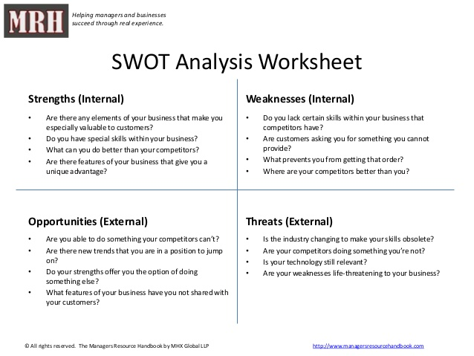**

**When analyzing INTERNAL Strengths and Weaknesses ask yourself:**

1. What are the strengths of our program?
2. What are the weaknesses of our program?

**When analyzing EXTERNAL Opportunities and Threats ask yourself:**

1. What opportunities exist in our external environment?
2. What threats to the program exist in our external environment?

**SWOT Group Exercise**

1. In your table groups, identify as many Strengths or Weaknesses, Opportunities and Threats for Family & MWR as an organization.
2. Chart your responses on the Chart Paper.
3. Select a spokesperson to brief the large group.

|  |  |
| --- | --- |
|  |  |
|  |  |

**Five year Program Requirements**

* Benefits of the 5-year plan:

- Balanced Family and MWR installation program

- Integration of Family and MWR activities

- Prioritizes programs according to significance to readiness and retention

* Includes both APF and NAF revenues and expenses
* Must be prepared in accordance with guidance from:
  + AR 215-1 (Section 15-1 and 15-2)
* Current fiscal year (FY) budget guidance

**NAF Financial Management Module Five**

**Annual Operating Budget (AOB)**

In module 5 of the NAF Financial Management course students will apply a scenario to the 5-Steps of the NAF Annual Operating Budget Process and complete a Manager’s Narrative for the scenario.

**Module Five Objectives**

* Given a scenario, apply the 5-Steps of the NAF Annual Operating Budget Process. Learners will:

1. Compile Historical Data
2. Apply a Trend Analysis
3. Determine factors that will impact the future
4. Forcast Performance and determine requirements
5. Review Big Picture

* Define components of the Manager’s Narrative in the NAF AOB and relate to the budget and planning process

**NAF AOB Process**

1. Compile Historical Data

* + Calendars
  + Financial
  + Non-Financial

2. Apply Trend Analysis

* + 5 Key Financial Trends
  + How has my program performed over the last 3-5 yrs?

3. Determine Factors that will impact the Future

* + Budget reductions and revisions
  + Policy, Command changes

4. Forecast Performance

* + Should I be making a profit?
  + Should I be applying break-even analysis?

5. Review the “Big Picture”

* + Does my data make sense?
  + Can I live up to my projections

**Outdoor Recreation Scenario**

- You are the Program Manager for an Outdoor Recreation Program (ODR) at Ft. Perfect, USA. The ODR program operates out of a building near Lake Tholocco on the Northwest side of the garrison. The ODR facility is 25,000 square feet, steel frame construction and was built in 1996. The facility houses the equipment checkout center, to include a large equipment checkout (canoes, boats, tents, campers, etc.), customer service area, travel camp office, lake lodging rentals, pro-shop, administrative offices, Hunter education courses are held in the facility.

- The ODR manages a travel camp site that boasts 30 concrete pads available for RV hook-up and 12 tent camp spaces. There are shower and laundry facilities available in the travel camp.

- ODR also manages the checkout of 6 covered picnic areas, 1 enclosed picnic room that can hold 40 people and 3 uncovered picnic areas at 3 small fishing lakes around the garrison.

**Available Programs**

|  |  |
| --- | --- |
| * Camping Equipment | * Canopies, Tables, Chair Issue |
| * Boats & Accessories Issue | * Fishing and Hunting Permits |
| * Sport Equipment | * Paintball Field & Equipment |

- Lake Tholocco is a 640 acres lake but has been closed since 2015 due to a broken dam. The garrison recently repaired the dam and the lake will open to the public again next fiscal year. The lake will be available for boating, fishing, and special events. Swimming is open during the summer months and only during designated day light hours when lifeguards are on duty, 10 a.m. - 6 p.m.

**West Beach Snack Bar**

- In the past, the West Beach Snack Bar on Lake Tholocco was open from Memorial Day weekend through Labor Day. Hours of operation for the Snack Bar were Wednesday through Friday from 12 p.m. until 2 p.m., Saturday & Sunday from 12 p.m. until 5 p.m., and holidays from 12 p.m. until 5 p.m. (unless posted otherwise).

- The Snack Bar offered a menu of American fare, including: Hamburgers, Hot Dogs, Chili Cheese Nachos, Buffalo wings, Chicken Tenders, and Popcorn Shrimp, and assorted beverages.

- Since the dam broke in 2015 the snack bar has remained closed.

- The Director of MWR has informed you that the lake will be open next summer and to reopen the snack bar in anticipation that the swim season and lake recreational activities will bring in hungry patrons.

**Given the scenario, complete the NAF AOB process in order to prepare to open the West Beach Snack Bar next summer.**

**Group Exercise – We will do one step at a time!**

Compile Historical Data

****

Apply a Trend Analysis

****

Determine factors that will impact the future

****

Forcast Performance and determine requirements

****

Review Big Picture

***If you are not involved in this process…someone else is making all the decisions for you***

**Manager’s Narrative**

* Describes
  + Current program
  + Out-years
* Includes
  + Needed construction, personnel adjustments, program changes, revenue generators, equipment, etc.
  + Planned changes or improvements
  + HOW and WHY there is a variance between actual and budget
* Incorporates manager’s decisions & ideas into long-range plan
* Covers the budget year & the next four years

**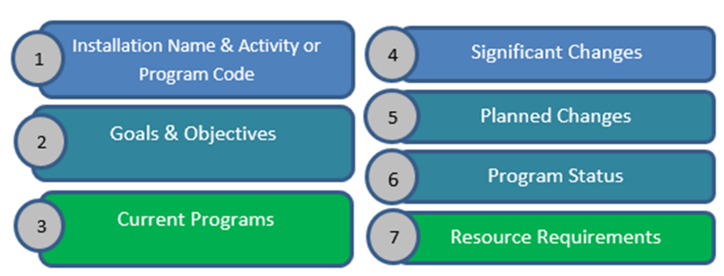**

1. Installation Name & Activity or Program Code
2. Goals & Objectives
3. Current Programs
   * + Serves as the baseline for developing the costs and direction.
4. Significant Changes
   * + Description of what has changed since last year such as population changes or new programs.
5. Planned Changes
   * + Documentation of decisions for changes or improvements, itemizing requirements by fiscal year.
6. Program Status
   * + Requires use of assessment tools such as program-specific evaluations and rating scales.
7. Resource Requirements
   * + For all activities and programs, a description of what is needed to meet goals.

**Manager’s Narrative Matching Game**

1. \_\_\_\_ Requires use of assessment tools such as program-specific evaluations and rating scales.
2. \_\_\_\_ Documentation of decisions for changes or improvements, itemizing requirements by fiscal year.
3. \_\_\_\_ Description of what has changed since last year such as population changes or new programs.
4. \_\_\_\_ For all activities and programs, a description of what is needed to meet goals.
5. \_\_\_\_ Serves as the baseline for developing the costs and direction.

**A. Description of current programs**

**B. Description of significant changes**

**C. Description of planned changes**

**D. Report on status of programs to designated standards**

**E. Resource requirements**

**Manager’s Narrative Exercise**

* Develop a Manager’s Narrative based on the given scenario
  + Use the provided template
* Work as a group
  + Complete all sections fully
  + Use the information ascertained from the AOB group work
* Be prepared to share your Narrative with another table group
  + Provide feedback
  + Incorporate feedback into final submission
* Turn in your completed/updated manager’s narrative to the instructors

**NAF Financial Management Module Six**

**Capital Purchase and Minor Construction (CPMC)**

In module 6 of the NAF Financial Management course, students will review processes for planning for capital purchases and minor construction. Students will further explore capitalization and depreciation and their impact on monthly income statements. Finally, the learner will explore a decision matrix and its applicability to the CPMC project.

**Module Six Objectives**

* Define and describe the CPMC Process
* Identify and apply the Capitalization and Depreciation procedures as they relate to the CPMC Process
* Identify and apply the decision matrix approach to ranking CPMC proposals
* Distinguish and discuss the key components of a CPMC proposal

**Reviewing the 5 Year Plan:**

* Examining what remains to be executed
* Changing priorities
* Estimating cost changes
* Determining which projects are in progress
* Determining the validity of existing projects
* Determining what needs to be added to the budget

**WHY DO WE NEED TO REVIEW THE PLAN?**

**What is CPMC?**

\_\_\_\_\_\_\_\_\_\_\_\_\_\_\_\_\_\_\_\_\_\_\_\_\_\_\_\_\_\_\_\_\_\_\_\_\_\_\_\_\_\_\_\_\_\_\_\_\_\_\_\_\_\_\_\_\_\_\_\_\_\_\_\_\_\_\_\_\_\_\_\_\_\_\_\_\_\_\_\_\_\_\_\_\_\_\_\_\_\_\_\_\_\_\_\_\_\_\_\_\_\_\_\_\_\_\_\_\_\_\_\_\_\_\_\_\_\_\_\_\_\_\_\_\_\_\_\_\_\_\_\_\_\_\_\_\_\_\_\_\_\_\_\_\_\_\_\_\_\_\_\_\_\_\_\_\_\_\_\_\_\_\_\_\_\_\_\_\_\_\_\_\_\_\_\_\_\_\_\_\_\_\_\_\_\_\_\_\_\_\_\_\_\_\_\_\_\_\_\_\_\_\_\_\_\_\_\_\_\_

\_\_\_\_\_\_\_\_\_\_\_\_\_\_\_\_\_\_\_\_\_\_\_\_\_\_\_\_\_\_\_\_\_\_\_\_\_\_\_\_\_\_\_\_\_\_\_\_\_\_\_\_\_\_\_\_\_\_\_\_\_\_\_\_\_\_\_\_\_\_\_\_\_\_\_\_\_\_\_\_\_\_\_\_\_\_\_\_\_\_\_\_\_\_\_\_\_\_\_\_\_\_\_\_\_\_\_\_\_\_\_\_\_\_\_\_\_\_\_\_\_\_\_\_\_\_\_\_\_\_\_\_\_\_\_\_\_\_\_\_\_\_\_\_\_\_\_\_\_\_\_\_\_\_\_\_\_\_\_\_\_\_\_\_\_\_\_\_\_\_\_\_\_\_\_\_\_\_\_\_\_\_\_\_\_\_\_\_\_\_\_\_\_\_\_\_\_\_\_\_\_\_\_\_\_\_\_\_\_\_

**CPMC Knowledge Check:**

* Fixed assets are tangible properties purchased by or donated to a NAFI that have an expected life of \_\_\_\_\_\_\_ or more and cost \_\_\_\_\_\_\_ or more.
* Could also be a group of \_\_\_\_\_\_\_\_\_\_ assets with a useful life of at least \_\_\_\_\_\_\_\_.
* Assets which do not meet capitalization criteria are considered \_\_\_\_\_\_\_\_\_\_ items and are not capitalized.
* Minor construction projects cost between \_\_\_\_\_\_\_\_\_\_ and \_\_\_\_\_\_\_\_\_\_\_\_\_.
* NAF dollars can be used for maintenance and repair projects over \_\_\_\_\_\_\_\_\_.

**Capital Purchase and Minor Construction**

**Capitalization:**

* Fixed asset
* Cash payment
* Balance Sheet
* Recorded fixed asset
* No impact to equity of fund

**Depreciation: Asset ÷ Life Expectancy (in months)**

**Notes:**

\_\_\_\_\_\_\_\_\_\_\_\_\_\_\_\_\_\_\_\_\_\_\_\_\_\_\_\_\_\_\_\_\_\_\_\_\_\_\_\_\_\_\_\_\_\_\_\_\_\_\_\_\_\_\_\_\_\_\_\_\_\_\_\_\_\_\_\_\_\_\_\_\_\_\_\_\_\_\_\_\_\_\_\_\_\_\_\_\_\_\_\_\_\_\_\_\_\_\_\_\_\_\_\_\_\_\_\_\_\_\_\_\_\_\_\_\_\_\_\_\_\_\_\_\_\_\_\_\_\_\_\_\_\_\_\_\_\_\_\_\_\_\_\_\_\_\_\_\_\_\_\_\_\_\_\_\_\_\_\_\_\_\_\_\_\_\_\_\_\_\_\_\_\_\_\_\_\_\_\_\_\_\_\_\_\_\_\_\_\_\_\_\_\_\_\_\_\_\_\_\_\_\_\_\_\_\_\_\_\_\_\_\_\_\_\_\_\_\_\_\_\_\_\_\_\_\_\_\_\_\_\_\_\_\_\_\_\_\_\_\_\_\_\_\_\_\_\_\_\_\_\_\_\_\_\_\_\_\_\_\_\_\_\_\_\_\_\_\_\_\_\_\_\_\_\_\_\_\_\_\_\_\_\_\_\_\_\_\_\_\_\_\_\_\_\_\_\_\_\_\_\_\_\_\_\_\_\_\_\_\_\_\_\_\_\_\_\_\_\_\_\_\_\_\_\_\_\_\_\_\_\_\_\_\_\_\_\_\_\_\_\_\_\_\_\_\_\_\_\_

**GROUP EXERCISE:** What would you bring to the deserted island?

1. **\_\_\_\_\_\_\_\_\_\_\_\_\_\_\_\_\_\_\_\_\_\_\_\_\_\_\_\_\_\_\_\_\_\_\_\_\_\_\_\_\_**
2. **\_\_\_\_\_\_\_\_\_\_\_\_\_\_\_\_\_\_\_\_\_\_\_\_\_\_\_\_\_\_\_\_\_\_\_\_\_\_\_\_\_**
3. **\_\_\_\_\_\_\_\_\_\_\_\_\_\_\_\_\_\_\_\_\_\_\_\_\_\_\_\_\_\_\_\_\_\_\_\_\_\_\_\_\_**
4. **\_\_\_\_\_\_\_\_\_\_\_\_\_\_\_\_\_\_\_\_\_\_\_\_\_\_\_\_\_\_\_\_\_\_\_\_\_\_\_\_\_**
5. **\_\_\_\_\_\_\_\_\_\_\_\_\_\_\_\_\_\_\_\_\_\_\_\_\_\_\_\_\_\_\_\_\_\_\_\_\_\_\_\_\_**

**Decision Matrix** (sample)

****

****

**CPMC Proposal**

Notes

* *AR215-1, Ch 15-7.*
* DD Form 1391
* Consolidated list
* Submitted in FMBS
* Approved locally
* NIBD

**CPMC Wrap-Up!**

* 5-year plan
* Fixed asset report
* Program changes and enhancements
* Alternatives
* Priorities
* FMBS

**NAF Financial Management Module Seven**

**Annual Operating Budget (AOB) Variance Report**

In module of the NAF Financial Management course, students will complete, brief, and participate in small and large group review of their AOB Variance Report. Next, they will complete an Individual Action Plan (IAP), review course expectations, and complete the End of Course Survey.

**Annual Operating Budget (AOB) Variance Report Exercise**

* Review your Annual Operating Budget (AOB) report
  + Complete the analysis section as an individual
  + Tell us what the variance is saying
    - Why the variance occurred
    - How you are going to FIX unfavorable variances or DUPLICATE or CONTINUE favorable variances!
* Brief your variance analysis to your group
  + Provide feedback to each individual
  + Update analysis accordingly
* Each table will choose 1 person to brief their analysis to the large group
* Turn in your completed/updated report to the instructors

***Financial Management Wrap-Up***

**INCOME STATEMENT**

* The basic income statement formula is Revenue minus Expenses equals Net Income/Loss.
  + *Net Income/Loss = Revenue - Expenses*
* The terms income statement and financial statement are not interchangeable although they are often used that way. The income statement is only one part of the financial stateemnt which also includes the balace sheet and supporting schedules.
* The simplified income statement format is comprised of seven major categories which are subtotals obtained by adding and subtracting the appropriate GLACs.
* The format prescribed in AR 215-5 is:

|  |  |  |  |
| --- | --- | --- | --- |
| **+** | SALES |  | 7,000 |
| **-** | COST OF GOODS SOLD | 4,900 | 70.0% |
| **=** | **GROSS INCOME FROM SALES** | 2,100 |  |
| **+** | OTHER OPERATING INCOME | 500 |  |
| **=** | **GROSS INCOME FROM OPERATIONS** | 2,600 |  |
| **-** | LABOR | 1,900 | 25.3% |
| **-** | OPERATING EXPENSES | 200 | 2.7% |
| **=** | **NET INCOME BEFORE DEPRECIATION (NIBD)** | 500 | 6.7% |
| **-** | DEPRECIATION | 275 |  |
| **=** | **NET INCOME/LOSS** | 225 | 3.0% |

* There are six steps in the trend analysis process

1. Select a type of trend analysis and lay out the data.
2. Determine where negative trends exist.
3. Select a single line where a negative trend exists and begin review of the data that is summarized to obtain the summary line of the income statement.
4. Display the GLACs that comprise the summary line in the same format as the original analysis. Determine which GLAC(s) caused the negative trend.
5. Identify the operational changes that may have caused the negative trend.
6. Decide on management action to improve performance.

**SALES**

* The single fact that distiguishes sales from other operating incomes is that there is always a product cost (cost of goods sold) associated with sales.
* The formula to calculate nets sales is:

|  |  |
| --- | --- |
| **+** | Cash Sales |
| **+** | Credit Sales |
| **+** | Layaway Sales |
| **-** | Sales Returns and Allowances |
| **-** | Customer Discounts |
| **-** | Employee Discounts |
| **=** | **Net Sales** |

* Sales trends can be monitored in either “real” dollars or as a percent of Total Revenue. A decrease in either represents a negative trend.
* In order to prepare a Sales Analysis, management must be familiar with the source documents from which the information can be extracted. Often management must design systems which gurarantee needed data is not lost during the recording process or when entered in the accounting system. The base source documents are:
  + Daily Activity Report (DAR)
  + Cashier’s Report
  + Cash Register Reading and Detail Tapes (if applicable)
  + Scatter Sheets
  + Sales Accountability Inventories
* Full analysis of a negative and positive sales trend often requires use of several different analyses.

**OTHER OPERATING INCOME**

* Other Operating Income (OOI) is defined as the revenue collected for services provided or use of equipment/facilities. Also included in this definition is the commission paid to us by concessionaires who operate MWR related activities on the installation.
* There is never a direct cost of goods associated with OOI.
* Total OOI is computed by totaling all of the 500 series GLACs used by the activity or program.
* OOI trends can be monitored in either real dollars or as in percent of Total Revenue.

**OTHER INCOME**

* Other Income (OI) is defined as the revenue collected from other than normal operations. The funds are not generated directly from selling a product or service associated with the activities primary purpose.
* The major sources of OI are intereste, gain on the sale of fund property, “grants” from higher headquarters, and charitable donations.
* Total OI is calculated by adding together all of the 800 series accounts.

**TOTAL REVENUE**

* Total Revenue is defined as the mathematical total of all of the income recorded on the income statement.
* The equation for calculating Total Revenue is the sum of Sales, Other Operating Income, and Other Income.
  + *TR = Sales + OOI + OI*
* Total Revenue is the base upon which all percentages (except COGS %) are computed.

**COST OF GOODS SOLD**

* Cost of Goods Sold (COGS) is defined as the cost associated with the purchase of merchandise which will be sold at retail. By definition, this cost includes any freight required to get the product to your location.
* The formula for calculating COGS is beginning inventory plus all purchases and receipts, minus all issues to other activities/departments, minus vendor returns, and minus ending inventory.
  + *COGS = beginning inventory + all purchases and receipts – all issues to other activities/departments – vendor returns – ending inventory.*
* COGS trends are monitored using the COGS Percentage which is below:
  + *COGS% = COGS $/Net Sales $ x 100*
* In order to undertand a specific problem, management must have a detailed understanding of the GLACs which are combined mathematically to calculate COGS.
* The causes of consistently low COGS% are:

1. Over Pricing
2. Under Portioning
3. Sales Recorded in the Wrong Department

* The causes of consistently high COGS% are:

1. Insufficient Pricing
2. Over Portioning
3. Employee Theft of Money or Inventory
4. Sales Recorded in the Wrong Department

* The casues fo rfluctuating COGS% are divided into subcategories:

1. Change in Sales Mix
2. Operational Problems
   1. Incorrect Inventory
   2. Receiving Report not Submitted
   3. Transfer Voucher not Prepared
   4. Sales Not Properly Documented
   5. Merchandise or Goods Diverted
   6. Over/Under Portioning
3. Administrative Problems
   1. Errors on Inventory Paperwork
   2. Errors on Transfer Vouchers
   3. Errors on Receiving Reports

**LABOR**

* Labor cost is defined as the total expense for services rendered by employees to complete the particular mission of the program or activyt for which they work.
* Labor cost includes all of the direct cost of wages and shift differentials as well as the indirect costs resulting from the employer’s contributions to FICA, health and life insurance, worker’s compensation, and retirement.
* Total Labor costs are calculated by adding together the GLACs which are used to record the parts of Labor cost. Review of these GLACs month to month may assist management in determining causes for increasing Labor costs.
* Incorrect estimates of Labor cost for the end of the month may skew reported financial data unless management is involved in providing input.
* Labor cost is monitored using absolute dollars and Labor cost %. While the Labor cost % is the most common tool used, absolute dollars are used when Labor cost is considered a fixed cost expense.
* The formula for calculating Labor cost % is:
  + *Labor Cost % = Labor Cost $ / Total Revenue $ x 100*
* There are four possible causes for increasing Labor cost

1. Scheduling Problems
2. Staffing Problems
3. Controlling Pay and Benefits Increases
4. Excess Use of Overtime

**OTHER OPERATING EXPENSE**

* Other Operating Expense (OOE) is defined as the cost of oepration not associated with COGS or Labor that are consumed to provide a product or service to the customer.
* Total OOE is calculated by adding together the individual GLACs used to record the expenses. There are more than 70 different GLACs avaiable for use.
* OOE is monitored using both absolute dollarsa dn the OOE%. In general, we treat OOE as a variabel cost and that is why the percentage is the most used method of monitoring trends.
* There are several different types of operating expenses:
  + Fixed – Do not change as use or revenue change
  + Variable – Change proportionately with changes in use or revenue.
  + Discretionary – A required expense that can be postponed without a major impact to operations
  + Nondiscretionary – A required expense that cannot be postponed.
  + Emergency – An unplanned expense which cannot be postponed.
* The formulas for calcualting the OOE% and any individual operating expense:
  + *OOE% = OOE$/Total Rev$ x 100*
  + *Individual Expense = Ind Exp $/Total Rev$ x 100*
* The major causes for increases in OOE are:
  + Excessive Use (Poor Controls)
  + Increasing Costs
  + Cost Shifting from APF to NAF
  + Poor Procurement
  + Poor Administration of Expense Areas

**OTHER EXPENSE**

* Other Expenses (OE) is defined as expenses incurred from other than normal operations. These expenses are not generated directly from selling a product or service.
* Most of the GLACs that comprise OE can be used only at the IMWRF level.
* Total OE is calculated by adding together all of the 800 series GLACs.
* OE is less periodic than other forms of expense. By the isolated nature of the expense it is also relatively easy to determine causes for negative trends.

**DEPRECIATION**

* Depreciation is defined as a non-cash expense which allocates the cost of the asset over its expected useful life.
* Depreciation is treated as a cost of doing business and is charged to the activity using the asset.
* Total Depreciation is calculated by adding together all of the 850 series GLACs that are used by the activity.
* Depreciation Expense is monitored based on increases and decreases in dollars as compared to a standard. While the standard is normally the budget, previous month depreciation and the depreciation for the same period last year are also used.
* The potential causes for increased Depreciation costs are:
  + Purchase of Additional Fixed Assets
  + Depreciation Schedule is Shortened
* The portential causes for decreased Depreciation costs are:
  + An Asset is Completely Depreciated
  + Fixed Assets are Sold (or disposed of)
  + Depreciation Schedule is Lengthened

**NET INCOME/LOSS**

* Net Income (Loss) is defined as the difference between Total Revenue and Total Expenses. If the figure is positive it is Net Income, and if the figure is negative it is Net Loss.
* We monitor Net Income (Loss) in terms of both absolute dollars and as a percent of Total Revenue. Absolute dollar comparisons are important because it is Net Income dollars that gurantee the future of the fund. On the other hand use of Net Income % is useful because it relates the return on investment to the Revenue which produced it.
* The Net Income % is calculated by dividing Net Income dollars by Total Revenue dollars and multiplying by 100.

**INVENTORY MANAGEMENT**

* Inventory Management is defined as the process by which you provide a variety of merchandise that meets customers needs and desires while safeguarding the fund’s assets from theft, obsolescence, and waste.
* The value of resale inventory is determined based on multiplying the physical count of the product by the cost price to determine the total value for each line item. All of the line items are then added together for the value of total inventory.
* We monitor inventory using one or more of the three techniques below:
  + Total Dollar Value –Est. a dollar ceiling for the total value of inventory.
  + Number of Units – Est. a minimum and maximum number of products for each line item of inventory. Computes a par stock for each item.
  + InventoryTurnover Ratio – Based on computing the ratio of COGS to average inventory. Tells you how much of inventory is used to support sales in a given month.
* The formula for computing par stock:
  + *Par Stock Level = Requisition Objective + Safety Level*
  + *Par Stock Level = Average Use Per Month/Desired Inv Turnover + (Avg Daily Use x Number of Days for Delivery)*
* The formula for Inventory Turnover Ration is:
  + *Average Inventory = Begin Inv + End Inv / 2*
  + *Inventory Turnover Ration = COGS/Avg Inventory*
* There are three types of generic inventory problems:

1. Low Turnover
   1. Causes
      1. Over Ordering
      2. Dead Stock
      3. Too Many Lines of Product
      4. Buying Quantity to Reduct Price
2. High Turnover
   1. Causes
      1. Stockage Level is set too low (Requistiion Objective)
      2. Safety Level is set too low
3. Inventory Accountability
   1. Causes
      1. Administrative
         1. Posting errors
         2. Transfer documents not prepared
         3. Incorrect Inventory Count
      2. Operational
         1. Waste
         2. Pilferage