MG ROBERT M. JOYCE INSTALLATION MANAGEMENT ACADEMY SCHOOL FOR FAMILY AND MWR

EFFECTIVE TIME MANAGEMENT

Trainer’s Guide

Effective Date: 18 August 2015

Supersedes: 30 June 2014

CHANGE RECORD

ITEM TO CHANGE | DESCRIPTION | DATE APPROVED

Effective Time Management

I. GENERAL INFORMATION:

Description: In this four (4) hour classroom course, timeless principles are combined with current research to assist students with better managing decisions, attention/focus, and energy in order to consistently make choices that create value for them and their organization. During this course we will review proven effective methods of planning and exercising conscious control over the amount of time spent on specific activities, especially those that increase effectiveness, efficiency, and/or productivity.
Course Goal/Outcome: Students will be able to better plan the amount of time they spend on specific activities and increase productivity.

Objective(s): 1) Describe techniques for improving time management; 2) Identify common difficulties with time management; 3) Identify consequences of poor time management; 4) Explain how to implement Covey’s ‘first things first’ philosophy

- Collaborative Learning:

- Methodology / Mode:

- Time Requirement: 4 HRS

- Prerequisites: Family and MWR Orientation Course

- Course Materials: The following books, textbooks, references, materials and/or equipment are required for course completion. (**Note** List references in APA format.)

- Required References: NA

- Additional References: Block, P. (1993). Stewardship. San Francisco, CA: Berrett-Koehler. Covey, S. R. (1989). The 7 habits of highly effective people. NewYork, NY: Simon & Schuster. MacKenzie, R. A. (1975). New time management methods for you and your staff (2nd ed.). Durham, NC: Dartnell Corp. Merriam-Webster. (2008). Merriam-webster's collegiate dictionary (11th ed.). Springfield, MA: Merriam-Webster.

- Material and Equipment: NA

- Schedule: Discuss course schedule with participants and ensure they understand the requirements.

**NOTE**Schedule is attached to the MACRO.

- Course Assignments: NA

- Grading Policy: NA

- Course Policies and Procedures: NA

II. COURSE PREPARATION: This list is not inclusive; you may have other items to prepare prior to the course.

- Primary Instructor/Presenter

DESCRIPTION |  | NOTES
- Provide registrar with course information for creation of the course:  - Course start and end dates.  - Course Description.  - Instructors/Presenters/Hosts.  - ACE CREDIT Recommendations (if applicable).  - IACET CEUs 0.4 CEU awarded 7/10/2014  - Coordinate with the Garrison on all logistics for a successful training session. (Maintain flexibility – this is about the awardees/participants |  | - This “exemplary award” course may be set up prior to –OR- after delivery due to roster/student information availability.
- Upon creation of the course description/sessions, create collaboration space. |  | NA
- Review course materials.
- Make course selections.  - Ensure all participants have meet/completed all prerequisites prior to selection.  - Send email to participant(s) on course selection. |  | - List of participants provided by Garrison  - See email example.
- Practice with Second prior to the start of the course.
- Create Charts
-Welcome to Effective Time Management
- Course Objectives
-Ground Rules

B. Secondary Instructor/Presenter

DESCRIPTION | NOTES
- Assist instructor with course preparation.
- Practice with instructor prior to the start of the course.
- Assist with creating charts, training guide, slide deck.

III. COURSE INTRODUCTION

- Preparation:

- Review course introduction.

- Load to wiki:
- Course introduction slides.
- Upload participant policies and procedures, course syllabus, etc: N/A

- Course Overview:

TOPIC | TIMING
Pre-Class Introductions and Expectations | 15 minutes prior to start of class.
Welcome, Introductions, Expectations/ Congratulations/Objectives | 25 Minutes
Characteristics of Time Management | 60 Minutes
Break | 10 Minutes
Covey’s Time Management Matrix | 45 Minutes
Covey’s Quadrant II Tool | 30 Minutes
Break | 10 Minutes
Elements of Time Management | 50 Minutes
Action Plan | 10 Minutes
Wrap-Up | 05 Minutes

- Pre-Class Welcome and Introductions
TIME | TOPIC | DESCRIPTION
15 minutes Pre-Class | Introductions and Expectations | Welcome participants to the training, attendance, distribution of materials, prepare for class.
SLIDE | INSTRUCTOR
 | DO: As students join the group…  - Welcome them to training.  - Ask them to sign in on the Sign In Sheet.  - Provide each student with a Participant Guide which includes all of the learning activities for the day.  - Ask students to find a seat and let them know we will be starting soon. | SET-UP  - Conference Style seating for 20–24 participants.  - Optional: Introductory Sign for door large picture of a stopwatch.  - Optional: Table top materials might include table cloths, pipe cleaners, and small slinky.  - Optional: Beverages and pastry.
 | TRANSITION: Let’s get started!

D. Course Welcome / Introductions / Objectives / Expectations
TIME | TOPIC | DESCRIPTION
25 minutes | Congratulations and Course Objectives
SLIDE | INSTRUCTORS
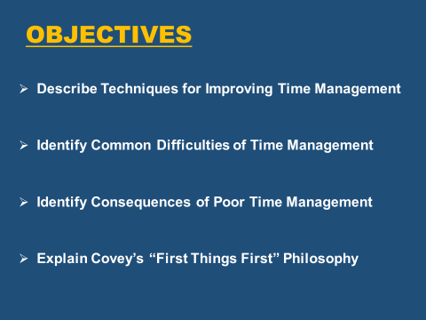 | SAY: Once again, Welcome to Effective Time Management!  Our course objectives for the day are:  - Assess personal time management skills.  - Identify common difficulties of time management.  - Identify consequences of poor time management choices.  - Explain Covey’s “first things first” philosophy.  We’ve provided the objectives in the front of the classroom so you may refer to them throughout the day. | DO: Prior to class the objectives should be charted and placed on the wall  DO: Show Objectives Slide  .
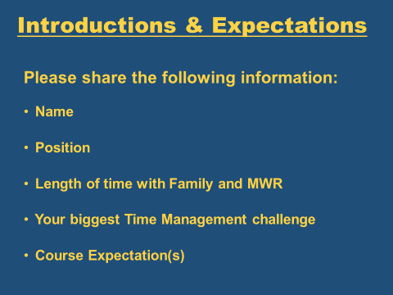 | SAY: Now we want to get to know you! We’re going to take a few minutes to hear your expectations for this course are.  We are going to give you 5 minutes to think about your answers to the following questions and to write out your expectations:  Here is what we want to know :  - Your Name  - Position at Family and MWR  - Length of Time at Family and MWR  - Your biggest time management challenge  - Expectations for today’s class  - On the tables we’ve provided index cards if you want to write down your thoughts  - We do ask that you list at least one expectation you have for today’s training BUT you may have as many as you’d like.  SAY: OK, we want to hear all about you and your expectations. Let’s start with the table in the back.  Thank you everyone, it is nice to meet you all. I’d like to introduce myself.  My name is ______ and I am a Training Instructor at the Installation Management Academy in San Antonio, Texas.  I have been with FMWR for ______ years.  My biggest time management challenge is _________.  My expectation for today is __________.  With me today is my training partner and she/he will introduce them-self.  Training Partner  SAY: I am _____ and I am also a Training Instructor here from San Antonio.  I have worked with FMWR ________ years.  My biggest time management challenge is ________.  My expectation for today is ________.  DO: Turn back to 1st Training instructor  SAY: Thank you ________. Are there any questions before we dive into time management? | DO: Show Intro/Expectations slide  DO: Keep track of the responses and length of time each person has worked for FMWR.  Ignore this line break.  DO: Allow a few minutes for the class to write their expectations.  DO: Have each participant introduce themselves one at a time.  DO: Move to the next class participant until all class participants have had the opportunity to introduce themselves.  DO: After each intro have the Secondary Instructor track/chart which objective the expectation is aligned with.
 | TRANSITION: SAY: I’m going to turn it over to ___ and they are going to get us started with a visual related to time management.

E. Characteristic of Time Management
Objective: Identify common difficulties with time management
TIME | TOPIC | DESCRIPTION
60 minutes | Characteristics of Time | - Instructor led discussion on the characteristics of time  - Exercise 1 and Exercise 2
SLIDE | INSTRUCTOR
 | SAY: This is a fairly simple approach to time management. It will involve each of you answering for yourselves three questions:  - Where are you now, in terms of how you spend your work day?  - Where do you want to be?  - What's the best way to get there?  The "heart" of time management is figuring out what's the best way to get there. But we will also look at the first two questions. |  | DO: Forward the slide to Visual of Time Terrain
 | SAY: In the next two exercises, will be dealing with the first question, "Where are you now?"  In terms of time management, answering the question "Where are you now" entails understanding yourself and really looking at how you use time now.  In your Participant Guide please turn to page 4.  - Locate Time Management Exercise 1.  - This is a self-assessment  - Place a check mark by statements that apply to you. This exercise will not be handed in - just for you.  Who wants to share their characteristics and how they impact their day?  Do you think that has a positive or negative impact on your personal time management?  Looking at the first two choices listed… Saying that you "keep an orderly, organized desk" or that your "desk is a mess" is not necessarily saying that you do or do not manage time well.  This is a characteristic, that if it applies to you as an individual, you might consider looking at more closely in relationship to Time Management.  The point is to look at those characteristics and habit patterns that apply to you, and see if you can find room for increasing productivity.  SAY: Are there any questions at this point? |  | DO: Forward the slide  DO: Allow about 5 minutes for the exercise.  NOTE: The drive for the student feedback is their Self Reflection on the question “Where are you now?”
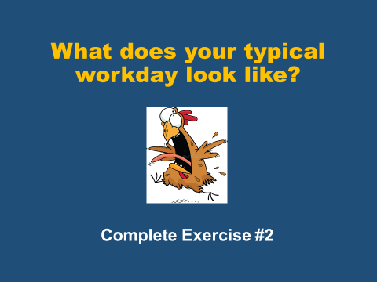 | Exercise 2 // Part A Instructions  SAY: I need a couple of volunteers to briefly describe what a typical workday is like.  NOTE: If no volunteers here are some Specific Questions to encourage volunteers might be:  - Do we have a Program Manager who would like to share about your day?  - Do we have a front line staff member who would like to share about your day?  - How about a child care provider, recreation aid or food service worker? What is your day about?  - Lastly, a division chief or the DFMWR – what is your day like?  What similarities, if any, can you identify? …Similar tasks or ways your time is spent?  Many positions require very similar things. We are all often confronted by similar time wasters, distracters, and difficulties with time management such as other people’s problems, emails, phone interruptions, unscheduled important activities – they affect us all regardless of the position. |  | DO: Solicit responses from a Program Manager, Front Line Staff, Child care, rec aid, food service worker, division chief and DFMWR.  DO: Monitor similarities and differences in tasks. Attempt to get volunteers with different job responsibilities.
 | Exercise 2 // Part B Instructions  SAY: In your Participant Guide please turn to page 5.  - Locate Time Management Exercise 2.  - This is a self-assessment.  - Place a check mark by statements that apply to you.  - Place a check mark next to each item that applies to you.  - Then, go back through the list and identify the biggest issues for you personally - What distracts you from staying on task?  - You’ll have about 10 minutes for this exercise.  - This will not be handed in - just for you.  Who wants to share and discuss any of the items on the list?  From these two exercises, Identifying Characteristics and your Big Issues, you should start to see, “Where you are now” and ways people and things in your environment impact your day.  Determining where you are is the first step in improving your TIME MANAGEMENT skills.  Are there any questions at this point?  Ok, so now that you have a picture of “Where you are NOW” - In this next segment we are going to look briefly at the second question: “Where do you want to be?” |  | If no responses when asked be prepared to say: “what about ….” To spark discussion.
 | SAY: Since this is a work-related course, we will start with the assumption that "where you want to be" or "what you want to accomplish" relates to fulfilling the organization's purpose or mission. |  | DO: Show Where do you want to be slide
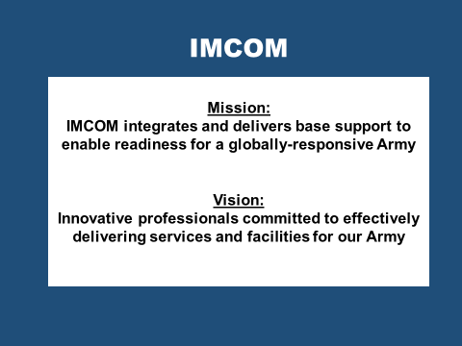  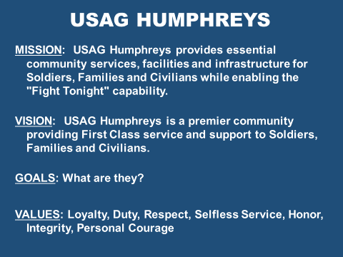 | SAY: These are the IMCOM Mission and Vision statements. They can also be found in your participant guide.  Every individual's basic purpose at work is fulfilling the organization's mission… our purpose.  Consider your place on an organization chart.  Now consider the boxes filled by others - your supervisor, your staff, co-workers, the Installation Commander.  Everyone has the same purpose to help the organization meet the overall mission.  However, your specific functions and responsibilities differ but the purpose is the same.  So, you have a general purpose/direction defined by the Army and the garrison but probably also have a more defined purpose for yourself/your activity.  Raise your hand if you know the ____ USAG Humphreys Mission and/or Vision Statement?  SAY: If you don’t we recommend that you find out what they are and write them down and post them where you can see them. This will help you stay on track – Having a written mission and vision statement defined will help you stay focused on your purpose/direction in the organization.  Your purpose/direction, functions and responsibilities are the driving force that answer the question: “Where do you want to be?”  Now let’s discuss how we get there? |  | DO: Show Mission / Vision Slide  DO: Allow the participants to answer  DO: Show Garrison Mission Slide
 | SAY: We have covered the start and end points on this map.  Now, the third question is, “What's the best way to get from where we are to where we want to go?”  On the map which path would you take to get from the Cave of Games (Starting Point of where you are now) to Mt. Success (End Point of where you want to be)?  Right – the Black Road – the most direct line to Mt. Success – the opposite is the winding red road that takes you through “Time Sucker Swamp.”  This is what Covey and others say is putting “First Things First” |  | DO: Show Terrain Slide  DO: Allow participants to answer.  Correct answer is the BLACK ROAD.
 | TRANSITION: ____ is going to talk to us about how we determine what is first and what goes first? BUT first, we’re going to take a ten minute break. Please ensure you are back in your seats NLT ____.

F. Covey’s Time Management Matrix
Objective: Explain how to implement Covey’s “first things first” philosophy
TIME | TOPIC | DESCRIPTION
45 minutes | Covey’s Time Management Matrix | Explore the Four Quadrants of Covey’s Time Management Matrix to determine what goes FIRST!
SLIDE | INSTRUCTOR
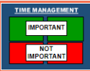 | SAY: What does IMPORTANCE mean?  Importance has to do with results!  People spend about 60% of their time on important tasks and issues and about 40% of their time on unimportant tasks and issues.  SAY: Effective Time Management isn’t about getting it ALL done, it is about getting the right things done and putting first things first.  While there are many different time management models out there to assist with time management we like to use parts of Covey’s Time Management to develop a frame work to help you put FIRST THINGS FIRST and get the right things done at the right time to support the mission. | DO: Show Important/Not Important Slide
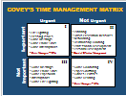 | SAY: This is Covey’s Time Management Matrix. Take a look at this chart and answer these questions.  - What does "urgent" mean?  Exactly, urgent requires immediate attention.  - We discussed important – Who remembers what "important" means?  Important has to do with results. Remember, if it's important, it contributes to your mission, your values, your high priority goals.  Looking at the quad chart you see 2 columns and two 2 rows. This chart is also in your participant guide on page eight.  See the Urgent/Not Urgent (columns) and Important/Not Important (rows)?  These are the dimensions Covey uses to characterize the way people spend time.  So let’s take a look into each of these quads.  Quad I is where you deal with urgent and important matters.  We all have some of these, but some people are consumed by them. These are the crisis managers. Also referred to as Seagull Managers.  Quad IV, is where you deal with not important and not urgent matters.  Quadrant IV activities may include any number of ways of passing time idly and perhaps very pleasantly. These activities contribute little or nothing to fulfilling an organization's purpose, but they may serve as a relief or escape valve.  Crisis managers live about 90% in Quadrant 1 and 10% in Quadrant IV with little time in II or III.  Quad III, is where you deal with urgent but not important matters.  These kinds of activities are urgent in that they insist on attention, but they are not important. Many phone calls, visits from others, meetings - perhaps called by others or maybe even called by you - fit into this category.  According to Covey, effective people stay out of Quadrants III and IV as much as possible, because these activities aren't important.  Raise your hand if you agree. Why?  Raise your hand if you disagree. Why?  In Quad II, you are dealing with important but not urgent matters.  This quad would include all the things we know we need to do but seldom get around to doing because they aren't urgent.  Activities here might include planning; goal setting; developing preventive measures to reduce the need for crisis management; developing procedures to handle routine tasks; training others; building relationships with employees, co-workers, supervisors, customers, and others; and even taking care of ourselves through recreational and other means.  This Quadrant, Covey says, represents the heart of effective personal management.  So, as we move forward we will take a deeper look into each quad and discuss further. | DO: Show Visual Time Management Matrix
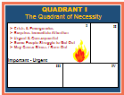 | SAY: We call this the quadrant of necessity.  You will find your crises or emergencies listed here. This quadrant screams for our attention because of its urgent and consequential nature. However, many people fall into the trap of getting caught up in Q1 and struggle to get out.  This example also represents the manager who spends most of each day in the fire-fighting or crisis management mode, even though life and death aren't typically in the equation.  Problems that may arise with living mostly in Q1 are things like stress and burn-out. | DO: Show Quad I slide.
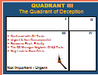 | SAY: Quad III is referred to as the quadrant of deception because some people spend a lot of time dealing with Q3 tasks and confusing them with Q1 tasks. They think the tasks are important when it is otherwise.  The difference is that here you're doing a lot of fire-fighting on unimportant matters.  The urgency feeling is often based on priorities and expectations of others.  The Q3 manager neglects Q1 and 2 activities. This is a short-term, non-planning focus that can lead to more crises in Q1. | DO: Show Quad III slide.
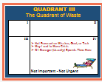 | SAY: Quad IV represents the quadrant of waste.  Since Q4 is characterized by activities that are neither urgent nor important, it should be clear that a focus on Q4 activities means not focusing on the organization's purpose. | DO: Show Quad IV slide

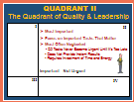 | SAY: Quad II is referred to as the Quadrant of Quality and Personal Leadership.  Q2 is the “magic” quadrant that we need to focus on – It is the most important, yet most often neglected.  Q2 is all about having personal leadership and focusing on the important tasks that matter.  There are two reasons why Q2 tasks are often neglected.  (1) Q2 tasks never become urgent until it is too late. For example, taking care of your health or pursuing your dreams.  (2) Compared to other quadrants, these tasks require more investment of energy and time for results, which conflicts with society’s obsession with instant results nowadays.  Are there any questions about the explanation of these four quadrants and what they represent?  We are going to move into an activity so you can apply the concepts that we just discussed. |  | DO: Show Quad II slide
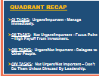 | SAY: I know that was a lot so let’s do a quick recap.  Q1 Tasks: Manage immediately to get them out of the way. Spend the required effort needed such that they do not blow out of portion  Q2 Tasks: Focus disproportionately due to the high payoff from the investment.  Q3 Tasks: Delegate to other people due to their urgent nature, but get minimally involved in them as they are not important  Q4 Tasks: Dump them as they are neither important nor urgent |  | DO: Show Recap slide.
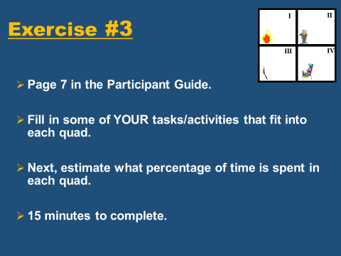 | SAY: Now we’re going to do an exercise and apply what we just discussed.  All of us probably spend more time in Q1, 3, and 4 than we might think we do or think we should.  In this exercise you can estimate the time spent in each of these four quadrants.  Turn to page 7 in your participants guide.  - First, fill in some of your own activities that fit in each of these quadrants.  - Next, estimate what percentage of your time is spent in each quadrant.  - You may want to refer to the Example Time Matrix in your Participant Guide on page eight to help you identify the kinds of activities that might belong in each quadrant.  - This exercise will not be handed in - just for you.  - You will have 15 minutes to complete and then we’ll discuss.  Does anyone want to volunteer to share what you discovered?  Thank you for sharing!  Are there any questions? | DO: Show Exercise Instructions slide.  DO: Repeat as time allows (2-3 students)
G. Covey’s Quadrant II Tool
Objective: Describe techniques for improving time management
TIME | TOPIC | DESCRIPTION
30 minutes | The Quadrant II Tool | Identify Roles, Select Goals, Develop Schedules and adapt to conditions.
SLIDE | PRESENTER
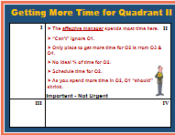 | SAY: We just discussed the four Quadrants of Covey’s Time Management Matrix.  Remember, from Covey's perspective, the effective manager spends most time on Q2 activities.  Initially, the only place to get more time for Q2 is from Q3 and 4. However, you can't ignore Q1, so as you spend more time in Q2 hopefully Q1 will shrink.  There is no ideal or standard for percentage of time you should spend in Q2.  This will vary with different jobs, but most people regardless of your position should spend the bulk of your time in Q2.  So how do you do that? |  | DO: Show Getting More slide.
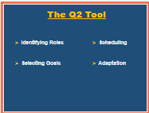  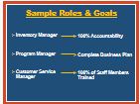  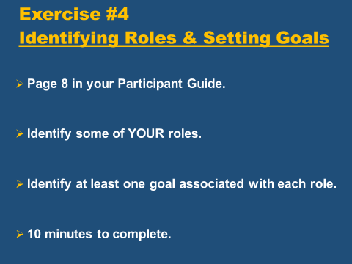 | SAY: Covey suggests use of the "Q2 Tool" which includes four key activities for organizing how time should be spent.  - Identifying Roles  - Selecting Goals  - Scheduling  - Adaptation  SAY: We will review each one, starting with Identifying Roles.  Each of us wears many hats, e.g., individual, family member, friend, maybe bowler or golfer or card player, and business manager.  What are your Roles?  I want you to keep these types of roles in mind as we move into the next exercise.  Now that you have identified the roles, I want you to think of some performance goals related to the Organization Mission?  SAY: This leads us to Exercise #4 located on page 8 in your Participant guide  The first step in using the Q2 Tool is to identify some of your roles  On the worksheet focus only on the roles in the left column.  Under “roles” write down the roles you have in your current position.  The next step in using the Q2 Tool is to identify one or two important goals for each role to be done during the next week or two.  We are going to take about 5 minutes for you to identify some of your roles one or two goals for each role.  We will leave this chart on the screen as an example.  Are there any questions: |  | DO: Show Q2 Tool slide.  DO: Show Roles/Goals slide.  Roles: inventory manager, program manager, customer service manager, security manager, budget developer or financial manager, program planner, program evaluator, sports or event supervisor, logistics manager, and so on. These are the kinds of roles that students should develop in the next exercise, so do not provide more than a few examples.  Goals: review inventory control procedures, complete milestones, survey customers.  DO: Show Exercise #4 slide.
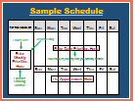 | SAY: The third step of Covey's Q2 Tool is "scheduling" - He suggests that people focus on weekly (instead of daily) schedules and allot time over the course of the week for key goals related to each role.  The advantage of organizing by the week instead of by the day is that it expands your planning horizon and gives you more time to see how to fit in your priorities.  Weekly priorities should be reviewed every day; daily priorities, of course, should be completed each day if at all possible.  You also might want to decide what percentage of your day you can realistically control and what percentage needs to left open for evolving priorities.  Depending upon your position could be 80% scheduled 20% flexible or as little as 25% scheduled.  In your Participant Guide on pp 11 to 12 we have provided you a sample weekly calendar just like this one but I find that using my outlook calendar works best for work and my smartphone calendar works best for personal scheduling. |  | DO: Show Sample Schedule slide.
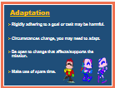 | SAY: A word of Caution - Rigidly adhering to a schedule or to a goal may be as harmful as not having a schedule at all.  As circumstances change, you may need to change to adapt to those circumstances so you can meet the mission.  Therefore, the fourth part of the Q2 Tool is "ADAPTATION".  Your schedule has to be flexible. (Add coworker example.)  Be open to allowing change that is necessary and supports the mission  Adapting can also mean making use of those "SPARE" 5-10 minute periods such as reading a memo or email, returning a quick phone call, etc. |  | DO: Show Adaptation slide.
TRANSITION: So, we just finished discussing the Q2 Tool. Are there any Questions?

Next we will discuss the Elements of Time Management but first, let’s take another 10 minute break. Please ensure you are back in your seats NLT _____. Thank you.

H. Elements of Time Management
Objective: Identify consequences of poor time management
TIME | TOPIC |  | DESCRIPTION
50 minutes | Elements of Time Management
SLIDE | PRESENTER
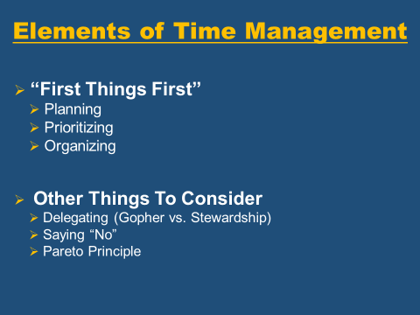 | SAY: Covey's "FIRST THINGS FIRST" philosophy centers around:  - planning,  - prioritizing,  - organizing.  Some other ways to improve time management that we will review are:  - delegating,  - Identifying Invisible Horses /zero value tasks,  - saying no,  - applying Pareto Principle.  We will start with delegating. |  | DO: Show Elements of Thought slide.
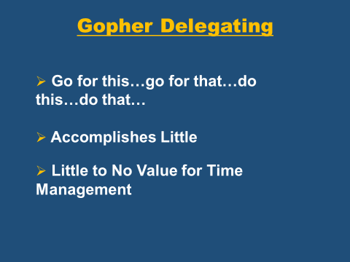 | SAY: On the slide you might see some delegating habits that you are familiar with - this is called Gopher Delegating.  Example: “Go for this, go for that, do this, do that and tell me when it’s done.”  This type of delegation accomplishes little, does not help with Time Management and provides little value for yourself, your employee, or the organization.  This does not set up an employee for success or provide the knowledge, skills and abilities for the employee to take task off your plate to improve your Time Management. |  | DO: Show Gofer Delegating slide.
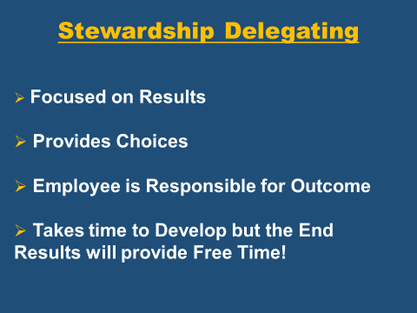 | SAY: So, what are some methods of EFFECTIVE Delegation that you have used or experienced?  The opposite from Gopher Delegation is Stewardship Delegating.  - It is Focused on results  - It Provides choices in how the employee completes the task and provides the employee ownership.  - Since the employee is responsible for the outcome they become committed to the process and are willing to be held accountable for the results removing your need to be totally in control and block progress.  - This delegation style takes time to develop but the end results will free your time for other task you can focus on completing. | DO: Wait on forwarding the slide until after the question is asked/answered  DO: Show Stewardship Delegating slide.
Stewardship Continued | SAY: On the slide are Some Keys are to the Stewardship Delegating method.  Why would you want to clearly explain the Expected Results?  [Create clear, mutual agreed upon understanding of what needs to be accomplished, Focus on the WHAT  Spend Time with the employee and be patient – have the employee rephrase what he/she visualizes the desired outcome / result will look like]  Why provide parameters or guidelines?  [Identify the parameters within which the individual should operate. This should be limited to the fewest possible restrictions but should include any formidable restrictions like SOPs or Regulations that must be adhered to.]  SAY: Remember – this is time management so, if there are known pitfalls or roadblocks – share with the employee – be open and honest – the employee shouldn’t have to figure it out.  What are Resources and why would you want to identify the available resources?  [providing the resources upfront saves time, resources include human, financial, technical and organizational anything used to accomplish the desired result is a resource]  Set up the performance standards so the employee is Accountable  Set up the standards of performance that will be used in evaluating the results and the specific times when reporting and evaluation will take place.  Why would you want to outline the Consequences?  [Specify what will happen (good and bad) as a result of the evaluation. Could include things like a rewards, different job assignment, and natural consequences tied to the overall organizational mission.]  This has been a good discussion about Stewardship Delegation. Does anybody have any questions?  Now let’s discuss two things that will get you stuck in TIME SUCKERS SWAMP.  Raise your hand if you know what a time sucker is. (Give example if no one gets it correct.) | DO: Show Stewardship Delegating slide.  DO: Explain Stewardship Delegation in a Q&A format. The answers to the Why questions are in RED
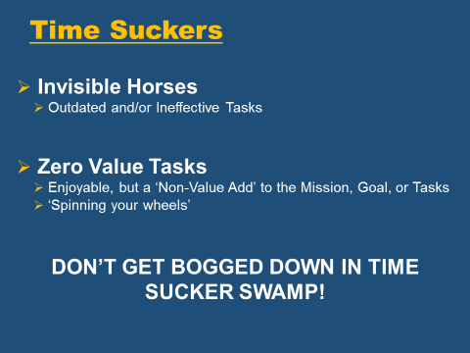 | SAY: In addition to Gopher Delegation there is the tendency to focus on Invisible Horses and Zero Value Task. These are additional detractors from good Time Management.  INVISIBLE HORSES consume you with task that are outdated, ineffective, once had a purpose but no longer have meaning – Completing these task bog you down in TIME SUCKER SWAMP.  ZERO VALUE TASKS consume your time with task that might be enjoyable but contribute zero to the completion of the mission – one might say it is spinning your wheels while you go nowhere.  Attending to INVISIBLE HORSES and completing ZERO VALUE task divert effort and attention from accomplishing the goals in Quadrant II that are focused on the organizational mission.  So, let’s identify some of your Invisible Horses and Zero Value task. | DO: Show XX slide.
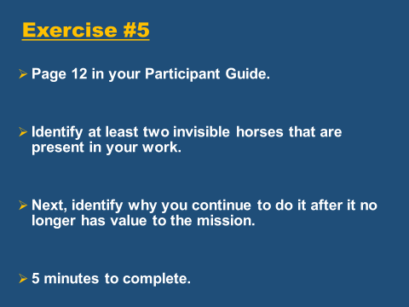  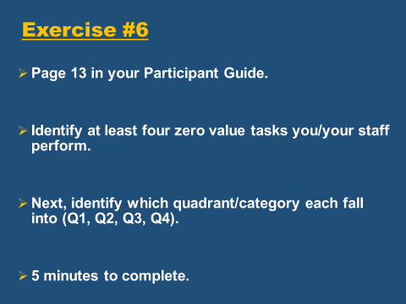 | SAY: Turn to page 12 of your participant guide and locate Time Management Exercise # 5.  First, identify at least one “invisible horse” that is present in your work—one that you do. Those are the things that have little to no value to meeting the mission, goal, or task.  Next, identify the reason this was initially done and why do you continue to do it.  You’ll have five minutes for this exercise.  SAY: Now turn the page to the Time Management Exercise #6.  First, list at least four zero value tasks you perform.  Once you identify your zero value task look at Covey’s four Quadrants and mark in which quadrant the task falls under.  Remember Quads 1 & 2 are important and Quads 3 & 4 are unimportant.  Is it really a zero value task or just one you don’t like to do?  Let’s take about 5 minutes to complete exercise #6 and then we will hear from several of you about your Invisible Horses and Zero Value Task.  Raise your hand if you don’t mind sharing your findings with us.  Thank you for sharing. | DO: Show Exercise #5 slide.  DO: Show Exercise #6 slide.  DO: Ask for one or two volunteers to share their findings, facilitate discussion.
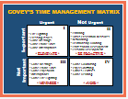 | SAY: The only way to develop more time for Q2 task (Important / Not Urgent) is to eliminate those things that take up our time in Quads III & IV (Unimportant).  As you develop skills in Planning, Prioritizing, Delegating and Organizing the task from Q1 (Important / Urgent) will shrink.  SAY: You have to be proactive to work on Q2 because Q1 and 3 work on you – draining time and energy.  In order to be able to say YES to the IMPORTANT issues in Quadrant II you have to develop the skill of saying “NO” to other activities that are NOT IMPORTANT and sometimes appear to be urgent.  What are some of your reasons for not saying “NO”?  This is a great lead into what Covey indicates are reasons we often don’t say “NO”. Let’s move on! | DO: Show TM Matrix slide.  DO: Facilitate quick discussion leading into next slide
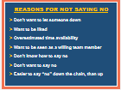 | SAY: The next element of Time Management is developing the skill of saying no.  Many time management challenges stem from the inability to say “no”.  Covey suggests the biggest reason is priorities are NOT deeply implanted.  Sometimes it is hard to resist Q4 unless you have the "big picture" clearly in mind.  You may not be clear on priorities because you are not clear on your roles, goals, responsibilities, or vision, etc.  SAY: Then other times, it may not be so easy to say no for any of the reasons listed here (or others).  For example, you may think you have enough time available to help another program manager but in reality you don't.  This is a case of overestimating time available. As another example, may not want to say "no" because it's your boss who is making the request.  Although all deserve respect, the way you say no to different people may differ. Such as the difference between saying no to your supervisor compared to your coworker.  It’s certainly easier to SAY NO ….DOWN THE CHAIN than UP THE CHAIN!  What are the consequences for poor time management?  In addition to poor productivity there are two other major consequences of poor time management  - Burn Out  - Increased Stress (health issues)  Take a look at the end of your participant guide on pages ______ - We have included several pages of common consequences or side effects of poor time management – the pages list the overarching issue: e.g. Cluttered Desk / Disorganization – followed by CAUSES and SOLUTIONS – Take a look at these pages for additional tips and tools to improve your time management skills.  SAY: So, does anyone have anything to add to the reasons you are not able to say no?  Let’s move forward to the last element of Time Management - The Pareto Principle | DO: Show Saying No slide.  DO: Allow participants to answer the question with their responses.
TRANSITION: So far today we have discussed Where you are now, where you want to be, and how to get there.
We have discussed Covey’s First Things First Philosophy.

We have provided you with the Q2 Tool and the Elements of Time Management.

Now, we want you to put this all into ACTION – After all – what gets written down gets done!
I. Action Plan:
Course Goal: Given the techniques for improving time management, develop two actions to improve time management using Covey’s “First Things First” philosophy.

TIME | TOPIC | DESCRIPTION
10 minutes | Develop an Action Plan | Develop two actions to improve time management using Covey’s First Things First Philosophy.
SLIDE | PRESENTER
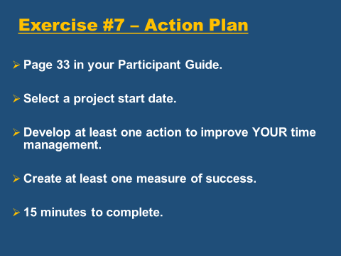 | SAY: We have covered a lot of information over these past few hours.  The last step to putting the knowledge we have learned today into practical actions is to write them down in the form of an Action Plan.  As a reminder The Goal for today’s class is: Given the techniques for improving time management, develop two actions to improve time management using Covey’s “First Things First” philosophy.  First, I want you to look back at your exercises 1 & 2 to determine where you are currently in your Time Management.  We discussed focusing on your mission so you have an idea of where you want to be professionally, so I recommend reviewing that next.  Then, consider your roles and the goals you identified in Exercise #4.  In exercises #5 and #6 you identified some major roadblocks like Invisible Horses and Zero Value Task and you were given the Q2 Tools.  SAY: Using all of the information we covered today to include Covey’s First Things First philosophy we want you to develop two specific actions to improving your time management.  In your Participant Guide, on pages 33-34, we have included the Action Plan Template. – It looks like the one here on the screen.  Please remember to put your name on the document and today’s date.  - You will identify one action to improve the Time Management area you want to concentrate on.  - Select a projected start date.  - Develop at least one action.  - Create two objectives or steps per action.  - List one measurement per action that indicates you have meet your desired outcome.  Are there any questions?  Take about 10 minutes to complete this action plan. | DO: Show Action Plan Instruction Slide.  DO: Show Action Plan.
 | TRANSITION: OK – now that we have completed the Action Plan let’s recap what we did today.

J. Wrap-Up Session 1:
TIME | TOPIC | DESCRIPTION
5 minutes | Wrap-up
SLIDE | PRESENTER
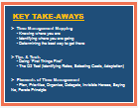 | SAY: We covered a lot today.  Time Management Mapping - Knowing where you are - Identifying where you're going - Determining the best way to get there.  We provided you some tips and tools to improving your time management skills like:  - Doing "first things first".  - The Q2 II Tool (Identifying roles, Selecting Goals, Scheduling and Adaptation)  The Elements of Time Management (plan, prioritize, organize, delegate, eliminating invisible horses and non-valued task, saying “NO” and the Pareto Principle) | DO: Show Key Take-Aways slide.
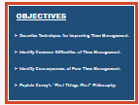 | SAY: We always like to review the objectives we started off with.  Does anybody have any questions about anything we covered?  Before we let you go I’d like to share with you some additional training opportunities you can access through the Installation Management Academy. | DO: Show XX slide.
 | SAY: Here is the contact information for the Installation Management Academy, School for Family and MWR.  We will be here after class to answer any final questions.  It was our pleasure spending time with you today and we thank you very much! | DO: Show Contact Info slide

