SMIRF INSTRUCTIONS

1. Click SMIRF and Click OK on the warning windows. Select the level that you are authorized, G9 level, Region/Macom or NAF Garrison, and click OK.

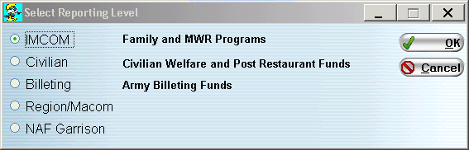

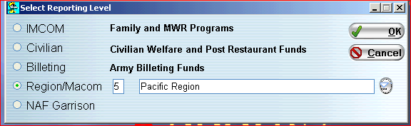

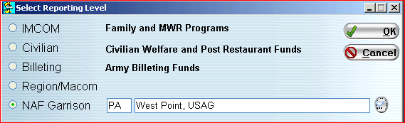

2. Now you are ready to run reports from SMIRF

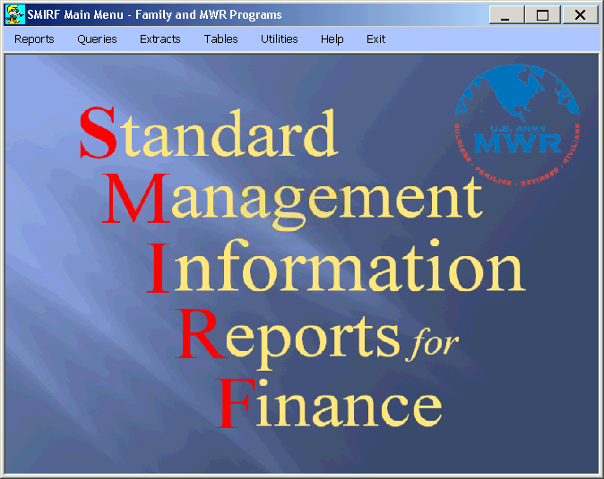
3. Choose the specific from the list. For analysis purposes the most useful reports are the “Detailed Income Statement”, the ‘Horse Blanket YTD Income Statement”, the “Actual Vs Budget, and the “Detailed Actual Income Comparison” report. To compare data from current year and 5 years prior, use the Summary Account Comparison report.

a. The Detailed Income Statement gives a detailed record of financial performance showing each GLAC individually, month-to-date and year-to-date actual results. The Detailed Income Statement does not show any budgeted numbers. In this example, we are pulling the rollup detailed income statement for Fort Hood, Fund 1. We are logged into SMIRF at Garrison level so it is not showing a garrison selection field.

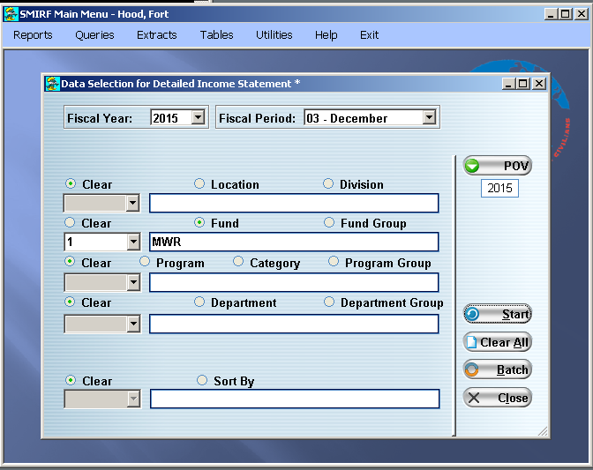

Click “Start” to run the report.
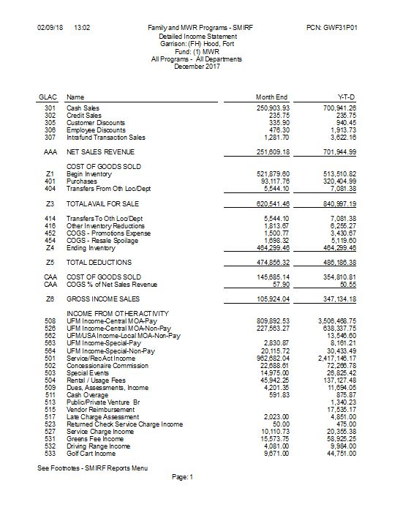

b. The Horse Blanket Y-T-D Income Statement will provide an overall snapshot of the selection that you made. In this example, we are evaluating all the Business Programs at the IMCOM-Europe “Region” Level.

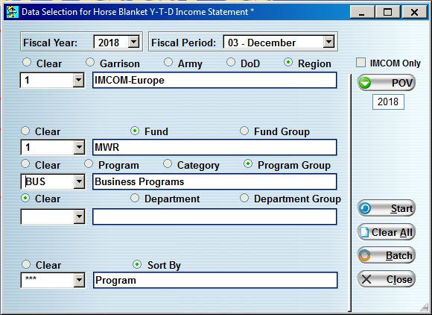

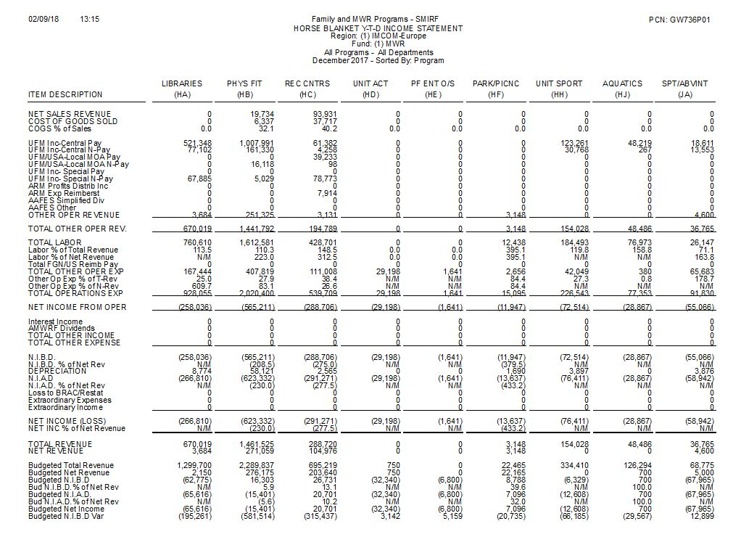

(1) Once you print the report, evaluate the NIBD of all the programs.

(2) It is always a good idea to have a budget Horse Blanket (from FMBS) to help you evaluate the annual NIBD.

(3) Looking at the NIBD you can ask yourself, are they on target to reach the budgeted NIBD? Did they budget for a loss in any of these programs? Does any program need more analysis?

c. To do more research on a specific Program, the Budget vs. Actual Report will compare the current financial performance to the budget.

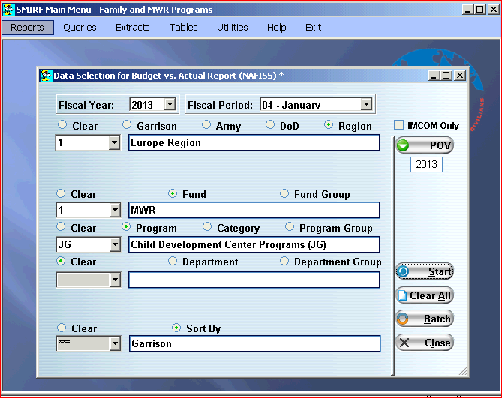

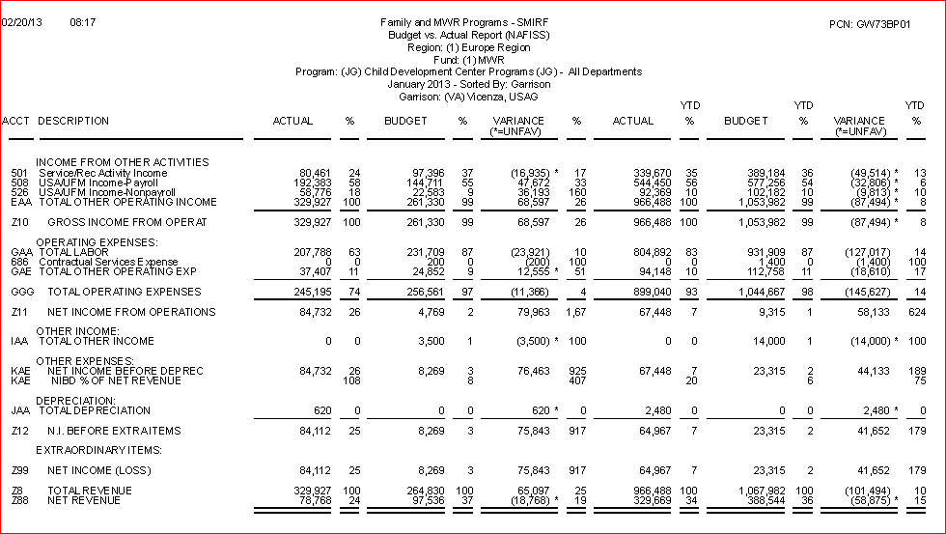
d. The Detailed Actual Income Comparison Report shows comparative data between two specified fiscal periods. In the example, we are comparing November 2014 and November 2015 income statement data for USAG Yongsan Fund 1, Program HB.

First, specify the base and comparative fiscal years as below:

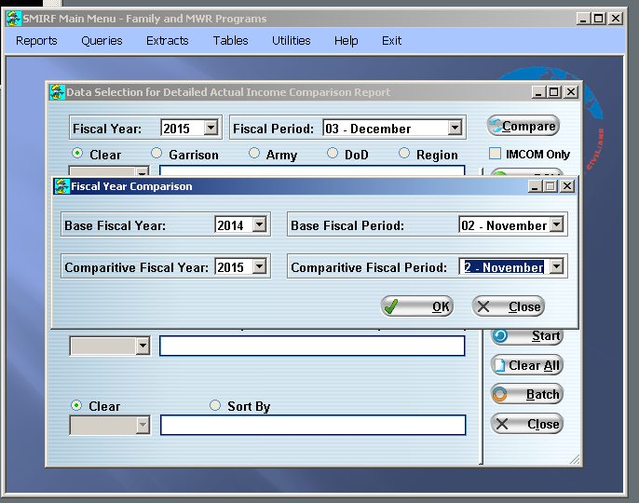

Then, choose garrison, fund and program parameters.

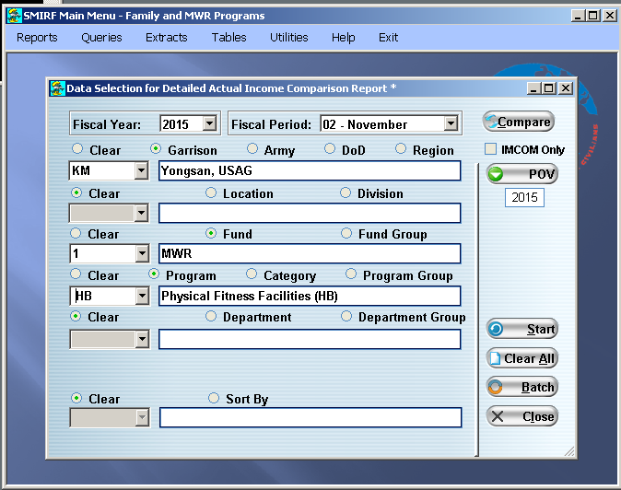

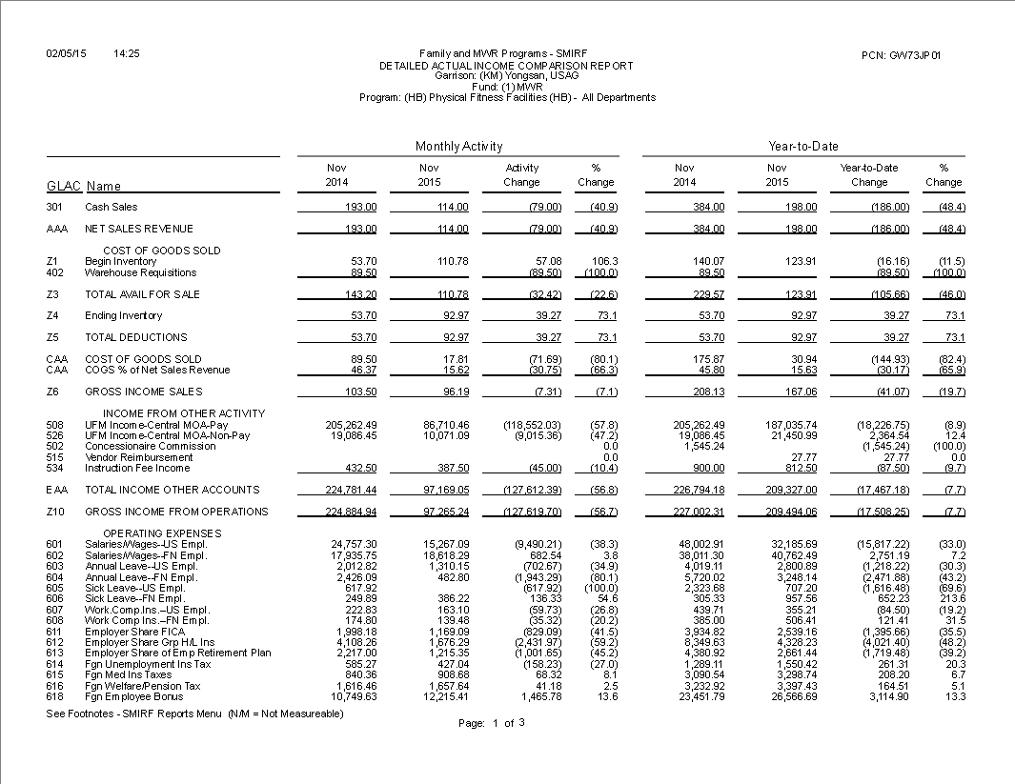

e. The Summary Account Comparison report lists summary GLACs for current year and 5 years prior and can be used to quickly compare actual financial results over time. In this example, we are looking at Food and Beverage programs at Fort Gordon.

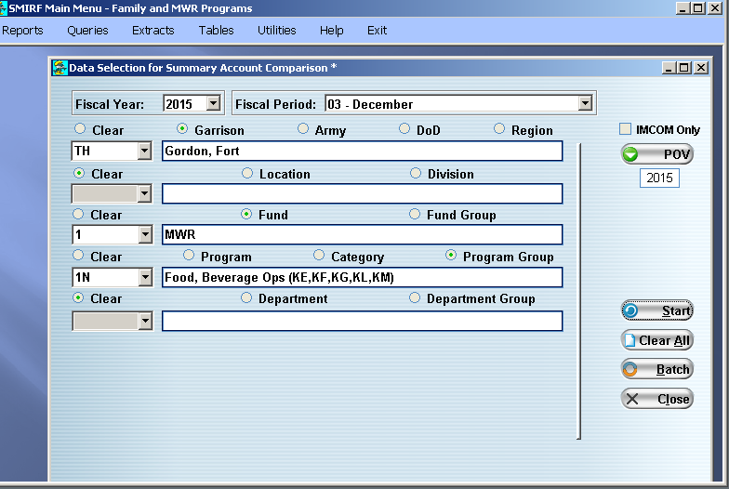
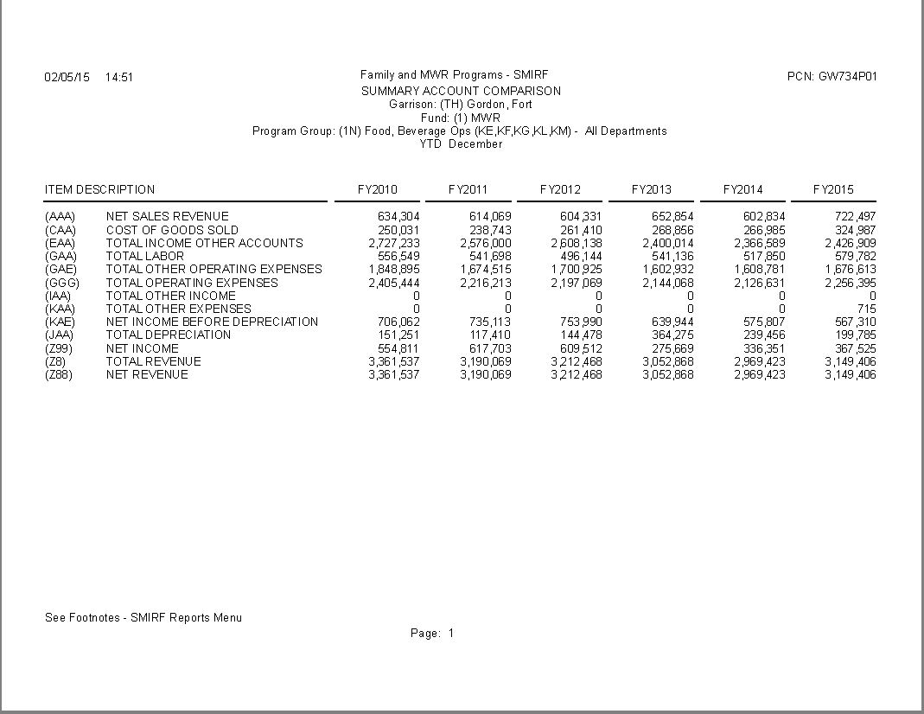

Review and Analysis Checklist

- Is the NIBD variance greater that 15%? If so, you need to do a more in-depth analysis of the program.
- Is the Sales/GOGS variance greater than 15%? If so, what are the issues?
  - Are the COGS meeting standard? If not, what are the issues?
  - Was the inventory turned in to NFS at the end of the month?
  - Were the purchases for that month recorded?
  - Spoilage/ breakage?
  - Issues with cash overage or shortage? Are they recorded in the appropriate departments?
- Is the Other Operating Income variance greater than 15%? If so, what are the issues?
  - Was all the income recorded to the appropriate GLACs and departments?
  - Any unusual GLAC being used to record income?
- UFM execution: Does UFM distribution correlate to the UFM budget? If not, what are the issues?
  - Did the program receive more or less UFM than budgeted?
  - Were the program expenses higher than budgeted, AND they only allocated the UFM budget amount?
- Is the labor variance greater than 15%? If so, what are the issues?
  - Do the number of employees match with IMETS?
  - Were there issues with scheduling?
  - Were labor transfers recorded to the appropriate locations?
  - Is the appropriate percentage of NAF labor off-set with UFM?
- Is the other expenses variance greater that 15%? If so, what are the issues?
  - Do the expenses correlate to the expenses budgeted?
  - Have they bought all the supplies or equipment that they budgeted for? If not, are they going to buy them in future months? Were the supplies or equipment bought earlier in the year and the variance will correct itself in future months?
  - Have they made extra purchases that were not in the budget? If there are UFM items, do they have enough funding to cover those expenses? If so, please explain the variance.

HOW TO SAVE SMIRF REPORTS TO PDF FILE

Example shows a detailed income statement – process is the same for any SMIRF report.

1. Change the printer option at the top left of the screen.

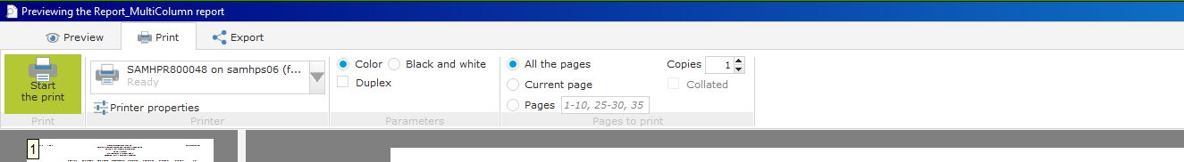

2. Change the printer name to Microsoft Print to PDF option.

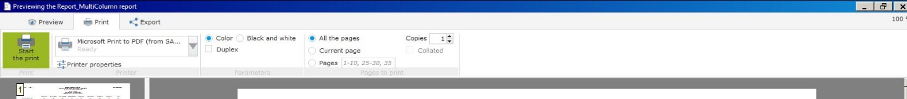

3. Save As screen appears to select location to save the PDF file.

a. Click Desktop

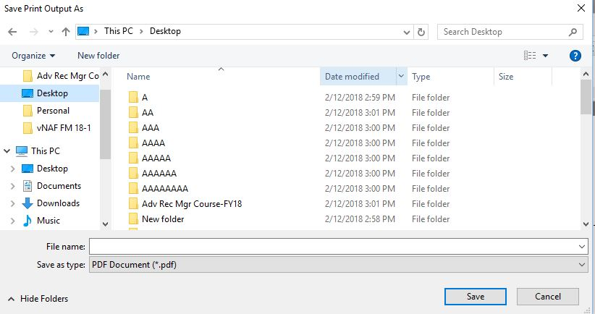

b. Desktop folders are displayed and then click New Folder

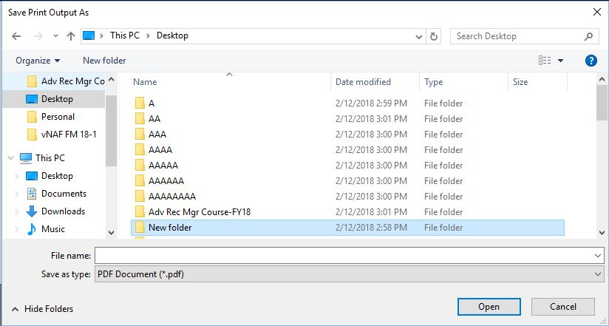

c. Rename the new folder SMIRF Reports and then click ‘Open’

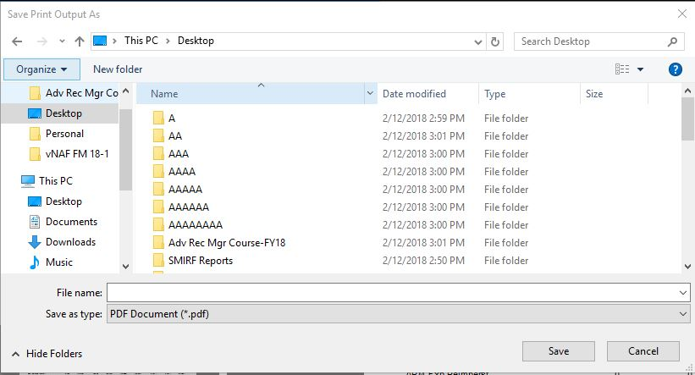

d. Rename the file and click ‘Save’.

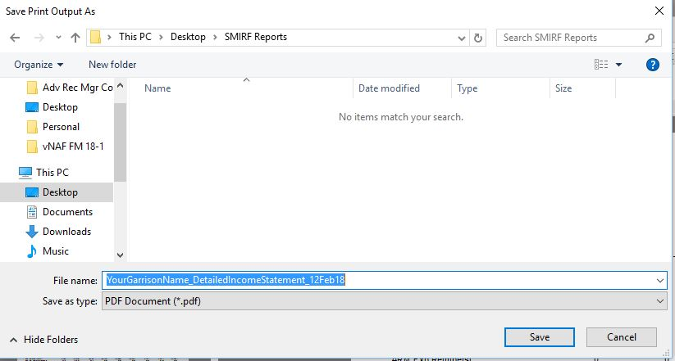

e. SMIRF will bring up screen stating after it saves your document. The SMIRF report PDF file is now saved to your computer hard drive.

