EFFECTIVE
TIME MANAGEMENT

PARTICIPANT GUIDE

MG Robert M. Joyce, Installation Management Academy, School for Family and MWR

MG Robert M. Joyce, Installation Management Academy, School for Family and MWR

“If we keep doing what we’re doing, we’re going to keep getting what we’re getting.”
~Stephen Covey

IMCOM MG Robert M. Joyce School for Family and MWR

“Time is the scarcest resource, and unless it is managed nothing else can be managed”
~Peter Drucker

KEY POINTS

- Time management basically involves answering questions about where you are (in terms of how you spend your time), where you want to be, and what's the best way to get there. Time management techniques and principles can help you answer the third question.

- In his book, The 7 Habits of Highly Effective People, Stephen Covey argues the effective time management begins not with to-do lists and calendars but with understanding and then acting on what is important. He uses the phrase "first things first" to emphasize this. By shifting one's focus from unimportant to important matters, personal effectiveness can increase.

- Implicit in Covey's "first things first" philosophy are the tasks of planning, prioritizing, and organizing. In this sense, Covey agrees with other authors of books on time and self-management.

- Effective delegating, saying no, and applying the Pareto principle to help focus one's efforts are other useful time management techniques.

COURSE OBJECTIVES

- Describe techniques for improving time management
- Identify common difficulties of time management
- Identify consequenses of poor time management
- Explain Covey’s “First Things First” philosophy

INTRODUCTIONS

- Name
- Position
- Length of time with FMWR
- Your biggest Time Management challenge
- Course Expectation(s)

TIME MANAGEMENT EXERCISE # 1 (Identifying Characteristics)

[ ] I keep an orderly, organized desk.
[ ] My desk is a mess.
[ ] I'm a list maker.
[ ] I actually use the lists I make.
[ ] I do tasks in priority order.
[ ] I do whatever seems the most pressing at the time.
[ ] I stick pretty much to a routine.
[ ] My routine helps keep me clearly focused on our MWR mission.
[ ] I procrastinate.
[ ] I usually arrive early for appointments.
[ ] I usually arrive on time for appointments.
[ ] I'm usually late.
[ ] I complain a lot.
[ ] I have perfectionist tendencies.
[ ] I enjoy doing paperwork.
[ ] I seem to shuffle papers around more than I accomplish anything with them.
[ ] I effectively use "organizers" like calendars, schedules, and to-do lists.
[ ] I have a lot of "organizers", but they seem more like trouble than help.
[ ] I like to talk.
[ ] I enjoy listening to others.
[ ] I give staff members a lot of individual feedback.
[ ] I'm pretty good about passing "general interest" information to my staff.

NOTES

TIME MANAGEMENT EXERCISE # 2 (Big Issues)
[ ] Meetings
[ ] Insufficient/inaccurate information to complete tasks
[ ] Personal procrastination
[ ] Telephone
[ ] Other interruptions
[ ] Not delegating effectively
[ ] Firefighting/crisis management
[ ] Socializing
[ ] Personal lack of organization
[ ] Lack of organization/disorder in the office
[ ] Inability to say no
[ ] Confused responsibilities
[ ] Feeling irritated
[ ] Lack of procedures/standards for recurring tasks
[ ] Micro-managing
[ ] Lack of coordination
[ ] Trying to do too much
[ ] Lack of direction
[ ] Insufficient planning
[ ] Rework - correcting my own or other's mistakes
[ ] Not knowing how to do certain required tasks
[ ] Fiddling with personal organizers (to-do lists, calendars, etc.)
[ ] Paper shuffling
[ ] Worrying
[ ] Waiting for others
[ ] Computer games, crossword puzzles, or similar activities
NOTES

WHERE DO YOU WANT TO BE? Or WHAT DO YOU WANT TO ACCOMPLISH?

IMCOM MISSION AND VISION STATEMENTS

Mission: IMCOM integrates and delivers base suppor to enable readiness for a globally-responsive Army

Vision: Innovative professionals committed to effectively delivering services and facilities for our Army

USAG HUMPHREYS MISSION, VISION, GOALS, VALUES

MISSION: USAG Humphreys provides essential community services, facilities and infrastructure for Soldiers, Families and Civilians while enabling the "Fight Tonight" capability.

VISION: USAG Humphreys is a premier community providing First Class service and support to Soldiers, Families and Civilians.

GOALS: (Do you know what they are?)

VALUES: Loyalty, Duty, Respect, Selfless Service, Honor, Integrity, Personal Courage

Time Management: Important vs. Not Important

- What does importance mean to you?

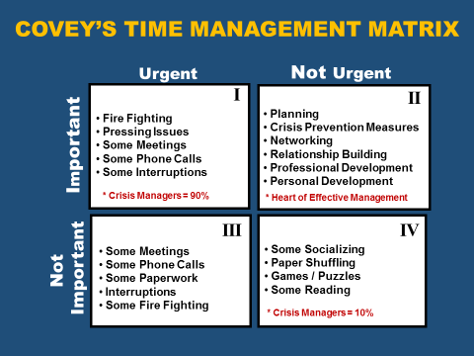
NOTES
Q1 | Q2
Q3 | Q4

If something truly is important, it has to do with RESULTS!!!
TIME MANAGEMENT EXERCISE # 3

 | URGENT | NOT URGENT
I  M  P  O  R  T  A  N  T | I  Estimated Time % | II  Estimated Time %
N  O  T  I  M  P  O  R  T  A  N  T | III  Estimated Time % | IV  Estimated Time %
NOTES

How do you get more time for Q2?

The Q2 Rule

- Identifying Roles

- Selecting Goals

- Scheduling

- Adaptation

TIME MANAGEMENT EXERCISE # 4

Roles | Goals
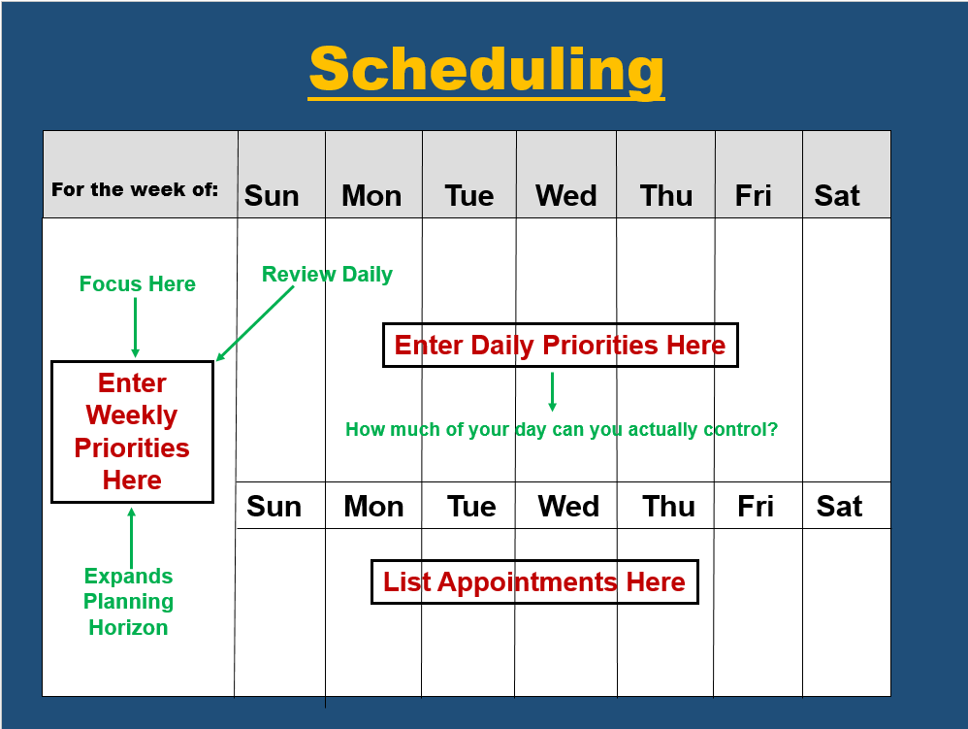

NOTES

ADAPTATION:

- Rigidly adhering to a goal or task may be harmful.
- Circumstances change, you may need to adapt.
- Be open to change that alters/supports the mission.
- Make use of spare time.

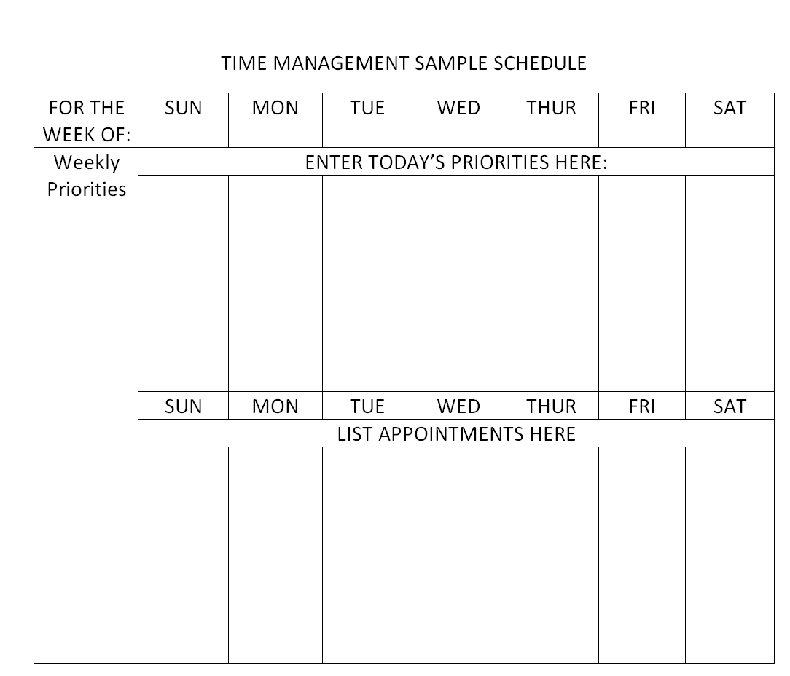

ELEMENTS OF TIME MANAGEMENT:

- Put “First Things First”

- Other Things to Consider

DELEGATING:

- Gopher Delegating

- Stewardship Delegating

- Time Suckers

- Zero Value Tasks

TIME MANAGEMENT EXERCISE # 5

Write down at least two activities you engage in, or require your employees to engage in, which can be labeled an “invisible horse.” Then identify your reason for still performing it after it has ceased to have value.

Activity:

Reason:

- - - - - - - - - - - - - - - - - - - - - - - - - - - -- - - - - - - - - - - - - - - - - - - - - - - - - - - -- - - - - - - - -

Activity:

Reason:

TIME MANAGEMENT EXERCISE # 6

Write down at least four activities you engage in, or require your employees to engage in, which you believe can be labeled a “ZERO VALUE TASK”. Then identify its 1-4 category rating, and see if your reasons for calling it ZERO VALUE are accurate.

ZERO VALUE TASKS | CATEGORY
 | 1 | 2 | 3 | 4
1.

2.

3.

4.

5.

6.

“Dost thou love life? Then do not squander time; for that’s the stuff life is made of.”
~Benjamin Franklin

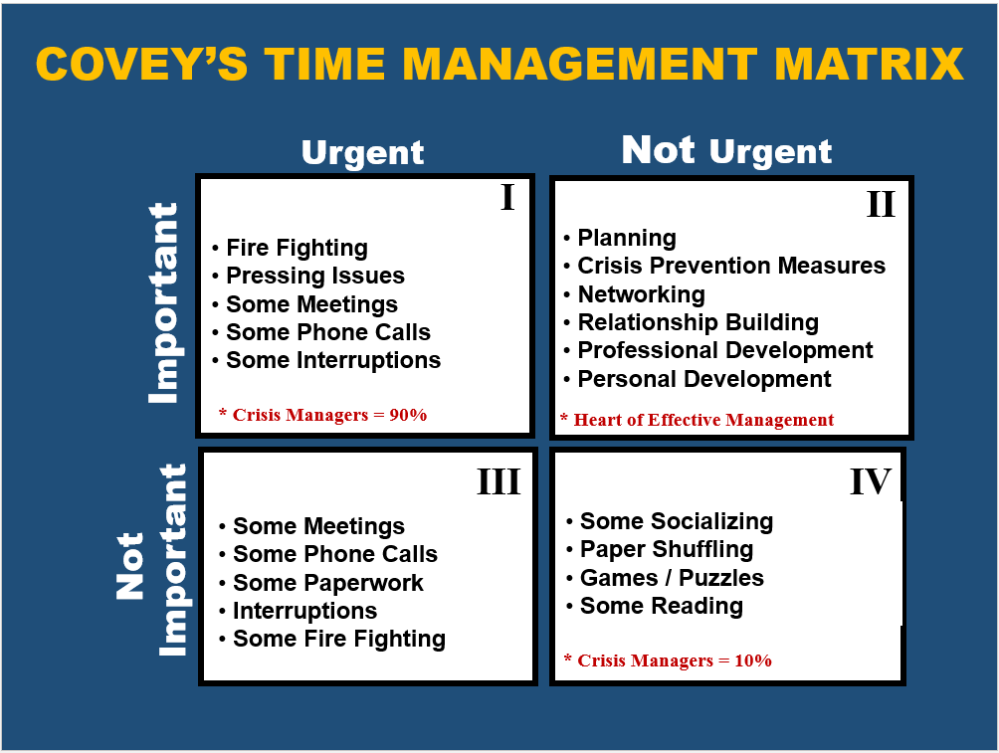

REASONS FOR NOT SAYING ‘NO’:

Exercise #7 – Action Plan
- Page 33

KEY TAKE-AWAYS

- Time Management Mapping
  - Knowing where you are
  - Identifying where you are going
  - Determining the best way to get there
- Tips & Tools
  - Doing “First Things First”
  - The Q2 Tool (Identifying Roles, Selecting Goals, Adaptation)
- Elements of Time Management
  - Plan, Prioritize, Organize, Delegate, Invisible Horses, Say ‘No’

CLUTTERED DESK/ PERSONAL DISORGANIZATION

 | Causes | Solutions
1 | Unaware of importance | Recognize stacked desk as major interrupter and loser of documents (retrieval time).  Take time log to assess retrieval time.
2 | Lack of system. | Develop a system for recording things you wish to remember so documents may be filed.
3 | Ego (viewed by some as symbol of busyness, importance, indispensability). | Recognize this may also symbolize personal disorganization, indecision, procrastination, insecurity, confusion of priority, and inability to meet deadlines due to lost documents.
4 | Fear loss of control. | Recognize that good planning and organization will provide better control than keeping all files on a cluttered desk.
5 | Fear of forgetting. | (Same as above)
6 | Failure to delegate. | Do nothing yourself you can delegate. You not only overload yourself with others’ work but deny them the experience
7 | Allowing interruptions. | Screen. Set aside ‘time banks’ for planned unavailability to complete your work.
8 | Leaving tasks unfinished. | Allowing diversions from tasks and not going back to finish them destroys effectiveness and cuts real results drastically.  Practice task completion, require completed staff work, resist interruptions, and finish the task before putting it down.
9 | Procrastination/ Indecision. | Tackle toughest or highest priority tasks first. Self-impose deadlines and reward yourself. 80% of tasks coming to your desk can be handled at once. DO IT NOW. Keep the paper moving…handle it once.
10 | Slow reader. | Screen and select with discrimination. Scan for essentials. Speed-reading course.
11 | Lack objectives, priorities and daily plan. | Recognize that poor planning causes switching priorities, leaving tasks unfinished and indecision. Plan your work. Work your Plan.
12 | Poor scheduling of tasks. | Schedule by priority and realistic time estimates.
13 | Ineffective administrative assistant. | Train and authorize administrative assistant to keep your desk clear. Information retrieval is his/her responsibility, not yours. Label files not to be removed. Keep to minimum.
14 | Failure to screen. | Administrative assistant screens out junk mail, refers requests others can handle, and types responses for your signature.
15 | Paper blockade, memo-itis, and over-communication. | Minimize over-communication, emphasize brevity, verbal communications.

DROP – IN VISITORS

 | Causes | Solutions
1 | Unaware of seriousness. | Take time log of visits (business and personal; scheduled and unscheduled).  Evaluate extent and causes.
2 | No plan for handling. | Develop plan to screen. Arrange appointments.
3 | Ego. Feeling of importance. | Recognize. Don’t overestimate importance of others of your availability. Plan visits to coffee and lunch.
4 | Enjoy socializing. | Do it elsewhere (coffee, lunch). Stick to priorities.
5 | Desire to be available. | Distinguish between being available for business and for socializing.
6 | No plans for unavailability. | Modified “open door;” “quiet hour;” screening; hideaway.
7 | Desire to keep informed. | Accomplish on a planned and more certain basis.
8 | Desire to be involved. | Recognize danger of involvement in detail.
9 | Fear of offending. | Don’t be oversensitive.
10 | Lack of delegation. | Delegate more. Direct inquiries to persons responsible.
11 | Making decisions below your level. | Make only the decisions subordinates can’t.  Do nothing you can delegate.
12 | Requiring or expecting subordinates to check with you excessively. | Manage by exception.  Expect information concerning only deviations from plan.
13 | Inability to terminate visits. | Go to their office. Meet outside your office. Stand up upon entry and keep standing. Preset time limits on visit. Foreshadow end. (Is there anything else before I leave?) Administrative assistant interrupts to remind you of urgent matter. Be candid. (I’m sorry, I must get back to some other matters now.) Stand up and walk to door.
14 | Unrealistic time estimates. | Take time log of all visits in one day.  Recognize difficulty of estimating time requirements in socializing.
15 | Open door policy. | Recognize “open door” does not mean physical open, but open to those who need assistance. Modify your open door by closing it regularly for periods of concentration. “Quiet hour” is best.
16 | Ineffective screening. | Train administrative assistant to screen all visitors with-out offending. Locate administrative assistant’s desk in a strategic position to make screening easy.
17 | Misdirected visitors. | Train receptionist. Advise others. Discuss problem.

MEETINGS

 | Causes | Solutions
1 | Before  Lack of purpose. | No meeting without a purpose; in writing if possible
2 | Lack of agenda. | No meeting without an agenda. Written agenda for scheduled meeting; verbal agenda if unscheduled to ensure that people come prepared and discussion is scheduled.
3 | Wrong people/ too many/ too few | Only those needed present.
4 | Wrong time. | Ensure opportune timing.
5 | Wrong place. | Select location consistent with objectives of freedom from interruptions, physical equipment necessary, and minimum of travel for majority of people.
6 | No planning. | Allow for and schedule appropriate planning for most effective meeting.
7 | Too many meetings. | Test need for ‘regular’ meetings. Occasionally don’t hold it-see what happens. Or cut time allowed in half for those attending to last a long time.
8 | Too few meetings. | Assess need for participation, information and coordination. Schedule accordingly.
9 | Inadequate notice. | Provide written notice with all essentials including expected contribution and materials necessary for preparation.
10 | Not starting on time. | Start on time. (By delaying for late arrivals the leader penalizes those arriving on time and rewards those who come late!)
11 | During  Socializing. | Reserve socializing for better place. Get down to business.
12 | Allowing interruptions. | Set policy and let everyone know.  Wherever possible allow no interruptions except for clear-cut emergency. Hold messages for delivery at coffee break and lunch times.
13 | Wandering from agenda. | Except and demand adherence to agenda.  Resist “hidden agenda” ploys.
14 | Failure to set ending time or time allotments for each subject. | Time-limit the meeting and each item on the Agenda to place discussion time in accordance with importance of subject.
15 | Keeping people after they are no longer needed. | Leave after expected contribution made.
16 | Indecision. | Keep objective in mind and move toward it.
17 | Deciding without adequate information. | Ensure requisite information will be available before convening meeting. Use it.

MEETINGS (cont.)

18 | Failure to end on time. | End on time. Otherwise no one can plan for the time immediately following.
19 | Failure to summarize conclusions. | Summarize conclusions to ensure agreement and remind participants of assignments.
20 | After  No minutes. | Record decisions, assignments and deadlines in concise minutes. Distribute within one day of meeting.
21 | Failure to follow-up. | Ensure effective follow-up n all decisions.  List uncompleted items under “Unfinished Business” at beginning of next agenda.
22 | Failure to abolish committees when business or objectives accomplished. | Take committee inventory. Abolish those whose mission has been accomplished.

CRISIS MANAGEMENT

 | Causes | Solutions
1 | Unaware of importance. | Take time log of crises. Analyze source, causes, seriousness, and controllable factors.
2 | Lack of planning. | Categorize crises and causes. Assess probability of occurrence. Develop plan for contingencies to ensure most effective handling.
3 | Failure to anticipate. | Expect the unexpected. (Murphy’s 3rd Law- If anything can go wrong, it will.) Anticipatory action is generally far more effective than remedial.
4 | Over planning  (attempting too much). | Plan less; leave 20% of day unplanned, thus allowing time to handle crises.
5 | Overreacting (treating all problems as crises). | Limit your response by:  a) ignoring problems which can be ignored  b) delegating all the remaining ones which others can handle  c) handling only those which you alone can.
6 | Firefighting. | Recognize that it is more important to prevent new fires from developing than to spend all your time putting out old fires.  Preventive action is preferable to remedial.
7 | Procrastination. | Recognize danger inherent in putting off key actions leading to deadline pressures and often to impaired judgment under stress.
8 | Unrealistic time estimates  (by manager or boss). | Recognize that everything takes longer than you think (Murphy’s 2nd Law). Analyze characteristic underestimates, then add appropriate cushion to all critical estimates – e.g., 20%.
9 | Switching priorities  (by manager or boss). | Switching priorities means leaving tasks unfinished and damaging morale if done excessively. Calculate cost, discuss with boss, and make suggestions for reducing frequency of switches.
10 | Mechanical breakdown/ human error. | Anticipate. Organize resources (human and otherwise) for rapid adjustment to compensate most effectively.
11 | Reluctance of subordinates to break the bad news. | Develop philosophy of mistakes (learning process). Discuss with subordinates.  Emphasize that fast reporting of bad news most likely leads to crises.
12 | Inadequate, inaccurate, delayed information. | Determine information critical to planning, decisions and feedback. Develop system to ensure its reliable delivery.
13 | Overlooking possible negative consequences of a decision. | Analyze what could go wrong. Set up contingency plan.

LACK OBJECTIVES, PRIORITIES, DAILY PLAN

 | Causes | Solutions
1 | Unaware of importance. | Recognize.
2 | Lack system. | Develop (Plan Sheet, Daily Objectives, Priorities and deadlines).
3 | Lack time to plan. | Take it. Put first things first. Recognize that planning takes time initially, but saves three to four times as much in the end and gets better results.
4 | Crisis-oriented (assumes crises are unavoidable). | Recognize fallacy. Except for acts of God, most crises are relatively predictable. Allow more time. Plan ahead for contingencies.
5 | Successful without it. | Recognize success may be in spite of, not because of your actions. Planned results are predictably more successful than chance results.
6 | Lack self-discipline. | Impose deadlines on yourself. Try objectives, priorities and daily plan for one month.  Enlist aid of administrative assistant or assistant. Monitor progress. Evaluate results.
7 | Action-oriented (would rather be moving than thinking). | Recognize most problems result from action without thought. Those who know what to do succeed once. Those who know why will succeed again and again. So take time to think it through. Then act.
8 | Fear of commitment. | Recognize that while objectives mean commitment, they also mean knowing when you have succeeded.
9 | Lack job description. | Recognize objectives are easier to develop when key result areas are clearly identified.
10 | Difficulty of assigning priorities to tasks. | Not easy, but one of the most productive of al managerial pursuits. Determines where efforts should be concentrated.
11 | Assumption that since few days are ‘typical’ it is futile to plan, or that emergencies will spoil plan anyway. | Recognize that most managers tend to waste time in the same or similar ways every day.  And while emergencies may disrupt a day, the damage can be minimized more easily if the day was planned and the most vital tasks completed before the emergency.

TELEPHONE INTERRUPTIONS

 | Causes | Solutions
1 | Unaware of seriousness. | Take time log of phone calls. Evaluate origin, extent and causes.
2 | No plan for handling. | Develop plan to screen, delegate, consolidate.
3 | Enjoy socializing. | Do it elsewhere. Stick to priorities.
4 | Ego. Feeling of importance. | Recognize ego factors. Don’t overestimate importance to others of your availability.
5 | Desire to be available. | Distinguish between being available for business and for socializing.
6 | No plans for unavailability. | Quiet hour; screening; set periods for taking calls.
7 | Desire to keep informed. | Accomplish on planned, more certain basis. Recognize that our team members will naturally want to keep you informed of everything they are doing, rather than simply the essentials.
8 | Desire to be involved. | Recognize danger of involvement in detail. Divorce yourself from routine matters and details.
9 | Taking and lacing own calls. | Delegate.
10 | Lack of delegation. | Delegate more. Direct inquires to persons responsible.
11 | Not listing items to be discussed. | Organize yourself. Plan calls. List points to be discussed.
12 | Over-dependent staff. | Refuse to make their decisions. Encourage initiative. Allow mistakes.
13 | Facts not available. | Be prepared.
14 | Fear of offending. | Don’t be oversensitive. Top secretaries never offend unnecessarily. Concentrate on priorities.
15 | Lack self-discipline. | Develop plan, implement, monitor progress, and assign responsibility to administrative assistant or assistant.
16 | Inability to terminate conversation. | Learn and practice techniques:  - Preset time limits (“Yes, Tom, I can talk for a few minutes.)  - Foreshadow ending (“Bill, before we hang up.”)  - Be candid (“Sorry, Joe, I’ve got to go now.”)
17 | Unrealistic time estimates. | Administrative assistant interrupts with reminder of urgent item demanding attention.  3-minutes egg timer in front of telephone.  Time yourself for one day. Recognize how much longer a call can take than is necessary.
18 | Lack ability to manage own administrative assistant. | Study. Develop plan. Implement. Train or replace with experienced administrative assistant requiring no training.
19 | Misdirected calls. | List of persons and numbers. Instruct personnel on directing of calls. Have “frequently called” numbers visible.
20 | “Answer your own” policy. | Recognize waste of time and talent. Revise or eliminate policy.

INEFFECTIVE DELEGATION

 | Causes | Solutions
1 | Insecurity – fear of failure. | Recognize. Accept risk as inherent. Allow mistakes. Learn from them.
2 | Lack confidence in staff. | Train, develop, and trust.
3 | Involving yourself in detail and routine. | Do nothing you can delegate; divorce yourself from detail.
4 | Delegating responsibility without authority. | Always delegate authority commensurate with responsibility.
5 | Giving unclear, incomplete or confused instructions. | Ensure clear, complete, unambiguous instructions. Ask subordinate to restate to ensure understanding.
6 | Envy of subordinate’s ability. | Laugh at yourself. Then give full credit where it is due.  Develop your own replacement.
7 | Can do job better and faster yourself. | Lower standards to what is “acceptable,” not your own level of performance. Avoid perfectionism.
8 | More comfortable “doing” than “managing.” | Recognize that practice leads to success which leads to comfort. Control.
9 | Expect everyone to “know all the details.” | Recognize that this should not be expected of someone who has delegated responsibility for handling.
10 | Failure to establish appropriate controls. | Establish plans, schedules with details, progress reports, monitoring of deadlines.
11 | Over-control. | Relax. Emphasize goal-accomplishment methods and procedures. Measure results, not activity.
12 | Failure to follow up. | Always check progress in time to take corrective action.
13 | Understaffed/overworked subordinates. | Limit expectations and reduce accepted responsibilities.
14 | Inadequate, untrained staff. | Train; reassign; rehire; better selection.
15 | Upward delegation. | Refuse to make decisions for subordinates. If they need help, ask the right question.
16 | Problem not clear. | Be candid. Ask subordinate to figure out and keep you informed.

ATTEMPTING TOO MUCH AT ONCE

 | Causes | Solutions
1 | Lack of planning. | Set objectives, priorities, deadlines daily. Plan strategy to achieve them.
2 | Unrealistic time estimates. | Recognize that everything takes longer than you think (Murphy’s 2nd Law). Analyze characteristic underestimates, then add appropriate cushion to all critical estimates – e.g., 20%.
3 | Starting late. | Plan ahead. Start early. Allow more time.
4 | Responding to the urgent. | Distinguish “urgent” from the truly “important.” Be more discriminating in sorting priorities. Maintain perspective in balancing short-term demands against long-term objectives.
5 | Over-response. | Limit your response to the urgent and important demands. Learn to say “NO” when necessary. Delegate
6 | Sense of achievement. | Ask yourself what you are trying to prove. Be realistic. Keep perspective. Lower standards if too high.
7 | Insecurity. | If over your head, check Peter Principle, cut back or switch to realistic assignment.
8 | Desire to impress boss. | Take a second look at what boss really wants… to be impressed short run, or to succeed in the long run?
9 | Difficulty in determining priorities. | Be discriminating Check your priorities with boss periodically. Vitally important that you be on same wavelength regarding priorities.
10 | Over-ambition. | Recognize. Trim back to realistic proportions.
11 | Action-oriented. | Don’t confuse motion with progress or activity with results. Work smarter, not harder. Slow down, think it through so you’ll get there faster.
12 | Ego. Over-confidence. | Beware. Control.
13 | Desire to appear cooperative by never saying “NO”. | Say “NO”. There are many ways of doing this without offending. (Offer alternatives, apologize, etc.)

LACK OF OR UNCLEAR COMMUNICATION

 | Causes | Solutions
1 | Unaware of importance. | Recognize.
2 | Lack of time. | Take it. Priority warrants.
3 | Not listening/Inattention. | Develop and practice listening skills. Concentrate.
4 | Purpose not clear. | Clarify.
5 | Use of wrong channel. | Select appropriate channel (Phone, letter, memo, conference).
6 | Poor timing. | Select appropriate time.
7 | Poor articulation. | Check. Improve.
8 | Over-communicating. | Be brief. Don’t repeat.
9 | Insufficient communication. | Assess legitimate needs for information. Provide through staff meetings, memoranda.
10 | Lack policies and procedures to ensure effective communication. | Develop both to ensure organizational emphasis.
11 | Lack of receptivity. | Test receptivity: “Would you like to talk about …?”
12 | Meaning of words. | Recognize words mean different things to different people. Choose them well.
13 | Differing value systems. | Recognize experience, training and environment create different backgrounds for interpreting communication.
14 | Distortion / line loss. | Check interference, noise, activity. Assess potential impact. Take preventive steps. Minimize organization levels.
15 | Language barrier. | Assess and adjust to accommodate.
16 | Lack of feedback. | Get feedback. Take corrective action.

INADEQUATE, INACCURATE, DELAYED INFORMATION

 | Causes | Solutions
1 | Unaware of importance. | Recognize and assign priority.
2 | Lack system. | Determine what information is needed for planning, decisions and feedback on results.  Then ensure its availability, reliability and timeliness.
3 | Difficult to know what information is needed. | Discuss and decide.
4 | Failure to test its reliability. | Make no assumptions. Too critical. Test periodically.
5 | Providing information not needed or requested. | Avoid unnecessary communication. Stick to essentials. Avoid overkill.
6 | Failure to assess priority or urgency of requested information. | Make assessment and allocate time accordingly. Standardize priority of information classifications.
7 | Lack uniform method of screening priority and urgency of requested information. | Develop method.
8 | Failure to anticipate probable delays in obtaining information. | Expect delays. Plan accordingly.
9 | Lack of authority to require information needed. | Clarify authority. Use “response deadlines.”
10 | Indecision or delay of others providing needed information. | “Unless I hear” memo.

INDECISION AND PROCRASTINATION

 | Causes | Solutions
1 | Unaware of importance. | Recognize.
2 | Lack techniques for improving. | Set deadlines on all objectives and priorities, use reminders (egg-timer or wrist – alarm), have administrative assistant check on progress, reward yourself (no coffee until you finish).
3 | Lack self-imposed deadlines. | Set deadlines on everything.
4 | Lack monitoring of progress | Have administrative assistant or associate check your progress against deadlines.
5 | Uncertain of priorities. | Ascertain daily.
6 | Shifting priorities. (“Why start? They’ll just change it.”) | Calculate cost; discuss; discourage.
7 | Fear of mistakes. | Avoid fixing blame; ask what’s been learned and how repetition can be avoided.
8 | Attempting too much (ensures delaying some things!). | More realistic goals and expectations.
9 | Unrealistic time estimates. | Recognize everything takes longer than you think. Allow more time – leave 20% of day unplanned.
10 | Habit. | Break it! Develop better ones.
11 | Doing what you like, postponing the unpleasant. | Do the unpleasant first, then the rest of the day is “downhill.”
12 | Doing the easy or trivial, postponing the difficult or important. | Do No. 1 first. Then you can relax. What doesn’t get done will not be the most important.

INABILITY TO SAY “NO”
 | Causes | Solutions
1 | Unaware of importance. | Recognize as seldom identified, but of major importance in wasting time.
2 | Humanitarian desire to help others. | Don’t overdo it. It will often be taken for granted.
3 | Desire to win approval and acceptance (“Nice Guy” image). | Recognize possible trap … if desired results are not achieved, you may lose instead of gaining respect and feel resentful.
4 | Fear of offending. | True friends are not offended by honest explanation. Develop techniques of saying “no” without offending. “Thanks for the compliment, but I’ll have to decline.” “I’m sorry I can’t, but let me offer a suggestion …”
5 | Possessing capabilities in demand. | Recognize this asset makes ability to say “No” even more imperative. Refuse to spread yourself too thin. Concentrate your efforts!
6 | Belief that agreeableness enhances prospects for promotion. | Don’t confuse continual assent with teamwork.
7 | False sense of obligation. | Recognize prevalence of this cause. Examine reasons for this feeling. Discuss with family, friends, associates. Control.
8 | Overdeveloped sense of sympathy, understanding, self-sacrifice or impulsive generosity. | Be more realistic.
9 | Insecurity or low self-esteem. | Recognize that always saying “Yes” may betray feelings of insecurity and low self-worth. Resist this urge. Say “No”. Perhaps offer alternative proposal.
10 | Guilt feelings or desire to convince yourself you are a good person. | Recognize. Assess whether failures are real or imagined.
11 | Not assessing consequences. | Take time log recording all “Yes” responses that could have been “No.” Assess time wasted.
12 | Easier to say “Yes”. | Assess consequences. (See No. 11 above)
13 | Successful without saying “No.” | Think it through. Develop several techniques as in No. 4. Practice.
14 | Not knowing how. | Recognize that mastering the art of saying “No” would likely enhance your success considerably. Develop techniques.
15 | Timid approach-building up to saying “No” gradually by offering excuses first. | Recognize there are answers for all excuses. Say “No” first before too many hopes are raised. Then explain.

INABILITY TO SAY “NO” (cont.)

16 | Lack excuses. | Don’t be too sensitive. Sometimes no excuse is better than a poor one. Think of acceptable excuses ahead o time.
17 | Fear that any excuses may not justify saying “No.” | Don’t feel every “No” has to be justified. Simply say “I’m sorry, but I’ll have to say no this time.”
18 | No time to think of answer or excuse. | Count to 10 before saying “Yes”. Give yourself time. Delay response.
19 | Fear of retaliation. | If such fear is justified, recognize shaky foundation relationship is built on. Try to improve it.
20 | To put others in your debt. | Practice the Golden Rule here.
21 | Losing sight of own priorities. | Remember, the best excuse is prior commitment to your own priorities.
22 | Lack of objectives and priorities. | Others will determine priorities for those who don’t have their own.
23 | Ambition of desire to be productive. | Better to do less, well … than more, poorly.
24 | Autocratic boss. | Balance the trade-offs – what you are learning versus what you are losing.
25 | Thoughtless assumption by others that you will say “Yes”. | Recognize that you have likely encouraged this assumption by never saying “No”.  Learn to say “No” especially to inappropriate or thoughtless request or those that will make you feel bad if you assent.

CONFUSED RESPONSIBILITY AND AUTHORITY

 | Causes | Solutions
1 | Failure to clarify precise responsibilities with boss. | Do so.
2 | Lack of job description. | Write one. Discuss with boss. Get approved.
3 | Job description overlaps others | Identify areas of duplication. Eliminate.
4 | Usurping of authority by others. | Identify. Discuss with boss. Clarify. Insist that if authority in doubt, then responsibility must be limited to match.
5 | Responsibility without authority. | Insist on commensurate authority (equal to responsibility). It is mandatory that one have the power (authority) to carry out his/her duty (responsibility).
6 | Ambiguous, confused communication or instruction. | Insist on clarity of communication or instruction. Request it in writing if verbal instructions are used inappropriately.
7 | Non-descriptive titles. | Titles convey apparent authority to the world in which the manager works. They must be descriptive of real authority to avoid confusion.
8 | Confused or no organization chart. | Organization charts provide the skeleton for authority relationships and are therefore essential to clarity of understanding of responsibility and authority within the organization. Clarify.
9 | Lack of emphasis on assumption of responsibility and exercise of initiative. | Emphasize through accountability for results; through recognition and reward for exercise of initiative; through citation, consideration in performance and salary review, promotion, etc.
10 | Subordinates unwilling to accept responsibility. | Select people with care. Train. Reward.
11 | Weak promotion practices resulting in placement above level of competence. | Identify potential and improve selection for promotion; career development program.

LEAVING TASKS UNFINISHED

 | Causes | Solutions
1 | Unaware of problem. | Tike time log. Assess impact of leaving task unfinished. (Number, length of interruption, importance of tasks left unfinished).
2 | Lack of objectives. | Set objectives to clarify those things which ought to be finished.
3 | Lack of priorities. | Prioritize. (Arrange objectives in order of importance to clarify those things which ought to be finished first).
4 | Lack of deadlines. | Set deadlines on all important tasks to provide incentive to complete them.
5 | Failure to reward yourself. | Reward yourself with a list of items to be crossed off, by deferring pleasant diversions until certain tasks are completed, etc.
6 | Responding to the urgent. | Recognize that urgent matters rarely are as important as they seem. Resist tendency to overreact, thus interrupting other tasks.
7 | Overload . . . too much to do. | Assess capabilities to achieve tasks within limited time. Resist overload. When accepting new responsibilities drop or defer old ones to make room.
8 | Cluttered desk . . . personal disorganization. | Get organized to permit effective control of tasks. Be systematic in handling information.  Recognize that sound organization saves time in retrieving information, processing decisions and maintaining control over projects.
9 | Lack determination to complete tasks (lack self-discipline, lazy). | Impose deadlines on yourself and announce to others. (Go public). Employ assistance (e.g., have administrative assistant remind you to ensure accomplishment). Monitor progress.
10 | Inability to delegate. | Delegate task completion to someone else.
11 | Accepting interruptions. | Train administrative assistant to screen interruptions.  Establish “quiet hour” for completing tasks.
12 | Indecision. | Recognize that a willingness to decide is a primary characteristic of successful manager.
13 | Lack motivation | Become aware of impact on your own effectiveness. Seek causes. Determine to correct.
14 | Postponing the unpleasant. | Recognize danger that postponed tasks, if unpleasant but important, will become urgent, interrupting whatever else you choose to do.

LACK OF SELF-DISCIPLINE

 | Causes | Solutions
1 | Lack of planning. | Recognize that planning encourages disciplined action. Lack of planning encourages undisciplined action.  Plan your work; then work your plan.
2 | Lack objectives or standards. | Set objectives in key result areas, both personal and organizational. Develop standards (conditions that will exist when the job is well done) for routine tasks.
3 | Lack of priorities. | Set priorities in order to focus effort on most productive areas. This ensures that what gets done will be most important. . . and what doesn’t get done is least important.
4 | Not setting deadlines. | Impose realistic but firm deadlines on yourself. Expect them of others.
5 | Doing what we like.  (Putting second things first). | Recognize this universal tendency. Question every action.  (Is this trip necessary?)
6 | Postponing the unpleasant or the difficult. | Schedule the unpleasant or difficult tasks first.  Then the rest of the day is easy.
7 | Responding to the urgent  (postponing the important). | Resist the tyranny of the urgent by limiting your response:  - Ignore problems if they will go away by themselves,  - Delegate those which others can handle,  - Respond yourself to those only you can handle.
8 | Not following up. | Recognize that people do what you inspect, not what you expect – and the same goes for you.  So, check your results against your plan.  Are you progressing according to “schedule”?  Have your administrative assistant, assistance or associate monitor your progress.
9 | Not utilizing available tools and techniques. | Evaluate and utilize such aids as “To Do list (Must; Should; Can), daily written plan, deadlines, Pert charts, progress reports, project control charts, ‘Day-timers’ daily and weekly diaries, weekly plan sheet.
10 | Unrealistic time estimates | Recognize that pursuit of unrealistic deadlines will lead to frustration and destroy self-discipline eventually. Be realistic in your own deadlines. Be candid in resisting unrealistic deadlines. Be fair in imposing them on others.
11 | Lazy. | Recognize. Determine to overcome.
12 | Unaware of this time-waster (successful without self-discipline). | Recognize can be more successful with it.
13 | Lack of interest. | Re-examine attitude toward job. Recognize that indifference makes self-discipline more difficult.

LACK OF SELF-DISCIPLINE (cont.)

14 | Inability to say “No”. | Quit trying to be a “nice guy”. Say “No” firmly and without offending.
15 | Drifting into trivia. | Avoid nonessentials. Divorce yourself from details! Concentrate on the critical priorities.
16 | Cluttered Desk. | Recognize as an impediment to an orderly mind. Use weekly Plan Sheet to record those things you do not want to forget.  Clear your desk. Be systematic in procedures for routine matters.
17 | Leaving tasks unfinished. | Recognize wasted effort in stopping and re-starting tasks. Economy of efforts dictates completing tasks before putting them down. Handle it once. Get it done the first time.
18 | Carelessness. | Get it right the first time. If you don’t have time to do it right, when will you have time to do it over?
19 | Day Dreaming. | Learn the art of concentration and practice it. Avoid distractions and self-interruptions.
20 | Fatigue/Poor health. | Practice health fitness, exercise, recreation, time management.
21 | Procrastination. | Identify tasks and decisions subject to procrastination. Set realistic deadlines. Go public by announcing them. Utilize administrative assistant/ assistant/ associate to help you monitor results. Reward yourself when successful.
22 | Bad habits. | Make automatic and habitual as many useful actions as you can. This frees the mind for more productive work. To acquire a new habit, launch the practice as strongly as possible – announce it to discourage yourself from back sliding. Never let an exception occur until the habit is firmly rooted. Seize the first possible chance to act on your resolution.

Taken from “New Time Management Methods,” by R. Alec Mackenzie
TIME MANAGEMENT EXERCISE # 7

Participant Name: | Date of Plan:
1. Identify Action to improving Time Management: |  | Projected Start Date:
Steps you will take to accomplish this behavior:

How will you measure success/What is your desired outcome?

Participant Name: | Date of Plan:
1. Identify Action to improving Time Management: |  | Projected Start Date:
Steps you will take to accomplish this behavior:

How will you measure success/What is your desired outcome?

