Creating PDP from scratch
- Determine if Job Title exists
Hover over Administration>Manage System
Select Job Titles.
Enter the job title into the Search Text field. Click on Search button. If 0 records are returned, proceed to B. Create Job Title. If the job title is found, proceed to C. Add Model Competencies.
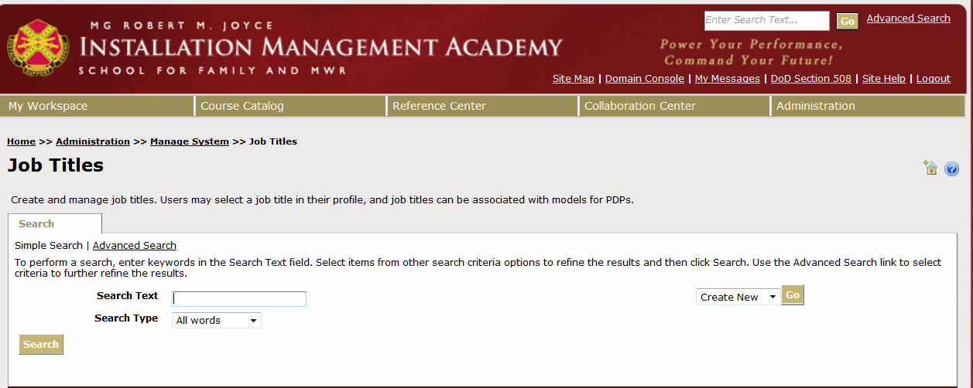

- Create Job Title
Open Fasclass in a separate browser tab (https://acpol2.army.mil/fasclass/inbox/). This is where you can access the position description (PD) by PD# or job title.
Return to Job Titles screen. Locate Create New field to left of Search Text field. Click on Go.

The New Job Title window will open.
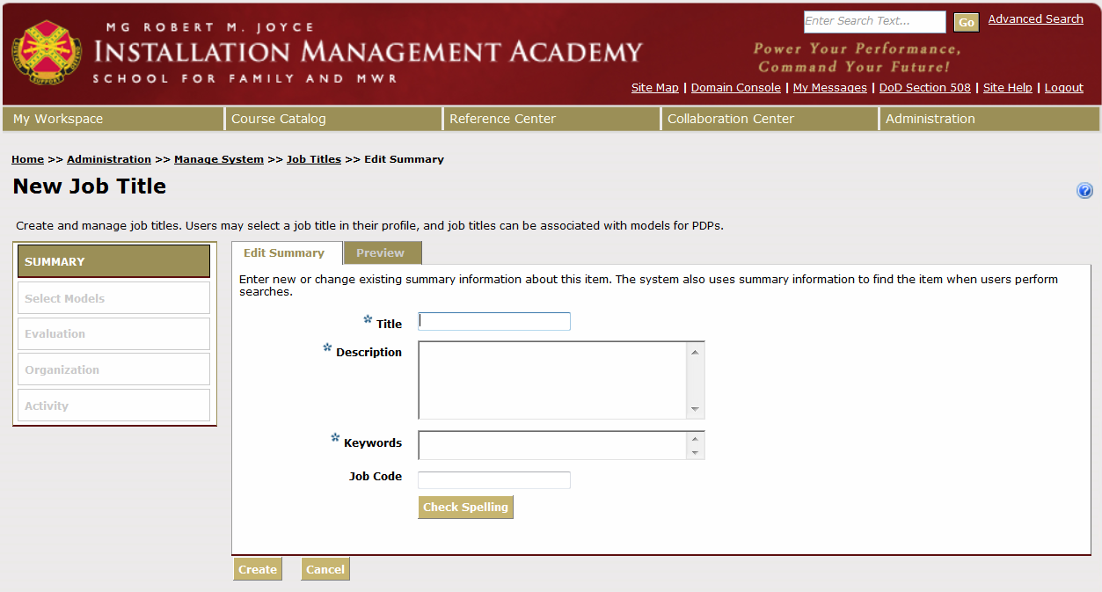
Title: Enter the Job Title name into the Title field as it appears on the Position Description (PD):
Job Title – Division or Program – Grade ***
Example: Executive Housekeeper – Lodging – NF03 ***
Description: Enter Title and Grade with Series Number:
Job Title – Grade-Series Number
Example: Executive Housekeeper – NF-0161-04
** Add (copy and paste) as much of the description from the PD as possible.
Key Words: Copy and paste Job Title from Title field.
Click Create.
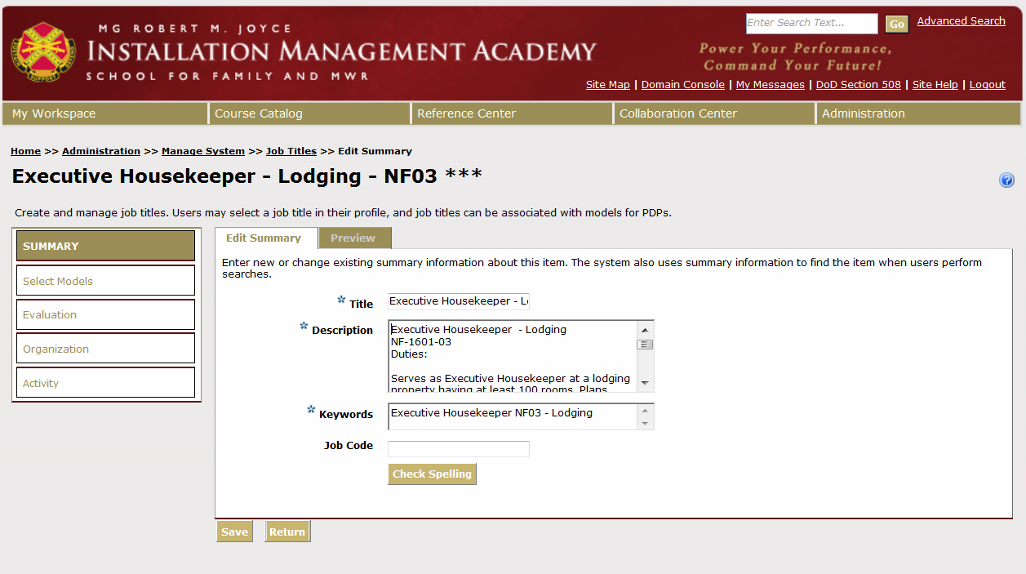

- Add Model Competencies
Click Select Models from menu on the left.
Determine the competency level equivalent using the table below:
Model Competency Level | Position Grade
Level 1 | NF01  GS 01-02  NA5 and below  WG6 and below
Level 2 | NF02  GS 03-04  NA6 and above  NL and NS  WG7 and above
Level 3 | NF03  GS 05-08
Level 4 | NF04  GS 09-12
Level 5 | NF05  GS 13 and above

Enter the level number in the Search Text field box. Click Search, a list of all model competencies will display on multiple pages for that level number.
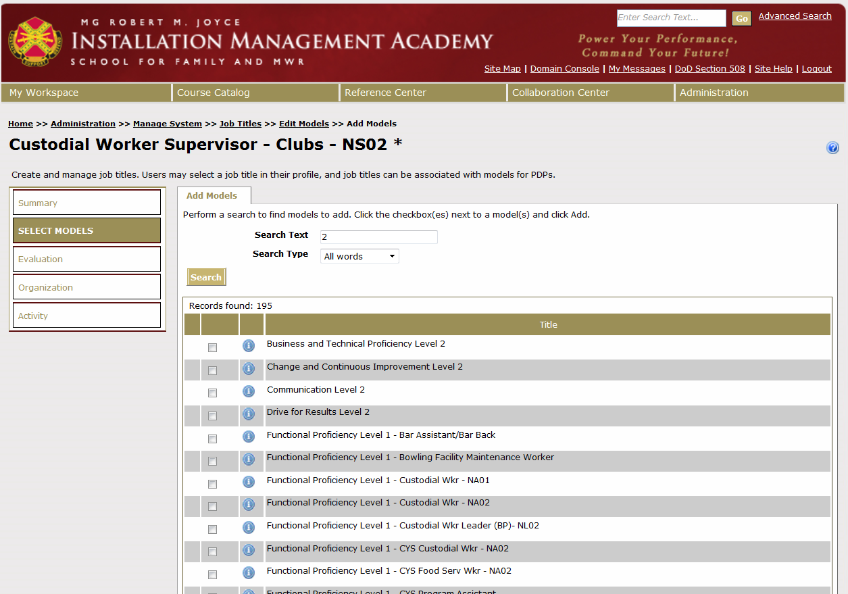

Click the check boxes next to each of the Model Competencies:
- Business and Technical Proficiency
- Change and Continuous Improvement
- Communication
- Drive for Results
- Leading People
Click Add (at bottom of page).
** Note: Can only do 1 page at a time.
Search Supervision (if PD has management/supervisory responsibilities). Type Supervision in Search Text field box.
Search Functional Proficiency Level __ (1-5). Type Functional Proficiency in the Search Text field box, then click Search. Select the Functional Proficiency for the desired job title. Click the Checkbox and click Add.
If you cannot find the Functional Proficiency Model for the job title, you will need to build it (and add it later – see instructions: D. How to Build a Functional Proficiency on page 7).
Click Return to make sure all of the Model Competencies are showing.
Select Organization from the menu on the left. Search for the Family and MWR area in which the position is located by expanding the division + box.
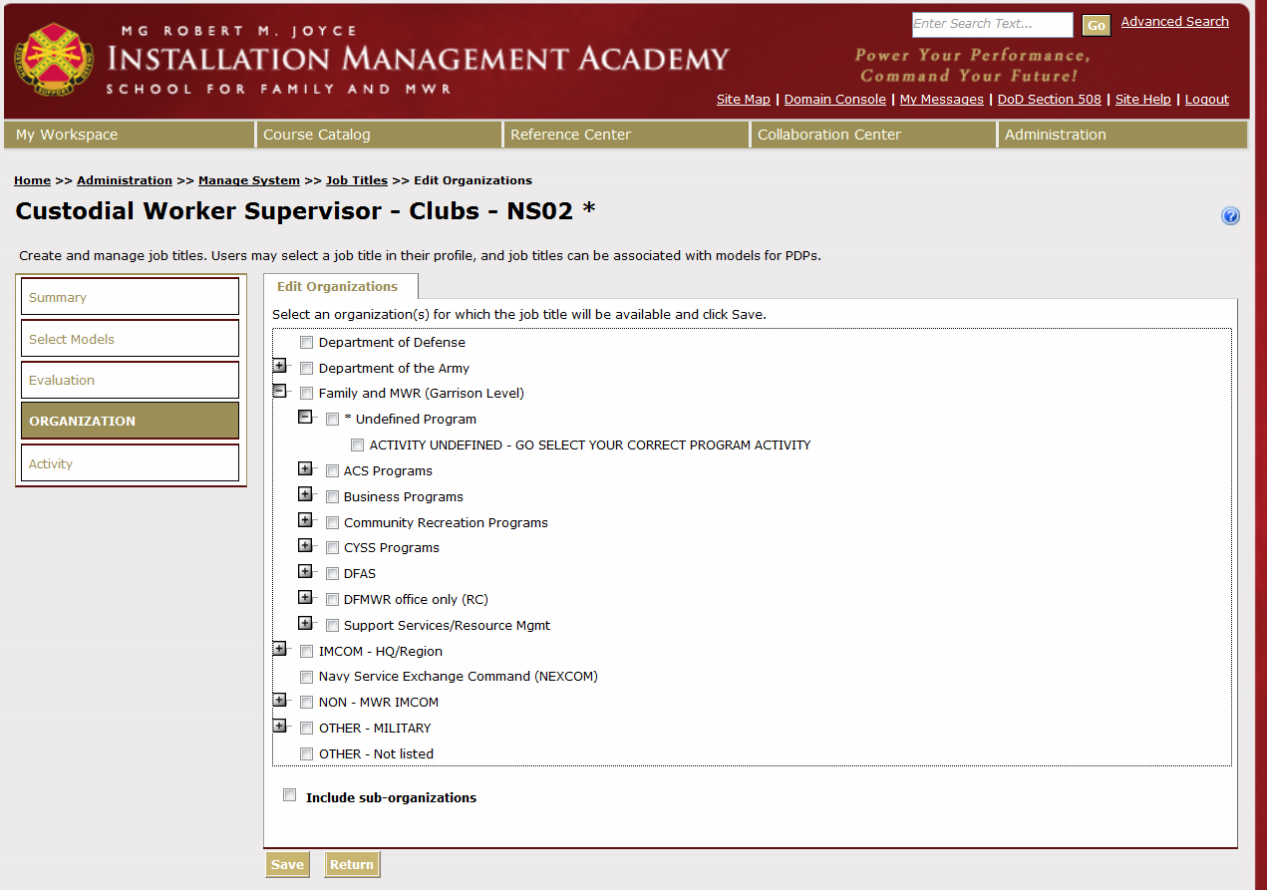
Place a check next to that Program Area.
Click Save.

- How to Build a Functional Proficiency
Hover over:
Administration>Manage Professional Development Program>Manage PDP>PDP Structure
Select Model.
Click Go next to Create New.
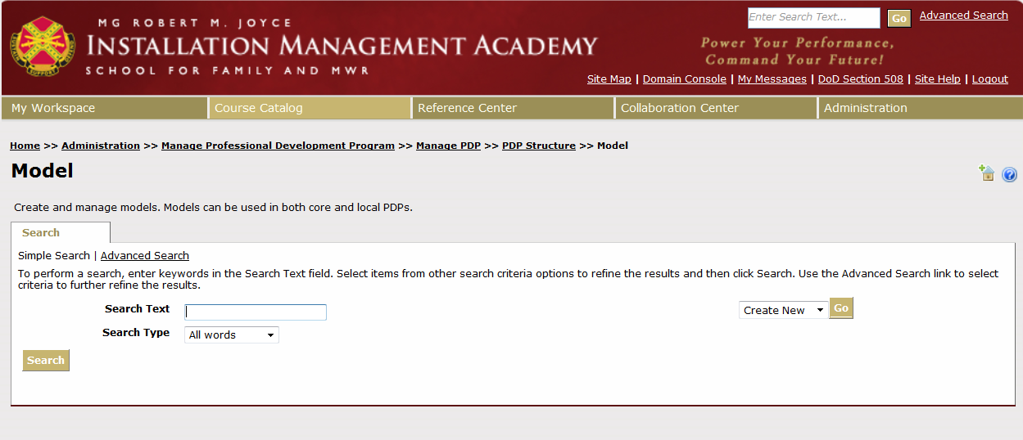

This screen displays, and allows you to enter the Functional Proficiency title, description, and keywords.
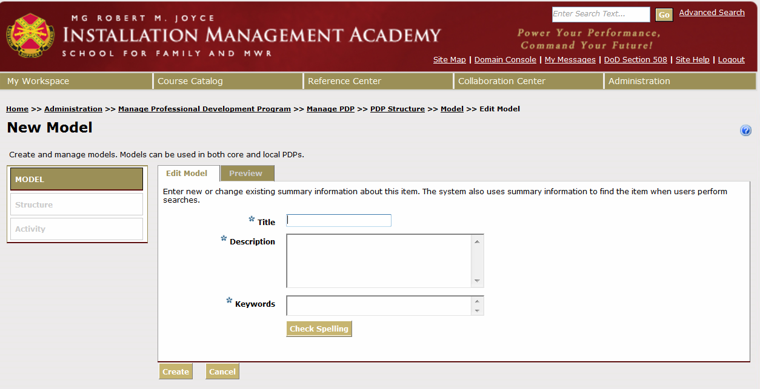

Title: Needs to read exactly: Functional Proficiency Level _____ - Job Title
Example: Functional Proficiency Level 3 – Executive Housekeeper
Description: Use the Functional Proficiency Description below depending on the level.
Functional Proficiency Description Level 1 and 2:
Understands and appropriately applies procedures, requirements, regulations, and policies related to specialized expertise. Is able to make sound decisions based on functinal knowledge.
Functional Proficiency Description Level 3 to 5:
Understands and appropriately applies procedures, requirements, regualations, and policies related to specialized expertise. Is able to make sound decisions based on functional knowledge. Identifies best ptactices and adopts where applicable. Understands linkages between competencies and mission needs.
Keywords: Same as Title.
Example: Functional Proficiency Level 3 – Executive Housekeeper
Click Create.
- How to Attach Functional Proficiency to Job Title
Hover over Administration>Manage System
Select Job Titles.
Enter the job title into the Search Text field. Click Search button.

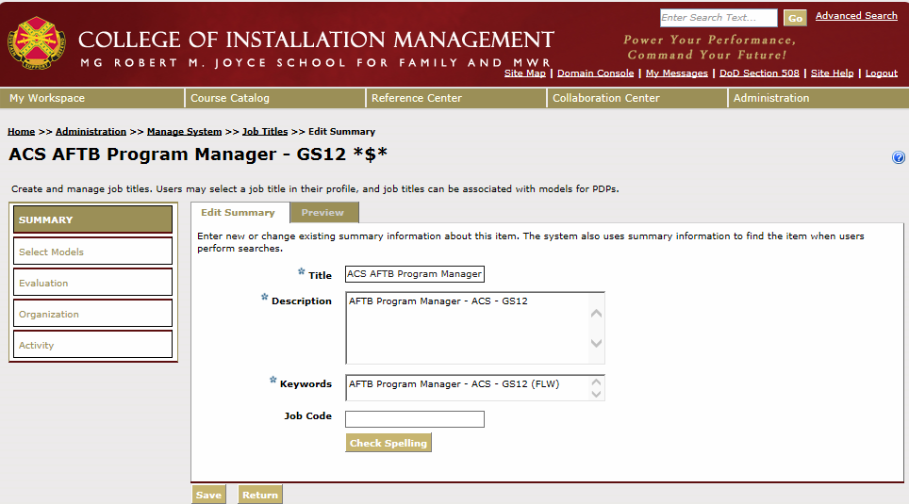
Select Select Models.

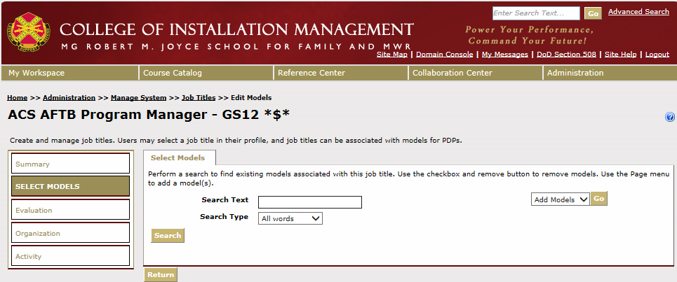
Then select the Go button next to Add Models.

Enter the level of the Text for the Functional Proficiency you wish to add, and click the Search button.
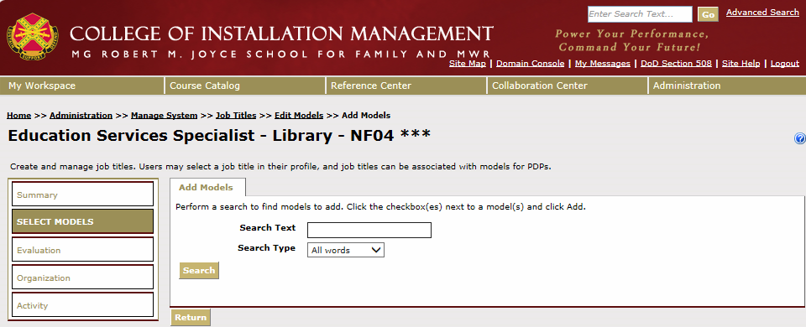

A screen will appear that lists Functional Proficiency you are seeking:
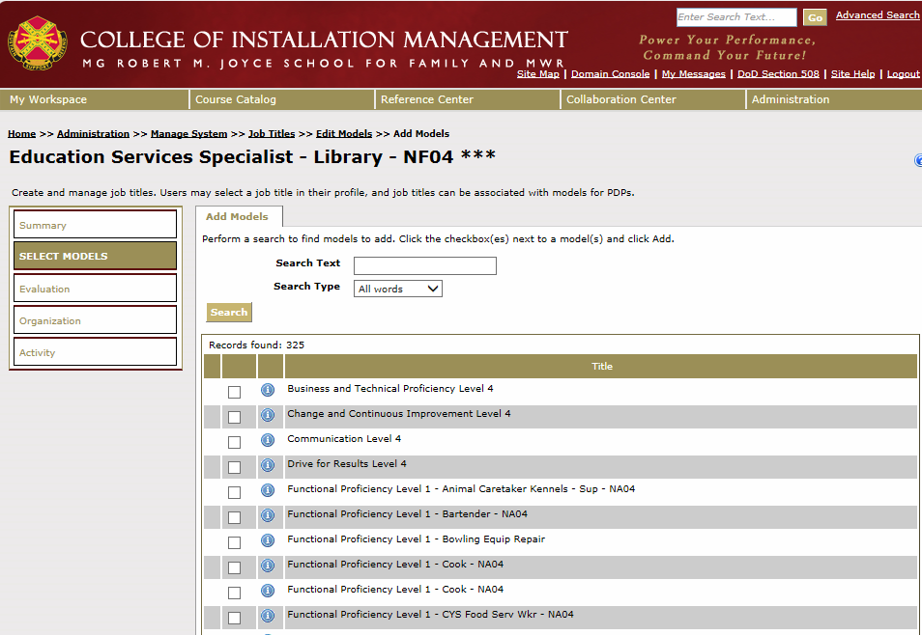

Check the box beside each, then scroll down to the bottom of the screen and click on the Add button.

