**FY16 Marketing Plan**

**Shades of Green (SOG)**

**June 24, 2015**

**Toshi Matsumura**

**Management Analyst**

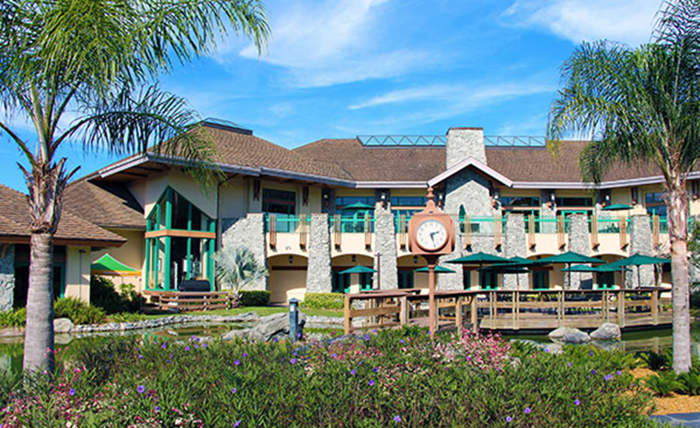

**Executive Summary**

Shades of Green (SOG) is located in the Walt Disney World Resort, Orlando, Florida.  SOG is one of four Armed Forces Recreation Centers (AFRCs) and is a 583 room full service resort hotel. SOG is dedicated to enhance readiness and morale of the combined Armed Forces by providing affordable, first class accommodation in a premier setting combined with friendly and enthusiastic service in an environment revolving around respect, dignity and teamwork for those who have served or continue to serve our great nation. SOG’s top 3 guests are Retirees (54%), Active duty (16%) and Family members (10%). The top 3 states where our customers come from are: Florida, Virginia and Georgia. “E6-O3, NF1-3, GS10 and below” represent the largest segment. Over 60% of our guests are return guests, showing their loyalty to SOG. Our customers are telling us “Price, Location and Military Affiliation with SOG” are the deciding factors.

SOG has identified two competitors: Disney’s Art of Animation Resort is our direct competition due to the proximity to the Disney theme parks and is competing with us for the same market segments that are budget conscious family members. Universal’s Cabana Bay Resort is our indirect competition. They are also competing for the same market segment in Orlando, Florida but their destination is Universal Studios.

Our research discovered some external environment that provides opportunities and threats to SOG. Lower fuel costs, below $3.00 per gallon, will encourage our guests especially within the drive-up markets (FL, GA, AL, TX and SC) to travel to SOG. DOD / DOA conferences are looking at SOG since our military affiliation makes them easier to attain approval. Growth in social media and changes in shopping habits will continue to encourage consumers to book hotels online. These trends represent opportunities for SOG. On the other hand, competitive labor market in Orlando area for Hospitality positions will increase hourly wages and overall labor costs. Looming sequestrations, military fiscal constraints and reduction in force will negatively impact SOG business. These are serious threats to SOG.

Improving facility, guest satisfaction and IT service are SOG’s top 3 program goals in FY16. One of SOG’s long term program goals is to renovate the entire 300-room Magnolia Wing in FY17. This project will cost $50 Million. The renovation will bring the Magnolia Wing up to par with the Palm Wing guest rooms. In terms of financial goals, in FY16, SOG will achieve an occupancy of 96.1% (vs.94.3% FY15), Average Daily Rate of $122.31 (vs. 118.74 FY15) to attain Rooms Revenue of $25.1M (vs. $23.8M). We anticipate FY16 NIBD to be $7.5M. Most of our NIBD will be reinvested in equipment and maintenance of our facilities for the guests to enjoy and for us to stay relevant. Our total Food and Beverage departmental COGS goal is 31% of the total F&B revenue, improving from 32% in FY15. SOG Marketing Goals are set as a means to achieve financial objectives. Our distribution channels have been the website and onsite reservations office. For us to be efficient, our goal is to achieve a 55% online booking ratio.

Shades of Green is our brand. Our affiliation with IMCOM, FMWR and AFRC definitely help us to send a strong message to the Military community. Our partnership with Disney and the proximity to the theme parks have created a very positive family oriented image. Our overall customer satisfaction rating is above 90.0%. SOG has been highly recognized by TripAdvisor as 2nd best out of 16 Specialty Lodging in Orlando. We will continue to establish personal relationships with our guests by calling them by name and remembering their preferences. At SOG, we believe that two of our newly renovated pools are added special features. Military affiliation is SOG’s #1 intangible benefit our customer can receive.

Our current room rates have enabled us to achieve a very healthy NIBD during the past few years. We believe the price points have been correctly set. A 5% room rate increase in FY16 will support additional guest services including lifeguards at two pools, more security officers to meet DOD requirements and an in-house pastry shop to provide quality pastries and goods. In comparison to our direct competition, Disney’s Art of Animation Resort, SOG’s room rates are discounted at least 50% or more during high demand months.

SOG takes internal marketing opportunities very seriously. At any given day, we have 1,500 to 2,000 captive in-house guests. We do our best to capture their business inside SOG. For this, electric information boards are strategically located throughout the property and inside the shuttle buses in order to market our Food and Beverage outlets, Spa, wedding packages and special promotions.

Approximately 90% of our promotional efforts are focused on the website and reservations & front desk. We also place our future promotions at the Attraction Ticket Desk to capture non-hotel guests who represent 60% of the ticket sales.

**Market Review**

The Market Review section of Shades of Green Marketing Plan includes Business & Program Overviews, Market Segmentation, Target Markets, and Needs Assessment.

1. **Business & Program Overviews:**
   1. Scope of Business

Shades of Green (SOG) is located in the Walt Disney World Resort, Orlando, Florida.  SOG is one of four Armed Forces Recreation Centers (AFRCs) and is a 583 room full service resort hotel, operating at an annual occupancy of 94.3% in FY15. We serve a total number of 1,500 to 2,000 in-house guests per day. We manage 7 large and small food and beverage venues plus a ballroom with a capacity of up to 400 guests. We have 2 life-guarded pools with splash grounds and slides. Other amenities include free Wi-Fi, covered parking, spa, fitness room, children’s playground, AAFES Exchange, gift shop and rent-a-car service.  In addition, we provide complimentary transportation to the Disney parks.  There are two 18-hole golf courses right next to our facility which are managed by Arnold Palmer Golf. We have between 400 and 420 employees depending on business demand and seasonality.  We generate $37 million in total revenue and retain $7.0 million in net income before depreciation (NIBD). We have been reinvesting most of the NIBD to facility maintenance and equipment to stay competitive and relevant.

* 1. Safety & Security

Guest safety and security is one of our utmost concerns. We have 24/7 security officers on duty to provide the level of security requirements. Our gated entrance “Welcome Center” is also 24/7 manned.

* 1. Sales, Seasonality and Pricing History
     1. Occupancy and Average Daily Rate (ADR) by Month: FY14, FY15 and FY16

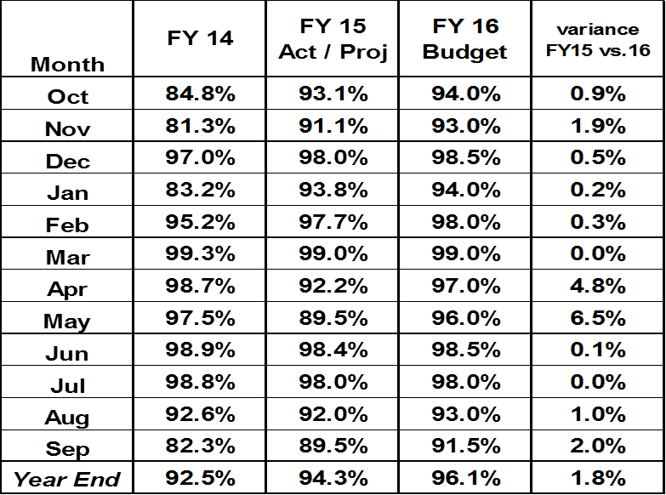

SOG occupancies are increasing steadily from 92.5% in FY14 to 96.1% forecasted in FY16. Our distribution channels have been website and onsite reservations office. Since we upgraded the website two years ago for guests to make reservations, the current web reservations has accounted for 50.0% of our business. We have seasonally week periods in January, August, September, October and November. In this respect, we offer special discounts and packages during these week periods. The discount programs are from 35% to 10% depending on the season. Our packages include breakfastsand sometimes dinners. The following chart represents monthly average daily rate, which shows lower rates offered in the weak months.

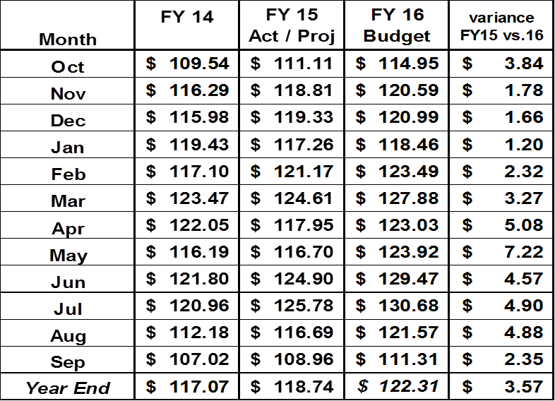

* 1. Positioning in the Market:

SOG pricing is below market average in the Walt Disney World Resort. During the holiday / vacation seasons, our average room rates are as much as 50-70% below our competitions due to their aggressive pricing strategies. SOG is restricted in establishing separaterates for high seasons. However, the products and service we provide are equivalent to 3 stars and 3 diamonds which represents very high quality standards.

* 1. Shades of Green Mission Statement:

Shades of Green is dedicated to enhance readiness and morale of the combined Armed Forces by providing affordable, first class accommodation in a premier setting combined with friendly and enthusiastic service in an environment revolving around respect, dignity and teamwork for those who have served or continue to serve our great nation.

1. **Market Segmentation:**
   1. SOG Market Segments:

SOG market segmentation is based on hotel industry standards. If the customer books less than 10 rooms, they are considered “Free Independent Travelers” (FITs) and if they book more than 10 rooms, they are considered “Groups”. At SOG, FIT segment is further broken down to rack rates, packages and discounts sub segments. Rack rates are non-discounted rates. Group segment is further divided by types of group businesses that SOG most frequently handles. Below is SOG market segment report, capturing a 12 month summary of total room nights, average rates and revenues by each segment for FY14, FY15 and FY16.

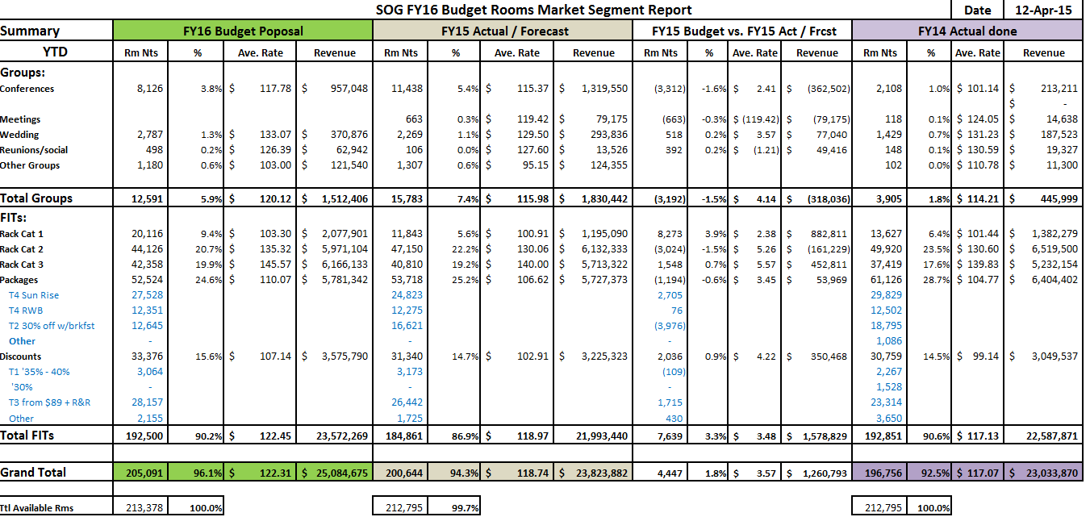

* 1. Changes We See Coming:
     1. With looming sequestrations and budgetary fiscal constraints, SOG anticipates less group businesses in FY16. We will focus on FIT market segments to fill the loss of Group businesses.
     2. Low cost of fuel has given families more discretionary income to spend on travel. We will leverage the drive-up market segment to increase last minute bookings.
     3. Smith Travel Research forecasts 3.0% occupancy increase in the Orlando area for 2016. We will offer discounted programs only when they are necessary so we don’t give out the house.
  2. SOG Rates and Military Ranks:
     1. Our rack rates are based on the guest’s military ranking. The higher the guest rank is, the more they pay. This is a unique room rate system to AFRCs in comparison to civilian hotel practices: the higher your social status is, the less you pay because they want your affiliation to tap into new businesses.
     2. The chart below indicates SOG room type and rates structure.

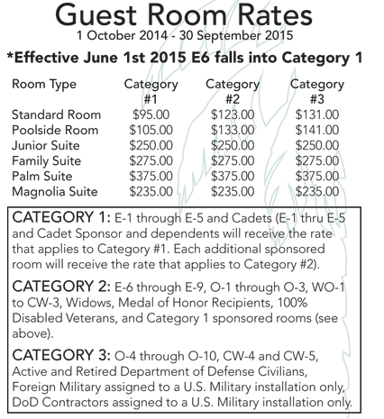

1. **Target Markets:**

Our target market statistics and data you see below are based on FY15 April year to date numbers unless indicated otherwise. We collect data from our guests after they have completed their stay at SOG and checked out. Every guest receives a survey from us via e-mail.

* 1. Demographics
     1. SOG top 5 guests are Retirees (54%), Active duty (16%), Family members (10%), Reserves (9%) and DOD employees (4%).

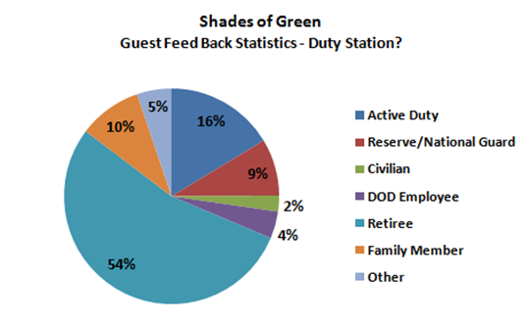

* + 1. 60% of our guests are return guests which indicates a high level of guest loyalty to SOG.
    2. Our top three best customers are Army, Air Forceand Navy. They consist of 86% of our market.

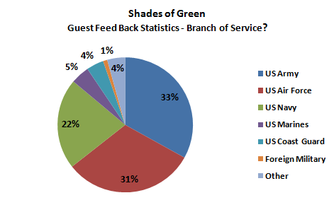

* + 1. Based on our FY14 statistics, the top 5 states where our customers come from are: Florida, Virginia, Georgia, Texas and Pennsylvania. These five states represent 39% of our entire market.

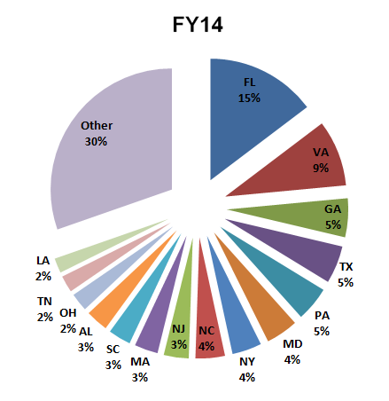

* 1. Psychographics
     1. Social Class and Status of our guests:
        1. E6-O3, NF1-3, GS10 and below segment represents the largest segment, 42% of our market,
        2. followed by O4-6, NF4 + and GS11+ segment , 35% of our market
        3. E1-E5 market only represents 16% of our market. Due to their level of discretionary incomes, they don’t make a commitment to make reservations 12 months out. They tend to make the last minute decisions and by then our rooms are sold out.

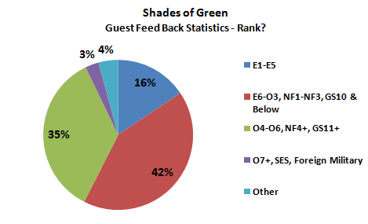

* + 1. Our customers are telling us Price, Location and Military Affiliation of SOG are the deciding factors. Those three factors represent 90% of the factors. As many of our guests are price conscious and budget travelers, they respond to our seasonal meal inclusive packages and discounted programs most often. They like SOG military affiliations and proximity to Disney. SOG offers value and convenience to the customers.

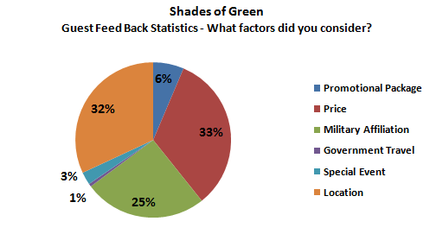

* + 1. What their spending patterns are?
       1. Typical Family Size: Two adults and two children
       2. Average Room Rate: $118.75, Average Lengths of Stay 4.0 nights, Total $475
       3. Theme Park Ticket Prices for two adults and two children for 4 days: Total $708

1. **Needs Assessment:**

SOG uses the following methodologies to find out what the customer really needs or wants.

* 1. Customer Survey:

Our Sales and Marketing Department conducts this customer survey by sending out emails to every guest after checking out. We compile data, information and customer feedback to improve customer service and create products our customer wants. During the last fouryears, we listened to the voice of the customer and created new Tier Marketing Program which enables us to align our strategies to the customer’s needs. We believe the Tier Marketing Program has simplified our strategies and made it easier to quantify the results thereby contributing to the success in increasing annual occupancies from 89% in FY11 to 96% in FY16.

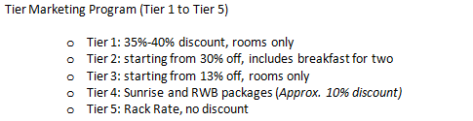

* 1. Social Media:

We take the power of social media and their potential impacts on our guests very seriously. For this we manage our website, Facebook and Trip Advisor very carefully in order to listen to what our customers are saying and respond to them if necessary to constantly improve our service, products and facilities. Most recently SOG has been upgraded by Trip Advisor to #2 out of 17 properties in specialty lodging category in Orlando area. 5 years ago we were rated #6.

* 1. Experience / Trial and Error:

When we don’t have enough data for new marketing initiatives but need to take actions, our revenue committee votes and get final approval from General Manager. We have done it few times in the past to test the market and discovered how customers respond to our new initiatives. We collected empirical data along the way to verify and measure success. If needed, we make some adjustments to improve the programs.

**Situational Review**

The Situational Review section of Shades of Green Marketing Plan includes Competitive Review, External Review and SWOT Analysis.

1. **Competitive Review:**

We have identified two of our competitors. Disney’s Art of Animation Resort is our direct competition due to the proximity to the Disney theme parks and is competing with us for the same market segments that are budget conscious FIT family members. The second property we have selected is Universal’s Cabana Bay Resort, our indirect competition. They are also competing for the same market segment in Orlando, Florida but their destination is Universal Studios.

* 1. Direct Competition
     1. Disney’s Art of Animation Resort
        1. Their Strengths
           1. A Disney’s 1,984 room value property
           2. Ranked #5 out of 160 hotels in Kissimmee by TripAdvisor
           3. Rooms with kids favorite thematic decoration
           4. Free transportation form and to Orlando International Airport
           5. Free shuttle to the parks
           6. Well trained employees
           7. In-room child care
           8. 3 outdoor pools for adults and children
        2. Their Weaknesses
           1. Less flexibility with their meal plan and not very healthy selections
           2. Their published room rates change depending on demand (dynamic pricing)
        3. Differences between SOG features and Art of Animation
           1. SOG focuses solely on Military market
           2. SOG’s published room rates stay the same throughout the year
           3. SOG’s rooms and corridors are the largest in the area
           4. SOG’s food and beverage prices are significantly lower than Disney pricing
        4. Their sales and pricing structure
           1. During the off season, their published room rates are similar to that of SOG. However, they go up during high demand months up to 50% more
           2. Their F&B pricing is 25 % to 50% higher than SOG
        5. The media vehicles they use to promote their programs
           1. Disney website
           2. ABC and ESPN network
        6. Their advertising message
           1. The "most magical place on earth"
        7. Their total advertising expenditures and frequency
           1. Disney generates $50 Billion in total sales, thus the Art of Animation Resort is part of their integrated sales and marketing plan. Their total advertising expenditures are not published; however the industry standard is to spend 5% of total revenue for sales and marketing which equates to $2.5Billion.
        8. Their overall goal (profitability, market share, leadership, etc.)
           1. Since Disney is a publically traded company, their main concern is profitability to the shareholders.
           2. They leverage Disney branding to create magical experiences in order to bring guests back.
        9. How they try to meet their goals
           1. Disney has been constantly increasing the park attendance fees as well as their room rates by approximately 5% every year to increase revenue.
           2. Disney packages everything they do including hotels room, meal programs, theme park tickets, as well as cruises. This cross selling creates convenience and added value to the guests, thus increase propensities for the guests to buy.
           3. Disney manages their business by controlling overhead costs and offering superb service provided by well trained employees.
        10. How they react to changes SOG makes in our program pricing or promotions.
            1. Disney has over 31,000 rooms here in Orlando vs. SOG has 583 rooms. What we do with our pricing and promotions is very insignificant to Disney.
  2. Indirect Competition
     1. Universal’s Cabana Bay Resort
        1. Their Strengths
           1. Ranked #62 of 328 hotels in Orlando by TripAdvisor
           2. A 1,600 room Loews Hotels property opened in Spring 2014
           3. Value oriented
           4. A bowling alley and 3 pools on the property
           5. Free shuttle and early access to the Universal parks
        2. Their Weaknesses
           1. According to TripAdvisor, Food and Beverage price points are high.
           2. Away from to Disney
        3. Differences between SOG features and Cabana Bay
           1. SOG is on the Walt Disney World Resort
           2. SOG focuses solely on the Military market
           3. SOG’s published room rates stay the same throughout the year
        4. Their sales and pricing structure
           1. During the off season, their published room rates are similar to that of SOG. However, they increase during high demand seasons
           2. Their F&B pricing is also higher than SOG
        5. The media vehicles they use to promote their programs
           1. Both Universal Studios and Loews Hotels websites
           2. Email, US mail
           3. Local TV, newspaper, travel magazines
        6. Their advertising message
           1. Expect the Unexpected
           2. The Wizarding World of Harry Potter
           3. Play. Stay. Night and Day
           4. The Center of Your Adventure
           5. Share Your “#UniversalMoments”
        7. Their total advertising expenditures and frequency
           1. Total advertising expenditures are unknown
           2. Universal’s Cabana Bay Resort is part of Loews Hotels and Universal Studio’s integrated sales and marketing campaigns
        8. Their overall goal (profitability, market share, leadership, etc.)
           1. Since Loews Hotels is a publically traded company, their main goal is profitability to the shareholders by expanding their market share and expanding their resort capacity
        9. How they try to meet their goals
           1. Just like Disney, Orlando Universal Resort has been constantly increasing the park attendance fees, as well as their room rates by approximately 5% every year to increase revenue
           2. Cabana Bay Resort manages their business by going after FIT business as well as convention & conference group market segments
           3. Their target markets are families with young adults and business incentives
        10. How they react to changes SOG makes in our program pricing or promotions.
            1. Universal has over 6,000 rooms in Orlando vs. SOG has 583 rooms. What we do with our pricing and promotions is very insignificant to Universal.

1. **External Review:**

The following four factors represent the external environment that provides opportunities and threats to SOG.

* 1. Economic Factors
     1. Lower fuel costs, below $3.00 per gallon, will encourage our guests especially within the drive-up markets (FL, GA, AL, TX, NC and SC) to travel to SOG. This represents an opportunity to SOG.
     2. Competitive labor market in Orlando area for Housekeepers, Bus Drivers, Front Desk Agents and Food and Beverage Servers will eventually increase hourly wages and overall labor costs. If open positions are not filled on time, it will affect our service level, employee morale and guest satisfaction. This represents a big threat to SOG.
  2. Technology
     1. Disney’s “My Magic” program, an RFID guest wrist band will potentially enable Disney to collect SOG guest spending patterns in a more intimate way and send targeted and timely marketing messages to in-house guests via smart phone. This will negatively impact SOG business and eat up our market segments.
     2. SOG needs to be nimble and more cognizant to the technological capabilities available in the Hospitality Industry and invest significant resources to stay relevant against competitions.
  3. Political

1. Looming sequestrations, military fiscal constraints and reduction in force will negatively impact SOG business. This is a serious threat to SOG.
2. DOD / DOA conferences are looking at SOG since our military affiliation makes them easier to attain approval. This is an opportunity to SOG.
   1. Social
      1. Growth in social media and changes in shopping habits will continue to encourage consumers to book hotels online. This trend is an opportunity for SOG.
      2. The population increase in the retiree group will positively affect SOG business. This trend also is an opportunity to SOG.
3. **SWOT Analysis:**

The chart below represents SOG’s current strengths, weaknesses, opportunities and threats. Each section is ranked in order of importance. Also some of the elements listed below are from our “Needs Assessment” results.

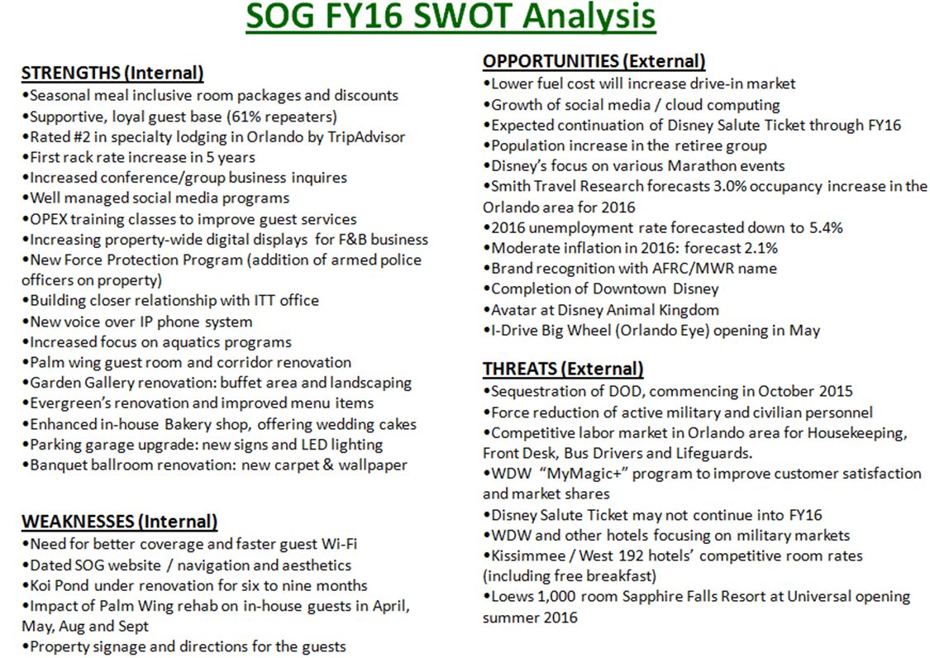

**Goals and Objectives**

Goals and Objectives section of the Shades of Green FY16 Marketing Plan discusses Program Goals, Financial Goals and Marketing Goals.

1. **Program Goals:**

The following represents SOG’s short and long term goals to improve guest’s experiences and their level of satisfaction to sustain our business into the future years.

* 1. Short Term Program Goals (FY16):
     1. Objective: Improve Facility and Equipment to Stay Relevant

A total of $10 Million has been committed for FY 16 CPMC projects to improve SOG facility and equipment to stay relevant.

* + - 1. Renovation of 300 guest rooms and corridors in the Palm Wing includes new painting, new furniture, new light fixtures and new artwork to keep up to our standard.
      2. Garden Gallery Restaurant renovation project is to improve the hostess stand, buffet area as well as the garden view of the restaurant for the guests’ dining experience.
      3. Koi Pond rejuvenation project is to redesign the courtyard of the resort with a newly designed wedding gazebo and landscaping. This is to create the WOW factor for arriving guests on the lobby balcony that overlooks the beautiful landscaped garden.
    1. Objective: Improve Guest Satisfaction
       1. OPEX Guest Service Trainings are scheduled once a month at SOG for new hires as well as current employees to learn how to deliver exceptional customer service.
       2. Supervisory Training Program has been scheduled for every supervisor at SOG. It will enable them to learn basic skills in order to build and lead a winning team.
    2. Objective: Improve IT Service to Guests
       1. Enhancing Wi-Fi Connectivity / Speed is critical to our guest satisfaction. The guests haven’t been very happy with our current program. We are committed to resolving this issue in FY16.
       2. Improving SOG website will not only enhance its aesthetics but also will enable guests to easily maneuver, find info they want and to make room reservations with less time.
  1. Long Term Program Goals (2-4 years out):
     1. Objective: Improve Facility and Building
        1. Renovate the entire 300-room Magnolia Wing in FY17: This project will cost $50 Million, which is much needed in order to bring the Magnolia Wing up to par with the Palm Wing guest rooms.

1. **Financial Goals:**

SOG Financial Goals are also further divided into FY16 Goals and Long Term Goals that are FY17-FY20.

* 1. FY16 Goals / Near Term
     1. Gross Sales:

Based on our SWOT Analysis, Smith Travel Research projects the Orlando hotels occupancy to grow 3.0% points in 2016. In FY16, SOG will achieve an occupancy of 96.1% (vs.94.3% FY15), Average Daily Rate of $122.31 (vs. 118.74 FY15) to attain Rooms Revenue of $25.1M (vs. $23.8M). Our revenue committee consists of the General Manager, Deputy GM, Director of Sales and Marketing, Rooms Division Manager, Restaurants Managers and Management Analyst who will meet every two weeks to assure strategies are in line with the budget and generating expected revenues.

* + 1. NIBD:

We anticipate FY16 NIBD to be $7.5M. Most of our NIBD will be reinvested in equipment and physical maintenance of our facilities for the guests to enjoy and for us to stay relevant.

* + 1. Cost of Goods Sold:

Our total Food and Beverage departmental COGS is 31% of the total F&B revenue, improving from 32% in FY15.

* + 1. ROI:

Since we have so many CPMC projects for FY16, average ROI will need to be determined.

* 1. Long Term Goals (FY17-FY20)
     1. Occupancy:

After FY16 occupancy of 96.1%, SOG will not expect to improve its occupancy much going into FY17 and beyond. According to Disney, once a hotel consistently reaches above 89% annual occupancy, they consider building a new hotel. We believe SOG has reached its plateau in terms of occupancy. SOG’s occupancy in FY17 and FY18 will drop due to the Magnolia Wing renovation. We believe 100 rooms will be out of order every day commencing in October 2017 for 24 months. The chart below represents our 4 year occupancy goals.



* + 1. Average Daily Rate:

FY 16 is the first year in five years that SOG is able to increase their published rate by 5%. It has been 0% increase. We believe that for the next 4 years, we probably will attain approval for a 5% increase every two years, commencing in FY18.



* + 1. Room Revenue / Gross Sales:

Room Revenue is the result of Occupancy multiplied by Average Daily Rate. We are confident that SOG’s room revenue will continue to improve as our competent revenue committee will optimize the yield management. However, due to the Magnolia Wing renovation, we will see the room revenue drop in FY17 and FY18.



* + 1. NIBD:

SOG’s NIBD is very important as the profit we generate belongs to Soldiers. Thus our goal is to reinvest the profit into CPMC projects to stay relevant. Here is our NIBD projection for FY17-FY20.



1. **Marketing Goals:**

Shades of Green Marketing Goals are set as a means to achieve financial objectives.

* 1. Distribution Channel:

Our distribution channels have been the website and onsite reservations office. Since we upgraded the website two years ago for guests to make reservations, the current web reservations have increased drastically. For us to be efficient, our goal is to achieve 55% online booking ratio. We will redesign our website to make it more user-friendly.

* 1. Advertising Awareness:

Our goal is to advertise special promotions and events 30 days out on our web and in-house displays. We will continue to advertise meal inclusive room packages and discount programs 360 days out.

* 1. Sales Units and Dollars:

SOG Rooms Target Markets are divided into two large market segments. They are Free Independent Travelers (FITs) and Groups. FITs are guests booking 1 room and up to 9 rooms. Groups are business with 10 rooms or more.

We believe that setting monthly goals will provide us the opportunity to measure and make necessary adjustments to stay on course. For this, the following represents FY16 monthly “Sales Dollars and Sales Units (room nights)” for each market segment.

Group Segments: Conferences, Meetings, Weddings and Reunion/Social

FIT Segments: Rack Rate 1, Rack Rate 2, Rack Rate 3, Packages, and Discounts

October

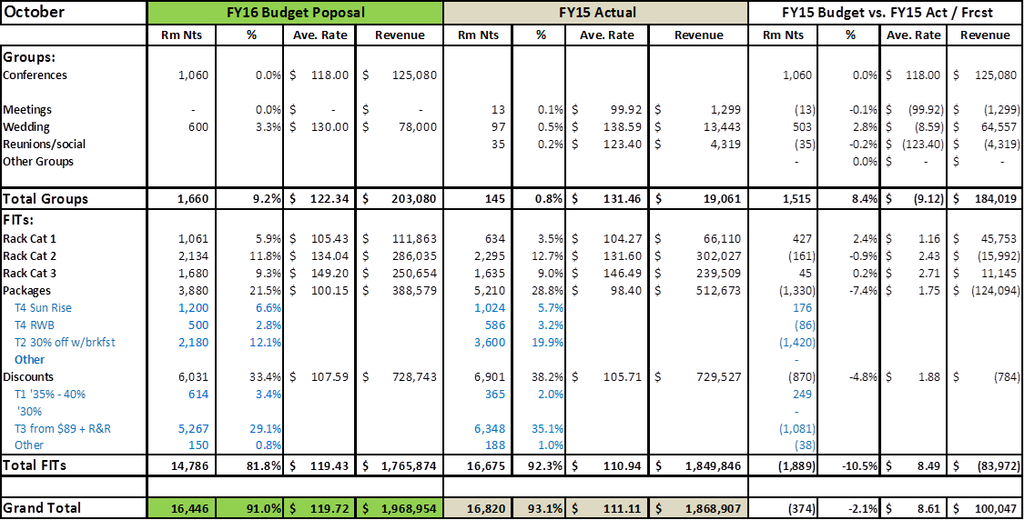

November

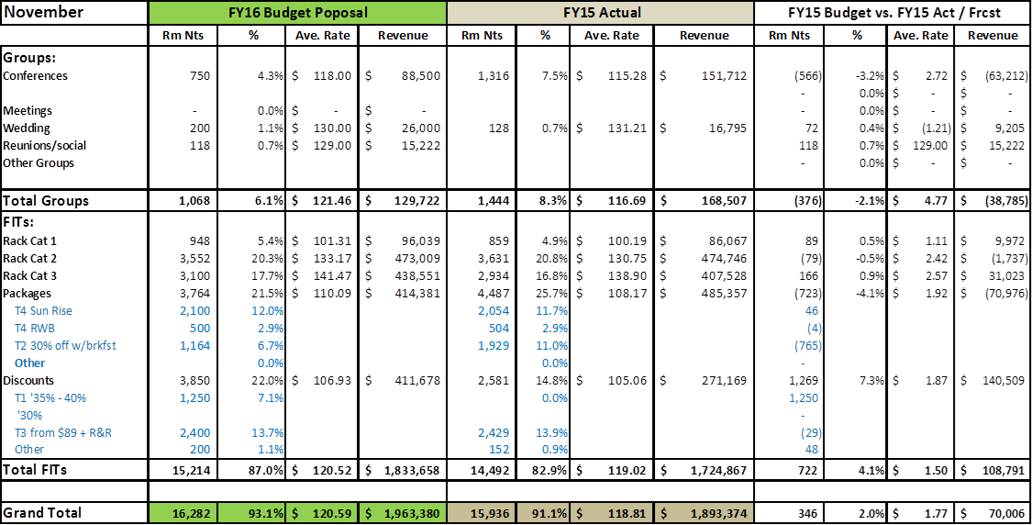

December



January

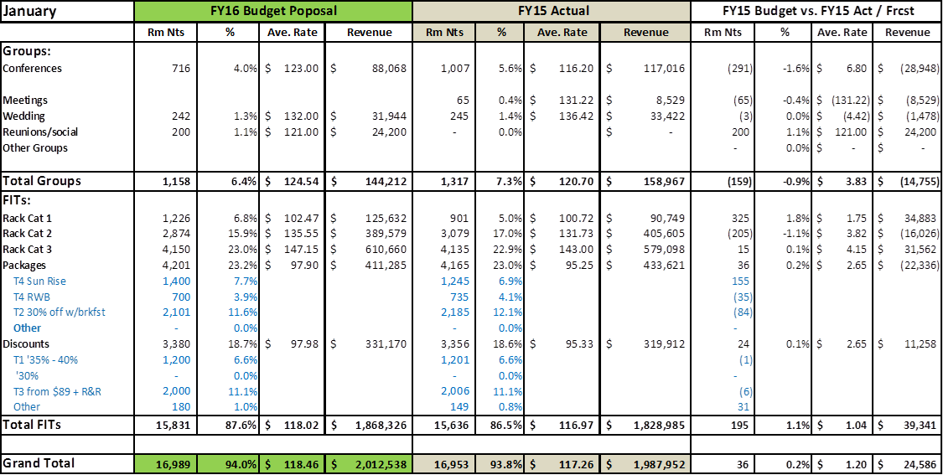

February

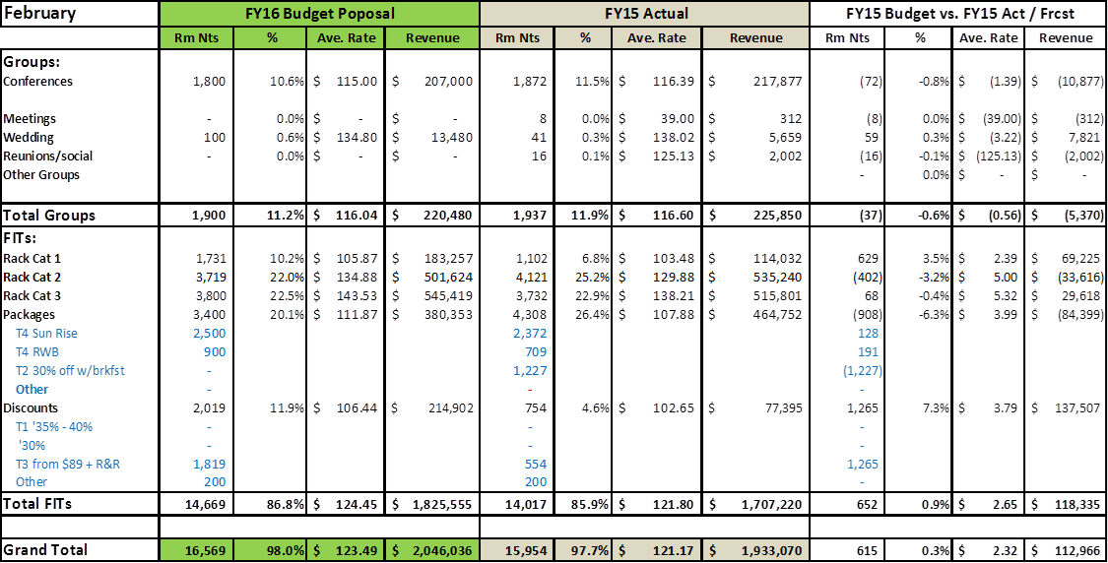

March

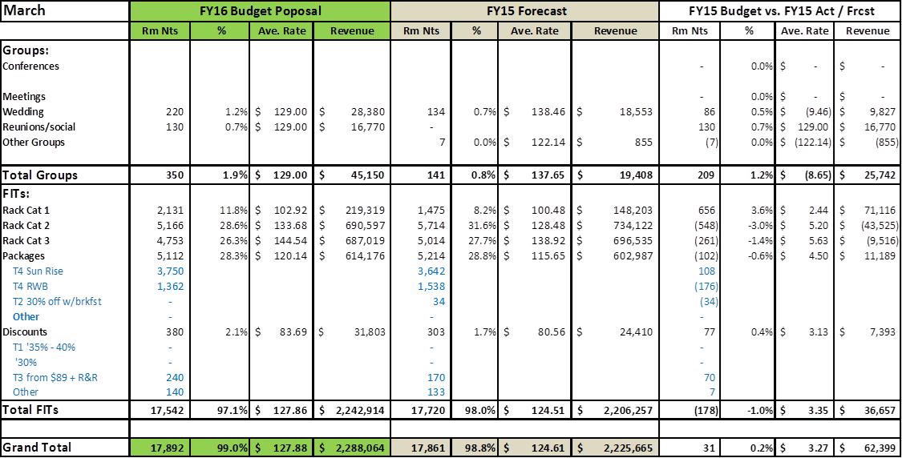

April

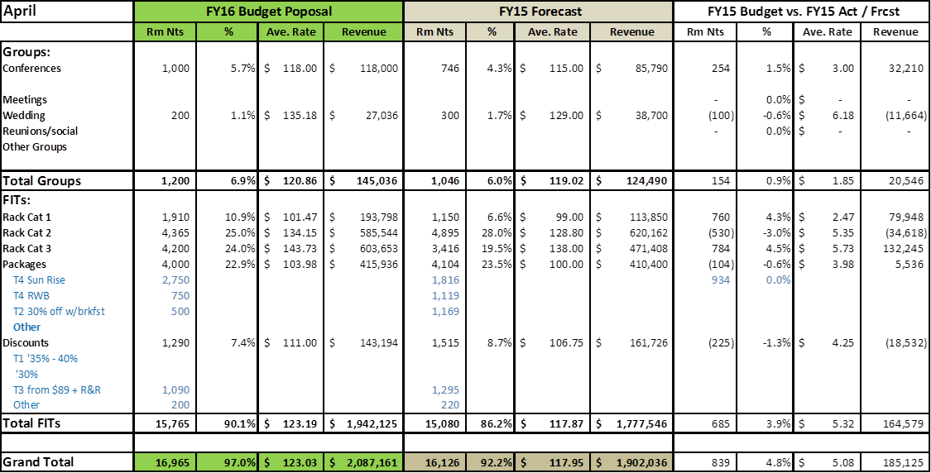

May

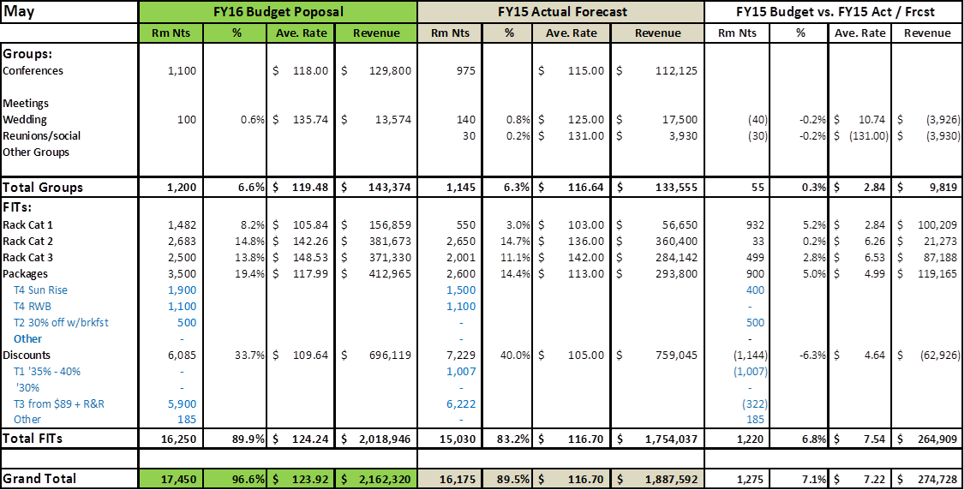

June



July



August



September

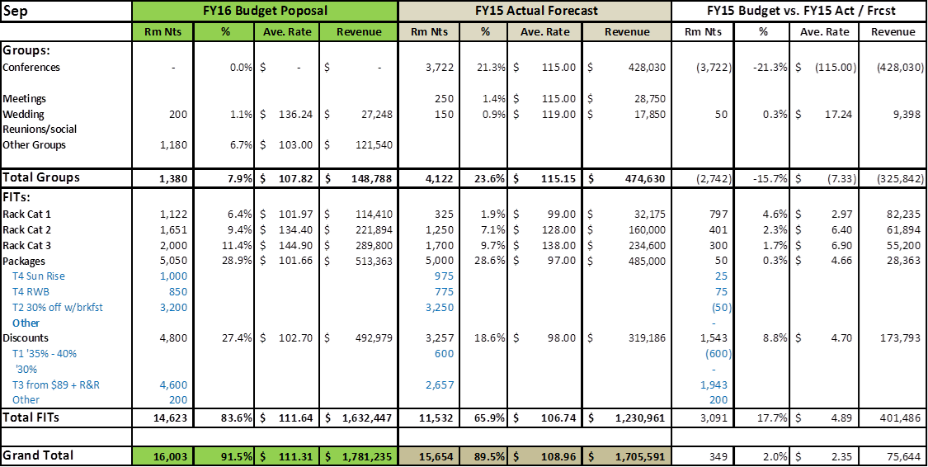

**Strategies- Marketing Mix**

Strategies section of the Shades of Green FY16 Marketing Plan discusses Marketing Mix (4 Ps / 4 Cs): Product/Customer, Price/Cost, Place/Convenience and Promotion/Communication. SOG Marketing Mix strategies focus on the benefits we provide our customers, which will increase the propensities to purchase our products.

1. **Product / Customer:**
   1. Brand &Image / Packaging & Labeling

Shades of Green is our brand. We worked very hard to establish ourselves in the Army Community as well as DOD organization during the past years. Our affiliation with IMCOM, FMWR and AFRC definitely help us to send a strong message to the Military community. Our partnership with Disney and the proximity to the theme parks have created a very positive family oriented image.

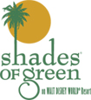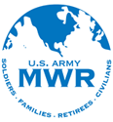**[](http://www.shadesofgreen.org/salutetickets.htm)**

* 1. Customer Service

Providing friendly and professional service with a smile goes a long way in the hospitality industry. All SOG employees go through the OPEX service training as well as Disney Traditions to learn about the history of Disney and their philosophy of customer service. Our employees are trained to anticipate customer needs and meet their expectations. Our overall customer satisfaction rating is above 90.0%. SOG has been highly recognized by TripAdvisor as 2nd best out of 16 Specialty Lodging in Orlando.

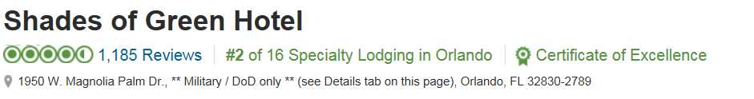

* 1. Relationships

Building customer relationship is part of SOG marketing commitments. We will be in this location for a long term. Over 60% of our guests are return guests, showing their loyalty to SOG. We will continue to establish personal relationships with our guests by calling them by name and rememberingtheir preferences. We will continue sending them emails after their stay to thank them and request their feedback.

* 1. Special Features

At SOG, we believe that two of our newly renovated pools are addedspecial features. According to a study conducted by Disney, the number one reason why guests come back to their resort properties is their pools and intra active water features. We created an Aquatics Department to handle the new pools, provide lifeguards and planned activities around the pools.

* 1. Safety

Guest safety and security are one of our utmost concerns. We have 24/7 security officers on duty to provide the level of security required. Our gated entrance “Welcome Center” is also manned 24/7.

* 1. Intangible Benefits

Our guests can see and sense how SOG takes care of the Military market. Language and pictures on our website and marketing collaterals enable Soldiers and Families to feel comfortable when booking their reservations and coming to stay with us while visiting Disney. Military affiliation is SOG’s #1 intangible benefit our customer can receive.

1. **Price / Cost:**
   1. Value to Our Customers:

Inside SOG, we have a ticket sales desk where our guests can purchase heavily discounted Disney as well as other theme park and attraction tickets. SOG offers complementary shuttle service to Disney theme parks. Because of SOG’s partnership with Disney, our guests are qualified for extended park hours. Our guest rooms are the largest in Disney resorts and each of our rooms has a large balcony.

* 1. Tangible Costs to the Customer:

Tangible costs to the customer at SOG include room price, food and beverage cost of sales, pool operations, parking fees, landscaping, shuttle service to the theme parks and front of the house employees (front desk, security, servers, cashiers, bartenders, housekeepers, ground keepers). Intangible costs to the customer include, utility bills, Wi-Fi connectivity fees, night clearing, back of the house employees (sales, accounting, HR, administrative office, engineering).

* 1. Price vs. SOG Financial Goals:

Our current room rates have enabled us to achieve a very healthy NIBD during the past few years. We believe the price points have been correctly set. However, a 5% room rate increase in FY16 will support additional guest services including lifeguards at two pools, more security officers to meet DOD requirements and an in-house pastry shop to provide quality pastries and goods.

* 1. APF Support:

SOG’s last APF support was in FY11. We are currently 100% Cat C funded.

* 1. Price Increase Procedure:

FY16 is the first year (in the last five years) to increase published room rates. TheSOG General Manager sends a request to Chief of Hospitality Programs who forwards it to the G-9 Director then to IMCOM CG. The CG has the final approval.

* 1. SOG Price vs. Competition:

In comparison to our direct competition, Disney’s Art of Animation Resort, SOG room rates are discounted at least 50% or more during high demand months. As far as food and beverage products, SOG prices are approximately 25- 50 % lower. Guests who are qualified to stay at SOG are getting the best value within Disney. Our covered parking garage fee is $5 a day whereas it costs a minimum of $17 a day to park at theme parks.

1. **Place / Convenience:**
   1. Marked Information at SOG:

At SOG we take internal marketing opportunities very seriously. At any given day, we have 1,500 to 2,000 captive in-house guests. We do our best to capture their business inside SOG. For this, electric information boards are strategically located throughout the property and inside the shuttle buses in order to market our Food and Beverage outlets, Spa, wedding packages and special promotions.

* 1. Convenience for SOG Customers:
     1. Location:

SOG’s proximity to Disney theme parks is exceptional. We are the only non-Disney property inside Magic Kingdom gate.

* + 1. Hours of Operations:

Basically SOG operates 24/7. There is always someone available at the Welcome Center and Front Desk to assist guests. However, our food and beverage, ticket desk, reservations and sales office hours vary depending on customer demand.

* + 1. Transportation / Parking for Customers:

Once our guests arrive at SOG, we offer free shuttle to Disney theme parks. Our covered parking is available to our guests at $5 per vehicle a day, which is by far the best deal in Disney.

* + 1. Technology / Equipment:

Free Wi-Fi connectivity is available inside SOG. We also offer a technology center with TV games, computers and printers. Guests can check their emails and print their airline boarding passes free of charge.

* + 1. Procedures and Methods:

When our Reservations Office is closed, all the calls are transferred to the Front Desk to handle reservation process. The guests can also go to our website and make reservations 24/7.

1. **Promotion / Communication:**
   1. Promotional Avenues:

We have two distinctive distribution channels. Approximately 50% of our guests book their reservations on our website. This percentage grew from 20% in the past 3 years. The rest of the reservations are handled by our reservations agents. In this respect, approximately 90% of our promotional efforts are focused on the web and reservations and front office. We also place our future promotions at the Attraction Ticket Desk to capture non-hotel guests who represent 60% of the ticket sales.

* 1. Integrated Marketing Communications:
     1. Advertising:

Shades of Green’s advertising strategies are to get the words out on our web and in-house message boards 30-60 days out so that future guests get information on what is going on at our resort while they visit us. The ads below are currently on our website as of 10 June 2015. We have two employees working on SOG advertising artwork and managing online and in-house marketing messages.

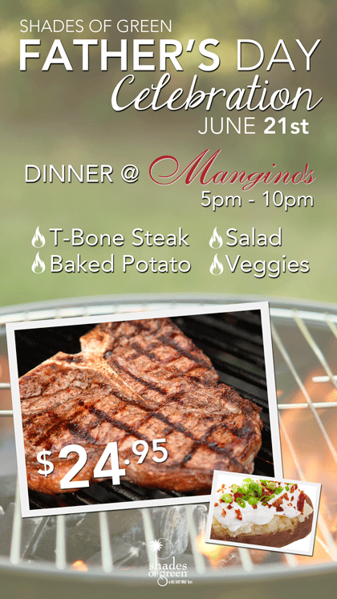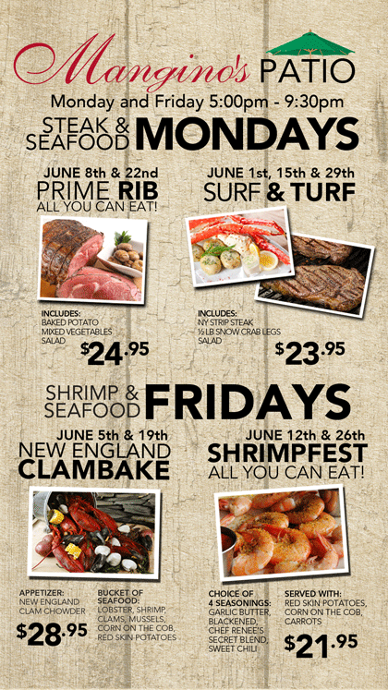

* + 1. Publicity / PR:
       1. Social Media, Web-site, Face Book, Twitter

We will continue to build our social media community through our Web-site, Facebook, Twitter to create awareness of upcoming promotions and events.

* + - 1. Direct E-Mail to Repeat Guest

We will reach out to our customer base through our Reservations System by sending direct e-mail of upcoming promotions.

* + - 1. Monthly Newsletter

We will email guests that have signed up through our web-site to receive monthly newsletter communications with upcoming promotions and events.

* + - 1. ITT Offices

We will send promotions and rack cards to 41 ITT Managers who visited SOG in April 2015 for follow up.

* + - 1. Exchange (AFFES) Marketing Partnership

Partnership with Exchange has allowed us to promote monthly promotions or events on weekly publications.

* + - 1. AFRC Resort Cross Promoting

We will continue to develop relationships with sister properties to create SOG awareness.

* + - 1. Training Base Initiatives

We will visit Military Training bases to promote to incoming recruits.

* + - 1. CYSS and BOSS Program

We will promote to CYSS and BOSS programs and bring their conferences to SOG.

* + 1. Direct Marketing:

SOG guest contact employees are aware of different promotions available throughout the property. Front Desk agents can promote weekly Food and Beverage specials to the guests upon check-in. Ticket Sales Desk agents can cross-sell future meal inclusive room packages or handout a 10% discount lunch coupon at Mangino’s restaurant. Restaurant servers can promote other food and beverage venues. Our Sales Department book the same conference business for the following year. During slow seasons, our Reservations Office emails to future guests and offer a discount rate to extend additional nights.

* + 1. Promotions:

SOG offers special promotions to increase occupancies. We know exactly what months, what weeks and what days we need to promote. Based on the monthly goals and objectives, we offer the best product 365 days out to build basic occupancies.

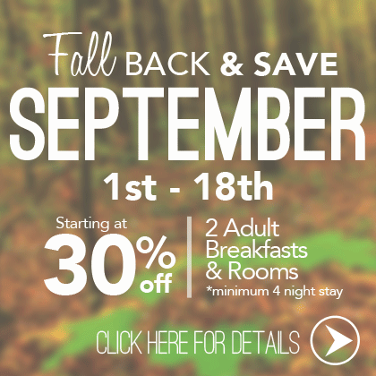

* + 1. Special Events:

SOG offers special events throughout the year and the following represents the top 6 events that are our guests’ favorites.

* + - 1. Thanksgiving Buffett
      2. Christmas Buffett
      3. New Year’s Eve Party
      4. Easter Egg Hunt
      5. Shades of Music in April
      6. Oktoberfest in September
    1. Premium / Promotional Items (Giveaways):

Unlike commercial hotels, we currently don’t give out free promotional items. One of the reason is we don’t deal with commercial tours and travel agencies, online hotel booking companies or conference and meeting planners. We only cater to the Military market and our customers don’t ask for freebies to give us business.

* + 1. Staff / Direct Sales:

SOG Sales and Marketing staff members are trained to sell. They make cold colds to past conference / meeting clients and or point of contacts (POCs) to find out why they stopped using us and to reestablish relationships to book new business.