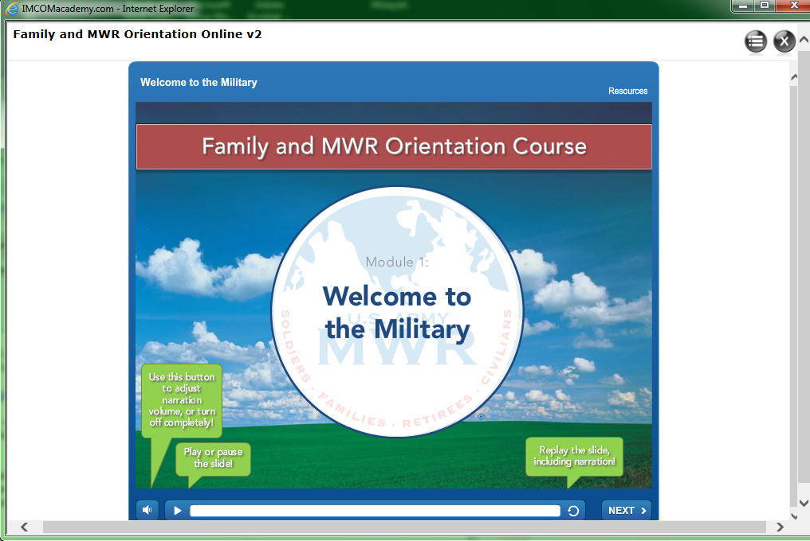

1. There is a very thin grey bar that separates the left window and the right window. The left window is currently in the “collapsed” position.

3. In some versions of IE, you may be able to see this icon, even when the Compatibility Mode if OFF. If you click on this icon, you will see a quick expansion and then collapse of the left window. So follow the [instructions on this web page](http://www.imcomacademy.com/ima/?page_id=7595) to turn on your compatibility mode and then go back to this course and try step #2 again.

2. If you don’t see this icon, you must turn on Compatibility Mode ([instructions on this web page](http://www.imcomacademy.com/ima/?page_id=7595)). If you do see this icon, click on it to toggle the left window.

Internet Explorer only!

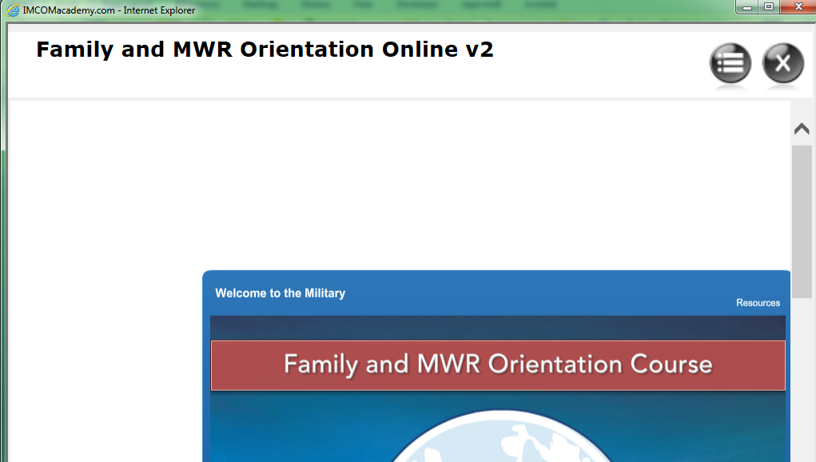

To see the grey bar, you may have to zoom in (use “Control +” keys). When it’s visible, you may be able to grab it and drag it to the right and then use the zoom out short cut (“Control -“ keys) to go back to normal zoom level.

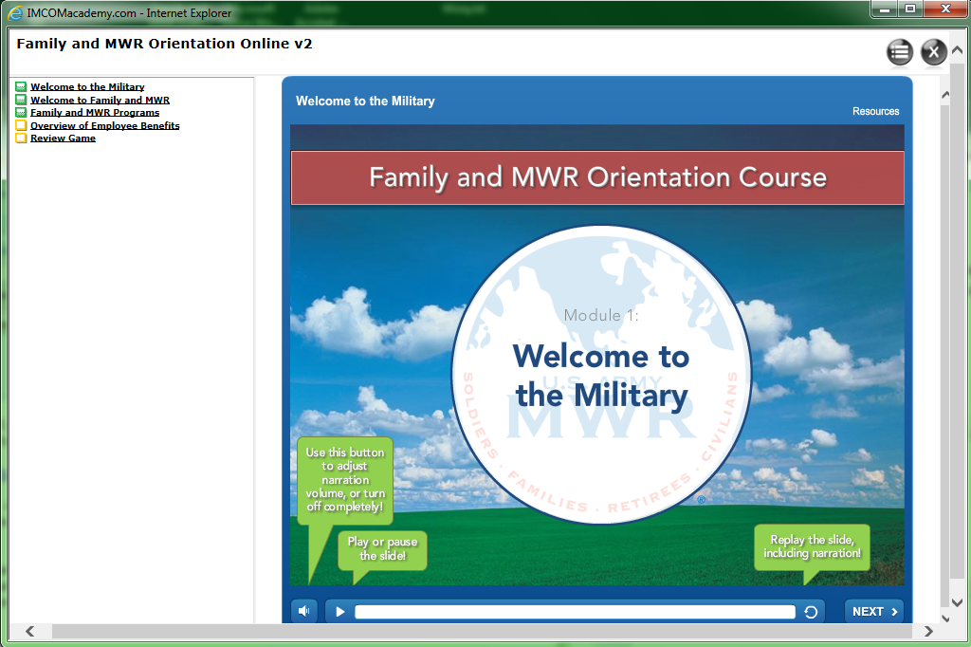

The menu now appears. Click on a link to load the content