This job aid will show you how to run progress reports, export to Excel, sort and interpret results. The goal is to get the number of new enrollments and new completions.
- Progress Report
Query all (select blank in progress Status droplist)

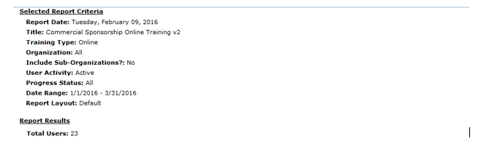
This record shows that the user completed the course within the date range but started before the date range
Select a date range of your choice. (January 1-march 31, 2016)
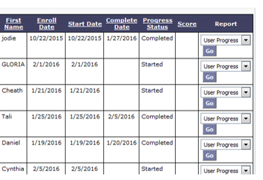
Started and Completed within date range
This record shows that the user started the course within the date range but has not completed the course as of “today”

(Export to Excel and go to step #2)
- View Report in Excel
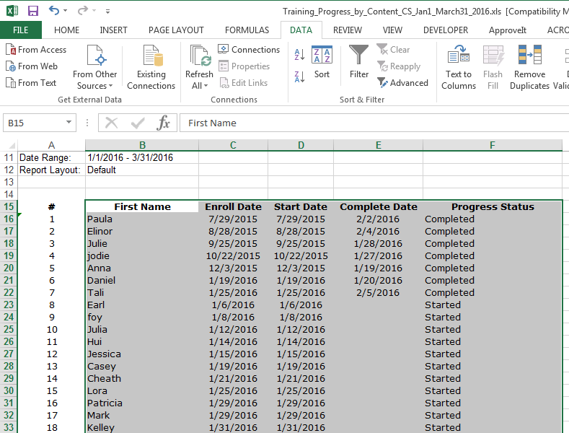
Highlight (select) the entire sheet except the first column

3. Sort Data

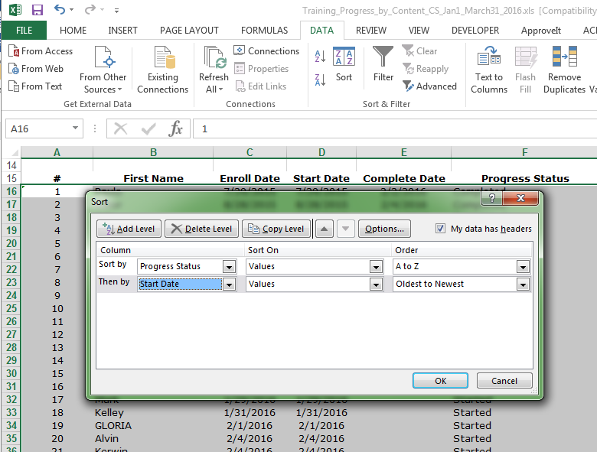
5./Click OK when done
4./Select “Start Date”
3./Click on “Add level”
2./select “progress status”
1./Check this box
Click on this tab to open dialog

- Interpret Results

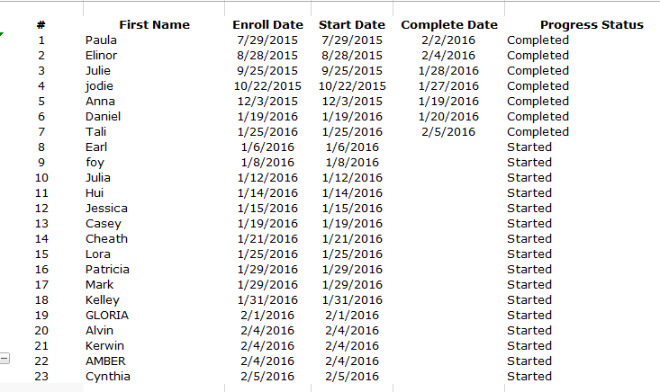
These 18 records represent the total “New Enrollments”. This number includes 2 new completions (Daniel and Tali)
These first 7 records represent the total NEW COMPLETIONS
of the date range
These first 5 records don’t belong to “New Enrollments” because start dates are outside of search criteria

