- Go to www.imcomacademy.com

- Click on the LOGIN banner
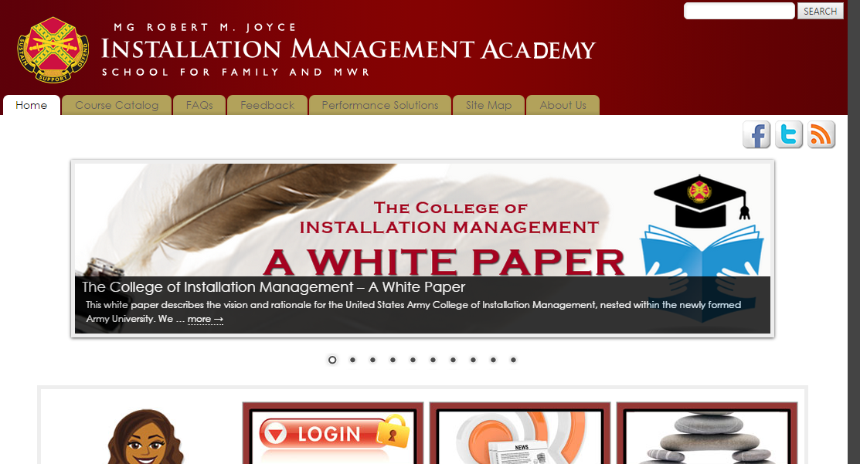

- Click “I Accept”

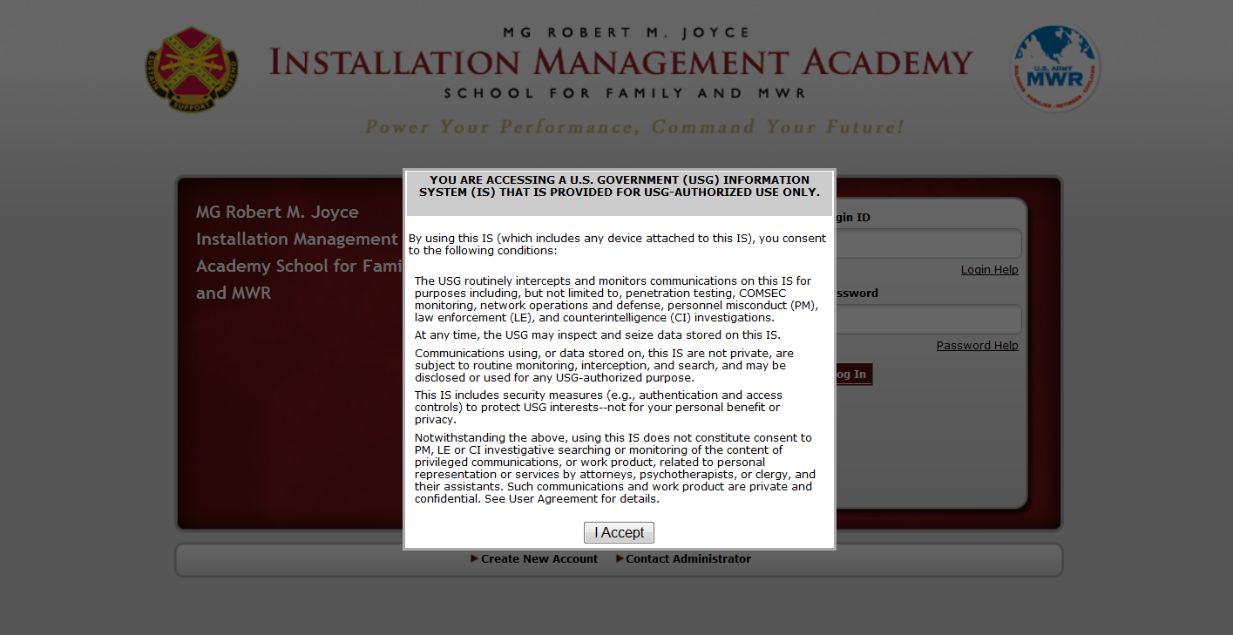

- Click on Password Help (to retrieve login, click on ‘Login help”)

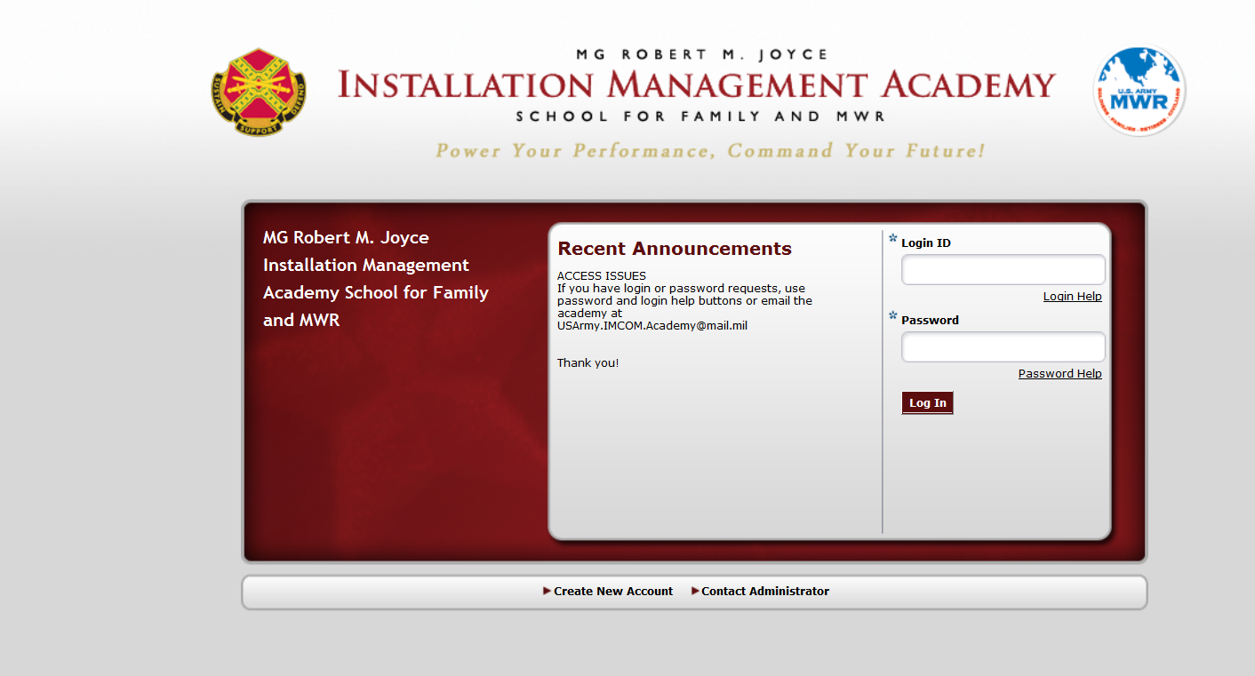

- Enter your Login ID and your email address (the one that you entered when you created your account). Then click on Get Password. (or enter your last name and email to retrieve your login)

- A temporary password will be sent to your email address. Use the temporary password to access your account, then change your password, and update your profile. (or your login ID will be sent to your email)

