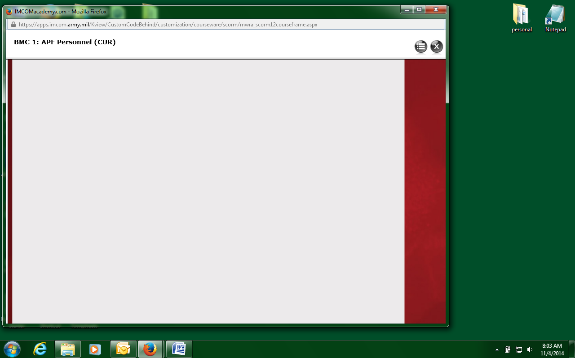

2. Click here to toggle the left window. You will see a slight movement on the left border

1. This grey bar is the divider that separates the left window and the right window. The left window is currently in the “collapsed” position

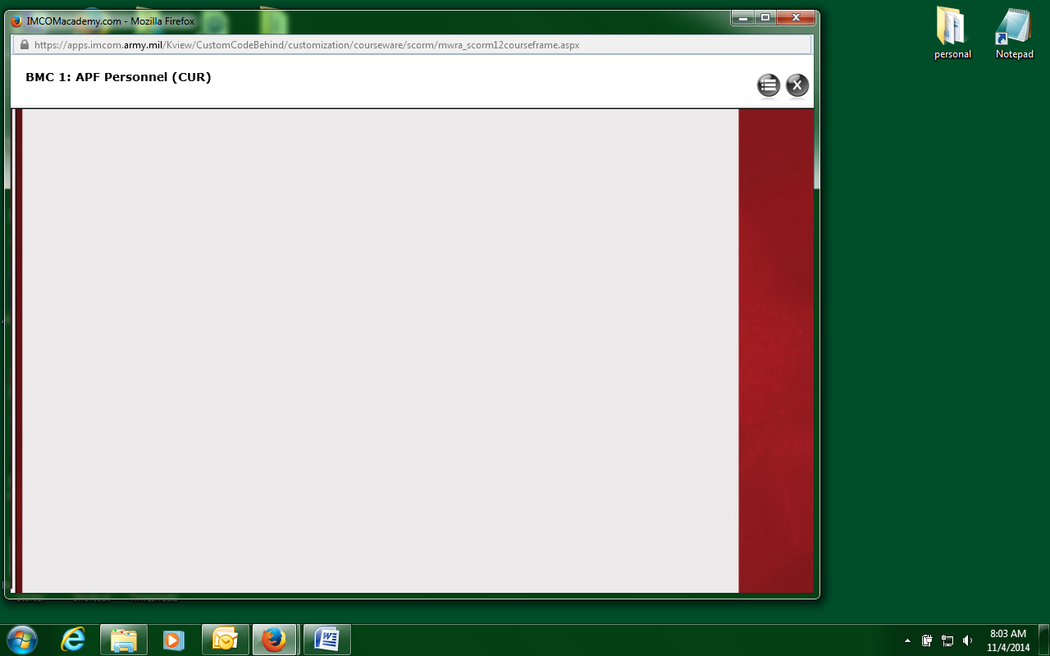

( If you click here again, the maroon bar on the left will disappear.)

5. Position your mouse on top of this grey bar and drag to the right

3. The left window is now in the semi-expanded position. A tiny maroon bar appears on the left of the grey bar.

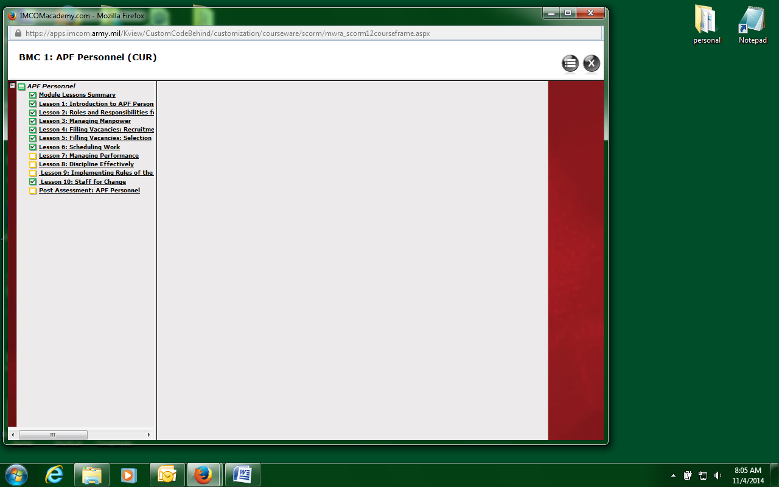

The menu now appears. Click on a link to load the content