Search for “Sharpe Road, TX 78234”

With the appropriate zoom level, our building will be here

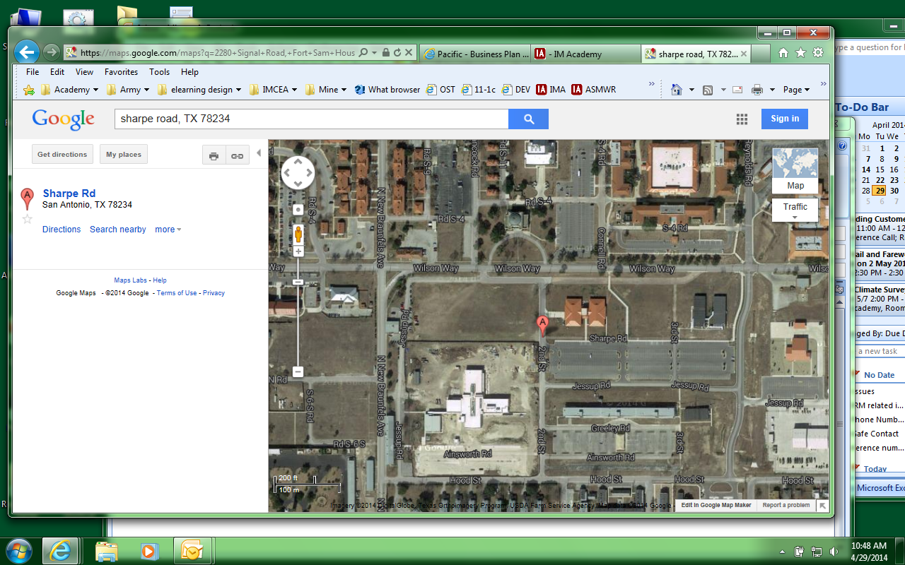

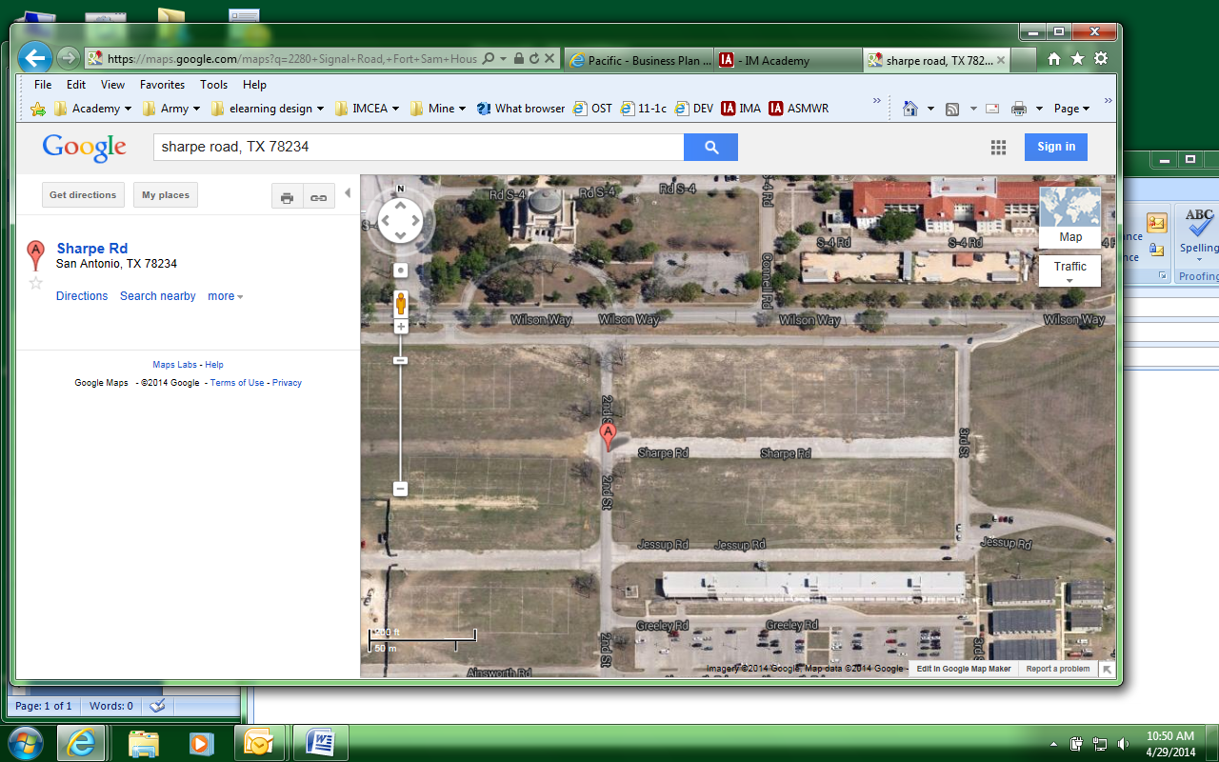

Our building will not be shown if you zoom in.