Contents

Create a new account 1

Finding a Course 8

View your Transcript 10

View your Certificate of Completion 12

Password Helper 13

I forgot my login and/or password 14

11/4/2015

Create a new account

Go to www.imcomacademy.com and Click on ‘Login’ box

Read privacy statement and click ‘I Accept’

If you don’t see the “I Accept” button, you may need to “Zoom Out” of your browser by holding the Control key and tap the minus sign key (or roll your mouse’s wheel up/down). You may have to tap the key more than one time before you can see the “I Accept” button.

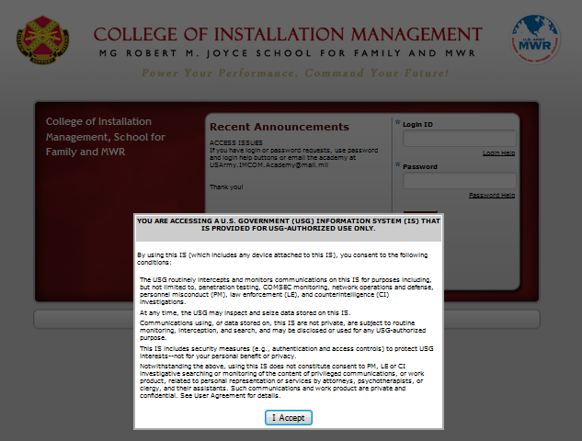

At the bottom left, click ‘Create New Account’

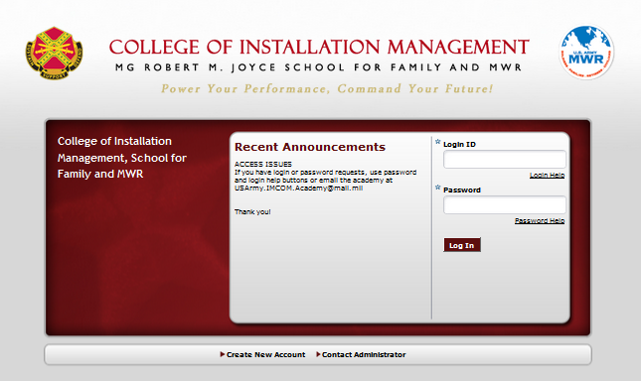

Read consent form, check the box and click next
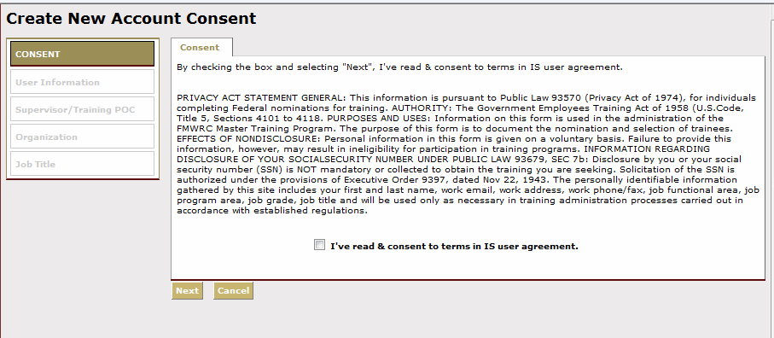

Complete your user information.

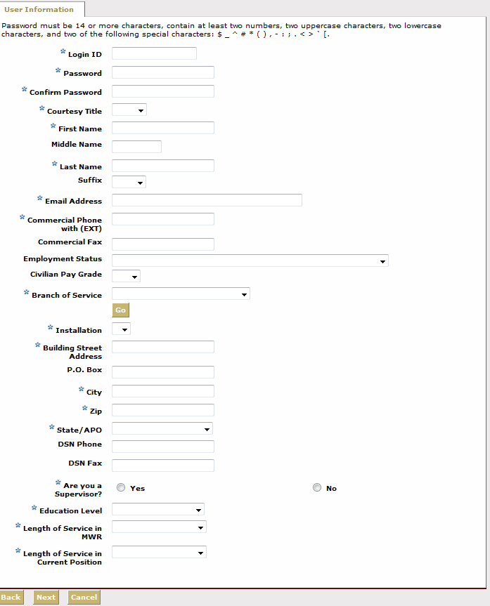
Attention military spouses: These questions apply to your status, not that of your sponsor. What is your pay plan and grade?
E.g. NAF, NA, APF? If
you’re not sure, ask your manager or look at your LES (pay stub).
You must click ‘go’ before anything will appear in the installation field. Scroll down until you find your installation. They are not all in alphabetical order. If you filled out your password above, clicking ‘go’ will unfortunately erase it and you will have to enter it again.
Fill in your password last. If you can’t come up with an acceptable password, use the password helper at the end of this guide.

Enter your supervisor’s name and click search. Once you’ve found your supervisor*, click next.
*Follow the instructions on the screen if your supervisor cannot be determined in the search.

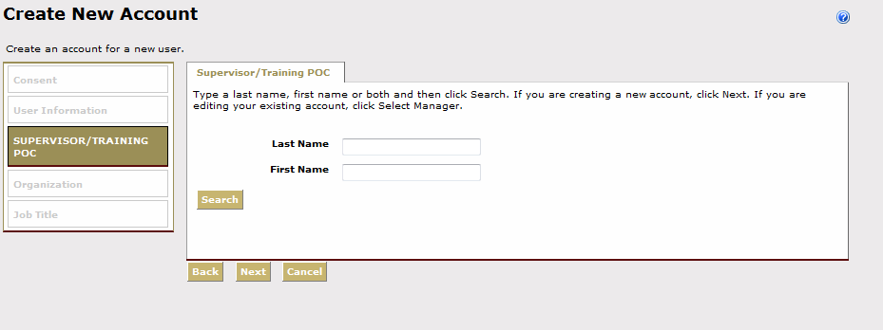

Select your organization and division
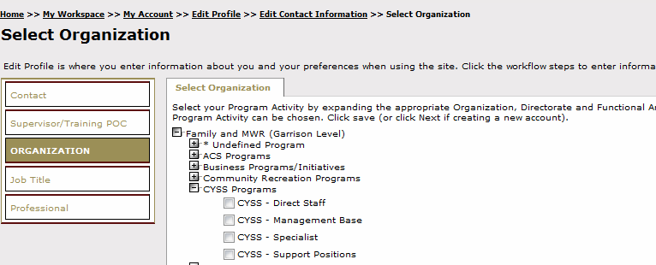
Most Family and MWR employees work at the garrison level. Click the + symbol by Family and MWR (Garrison Level) to drill down to your division. Once you’ve identified your division, drill down again (click + symbol) to select the program that most closely matches what you do. If you are unsure of your organization or division, check with your supervisor.

Finally, select your job title.
Enter your job title in the search box.
Note that only 10 jobs at a time appear on the screen. If you don’t see your job title, click the next page number or enter a more specific search term.
You are encouraged to select a job title with three asterisks (***) next to it. This will be important later when you are completing your individual development plan (IDP)
If you can’t find a job title with three asterisks, please select any job title that is close enough to what you want in order to complete the registration process, then contact our registrar immediately for assistance.

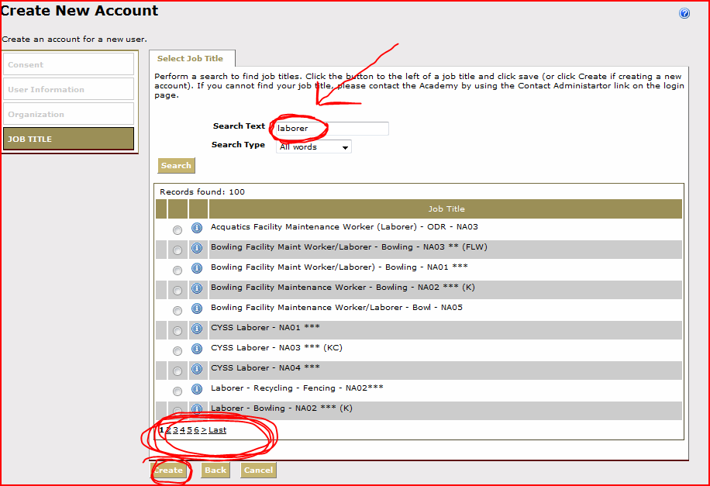

Click create. Now you will be led to the Welcome Screen.

Finding a Course

Hover the mouse over Course Catalog and click the second Course Catalog heading in the drop down menu.
Type in the course title or keywords* and click search.
*Use these keywords to search for common courses:

Family & MWR Orientation Course (keywords: “orientation v2”)
Operation Excellence – Customer Service Training (online) (keywords: “operation excellence v2”)

Click on the course name to access it – not the green, red or blue icons.

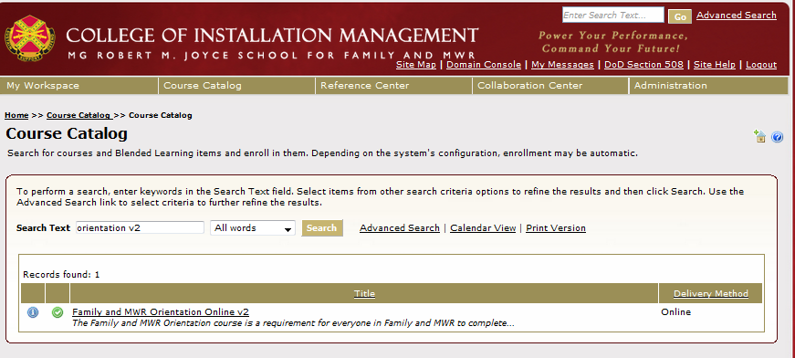

Click Access Item to begin your course.
The ‘View Certificate’ button will be available upon completion.

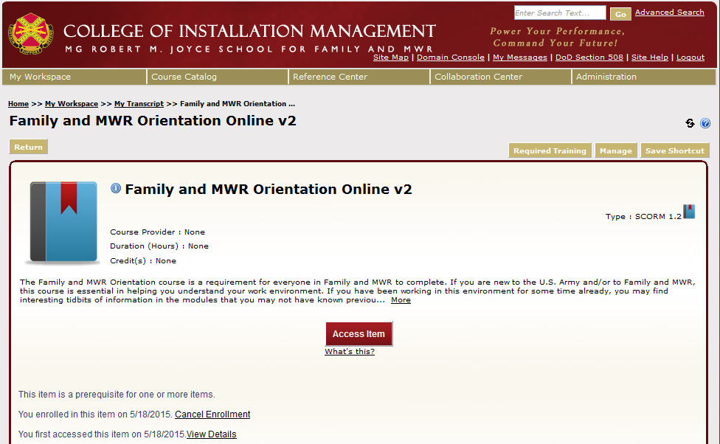

View your Transcript

You don’t need to complete a course all at once. The system will save your work. To pick up where you left off at another time, go to My Workspace > My Transcript.

Click on the course title you wish to resume.

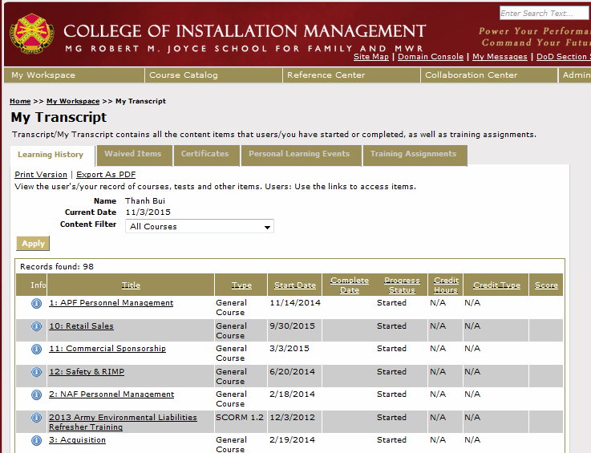

View your Certificate of Completion

Go to ‘Transcripts’ or Course Catalog* to locate your desired course.
*See previous page for instructions on how to do so.
Click view certificate.

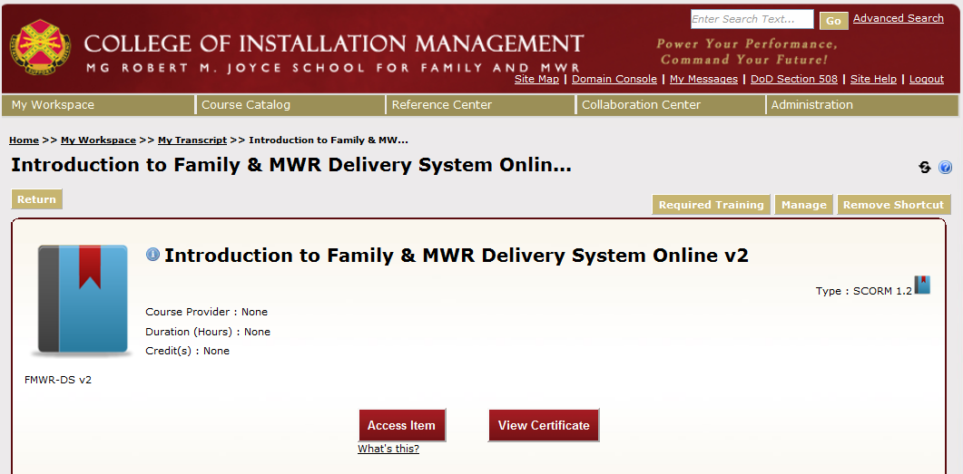

Password Helper

Your password must have AT LEAST 14 characters comprised of at least 2 uppercase letters, 2 lowercase letters, 2 numbers and 2 special characters from this list:

$ _ ^ # * ( ) , - : ; . < > ` [.

_ _ _ _ _ _ _ _ _ _ _ _ _ _
1 2 3 4 5 6 7 8 9 10 11 12 13 14

I forgot my login and/or password

If your email in our system is still valid and available to you, you may use our automate system to reset your password and to retrieve your login. If your email in our system is outdated or no longer accessible to you, please contact our Registrar for assistance.

- Go to www.imcomacademy.com
- Click on the LOGIN banner

- Click “I Accept”
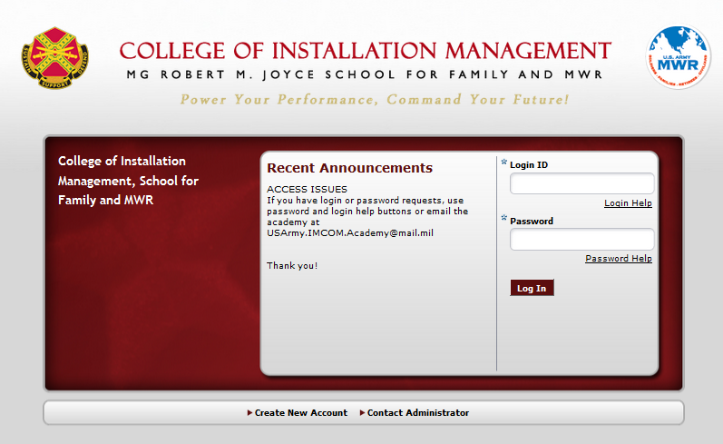
- Click “Password Help” (or “Login Help”)
- Enter your Login ID and your email address (the one that you entered when you created your account). Then click on Get Password. For Login help, you’ll need to enter your last name and email.

- A temporary password (or login) will be sent to your email address. Use the temporary password to access your account, then change your password, and update your profile.

