PROFESSIONAL DEVELOPMENT
PROGRAM USER'S GUIDE
Connect with us by email at USArmy.IMCOM.Academy@mail.mil
or by phone at 210-466-1050.

11/6/2015

Professional Development Program

Table of Contents
Website 101 3
Update Profile 3
Access Professional Development Plan (PDP) 5
Create Individual Development Plan (IDP) 6
- Year Development Plan 7
Career Goals 10
Developmental Goals 11
Career Broadening 11
Signatures 12
View IDP 13
Access Professional Development PLan Library 14
Add Learning Events 15
Add Certificate 18
Access Professional Development Plan Supervisor Console 20
Approve IDP 23

2

Professional Development Program

Website 101
Before beginning please note the following about using the School for Family and MWR Website:
  - A blue asterisk indicates a required field
  - When navigating the site “hover” rather than click until you get to your final destination. At that time click on where you want to go.
  - Avoid using the “back” button on your browser. To return to a previous screen look for the Return button or use the “Breadcrumbs.” Breadcrumbs refer to the black letters at the top of each screen which highlights what part of the website you are currently accessing.

Update Profile
In order for your PDP to populate correctly it is essential you have your profile information correct. Please Ensure your profile is updated by completing the following steps.

If you are not automatically there upon login, perform the following steps: Roll mouse over My Workspace.
Roll mouse over My Account. Click Edit Profile.

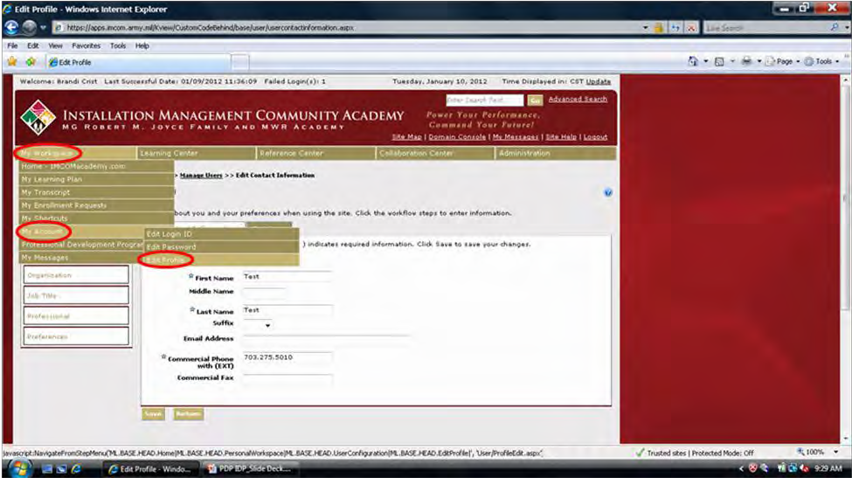

3

Professional Development Program

Click on each of the tabs on the left and complete/update the information shown as needed. Click Save after completing each tab.

Note: When selecting your job title only select a job title with *** next to it

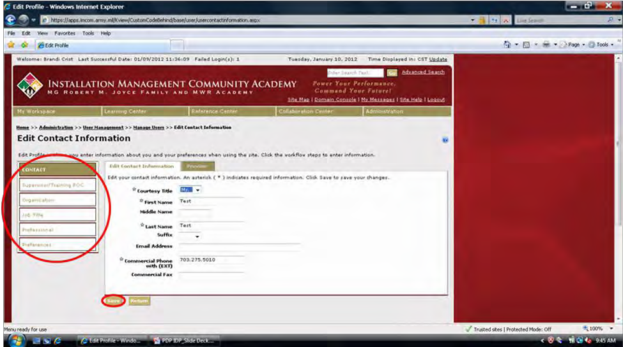

4

Professional Development Program

Access Professional Development Plan (PDP)
The Professional Development Plan is a job specific “menu” that helps you select individual items to add to your IDP. Your PDP will highlight trainings, books, and other resources to assist you in your career development. Before creating your IDP you will want to review your PDP and look for items that you would like to add to your IDP.

Roll mouse over My Workspace.
Roll mouse over Professional Development Program. Click Current PDP.

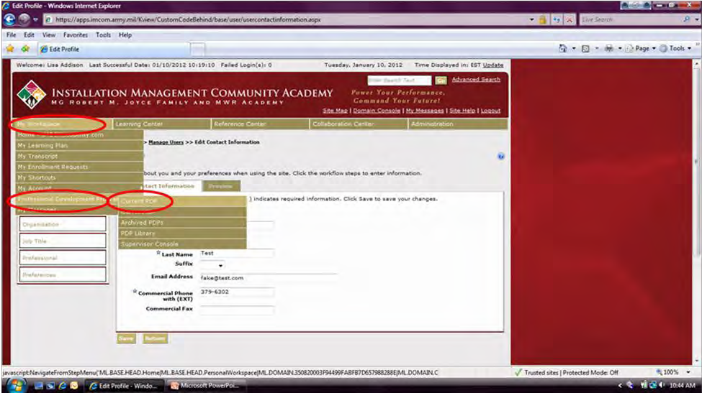

In order to expand the view of the PDP, click the box next to Learning Elements. Click Refresh PDP.

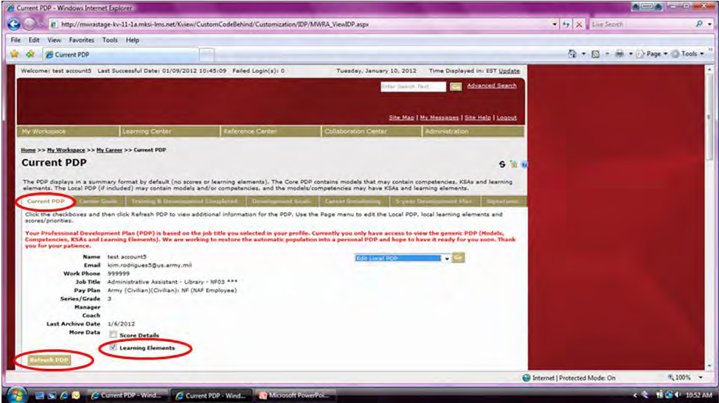
5

Professional Development Program

Click the (plus sign) next to the Model Competencies and Core Competencies to expand them.
- indicates Model Competencies. Click on the box for description.
- indicates Core Competencies. Click on the box for description.
- indicates Knowledge, Skills, Abilities (KSAs).
- indicates Learning Elements. Click on the title of the element for information.

Note: Learning Elements will be trainings, books and resources that will assist you in your career development. You will be able to add these specific learning elements to your IDP. To find out more information about each learning element click the link. Write down the learning elements you would like to work on and we will next show you how to add them to your IDP.

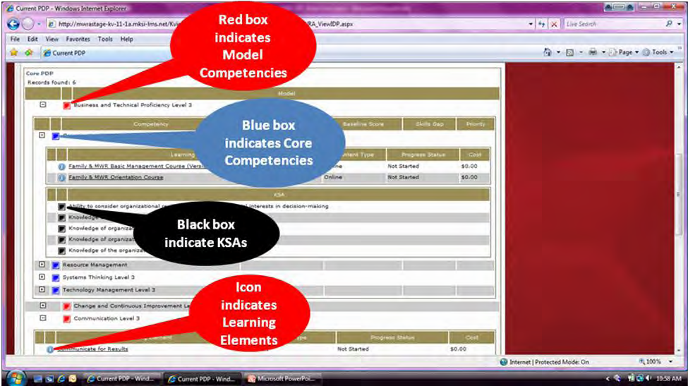

Create Individual Development Plan (IDP)
The Individual Development Plan is your opportunity to customize your career development. Here you will “select” items from your PDP “menu” and add in career development goals and opportunities to create a plan that is customized to your needs.

Click on each of the tabs and complete the required information in order to create an IDP. Go to the 5- Year Development Plan tab first so you can add your learning elements.

NOTE: We need to add the learning elements first so that you IDP populates correctly.

6

Professional Development Program

5-Year Development Plan: Select Learning Elements to add to the IDP.
In order to add a new element, ensure Edit Five Year Development Plan is showing in dropdown. Click GO.

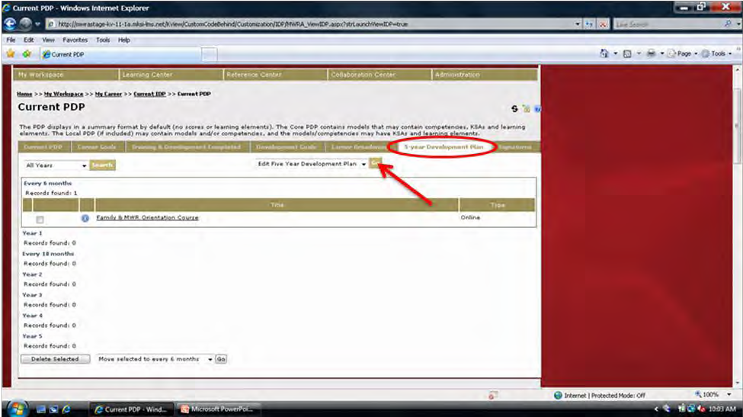

All Learning Elements from the current PDP will be listed.
In order to narrow the search, type a keyword in the Search text box. (Optional: Select a Content Type from the dropdown.)
Click Search.

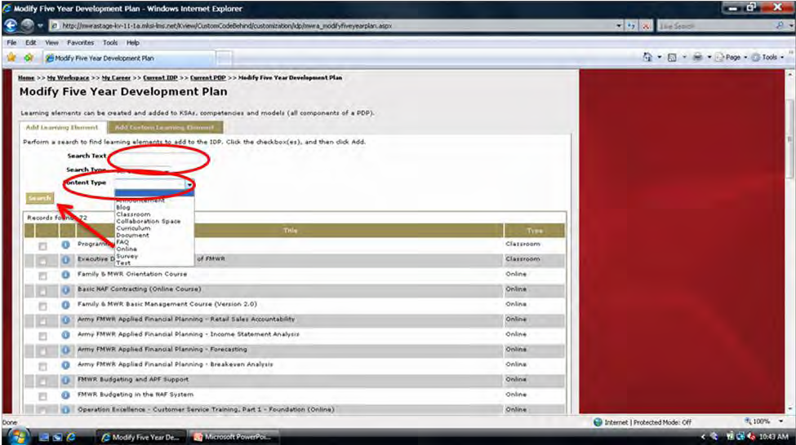

7

Professional Development Program

Click the box next to the element to be added to the IDP.
Click the dropdown arrow at the bottom of the page in order to select the year.
Click Add To. Note: Items can only be added one page at a time to one year at a time. Continue adding Learning Elements for the timeframe chosen.
Click Return to view the plan.

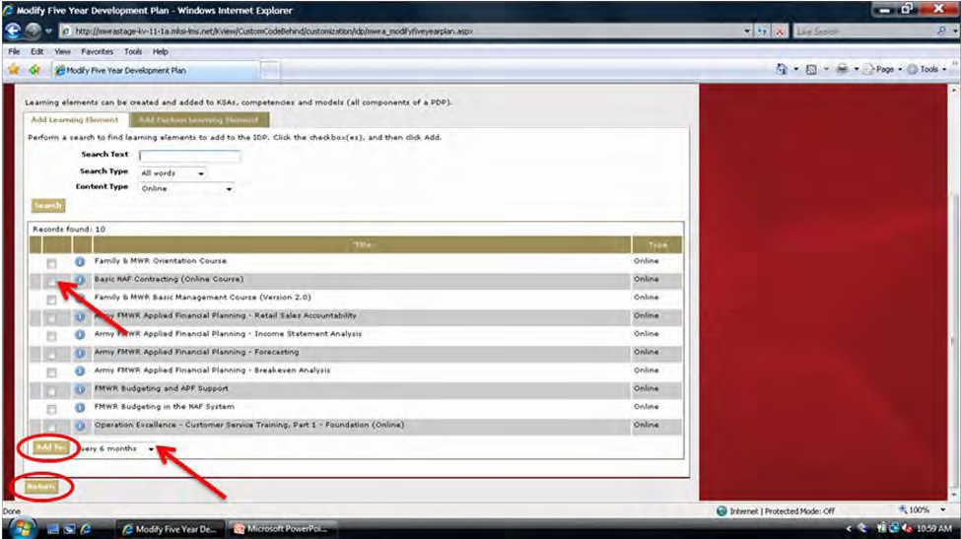

Remove items by clicking on the box next to the title.
Click the Delete Selected button at the bottom of the page.
Move selections around once they are listed by clicking on the box next to the title and choosing a different year from the dropdown (on bottom).
Click GO.

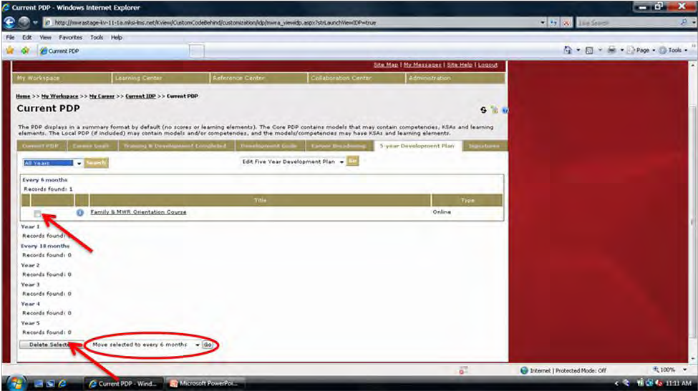

8

Professional Development Program

OPTIONAL: Installation-specific Learning Elements can also be added.

Ensure Edit Five Year Development Plan is showing in dropdown. Click GO.

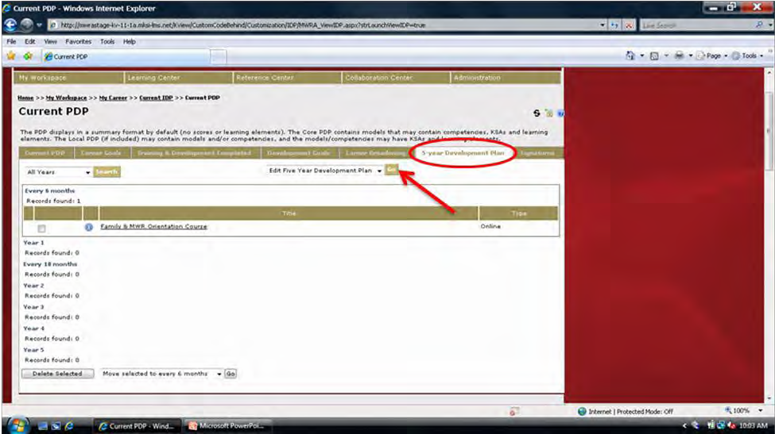

Click on the Add Custom Learning Elements tab.
Type in the name of the training (i.e., SHARP, AT-Level 1, etc.). Click Add.
Click Return to view the plan.

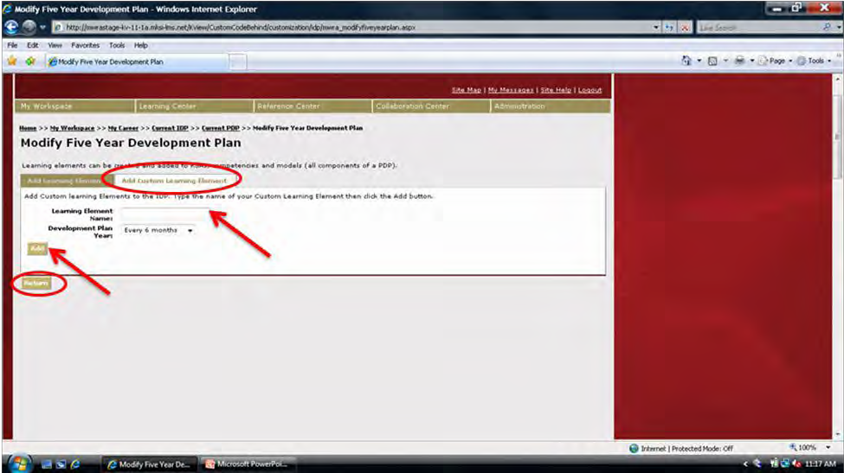

9

Professional Development Program

Career Goals: Type in short- and long-term goals.

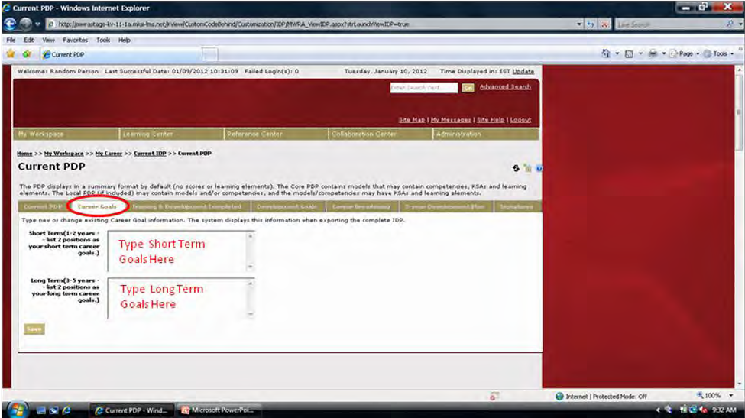

Training and Development Completed: This is a list of training and/or development work completed through the Academy or entered as personal learning events (see Add Learning Events, page 15).

Note: At this time, training completed prior to 2003 is not listed.

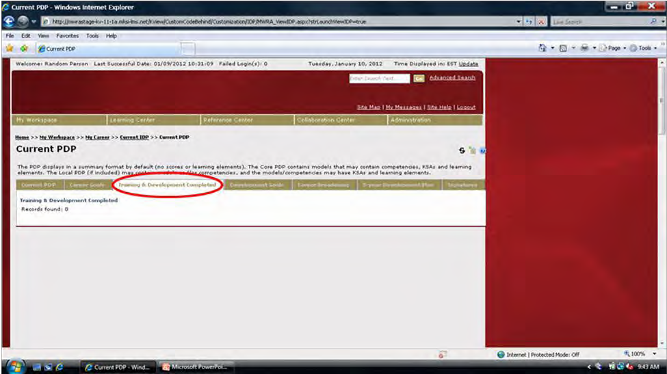

10

Professional Development Program

Developmental Goals: Enter goals and desired outcomes including educational, training, and/or resources needed to reach those goals. These goals should be accomplished within the next 12 months. In addition, enter desired outcome for each goal.

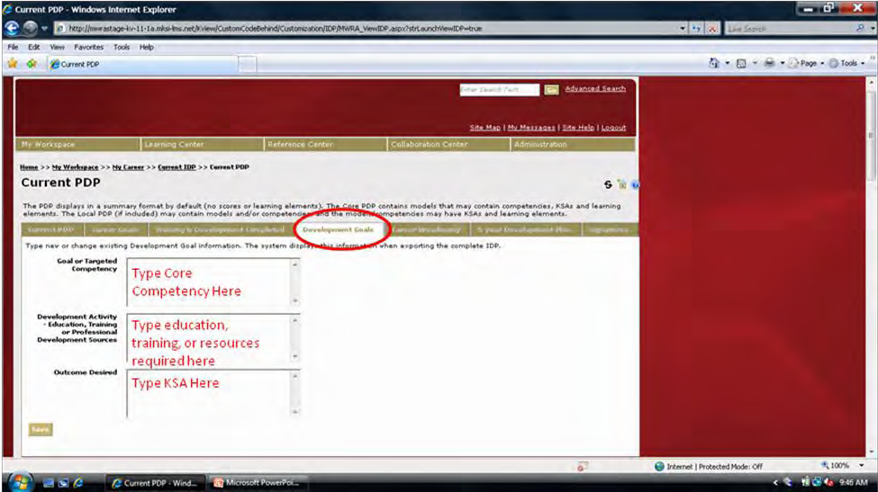

Career Broadening: List desired developmental assignments if applicable.

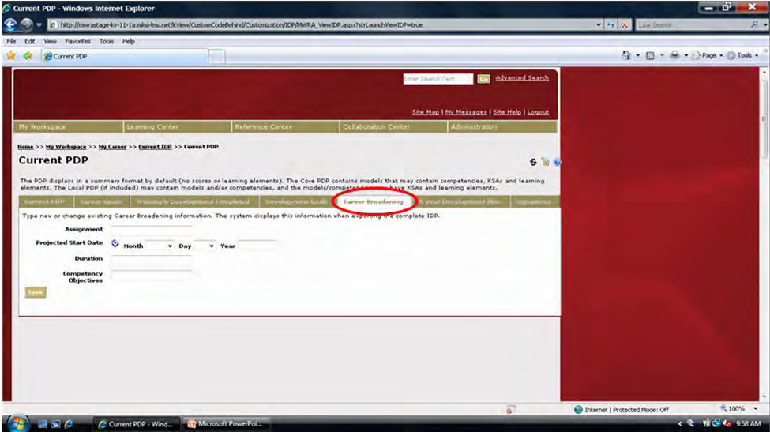

11

Professional Development Program

Signatures: Ensure supervisor’s information is correct.
NOTE: If information is not correct, employee and/or supervisor profile must be updated. Select a date.
Click Save.
Click Send IDP to Supervisor for approval.

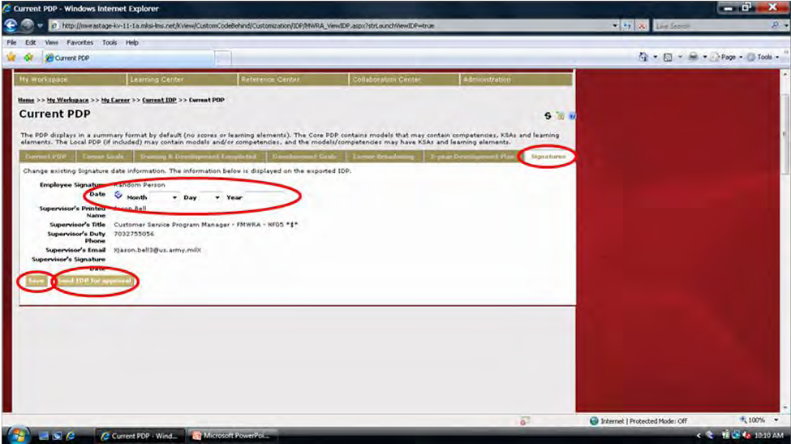

Congratulations!
You have successfully completed and submitted your IDP!

12

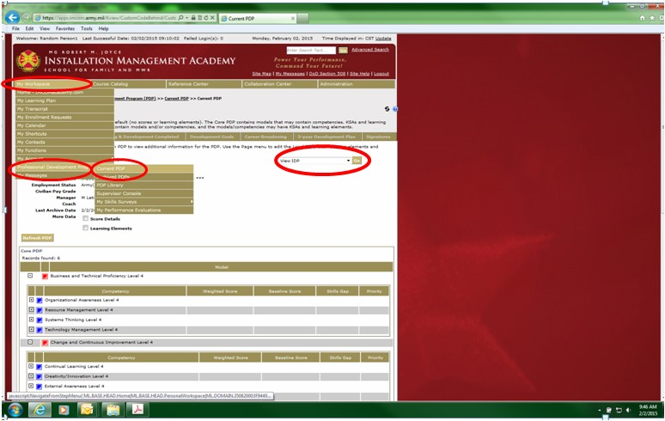Professional Development Program

View IDP
After completing your IDP you have the opportunity to go back and view it or print it.

Roll mouse over My Workspace.
Roll mouse over Professional Development Program. Click Current PDP.

Locate View IDP in the text box to the right. Click Go.

13

IDP can be printed or saved to desktop. To make changes, return to Current PDP.

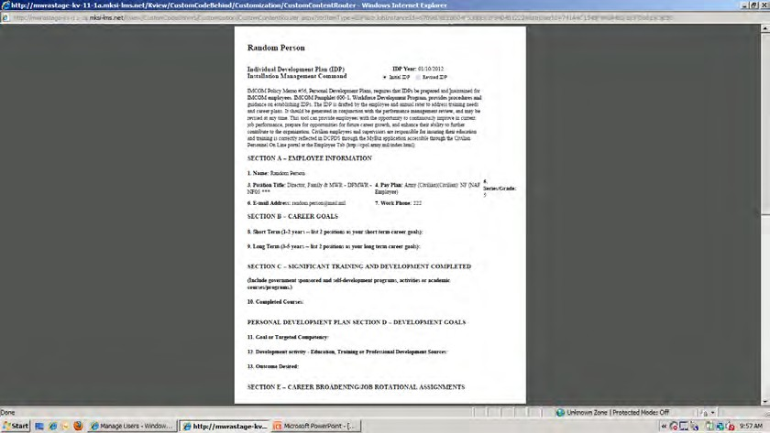

Professional Development Program

Access Professional Development Program Library
The Professional Development Program Library allows users to view PDPs for any position in Family and MWR. This is helpful for those who would like to broaden their careers by moving into other positions.

Roll mouse over My Workspace.
Roll mouse over Professional Development Program. Click PDP Library.

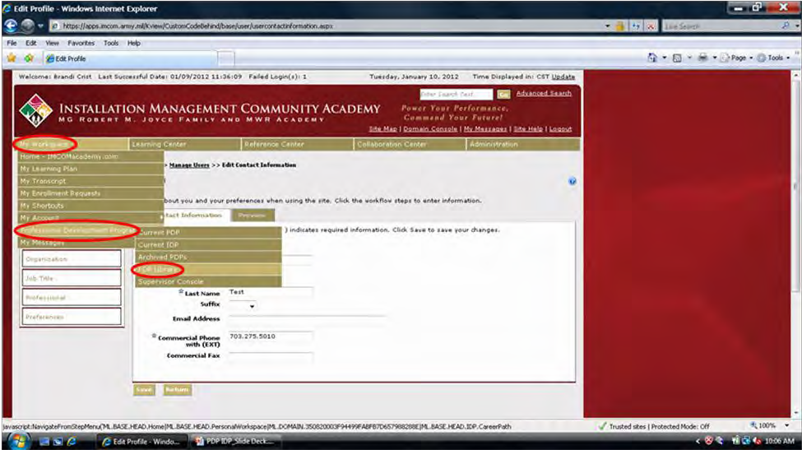

Click Search leaving Search Text field blank in order to pull up ALL PDPs. In order to find a specific PDP, type in keyword(s) in Search Text field.
Click Search.

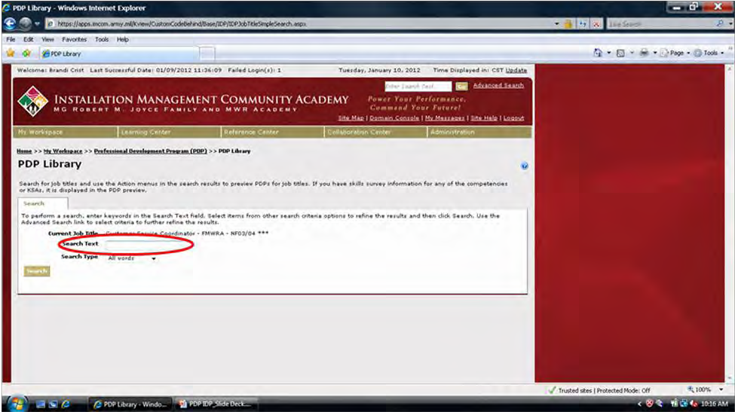

14

Professional Development Program

On right under Action, ensure Preview PDP is showing in dropdown. Click GO.

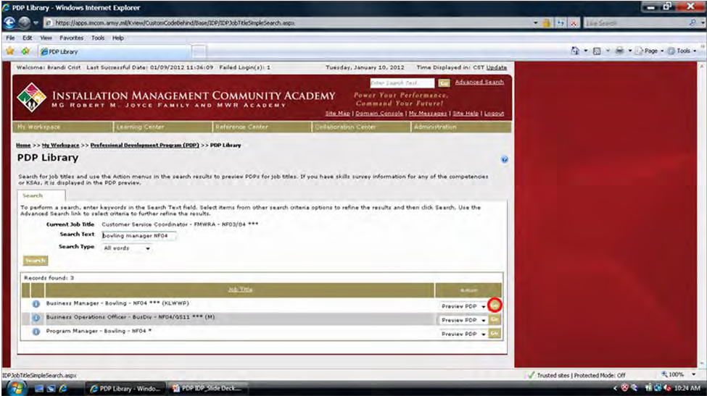

In order to view PDP with Learning Elements, click Learning Elements box. Click Refresh PDP.

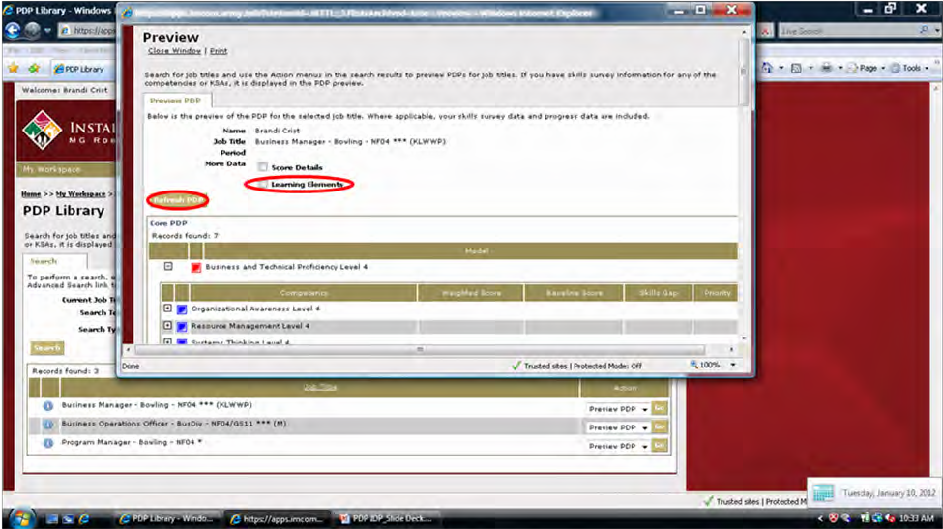

15

Professional Development Program

Click the (plus sign) to expand each competency and to view KSAs and Learning Elements.

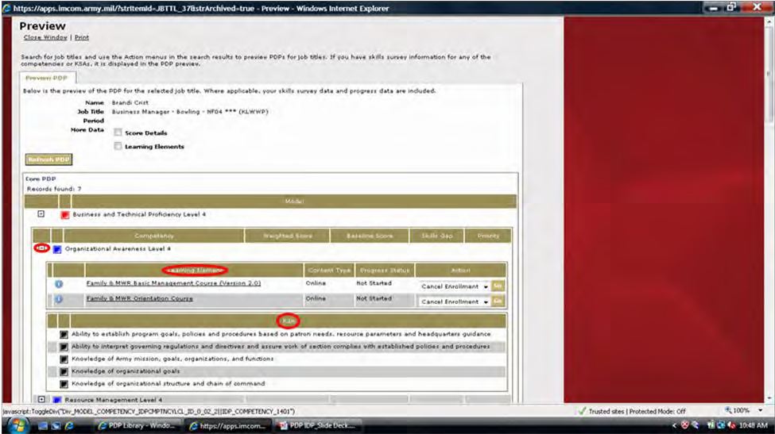

Add Learning Events

All users are able to add Learning Events, if they choose, that have taken place outside of the School for Family and MWR Website. This may include local trainings, conferences, workshops, etc.

Roll mouse over My Workspace. Click My Transcript.

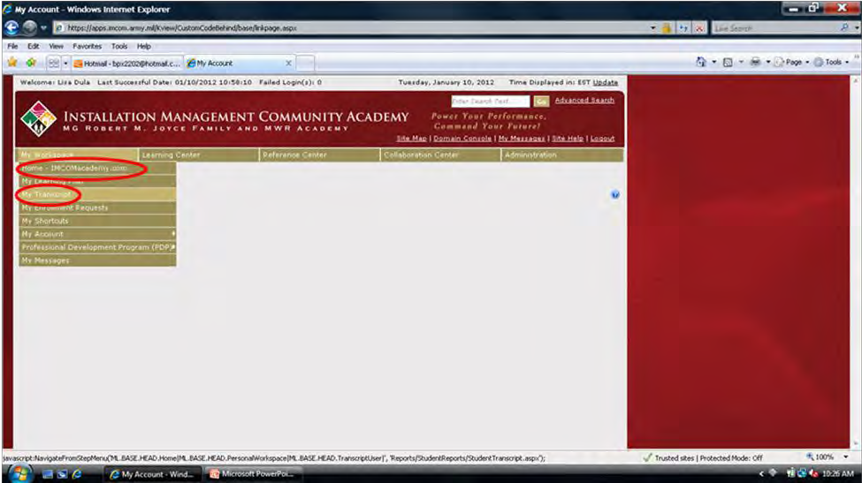

16

Professional Development Program

Click Personal Learning Events.
Ensure Manage Personal Learning Events is showing in dropdown. Click GO.

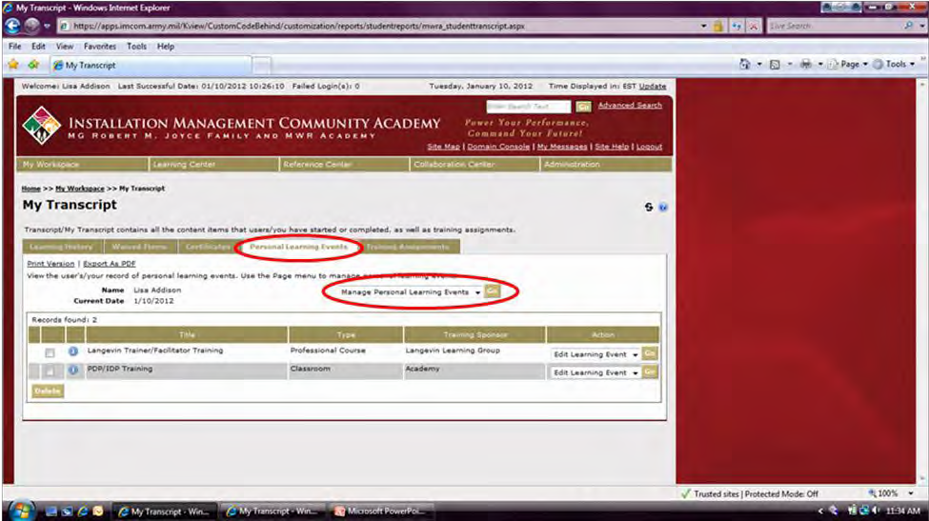

Ensure Create New Learning Event is showing in dropdown. Click GO.

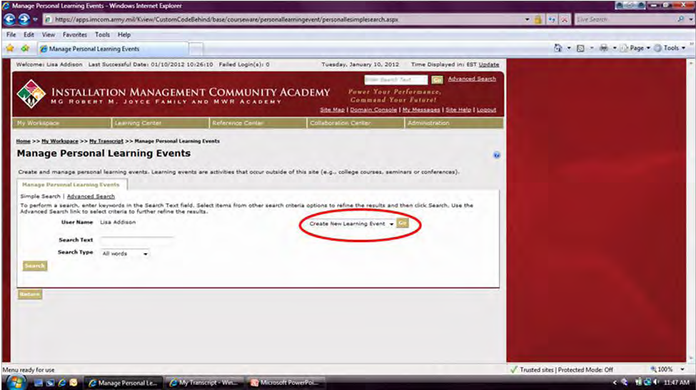

17

Professional Development Program

Complete all necessary fields. All fields with * are required. Click Create.

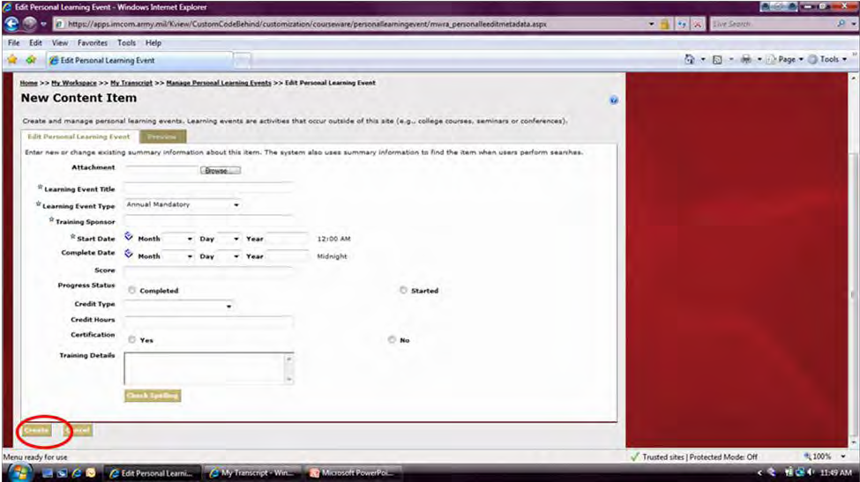

Employee and supervisor will receive an email confirming that training has been added.

Add Certificate

All users are able to add Certificates, if they choose, from events that have taken place outside of the School for Family and MWR Website. This may include local trainings, conferences, workshops, etc. Please note that these certificates will not be included in your IDP form. If you need to include your certificates in your IDP form, please use the “Personal learning Events” tab.

Roll mouse over My Workspace.
Click My Transcript.

18

Professional Development Program

Click Certifications.
Ensure Add New Certificate is showing in dropdown. Click GO.

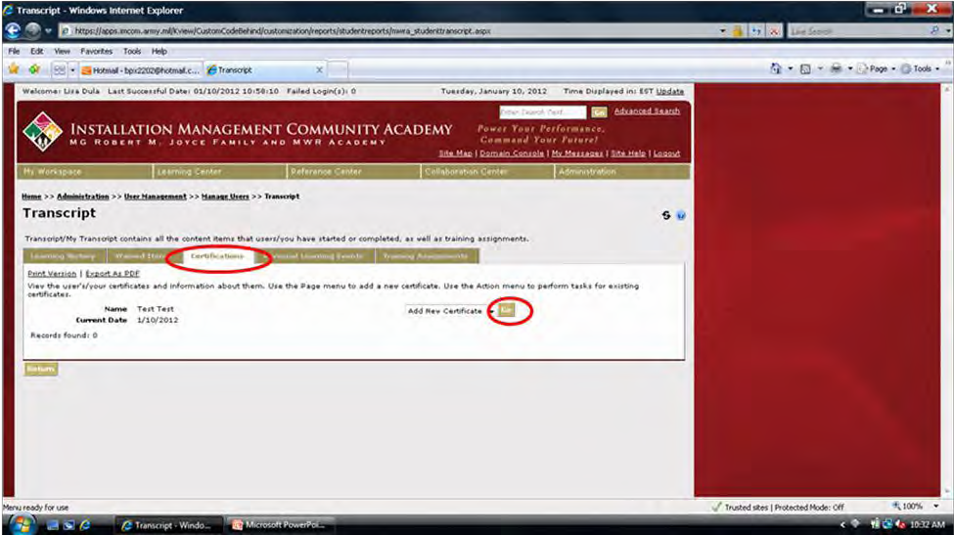

Click Browse to locate certificate image on your computer. Complete all necessary fields. All fields with * are required. Click Add.

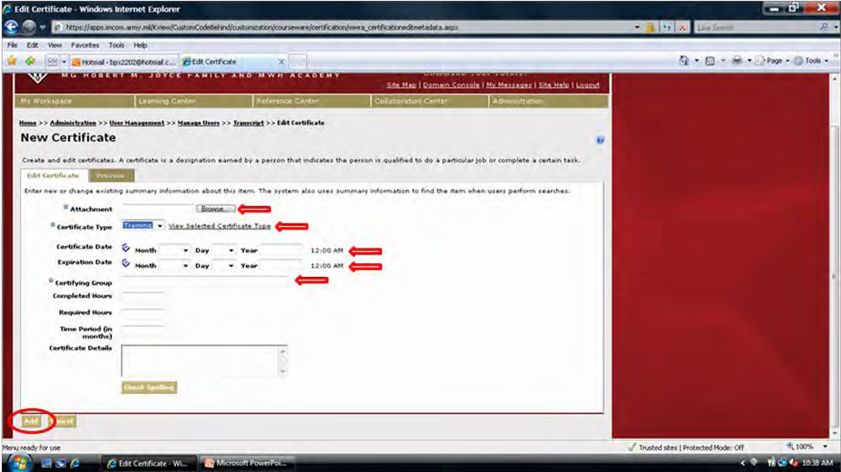

Employee and supervisor will receive an email confirming that training has been added.

19

Professional Development Program

Access PDP Supervisor Console
The Supervisor Console is for supervisor’s use. It allows you to view Team Members’ PDPs, IDPs and their transcripts.

Roll mouse over My Workspace.
Roll mouse over Professional Development Program. Click Supervisor Console.

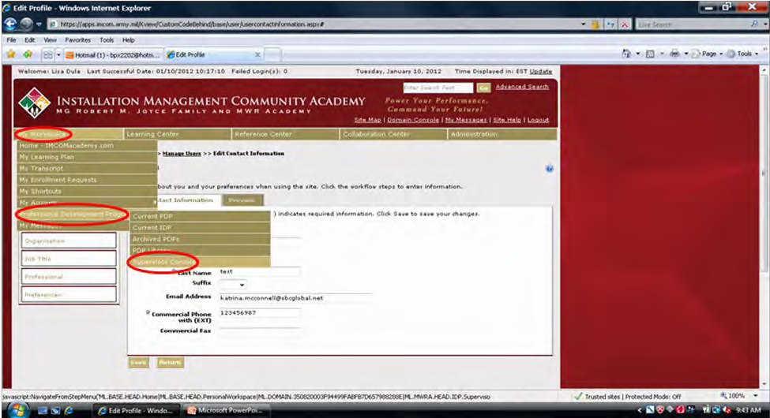

A list of employees that you supervise will appear. If list is not correct, then employee(s) need to update their profiles to connect to correct supervisor.
On right under Action, use dropdown to select option to view supervised employee’s IDP, PDP, or Transcript.
Click GO.

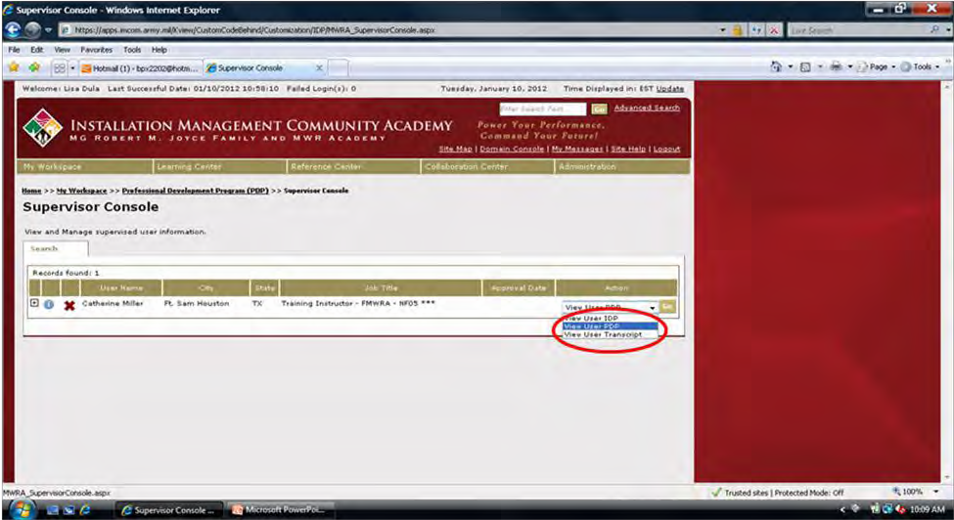
20

Professional Development Program

Use breadcrumbs located under tabs in order to return to Supervisor Console (Home >> My Workspace >> My Career >> Supervisor Console).
Select another option in dropdown for same employee or select option for a different employee.

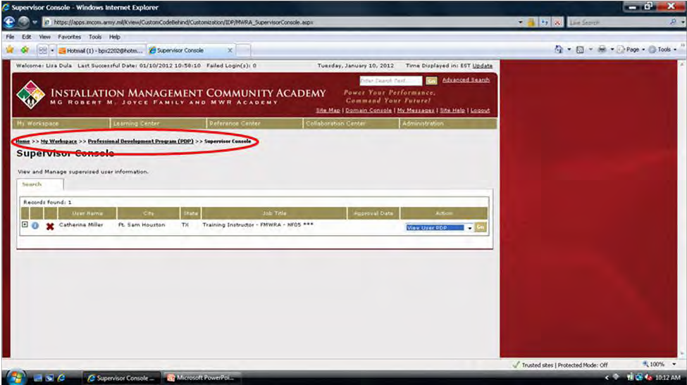

Approve IDP
Roll mouse over My Workspace.
Roll mouse over Professional Development Program. Click Supervisor Console.

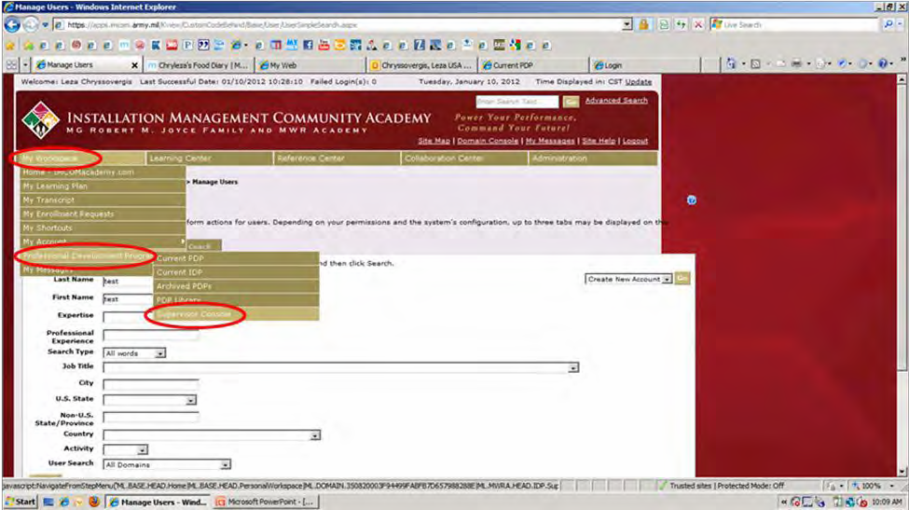

21

Professional Development Program

A list of supervised employees will appear.
On right under Action, ensure View User IDP is showing in dropdown. Click GO.

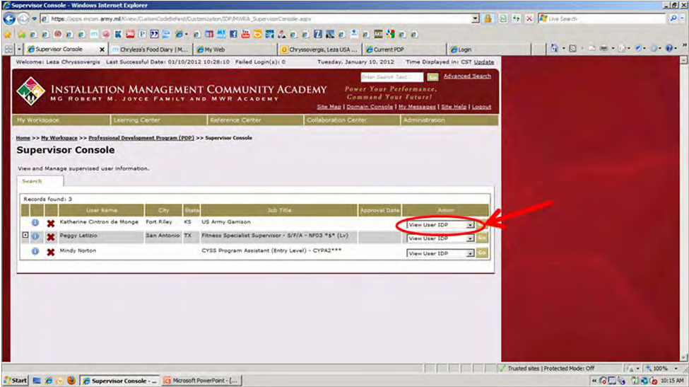

IDP will launch in a new window.
After reviewing for correctness, scroll down to bottom of form. Click Approve or Deny.

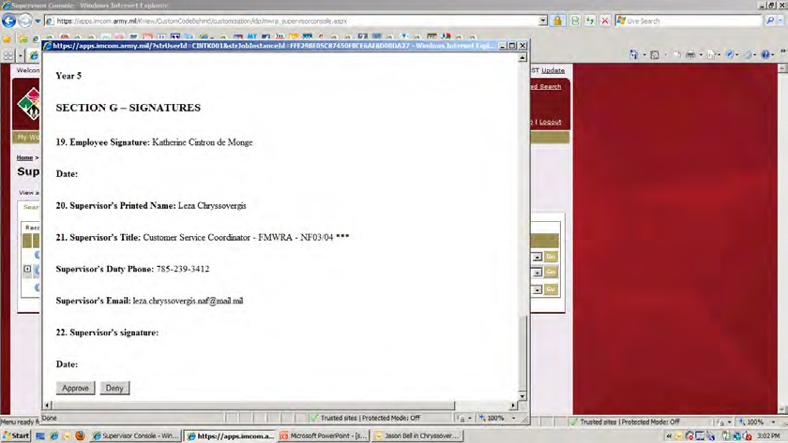

If IDP is approved, an email is generated to employee notifying of approval status.
If IDP is denied, an email is generated requesting that employee contact supervisor to discuss IDP.

22

Professional Development Program

NOTE: If supervised employees are also supervisors, click the (plus sign) to left of their name to view their employees.

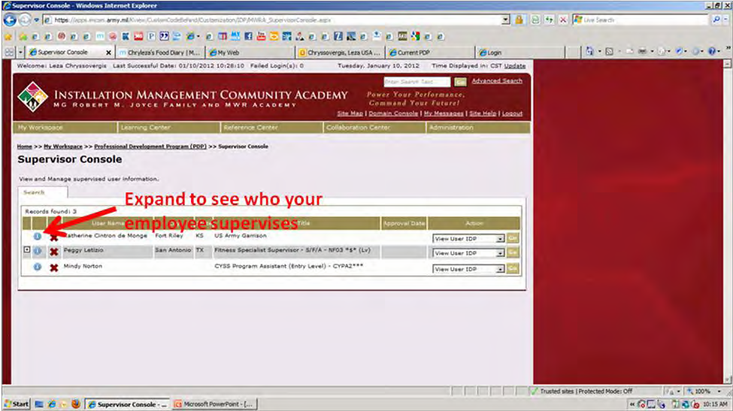

23

