Approval Console

11/5/2015

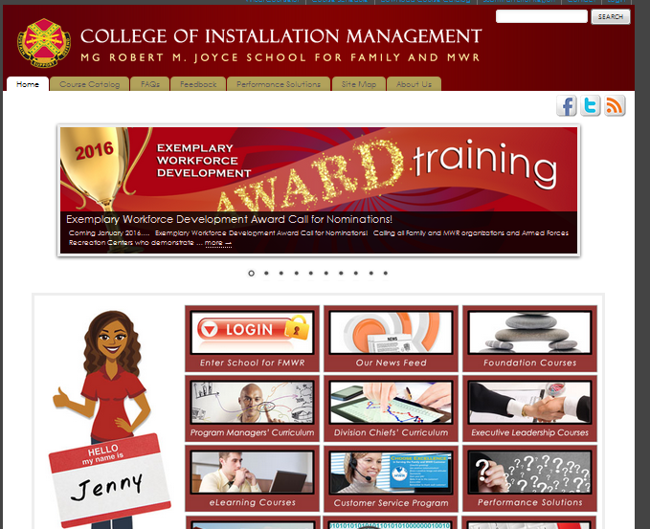
Go to www.imcomacademy.com and Click on ‘Login’ box

Read privacy statement and click ‘I Accept’

If you don’t see the “I Accept” button, you may need to “Zoom Out” of your browser by holding the Control key and tap the minus sign key (or roll your mouse’s wheel up/down). You may have to tap the key more than one time before you can see the “I Accept” button.

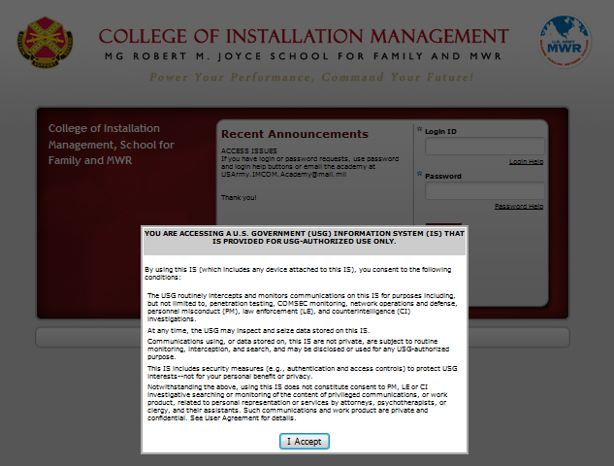

Login

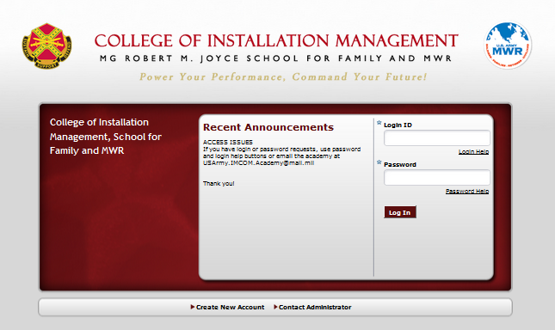

If you are a supervisor or admin, roll your mouse over the "Administration" tab on the top navigation and select "Approve Console"

Click on the search button

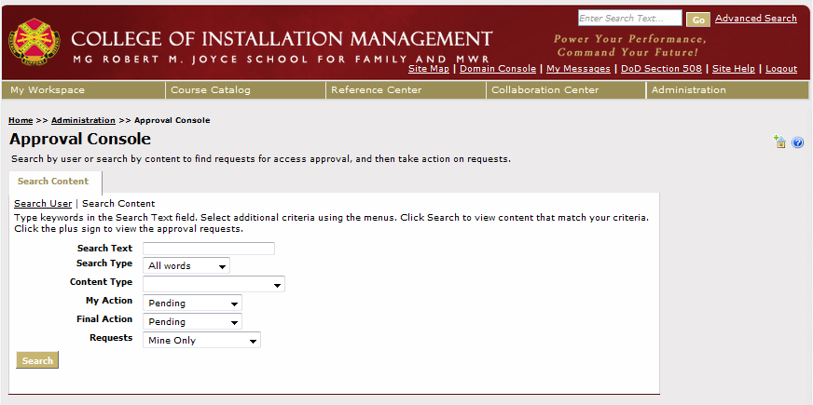

On the results page click on the "+" sign before the name of your employee(s) to see more option.

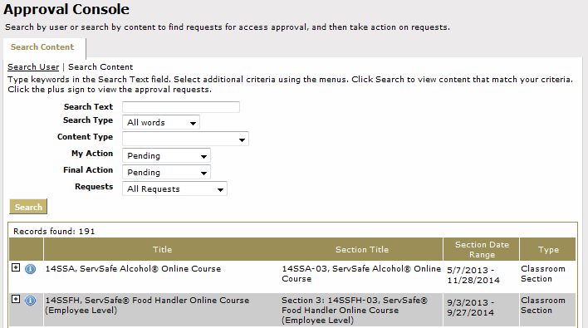

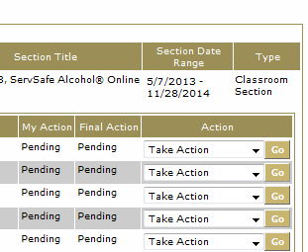
Click "Go" button at the end of each record and follow instruction to approve or deny the request

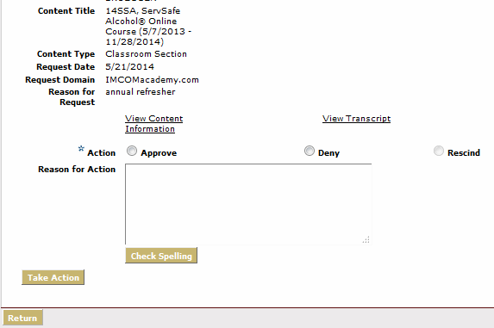
Enter the reason for approval/disapproval and click on “take action”, then click “return” to go back to the previous screen to approve other requests or to exit the web site.

