GO TO FMBS located within the MWR Portal at https://cloud.mwr.army.mil/

Select FMBS Web

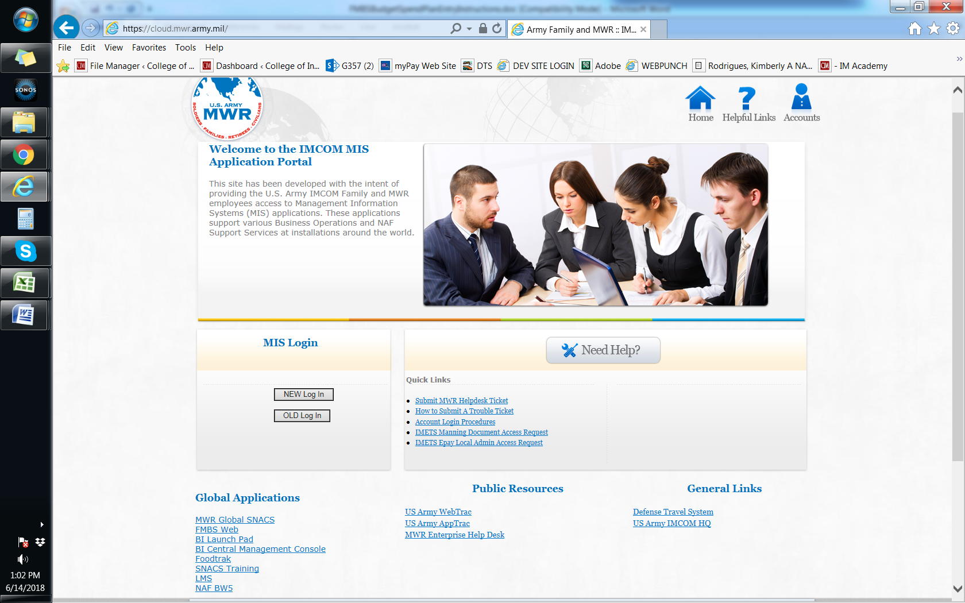

Select Budgets and AOB Data Entry
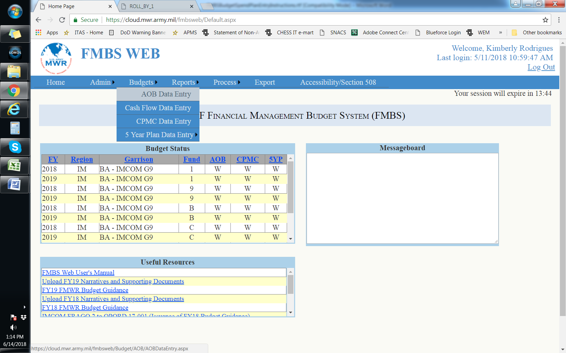

Select Year
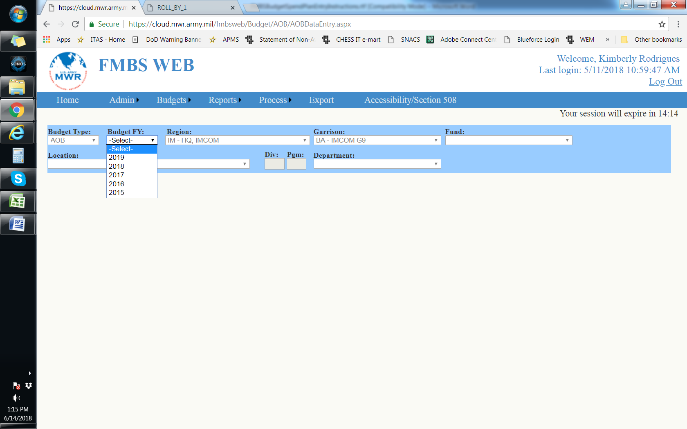

Then Location and Department Codes for your program
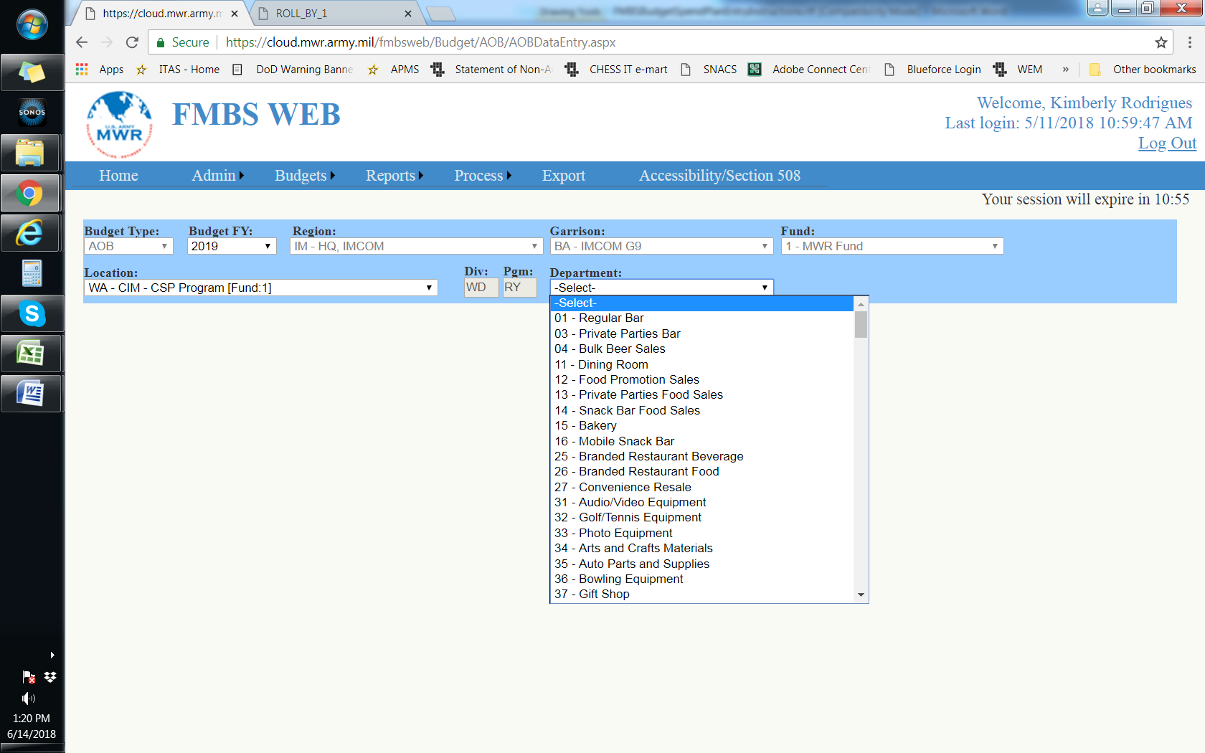

ENTERING FINANCIAL DATA.

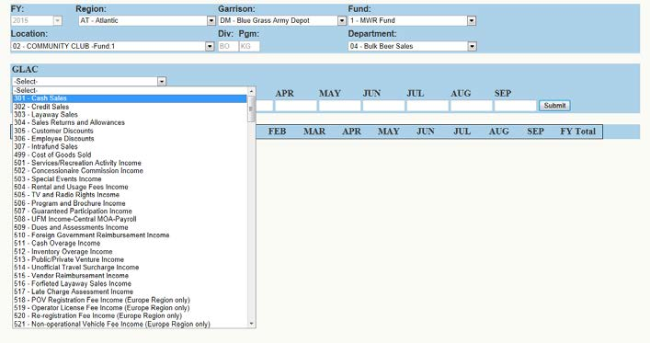Select the GLAC in which data will be entered from the dropdown menu.
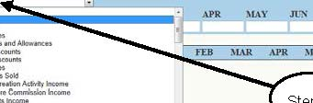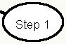Step 1

Example:
301 – Cash Sales.

Select GLAC from Budget Input Screen

Methods of selecting a GLAC from the Data Input Section (3 methods):

• Method 1: While GLAC selection is highlighted, but not opened up, type the first number of the GLAC and the selection will jump to the first number in the GLAC series. Then open up the drop down menu and select the GLAC desired without having to scroll through all the GLACs. Example. Want to use GLAC 605. Type in “6” and the GLAC selection will go to GLAC 601; the select GLAC 605 from the dropdown menu by clicking on GLAC 605.
• Method 2: Open the GLAC selection dropdown menu and type in the GLAC desired. Hit the TAB or ENTER key and the GLAC will be selected. Example: Want to use GLAC 605. Open drop down menu, type in “605” and hit the “Tab” key. GLAC 605 will be selected.
• Method 3: Open the GLAC selection drop down menu and scroll down to the GLAC you want to use. Click on the GLAC and it will be selected.

STEP 2. Enter budget data for each month.

Step 2
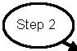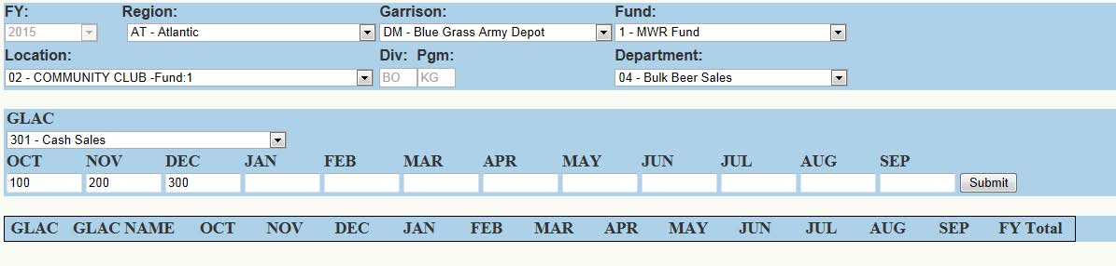Enter financial data using whole numbers in the Budget Input Screen

• Enter whole numbers only. An error message will appear if unauthorized characters are entered.
• Use Tab to move from month to month.
• Alternative method to move from month to month is to place your cursor in the month and left click the mouse.
• Do not use “Backspace” key to move back to a previous month or the user will be kicked out of FMBS Web and have to re-login.
• Any month left blank (no number to include zero entered) will when saved auto-fill with a zero.
TIP: Methods to copy data from one month cell to another month cell. (3 methods)

• Method 1: PAGE-UP KEY. Place the cursor in the month you want to copy. Press the Page-Up Keyon the keyboard and the data will copy into the next month’s cell. Continue to press the Page-Up Key to keep copying into other month cells.
• Method 2: RIGHT CLICK CURSOR. Highlight the month cell in which the data is to be copied from. Right click the mouse. Select “Copy” from the drop down menu. Move your cursor to the month cell in which the data is to be copied into (if there is data in the cell, the data needs to be highlighted). Right click your cursor and select “Paste” from the drop down menu.
• Method 3: SHORTCUT KEY FUNCTION. Highlight the month cell in which the data is to be copied from. Click “Control-C” keys on the keyboard together. Move your cursor to the month cell in which the data is to be copied into (if there is data in the cell, the data needs to be highlighted). Click “Control-V” keys on the keyboard together to paste the copied data to the selected cell.

Method 3
Method 1
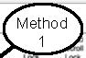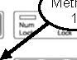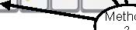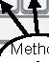Copy Budget Data from Month Cell to Cell Month Cell in Data Entry
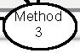
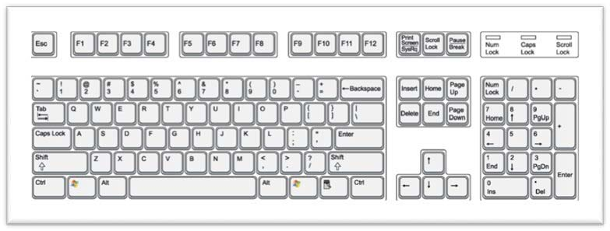

STEP 3. Save data entered by one of the following methods.

• Data saved will be shown in the Data Grid below the Data Input section. Any data in the Data Grid has been saved to the AOB database.

• Methods of saving data (3 methods):

o Method 1 – FASTEST METHOD - Click the ENTER or RETURN key on the keyboard at any time while entering monthly data and the GLAC and data will be saved to the data grid. This save function will work from any month cell.

o Method 2 - Using the TAB key on the keyboard, tab through the months until the SUBMIT button is highlighted. This occurs immediately after tabbing through September. Click the ENTER or RETURN key on the keyboard to save.

o Method 3 – Place the cursor over the SUBMIT button and left click the mouse.
o

Method 2
Method 1
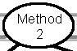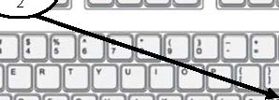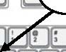Saving Budget Data
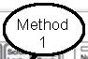
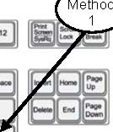

STEP 4. Saved GLAC and budget data will be added to the information in the Data Grid (located immediately below the Data Input section) and a confirmation message will appear above the GLAC selection dropdown menu area.

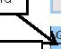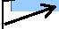Step 4 Total Lines NIBD & NIAD/ Net Income
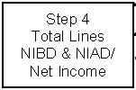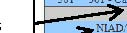Step 4 Data Saved to Data Grid
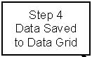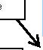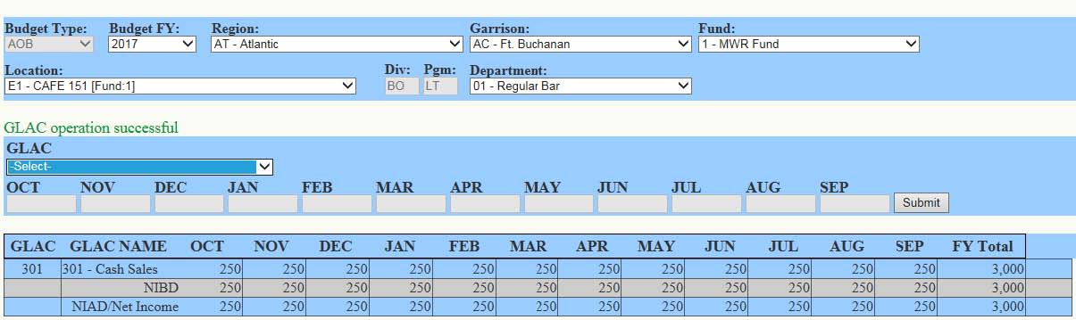Step 4 Confirmation Message
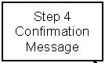Confirmation of GLAC Financial Data Saved and Added to Data Grid

• Confirmation Message for the example of entering GLAC 301 data, the message reads “GLAC operations successful”.
• There are two total lines at the bottom of each month which reflects the NIBD and NIAD/Net Income respectively.

MODIFYING FINANCIAL DATA.
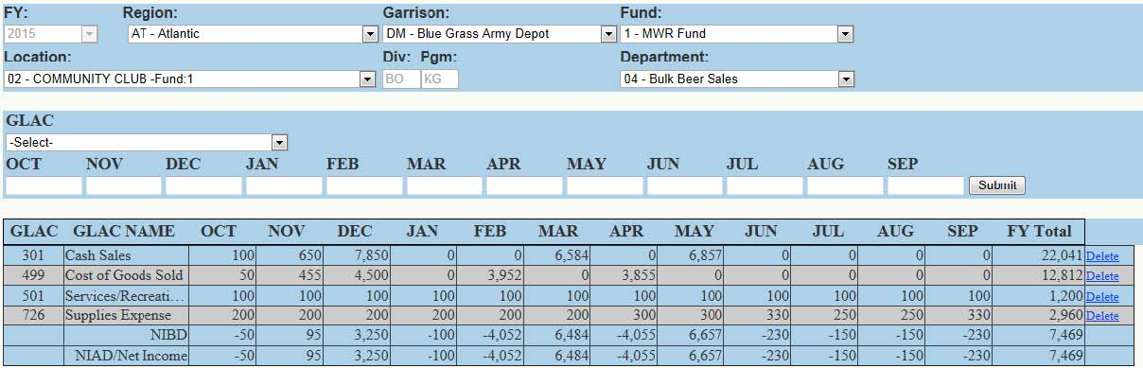
EXAMPLE: Start of Modification of GLAC 301 Financial Data

STEP 1. Select the GLAC to be modified from the GLAC dropdown menu in the Data Input section.

STEP 2. The monthly financial data for the selected GLAC will be loaded into the Data Input section.

STEP 3. Change/update the financial data. Example: Change GLAC 301 in August from zero to 99,999.

STEP 4. Save the data.

STEP 5. The updated GLAC financial data is updated in the Data Grid below the Data Input section. Example: Changed GLAC 301 August from zero to 99,999.

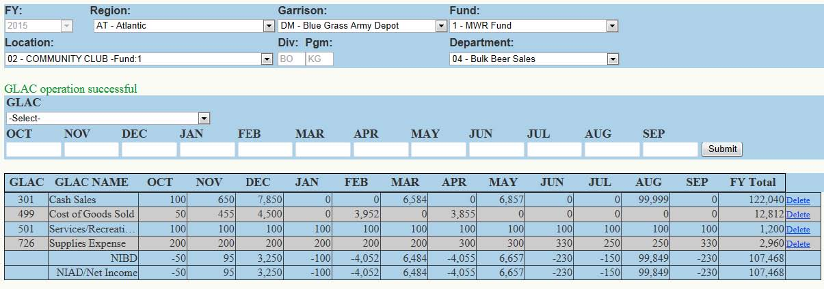

EXAMPLE: Completed Modification of Existing GLAC 301 Data (Step 5)

o

Method
Saving Budget Data

5-5. DELETING FINANCIAL DATA.

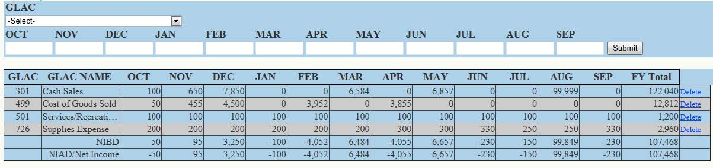
EXAMPLE: Start of Deletion of GLAC 501 from Data Grid

STEP 1. Identify the GLAC to be deleted from the data grid below the Data Input section. Example: GLAC 501

STEP 2. Click the DELETE link at the left side of the GLAC 501 line of data.

STEP 3. A confirmation screen will appear asking “Are you sure you want to delete that GLAC from the Budget?” If yes, click the OK button and continue; if no, click the CANCEL button.
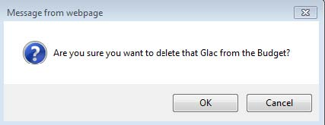
Confirmation Screen (Step 3)

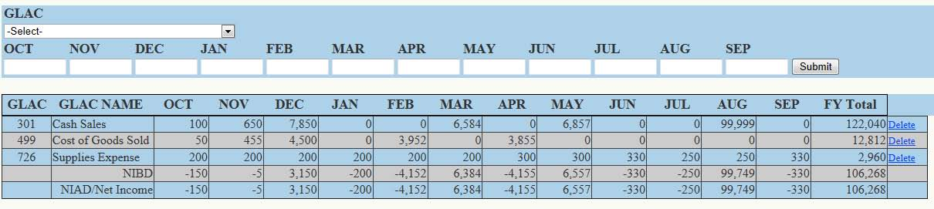STEP 4. The data grid will appear with the selected GLAC deleted from the data grid.

EXAMPLE: Completed Deletion of GLAC 501 and Financial Data from Data Grid and AOB

